Annexure MRTS300.1 (March 2024)
Construction of Boat Ramps
Specific Contract Requirements
Contract Number
Note: | Clause references within brackets in this Annexure refer to Clauses in the parent Technical Specification MRTS300 unless otherwise noted.

Scope of Works and extent of contract (Clause 4.1)
This is a general guide to the scope of works and extent of contract. Refer to the Schedule of Rates and the Drawings for quantities.
[General scope of work is one or 2 high level dot points. select / edit / add as appropriate]
The general scope of work is:
- Construct a new [number of lanes] boat ramp.
- Resurface / reconstruct the existing [extent of lanes] to current standards.
- Design and construct a new floating walkway.
The scope of works and extent of contract are:
[for this section use numbered points generally in the order of works and/or broad major items from the schedule of rates – delete / add / select / edit as appropriate. Do not break down to low sub-levels]
- Site establishment.
- Removal of vegetation.
- Removal of the existing ramp / structures.
- Earthworks including cut, and supply and placement of geotextile, geogrid and 75mm crushed rock.
- Supply and placement of precast ramp planks.
- Supply and placement of precast concrete slabs or Type 1 anchor beams.
- Design, supply, and construction of a floating walkway (including support lane, abutment, restraining piles and flotation modules.
- Construction of fully grouted stone pitched shoulders.
- Reconstruction of access pavement.
- Supply and install of grouted mattress.
- Pavement markings.

Ramp closure constraints, site constraints, traffic control arrangements or program requirements (Clause 5.4)
The following requirements will be included in the Works Program and when undertaking the Works.
[for this section use numbered points generally in the order of works – select / add / delete edit as appropriate] [for a new build it may not have special requirements].
- School holiday blockouts.
- Earliest start date (around school holidays).
- Storage of planks allowed onsite prior to start of works -defined locations.
- Order of works (define by Lane numbers).
- Minimum number of lanes to be available at weekends / specific times or full closure allowed?
- Requirements for public notification (– example VMS if required).

Quality Plan Components (Clause 5.5)
These components shall be included in the Quality Plan:
Procurement Plan | Mandatory
Concrete Mix Design | Mandatory
Crushed Rock Compaction Plan  - Significant depth of fill requires multiple lifts or length of slabs over fill. Not required for a Type 1 anchor beam | ☐ Required  ☐ Not required
Concreting Preparation Plan | Mandatory

Earthworks (Clause 8)

Removal and disposal of existing structures (Clause 8.2)

Clearing and grubbing of vegetation (Clause 8.3)

Existing services relocation (Clause 8.4)

Transport and disposal of excavated spoil (Clause 8.7)

Treatment of acid sulfate soils (ASS) (Clause 8.8)
The following treatment requirements shall apply only if indicated by Item 1:
Excavated spoil is required to be treated for ASS:
 | ☐ Yes  (MRTS300 Clause 8.8 applies) | ☐ No  (MRTS300 Clause 8.8 does not apply)
- Limits of material requiring treatment
- Rate of Liming (kg lime / m³ of soil)
- Other treatment requirements

Minimum machine size for rock core compaction (Clause 8.13)
Minimum machine size not specified | ☐
Minimum machine type and size (mass):

Guidance table for selecting plant size – remove this box after selecting the appropriate machine.
Type 1 or Type 2 anchor beams do not require machine compaction
Designer to select an appropriate machine considering access, depth of fill and area of fill.

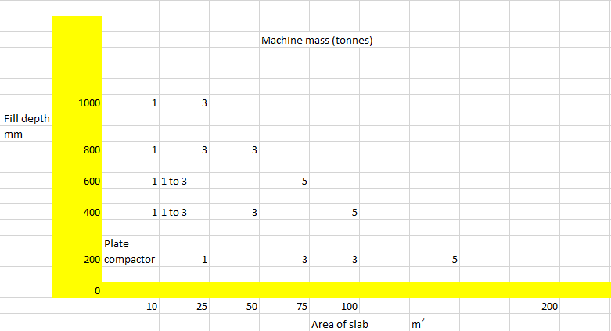

Definition of Non-Standard Work Items (Clause 12)
☐ Nil Non-Standard Work Items [delete remainder of Clause 5]
☐ These definitions apply to the Non-Standard Work Items in the Schedule of Rates:

Non-Standard Work Item Number Series | Unit of Measurement | Range
90100 | lump sum | 90101 to 90499
90500 | each | 90501 to 90999
91000 | m | 91001 to 91499
92000 | m² | 92001 to 92499
92500 | m³ | 92501 to 92999
93000 | kg | 93001 to 93499
93500 | tonne | 93501 to 93999
94600 | hr | 94601 to 94799
94800 | day | 94801 to 94999
[Add / delete these Item Number boxes as required]
Item Number | Description | Unit
9xx0x | Description as it will appear in the Schedule of Rates [edit] | [Define Unit]
Work Operations incorporated in this item include:
- Work operations listed in Clause 2.1.5 of MRS01 Introduction to Specifications
- Work operation 2
- Work operation 3
- Work operation n
Supply, placement and / or Installation Requirements
[Specification of materials, approval of materials, programming of works, construction / installation requirements]

Item Number | Description | Unit
 | Description as it will appear in the Schedule of Rates [edit] | [Define Unit]
Work Operations incorporated in this item include:
- Work operations listed in Clause 2.1.5 of MRS01 Introduction to Specifications
- Work operation 2
- Work operation 3
- Work operation n
Supply, placement and/or Installation Requirements
[Specification of materials, approval of materials, programming of works, construction / installation requirements]

Example only (delete the following table).
Item Number | Description | Unit
90100.01 | Supply and installation of abutment bollards | lump sum
Work Operations incorporated in this item include:
- Work operations listed in Clause 2.1.5 of MRS01 Introduction to Specifications
- Supply of fabricated bollards and SS316 studs and vandal resistant nuts.
- Installation including chemsetting studs to abutment, bolting, and vandal resistant treatment.
- Repair of surfaces damaged during the installation process.
Supply, placement and / or Installation Requirements
Refer to Drawing xxxxxx for dimensions, materials, specifications, and placement.

Environmental and Cultural Heritage Requirements (Clause 5.3 and 6)
☐ Nil supplementary requirements. [delete remainder of Clause 6]
☐ The following supplementary requirements shall apply:
6.1 Supplementary requirement 1 [requirement heading]
[Supplementary requirement #1 text]
6.2 Supplementary requirement 1 [requirement heading]
[Supplementary requirement #1 text]

Supplementary Requirements (Clause 18)
☐ Nil supplementary requirements. [delete remainder of Clause 6]
☐ The following supplementary requirements shall apply:
7.1 Supplementary requirement 1 [requirement heading]
[Supplementary requirement #1 text]
7.2 Supplementary requirement 2 [requirement heading]
[Supplementary requirement #2 text]

