

Scarborough Boat Harbour Master Plan 2024

The Department of Transport and Main Roads (TMR) respectfully acknowledges the Traditional Owners and Custodians of the land and waterways and we pay respect to their Elders past, present and emerging. TMR recognises those whose ongoing effort to protect and promote Aboriginal and Torres Strait Islander cultures will leave a lasting legacy for future First Nations people.
The Queensland Government is committed to providing accessible services to Queenslanders of all cultural and linguistic backgrounds. If you have difficulty understanding this publication and need a translator, please call the Translating and Interpreting Service (TIS National) on 13 14 50 and ask them to telephone the Queensland Department of Transport and Main Roads on 13 74 68.
Contact us for alternative accessible formats.
Please email: bhplanning@tmr.qld.gov.au
This information can also be found on our website: https://www.tmr.qld.gov.au/projects/scarborough-boat-harbour
Copyright
This publication is protected by the Copyright Act 1968.
© The State of Queensland (Department of Transport and Main Roads) 2024.
All rights reserved.
Disclaimer
This publication is provided as a source of information only and the State of Queensland makes no statements, representations or warranties about its accuracy or completeness. To the extent permitted by law, the State of Queensland disclaims all responsibility for decisions or actions taken as a result of any data, information, statement or advice, expressed or implied, contained within and excludes all liability (including, without limitation, liability in negligence) for all expenses, losses, damages and costs that may be incurred.

Contents
Shaping the future of the Scarborough Boat Harbour 3
Queensland state boat harbours 5
The Scarborough Boat Harbour Master Plan 7
Master planning process 8
Consultation and engagement summary 9
Phase 1 — Early engagement summary 9
Phase 2 — Public consultation summary 11
Phase 3 — Additional community and stakeholder feedback summary 13
Master plan vision, strategies and structure plan 14
Strategy 1 — Strategic positioning and regional profile 17
Strategy 2 — Harbour function and operation 19
Strategy 3 — Environmental sustainability 21
Strategy 4 — Connecting to Scarborough 23
Strategy 5 — Character and activation 25
Harbour activities and structure 27
Land use structure and precincts 27
Implementation and next steps 44
Stakeholder engagement 44
Statutory planning framework 44
Further studies and investigations 44

Shaping the future of the Scarborough Boat Harbour
Scarborough Boat Harbour is a strategic state-owned maritime public asset and gateway to the Moreton Bay Marine Park and the broader Queensland coastline. The harbour plays an important role in supporting access to a range of maritime, tourism and recreation functions in a dynamic fast-growing region, and is a key focal point and destination for the region and the Redcliffe Peninsula.
Scarborough Boat Harbour’s limited space is highly valued, and has a broad range of stakeholders with competing needs and objectives around what the future form and function of the harbour could look like. It is therefore important to plan for the harbour’s sustainable long-term future and the Scarborough Boat Harbour Master Plan (master plan) aims to strike a balance between sustaining a working harbour and maritime operations, while enhancing the experience and access for all.
The Scarborough Boat Harbour is more than just a maritime asset, it is an important part of the unique lifestyle of the local community. That’s why the master plan acknowledges its local context and provides a roadmap to proactively manage its growth over the next 25 years. Change is inevitable, but through planning for our future and ongoing communication, this document aims to enhance the liveability of the area.The master plan has been informed by supporting technical studies and the consultation and engagement of a broad range of stakeholders and the community.
This document provides a summary of the consultation and engagement process and insights which helped inform the development of the master plan.
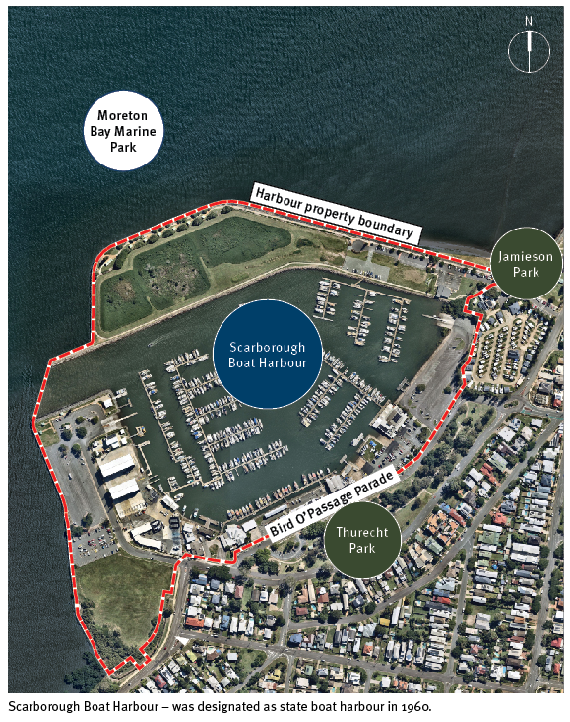

Queensland state boat harbours
The Scarborough Boat Harbour is one of Queensland’s eight state owned and managed harbours that form a network of important strategic maritime public assets which:
- provide safer and more efficient all-tide deepwater sheltered access for recreational and commercial vessels
- support sustainable recreational and commercial boating activities and the broader maritime and tourism sectors
- support maritime-related community functions, government services and public recreation.
The Department of Transport and Main Roads (TMR) manages Queensland’s state boat harbours to protect and enhance their important strategic maritime function and provision of access to Queensland’s waterways. The state boat harbours also accommodate maritime community groups and clubs, government services and marine rescue. Each harbour plays an important function in its local and regional context, creating a destination that balances sustaining a working harbour and maritime operations, alongside public access and recreation.
TMR leases land and seabed within the harbours to facilitate investment and development that supports sustainable maritime and tourism sectors and promotes local employment. TMR owns and maintains public boating infrastructure and facilities in each harbour and is responsible for maintaining the entrance and internal public navigation channels to public boating facilities. Lessees of seabed within each harbour precinct (such as marinas, commercial operators and boat clubs) are responsible for maintenance dredging within their leased area.

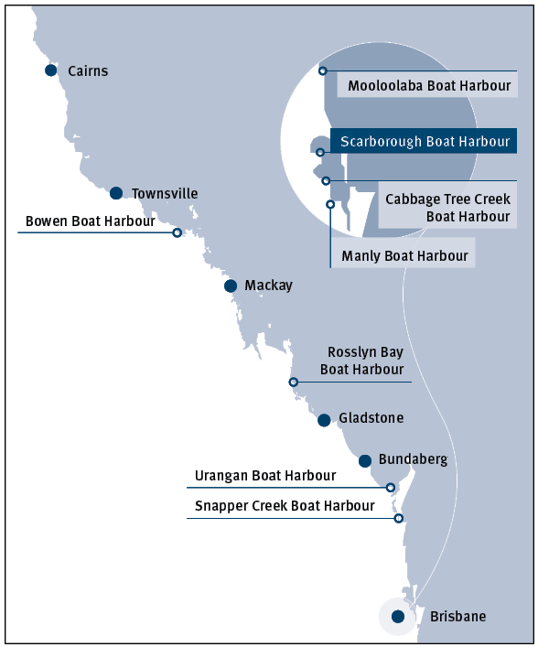

The Scarborough Boat Harbour Master Plan
The master plan sets out a long-term vision and will serve as a strategic, non-statutory decision-making tool to guide development and implement actions over time. The master plan will be updated, monitored and reviewed, and will be used to inform future detailed planning and investigations, and existing infrastructure planning and prioritisation programs.
The master plan does not approve development, provide detailed design, or confirm infrastructure arrangements and funding. TMR will continue to work and collaborate with Moreton Bay City Council (MBCC), industry and stakeholders, the community, and relevant state agencies regarding these matters.
The master plan identifies a range of key opportunities to improve the harbour, including:
- enhanced access and berthing for vessels
- growth of the maritime and tourism sectors
- improved public access, public realm and open space
- minimising the harbour’s environmental footprint and impact
- improved integration with surrounding areas
- driving Scarborough Boat Harbour as a destination.
The master plan will:
- create a shared vision for the future of the harbour
- identify potential uses and design concepts
- work within, and rely on existing planning and environmental legislative requirements and processes
- identify and guide future detailed planning and investigations relating to transport and access, public boating facilities, open space and public realm, and environmental and coastal processes.
Importantly, the master plan does not:
- replace existing legislation and processes
- impact existing lease agreements
- guarantee development, funding or infrastructure delivery
- provide detailed design
- affect areas under MBCC's jurisdiction.
Key statistics and information of the Scarborough Boat Harbour and the Australian maritime industry
- The harbour generates in the order of $20 million to $24 million in direct and indirect expenditure for the Scarborough local area
- Increasing demand for supporting marine infrastructure
- 7% growth per annum in net personal water craft in QLD from 2016 – 2021
- Development at the harbour could result in increased expenditure in the Scarborough local economy of $7.4 million to $8.9 million per annum
- 1.22% growth per annum in boat registrations in QLD from 2016
- 1 in 10 Aussies have a boat licence. QLD has the highest number of perpetual licenses in the country (July 2021)
Sources:Economy.id, 2022, MSQ Registered Vessel Census 2021, Australian Sailing Annual Reports, 2018-2021

Master planning process
The master plan has been developed using an evidenced-based and consultative approach. Feedback received from stakeholders and the community has been integrated alongside the exploration of the opportunities and constraints of the harbour and technical analysis. Analysis areas included environmental, commercial and property, maritime infrastructure and operations, infrastructure and access, recreation, tourism, future trends, and urban design matters relevant to the harbour and the surrounding area.
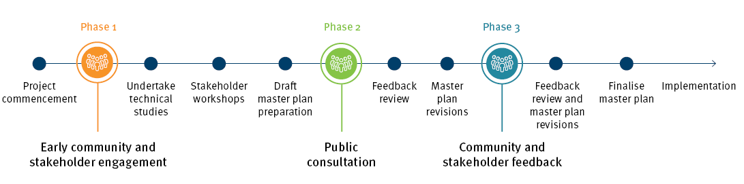

Consultation and engagement summary
Community and stakeholder engagement has helped to inform the development of the Scarborough Boat Harbour Master Plan. For a more detailed summary of the consultation and engagement, refer to the Consultation and Engagement Insights Summary.

Phase 1 — Early engagement summary
TMR undertook a program of community and stakeholder engagement from 9 September to 24 October 2021, to understand community and stakeholder values about the harbour, as well as ideas about current and future use. An awareness and positioning campaign supported a variety of in-person and online activities during the engagement period.

Engagement insights
Feedback identified what would encourage more frequent use of Scarborough Boat Harbour and enhance experiences:
- Protection of the natural environment
- Continued support and enhancement of the harbour's maritime purpose
- Well-planned and improved utilisation of public spaces
- Improved public amenities and infrastructure
- More events, activities and activations
- Improved access and connectivity
Respondents also shared what is special about Scarborough Boat Harbour, including:
- Views, visual amenity and natural environment
- A sense of community ownership
- Existing facilities, access to the harbour and activities
- Location, access to water and proximity to Moreton Bay
The findings from engagement were used to inform the master planning program, including developing background technical studies, draft master plan outcomes and content, and planned engagement activities.
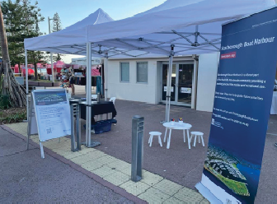
Source: Phillips Group, 2021

Phase 2 — Public consultation summary
TMR commenced public consultation for the draft master plan on 13 November 2023. It was initially planned to close on 11 December 2023, however in response to community and stakeholder feedback the public consultation process was extended until 11 March 2024.
The feedback received highlighted varying views across all response areas. A summary of feedback received identified:
- there is an opportunity to achieve more balanced land-use outcomes across the harbour, including:
  - reconsidering relocation of the trawler facility and public boat ramps to northern arm, due to safety, traffic and amenity impacts
  - inclusion of lower intensity activities along the harbour's northern arm such as tourism, hospitality and marina related activities
  - greater provision of open space for public recreation and improved public facilities, particularly on the harbour's northern arm
  - retaining maritime industry uses within existing locations in the southern arm of the harbour
- there is a need to provide additional boat launching capacity, supporting parking facilities and ancillary support services to meet current and future demand
- there is a need for greater consideration of terrestrial and marine environments, including mangroves, birdlife and marine life
- further information was requested regarding:
  - how future building heights and potential noise and emissions might affect residential areas and views
  - how traffic impacts on the surrounding road network would be managed and what infrastructure upgrades may be required
  - how tidal inundation and overland flow issues in surrounding areas would be managed.
In response to the feedback received during public consultation, TMR revised the draft master plan to improve the balance between sustaining a working harbour and maritime operations, while enhancing the experience and access for all harbour users. Some of the key changes in response included:
- removal of the proposed new boat ramp and associated parking from the northern arm
- changes to the precinct locations and land uses within the harbour along the harbour's northern arm
- inclusion of additional overflow car parking
- investigation of a new road connection to the northern arm
- approximately 26% of the land-side harbour now dedicated open space for public access with a 35% increase in pathway connections improving pedestrian connectivity
- retention of the trawlers in their current location.
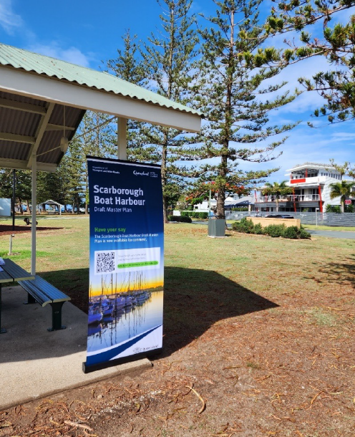

Phase 3 — Additional community and stakeholder feedback summary
Responding to the findings of the public consultation process, TMR published a revised master plan on 7 June 2024. Stakeholders and the community were invited to share their feedback on the revised master plan between 10 June to 24 June 2024. In support of the revised master plan, TMR also attended a community forum held at the Redcliffe Leagues Club on 8 June 2024, which had over 130 attendees including representatives from MBCC, industry and the local community.
Following community and stakeholder feedback, and including additional feedback received from state agencies and MBCC, TMR made changes to the master plan including:
- strengthened commitment to no short-term accommodation or residential uses on TMR controlled land within the harbour
- commitment to seek reduction in heights on the northern arm as part of any future amendments to the MBCC planning scheme
- clarification that the potential breakwater area and temporary spoil transfer pocket are subject to further detailed investigation and environmental approvals
- ongoing commitment to stakeholder and community engagement on the implementation of the master plan
- working with MBCC on management of localised traffic and drainage issues as part of any future development.

Master plan vision, strategies and structure plan

Scarborough Boat Harbour vision
Support maritime industry growth, stimulate tourism and recreation, sustain the natural environment, and ongoing stakeholder and community engagement.

Master plan strategies
This master plan and the following supporting strategies form a strategic decision-making tool offering greater certainty to government, investors, tenants and the community about the harbour’s future form and activity.

Strategic positioning and regional profile
Position Scarborough Boat Harbour as a regionally significant maritime, commercial and recreational destination and a gateway to Moreton Bay.

Harbour function and operation
Develop a regionally significant harbour that prioritises the long-term health of Queensland's maritime industry, protects and enhances its role to provide all-tide deepwater sheltered access to Moreton Bay and allows for the sustainable growth of a broad range of maritime-related commercial, club, tourism, recreation and community activities.

Environmental sustainability
Recognise and respond to the significant ecological values of the Moreton Bay Marine Park and the Redcliffe Peninsula through a balanced approach to the sustainable growth of Queensland’s maritime industry and environmental sustainability.

Connecting to Scarborough
Plan for harbour evolution in a manner that respects the residential setting, promotes safe and efficient movement networks, and enhances the wider Scarborough waterfront experience for harbour users, local residents and visitors.

Place character and activation
Enhance the harbour’s place quality and the visitor experience through improved public realm design and open space, better public access and diversifying maritime related recreation and entertainment opportunities.
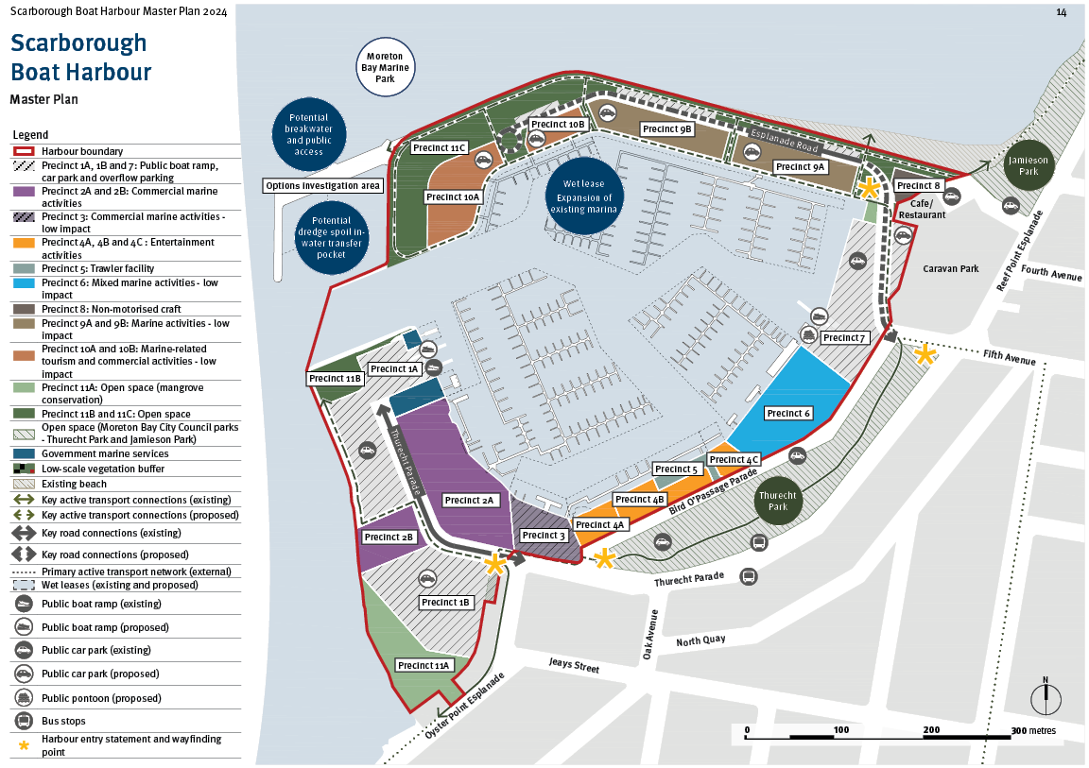
Legend
- Harbour boundary
- Precinct 1A, 1B and 7: Public boat ramp,
- car park and overflow parking
- Precinct 2A and 2B: Commercial marine activities
- Precinct 3: Commercial marine activities - low impact
- Precinct 4A, 4B and 4C : Entertainment activities
- Precinct 5: Trawler facility
- Precinct 6: Mixed marine activities - low impact
- Precinct 8: Non-motorised craft
- Precinct 9A and 9B: Marine activities - low impact
- Precinct 10A and 10B: Marine-related tourism and commercial activities - low impact
- Precinct 11A: Open space (mangrove conservation)
- Precinct 11B and 11C: Open space
- Open space (Moreton Bay City Council parks - Thurecht Park and Jamieson Park)
- Government marine services
- Low-scale vegetation buffer
- Existing beach
- Key active transport connections (existing)
- Key active transport connections (proposed)
- Key road connections (existing)
- Key road connections (proposed)
- Primary active transport network (external)
- Wet leases (existing and proposed)
- Public boat ramp (existing)
- Public boat ramp (proposed)
- Public car park (existing)
- Public car park (proposed)
- Public pontoon (proposed)
- Bus stops
- Harbour entry statement and wayfinding point

Strategy 1 — Strategic positioning and regional profile
Position the Scarborough Boat Harbour as a regionally significant maritime, commercial and recreational destination and a gateway to Moreton Bay.

Profile and role
- Promote the regional profile and elevate community awareness of the harbour as a state and regionally significant centre of maritime, economic and recreation activity within Moreton Bay’s wider network of maritime and tourism infrastructure
- Promote and protect the harbour’s strategic role in accommodating maritime industry growth, the trawler industry, nature-based and marine tourism opportunities, and sustainably managing increasing public access to Moreton Bay’s waterways and tourism destinations
- Utilise the harbour’s regional significance, history and identity as a working harbour to inform planning, public realm design and ongoing operations

Regional and local economy
- Attract a broad range of tourism, entertainment, recreation and commercial businesses and operators that elevate the harbour’s regional tourism function
- Provide opportunities for job creation through the delivery of a balanced mix of maritime industry, commercial marina, commercial tourism, hospitality and entertainment, and recreation activities and infrastructure
- Coordinate with state and local tourism policy and strategy initiatives
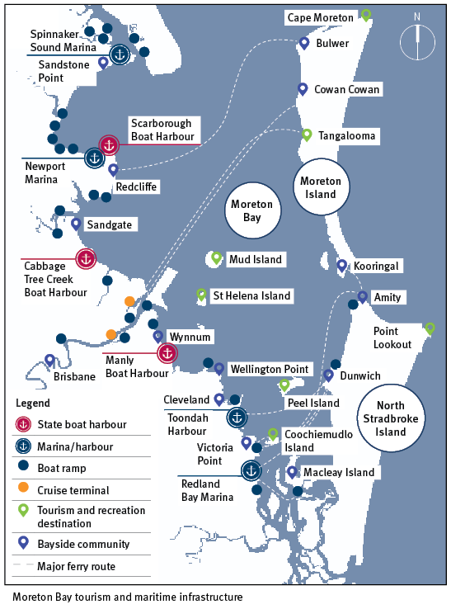

Strategy 2 — Harbour function and operation
Develop a regionally significant harbour that prioritises the long-term health of our maritime industry, protects and enhances its role to provide all-tide deepwater sheltered access to Moreton Bay and allows for the sustainable growth of a broad range of maritime-related commercial, club, tourism, recreation and community activities.

Industry growth
- Maximise opportunities for short and long-term vessel berthing, boat storage, recreational boating and public boat ramp infrastructure, commercial marine tourism infrastructure, commercial fishing, and associated marine infrastructure and services
- Enhance opportunities for the harbour to accommodate a broad range of maritime related community-based groups, volunteer organisations, boating clubs and state service providers

Harbour function and operations
- Structure harbour areas to deliver an optimal mix of maritime activities and commercial services, recreational and community activities capable of attracting a range of operators and users
- Ensure new marine infrastructure, or improvements to marine infrastructure support safety and efficiency, utilise dry and wet lease space efficiently, incorporate sustainable design principles, and are responsive to changes in vessel sizes and emerging technologies
- Encourage a diverse range of harbour activities by providing supporting maritime industry services such as fuelling, vessel maintenance and sewerage pump-out facilities
- Maintain and enhance commercial fishing operations and infrastructure
- Provide highly accessible, dedicated spaces for water access of non-motorised and motorised craft for public and boating groups
- Facilitate activities that support a commercially sustainable maritime and trawler industry
- Sustainably manage dredge spoil storage, re-handling, and disposal. Prioritise beneficial reuse of dredged material

Master plan responses
- Harbour expansion investigation area to provide future marine access, manage dredge spoil, and enhance public access.
- Maintain and investigate enhancing the trawler fleet and access to enable 'direct to public' seafood sales.
- Precincts arranged to deliver a variety of dry and wet lease options suited to a wide range of marine-based commercial operators, tourism and entertainment businesses.
- Paddle craft launch area and club and community group areas.
- Investigate providing additional public boat launching capacity.
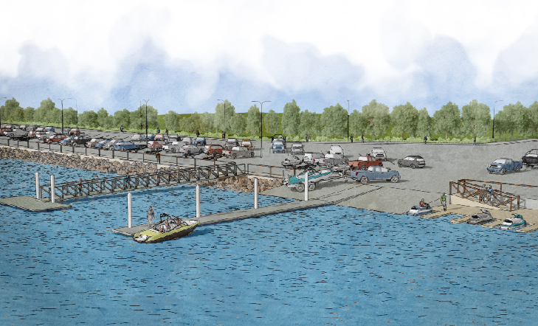

Strategy 3 — Environmental sustainability
Recognise and respond to the significant ecological values of the Moreton Bay Marine Park and the Redcliffe Peninsula through a balanced approach to the sustainable growth of Queensland’s maritime industry and environmental sustainability.

Ecology and environment
- Maximise and consolidate opportunities to accommodate demand for maritime activities and boat launching infrastructure at the harbour to alleviate development pressure on the wider Moreton Bay Marine Park
- Avoid, reduce or minimise potential impacts on terrestrial and marine habitats, coastal processes, and water quality incorporating sustainable mitigation measures and offsets where required
- Harbour interventions and development account for future coastal hazard and sea-level rise

Education and awareness
- Elevate awareness of the ecological values and sustainable use of the harbour and Moreton Bay waters through interpretive infrastructure and ‘smart’ or online platforms targeting community and tourist visitation
- Encourage nature-based tourism and eco-tourism businesses and operations to establish within the harbour that will contribute to the appreciation, and coordinated management of Moreton Bay Marine Park

Master plan responses
- Consolidation of maritime activities within the harbour.
- Mangrove and habitat protection areas.
- Dedicated open space.
- Undertake further environmental investigation work and collaborate with relevant environmental agencies.
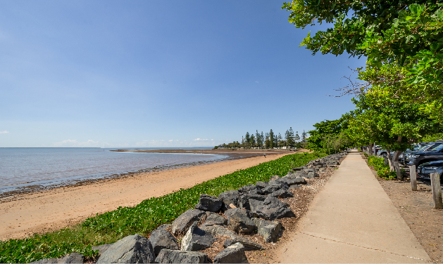

Strategy 4 — Connecting to Scarborough
Plan for harbour evolution in a manner that respects the residential setting, promotes safe and efficient movement networks, and enhances the wider Scarborough waterfront experience for local residents and visitors.

Harbour integration
- The character and amenity of the harbour respond to the surrounding area through land use transitions, buffers and landscape interface treatments, scale and visual context of harbour buildings, and high-quality public realm design of streets and open spaces
- Open spaces, active transport connections, water access and recreation opportunities complement Scarborough’s broader waterfront recreation and movement experiences
- Streetscapes and open spaces are designed to be highly integrated with Jamieson Park, Thurecht Park, and the connecting streets

Access and connectivity
- Promote high levels of integration with existing access and movement networks including the road network, public transport services, and active transport, including the Principal Cycle Network
- Improve car parking to service harbour users in a manner that minimises impacts on surrounding streets
- Establish clear public access and wayfinding minimising conflict between public visitation and commercial harbour operations and functions

Master plan responses
- Low impact and scale activities on the northern harbour arm, and buffers and appropriate development interfaces along street frontages.
- New and enhanced open space, walking and cycling connections and new maritime related recreation opportunities.
- Enhance existing public transport opportunities and integration.
- Integrate with and respond to the existing street network hierarchy and functions to minimise traffic implications and enhance the Northern Moreton Bay Tourist Drive.
- Indicative car parking requirements identified.
- Clear arrival points delineated through streetscape design and wayfinding signage.
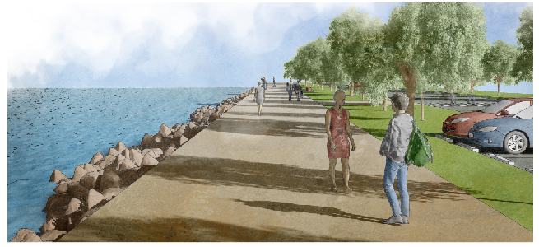

Strategy 5 — Character and activation
Enhance the harbour’s place quality and the visitor experience through improved public realm design and open space, better public access and diversifying marine-related recreation and entertainment opportunities.

Harbour activation
- Increase and diversify public activation of the harbour through the facilitation of a range of tourism, entertainment, hospitality, and recreation activities that complement the core role and maritime functions of the harbour

Place character
- Protect and enhance the intrinsic character and function of the harbour as a working harbour that sustains commercial maritime activities
- Ensure new buildings, structures and public realm enhancements are of an appropriate scale, quality and character that respect the wider residential context and align with future harbour uses

Public realm quality
- Deliver access and public realm enhancements capable of attracting a broad range of maritime related tourism, leisure and hospitality businesses and service providers, as well as community organisations
- Enhance the functional and visual quality of the public realm, addressing active transport accessibility, safety and legibility, open space function, character and quality, and streetscapes and car parks
- Reinforce separation of public and maritime industry functions and access, through public realm design and wayfinding signage
- Manage visual relationships within the harbour, including minimising the visual impact of the built form, car parking, and hard-stand areas

Cultural heritage
- In coordination with the Traditional Owners, seek opportunities to respect and highlight the area’s cultural significance

Master plan responses
- New and enhanced open spaces and active movement experiences that complement and connect to the surrounds.
- Investigate protection of critical views through placement of buildings, building and structure heights, and bulk of buildings.
- Enhanced beach access area, formalising its use as a public launching location for paddle craft.
- Expansion of maritime related tourism, entertainment, hospitality, and recreation activities including dedicated wet lease area for commercial tourism operators and short-term visitor berthing.
- Provide high quality public boat ramp and jetty infrastructure.
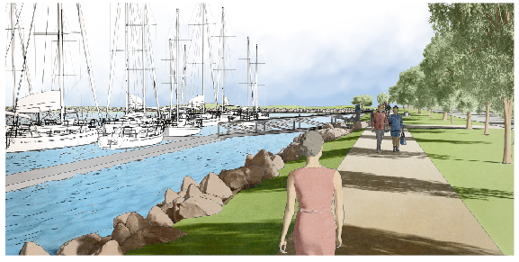

Harbour activities and structure

Diversifying and strengthening harbour activity
A key priority for the harbour is to diversify activity, attracting a mix of tenants that support the long-term health of the maritime industry at Scarborough while strengthening the harbour’s profile and role as a tourism and recreation destination.
Dry and wet areas are limited at Scarborough Boat Harbour and will become increasingly contested with the anticipated growth of commercial and recreational boating. This elevates the importance of planning for the appropriate balance of uses required to protect the primary maritime functions, allow for growth, diversify the activity mix, while responding to the environment and community. Residential or short-term accommodation does not align with the strategic maritime function of the harbour and is therefore not supported by the master plan.

Land use structure and precincts
The structural arrangement and function of land uses is critical to the success of Scarborough Boat Harbour. Clear functional separation of maritime uses from publicly accessible destinations and spaces underpins the layout and is required to minimise conflicts and potential impacts on harbour functions and the public realm.
The master plan identifies eleven precinct areas that offer a range of dry and wet area opportunities.

Precinct 1A Public boat ramp and car park
Maintain and enhance existing public boat ramp and car-trailer unit parking facility including:
- improved pedestrian connectivity, streetscaping / landscaping and activating the foreshore to Precinct 11B (open space)
- improved safety, efficiency and accessibility of the parking facility (improve traffic circulation and infrastructure interventions to deter hooning activities)
- improved public facilities – accessible public toilets
- investigate additional boat launching capacity in this location (adjacent to existing boat ramps) to cater for existing and future demand.
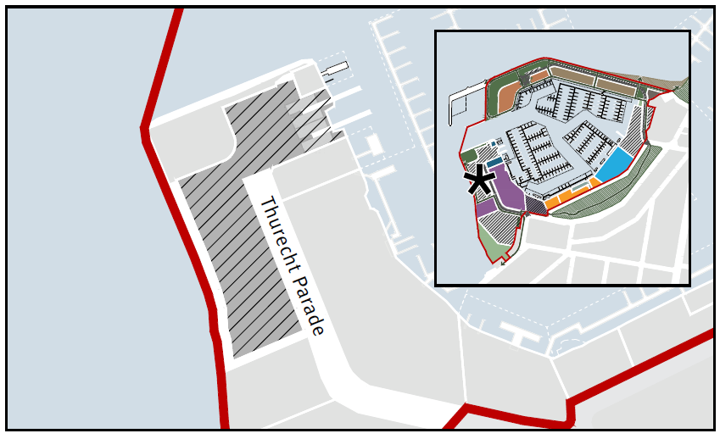

Precinct 1B Overflow parking
Provide an overflow parking facility including:
- shared parking facility to cater for single vehicles and car-trailer units
- landscaping and low scale vegetation buffer to adjoining residential and mangrove conservation areas
- investigate alternative car-park design solutions to avoid hard-stand and integrate landscaping where possible (for example, grasscrete).
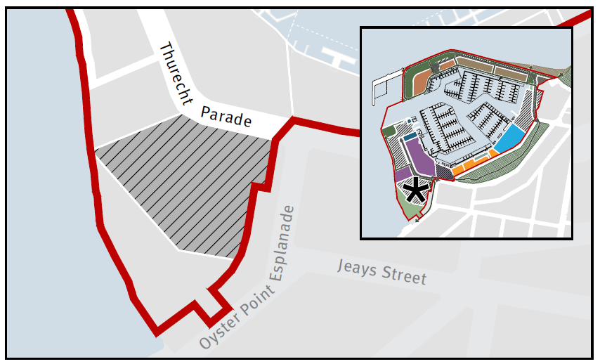

Precinct 2A and 2B Commercial marine activities
Maintain and enhance existing marine activities, offering a broad range of traditional maritime industry activity with associated wet leases.
Indicative land-use activities include:
- recreational boat moorings and berths
- mechanical, electrical services, marine engineering workshop
- boat repair – sanding, painting, welding
- boat maintenance
- sail makers, marine trimmers, boat detailing, upholstery
- travel lift
- slip yard
- fuelling facilities and fuel storage
- dry storage
- dock boatyards
- general storage
- chandlery
- bait, tackle and ice supplies
- convenience food and beverage
- toilets, laundrette, showers
- rubbish collection, sewage disposal, biosecurity facilities
- administration office
- parking.
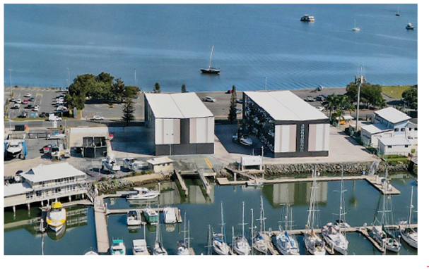
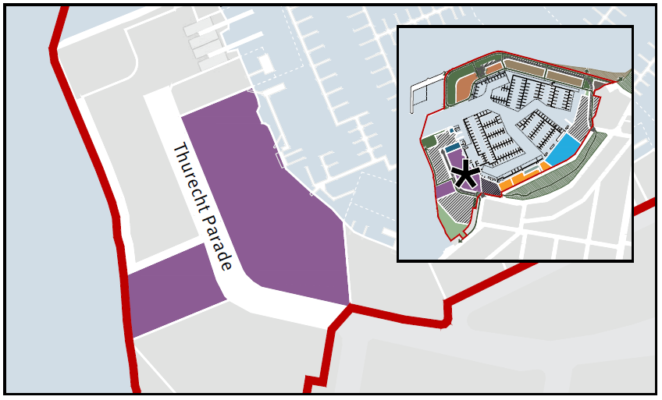

Precinct 3 Commercial marine activities – low impact
Maintain and enhance existing low impact and scale maritime activities or commercial uses requiring a public interface. Provides a logical land use intensity transition to public open spaces and surrounding residential areas.
Low impact and scale uses will:
- not have significant noise or air emissions
- have hours of operation compatible with the surrounding context
- have articulated building forms and scale responsive to the surrounding context.
Indicative land-use activities include:
- recreational and commercial boat moorings and berths
- seafood processing
- mechanical, electrical services, marine engineering workshop
- boat repair – sanding, painting, welding
- boat maintenance
- sail makers, marine trimmers, boat detailing, upholstery
- travel lift
- slip yard
- fueling facilities and fuel storage
- dock boatyards
- dry storage
- general storage
- chandlery
- bait, tackle and ice supplies
- convenience food and beverage
- toilets, laundrette, showers
- rubbish collection, sewage disposal, biosecurity facilities
- administration office
- parking.
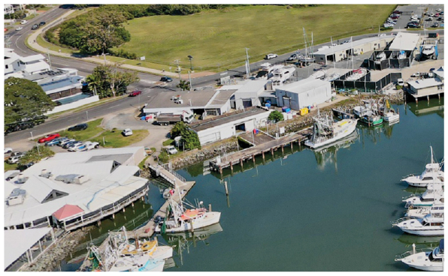
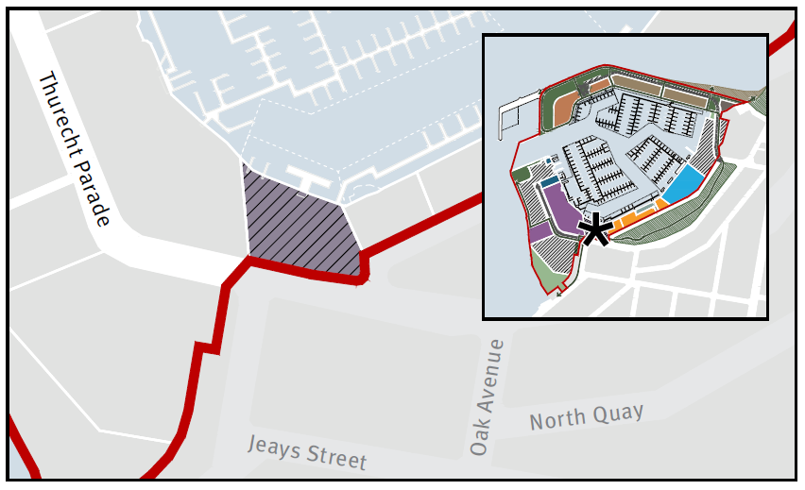

Precinct 4A, 4B and 4C Entertainment activities
Maintain and enhance existing waterfront marrine hospitality precinct.
Indicative land-use activities include:
- cafés / coffee carts
- restaurants / bistro / licensed premises
- micro-brewery
- fishmonger
- function facilities
- commercial boat moorings and berths
- parking.
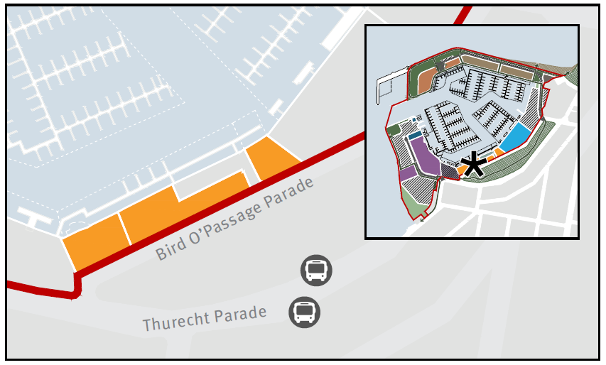

Precinct 5 Trawler facilities
Maintain and enhance existing trawler facility and access including:
- investigate safety and efficiency of access to the trawler facility, and potential to enable direct to public seafood sales
- investigate future trawler facility enhancements and upgrades
- investigate alternative management options for the facility.
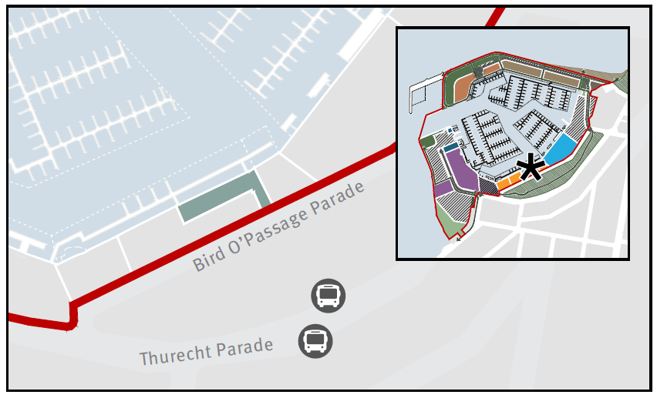

Precinct 6 Mixed marine activities – low impact
Maintain and enhance existing marina related uses.
Precinct that suits a range of low impact and scale marine or commercial uses requiring a public interface or community focus.
Low impact and scale uses will:
- not have significant noise or air emissions
- have hours of operation compatible with the surrounding context
- have articulated building forms and scale responsive to the surrounding context.
Indicative land-use activities include:
- recreational boat moorings and berths
- boat club
- community-based groups
- mechanical, electrical services, marine engineering workshop
- boat repair and maintenance
- sail makers, marine trimmers, boat detailing, upholstery
- travel lift
- slip yard
- fuelling facilities and fuel storage
- dock boatyards
- dry storage
- general storage
- chandlery
- bait, tackle and ice supplies
- convenience food and beverage
- toilets, laundrette, showers
- rubbish collection, sewage disposal, biosecurity facilities
- administration office
- parking.
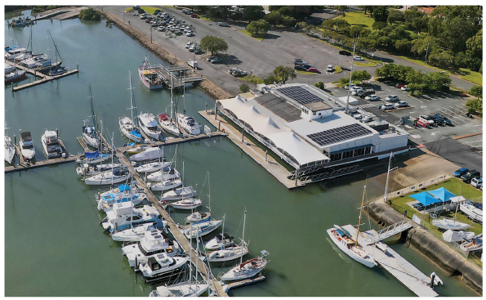
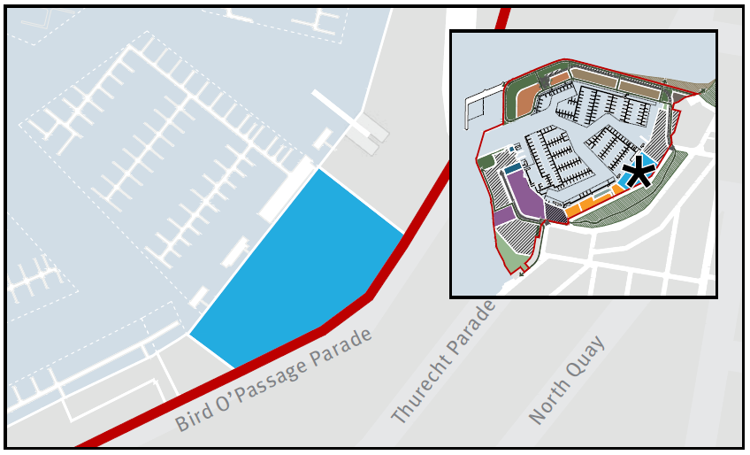

Precinct 7 Public boat ramp and car park
Reconfigure and enhance existing public boat ramp and car-trailer unit parking facility including:
- reconfiguring public boat ramps to enable new access road from Bird O’Passage Parade to the northern arm
- improved pedestrian connectivity, streetscaping / landscaping and activation to the precincts on the northern arm
- improved safety, efficiency and accessibility of the parking facility (improve traffic circulation, infrastructure interventions to deter hooning activities)
- investigate new public pontoon (adjacent to reconfigured boat ramps) to cater to existing and future demand.
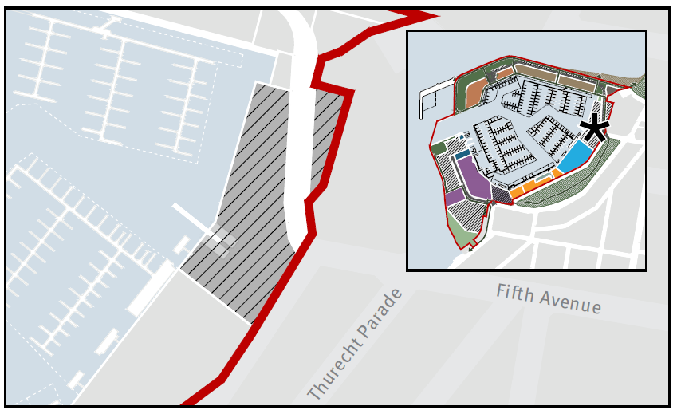

Precinct 8 Non-motorised craft
Provide a new precinct that improves access to beach and for paddle/ non-motorised craft launching, integrating with surrounding open space areas.
Indicative land-use activities include:
- small scale kiosks for paddle craft hire
- other sailing/paddle craft opportunity (other community functions)
- administration office
- storage
- paddlecraft wash down facility.
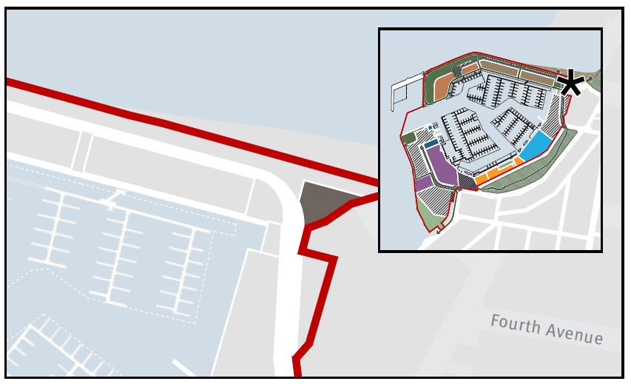

Precinct 9A and 9B Marine activities – low impact
Maintain and enhance the existing marina including:
- adding marina berthing capacity and marine-related services
- opportunity for greater land-side marina offering, including hospitality venues to improve public access and community focus
- improved pedestrian connectivity, streetscaping / landscaping and activation along the foreshore.
Low impact and scale uses will:
- not have significant noise or air emissions
- have hours of operation compatible with the surrounding context
- have articulated building forms, scale and height, and footprint locations responsive to the surrounding context and important views.
Indicative land-use activities include:
- recreational boat moorings and berthing
- boat club
- parking facilities
- marina facilities (admin, toilets, laundrette, shower)
- ancillary services (sewer pump, fuel services)
- food and beverage/ hospitality venue
- dry storage – dock boatyards,
- sailing/paddle craft opportunity (other community functions)
- minor repair and boat maintenance
- small scale function room/facilities.
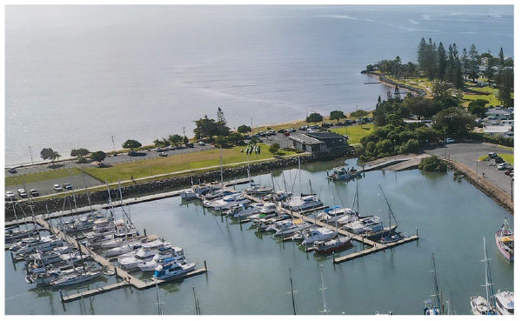
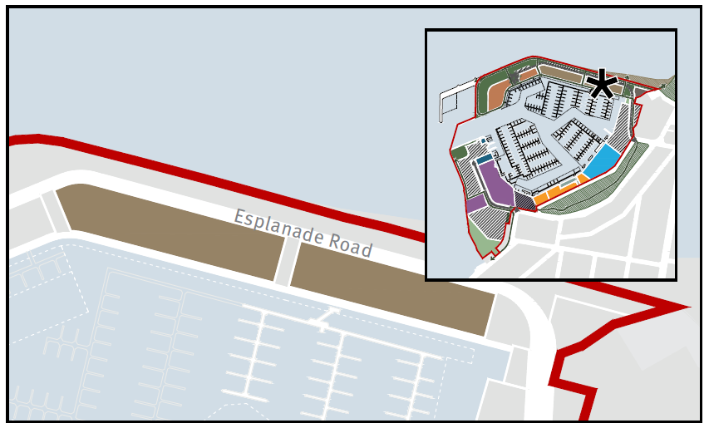

Precinct 10A and 10B Maritime related tourism and commercial activities – low impact
Waterfront precincts that provide opportunities for maritime-related recreation and leisure activities such as food and beverage businesses and low scale commercial marine tourism operators. A dedicated wet area allows for commercial mooring and berthing for tourism and commercial vessels as well as recreational short term and day use berths.
Low impact and scale uses will:
- not have significant noise or air emissions
- have hours of operation compatible with the surrounding context
- have articulated building forms, scale and height, and footprint locations responsive to the surrounding context and important views.
Indicative land-use activities include:
- commercial moorings and berths
  - tourism
  - ferry services
  - fishing
  - charter services
  - boat hire
  - short-term and day use berths.
- small scale marine education
- booking offices
- information
- event management
- small scale hospitality (cafés, coffee carts)
- parking.
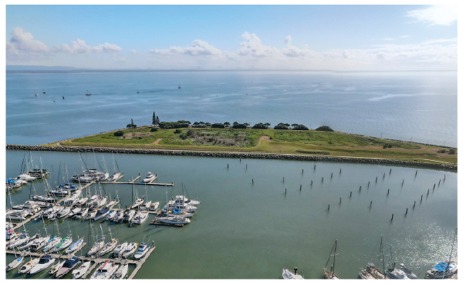
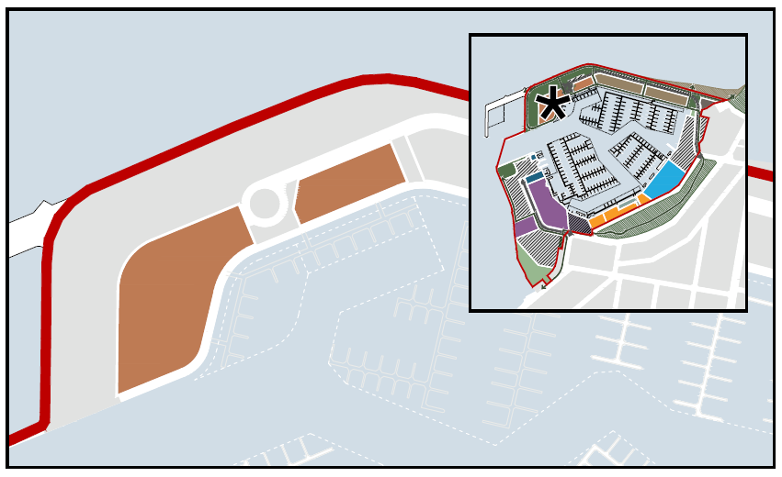

Precinct 11A, 11B and 11C Open space
Southern mangrove conservation
Maintain, enhance and buffer the mangrove habitat area.
Southern area
Maintain and enhance existing open space including improved pedestrian connectivity, streetscaping / landscaping and activating the foreshore.
Northern arm
Provide new open space including:
- improved pedestrian connectivity, streetscaping / landscaping and activating the foreshore
- enhanced public amenities including seating and toilets
- opportunity for maritime-related short-term events and activations.
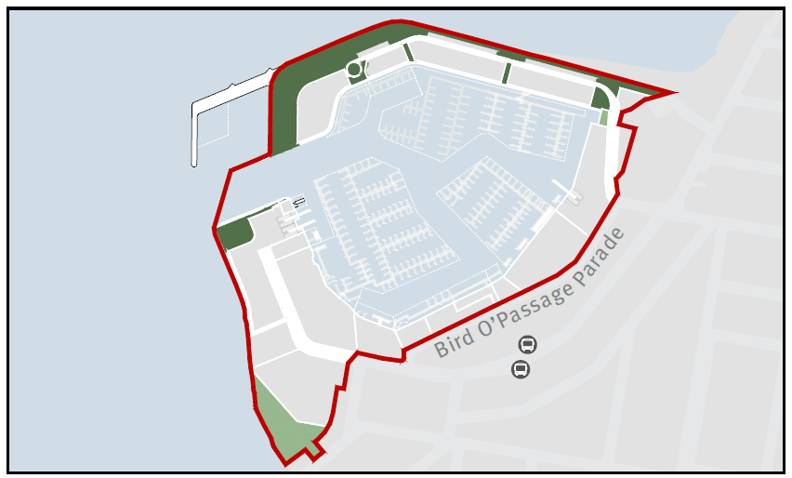

Options investigation area
Subject to feasibility studies and approvals, potential new breakwater to create new harbour area for the purposes of:
- staging and pick-up / drop-off for vessels to cater for long term future demand if required (no land side infrastructure proposed)
- short-term marine events area
- managing the transfer of dredge-spoil in-water
- extending public access along the breakwater.
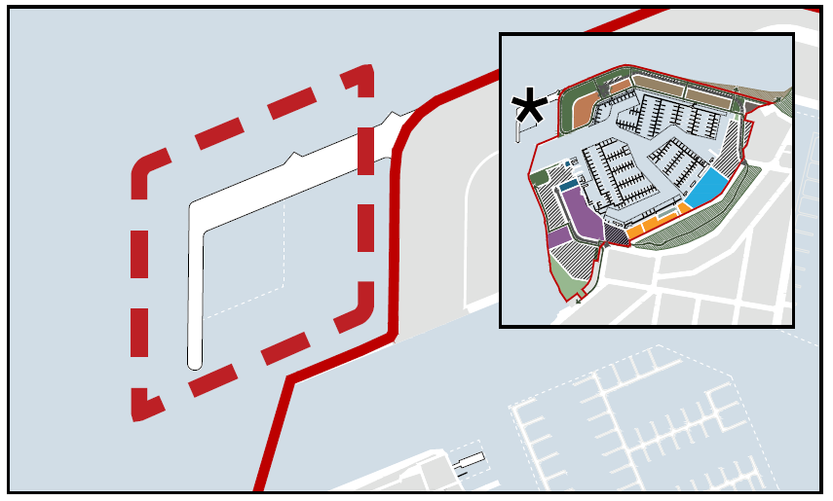

Implementation and next steps
The master plan sets out a long-term vision and will serve as a strategic, non-statutory, decision-making tool to guide development and implementation actions over time, including informing infrastructure planning and prioritisation programs. The transition of Scarborough Boat Harbour towards the vision outlined in the master plan will be achieved through a combination of staged improvements and changes to existing infrastructure, new development and leasing opportunities, and private and public investment.

Stakeholder engagement
Implementation of the master plan will require ongoing engagement and collaboration with MBCC, harbour and industry stakeholders, leaseholders, Traditional Owners and the community. A stakeholder and community engagement strategy will be prepared to support implementation of the master plan.

Statutory planning framework
The master plan is a non-statutory document and works within existing legislative, planning, and leasing frameworks. Collaboratively working together with MBCC to inform and guide further studies and investigations and to determine appropriate implementation actions are important next steps. This collaboration will include but is not limited to the management of localised flooding and drainage issues, and building form and heights on the harbour's northern arm.

Further studies and investigations
The master plan sets a long-term vision that requires further investigations and studies to support its implementation. Key informing studies required include:
- northern arm access road feasibility study
- a movement network and car parking strategy addressing public and active transport, private and public car parking, recreational boating and car-trailer parking, and integration with the surrounding networks
- geotechnical investigations into the proposed dredge spoil rehandling area
- harbour dredging strategy
- detailed assessment of the ‘investigation area’ in accordance with all relevant environmental and Marine Park legislation
- urban design, public access, signage and wayfinding strategy.
The outcomes of these studies will inform development of an implementation strategy and supporting stakeholder and community engagement strategy. The master plan will be updated, monitored and reviewed into the future.

