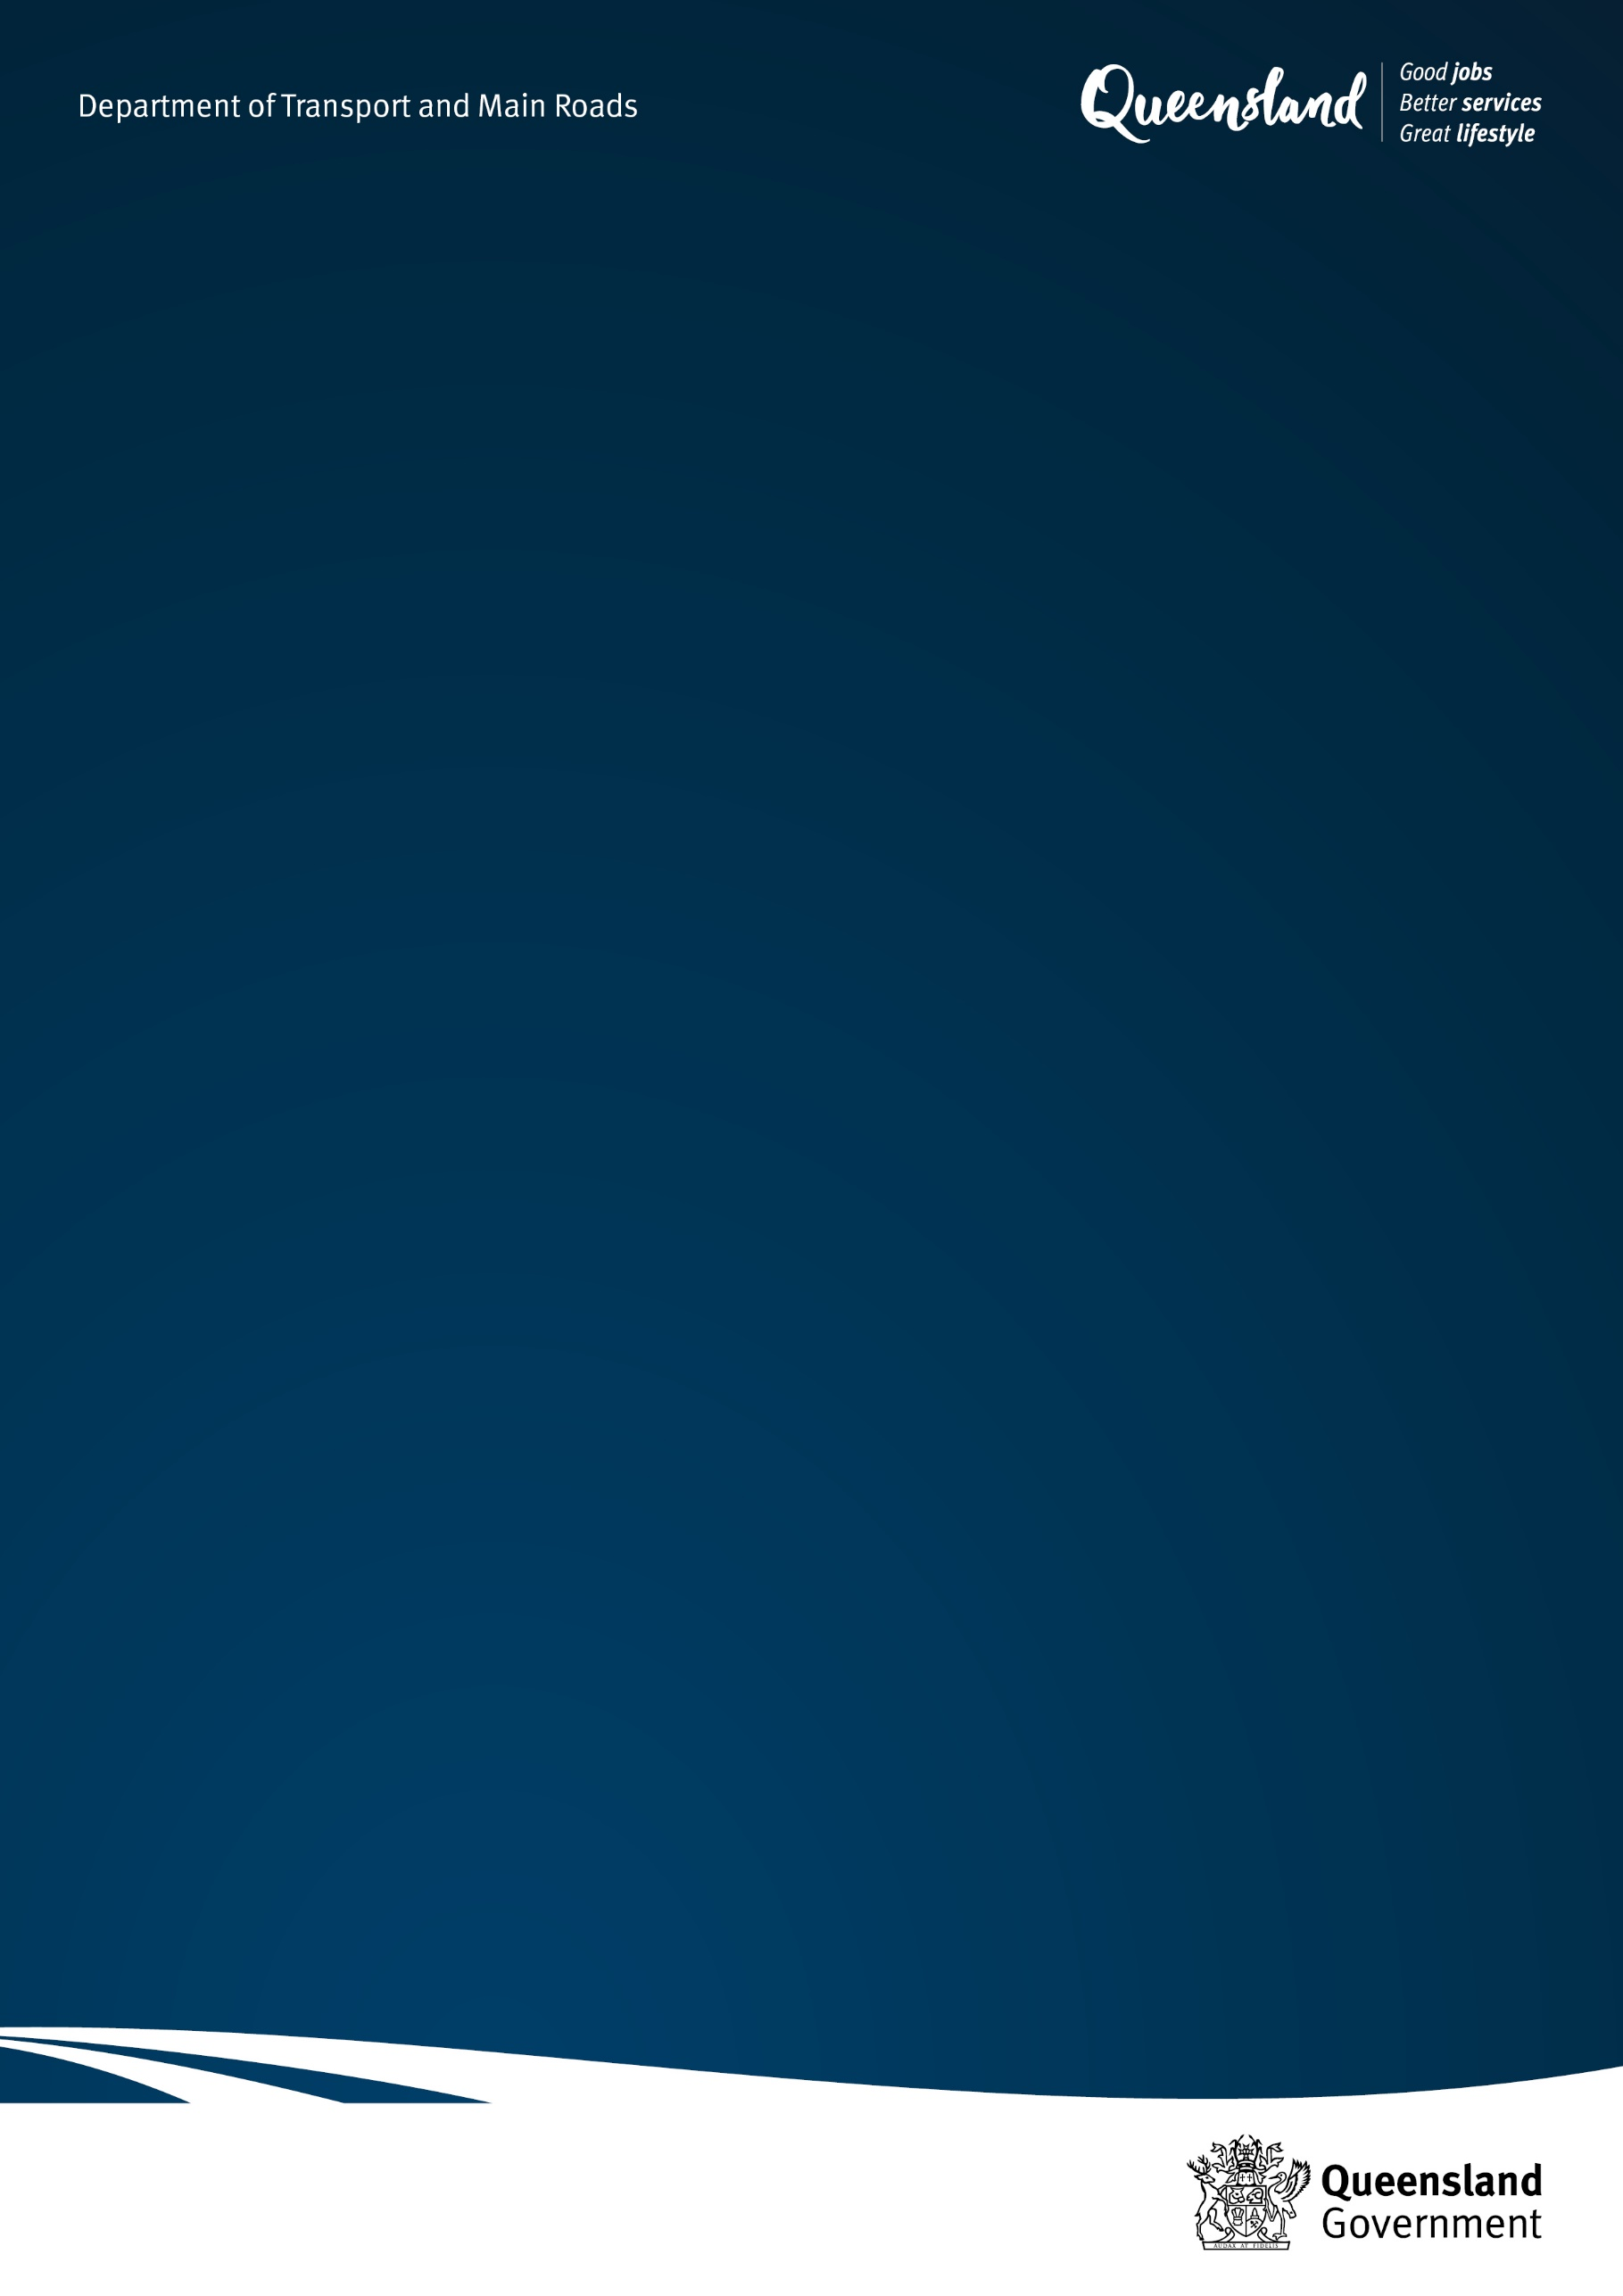

# Queensland Level Crossing Safety Strategy 2024-2033

Prepared by the Department of Transport and Main Roads

**Acknowledgement to Country**

The Department of Transport and Main Roads acknowledges the Traditional Owners and custodians of this land and waterways. We also acknowledge their ancestors and Elders both past and present. The Department of Transport and Main Roads is committed to reconciliation amongst all Australians.

**Copyright**

© State of Queensland (Department of Transport and Main Roads) 2024

<http://creativecommons.org.licences/by/4.0/>

This work is licensed under a Creative Commons Attribution 4.0 Licence. You are free to copy, communicate and adapt the work, as long as you attribute the authors.

The Queensland Government supports and encourages the dissemination and exchange of information. However, copyright protects this publication. The State of Queensland has no objection to this material being reproduced, made available online or electronically but only if it’s recognised as the owner of the copyright and this material remains unaltered.

**Translating and interpreter assistance**

The Queensland Government is committed to providing accessible services to Queenslanders of all cultural and linguistic backgrounds.

If you have difficulty understanding this publication and need a translator, please call the Translating and Interpreting Service (TIS National) on **13 14 50** and ask them to telephone the Queensland Department of Transport and Main Roads on **13 74 68**.

**Disclaimer**

While every care has been taken in preparing this publication, the State of Queensland accepts no responsibility for decisions or actions taken as a result of any data, information, statement or advice, expressed or implied, contained within. To the best of our knowledge, the content was correct at the time of publishing.

# Foreword

Level crossings allow Queenslanders to safely cross railway tracks, whether in a vehicle or on a motorbike, bicycle or personal mobility device, or as a pedestrian. On most occasions crossings are made safely and without incident. However, level crossings present a unique set of safety hazards, and collisions at level crossings are still the primary cause of railway fatalities among the general public, excluding suicide and trespass[1].

As we all know, one level crossing collision and near hit is one too many. Sadly, in recent years there has been little change to the number of reported incidents. More needs to be done. The *Queensland Level Crossing Safety Strategy 2024-2033* sets out a roadmap for how we will meet the challenges in improving level crossing safety across Queensland.

It is the second ten-year level crossing safety strategy developed by the Queensland Level Crossing Safety Group. Current members are the Department of Transport and Main Roads (chair), Queensland Rail, Aurizon, Australian Rail Track Corporation, Local Government Association of Queensland, Queensland Police Service, Queensland Trucking Association, and the Australian Sugar Milling Council (observer).

Zero harm at level crossings across Queensland remains the long-term vision of this new Strategy. It is founded on the firm belief that level crossing incidents are avoidable and builds on the efforts and achievements made under the previous *Queensland Level Crossing Safety Strategy 2012-2021* and its *2019 Update: On Track to Zero Harm*. Over the next ten years, this Strategy will continue the effort to reach this vision.

During the previous strategy there were major changes in both the rail and road environments, significantly the transfer of regulatory responsibility for both rail and heavy vehicles from the Queensland Department of Transport and Main Roads to the Office of the National Rail Safety Regulator and the National Heavy Vehicle Regulator, respectively. The Australian Transport Safety Bureau also became responsible for no-blame rail safety investigations in Queensland.

Over the life of this strategy, further significant developments in the rail and road environment will occur. These include technology advancements with the continuing development of automated vehicles and rail system enhancements. We will see an increased capacity on the passenger rail network as well as the freight rail and road networks. In addition, Queensland is anticipated to experience continuous population growth increasing the number of level crossing interactions by all road users, including personal and motorised mobility devices. Queensland must be adequately prepared to meet these challenges when addressing level crossing safety.

The Strategy aligns with the *National Level Crossing Safety Strategy 2023-2032* (National Strategy) and identifies the same strategic objectives and focus areas. It also complements the *South East Queensland Level Crossing Program 2024*. This acknowledges the benefits of collaboration between the Australian Government, state jurisdictions and industry, as well as recognising level crossing safety is a shared responsibility between all rail and road stakeholders. It will also enable Queensland to leverage and adapt the work undertaken at the national level.

It also complements the Office of the National Rail Safety Regulator’s Level Crossing Policy and supports the *Queensland Road Safety Strategy 2022-2031*, by providing strategic initiatives that focus on the reduction of fatal and serious injuries at level crossings.

The Queensland Government will continue to work together with all levels of government, regulators, industry, and the community with the aim of reducing the safety risks at level crossings. I commend the work of the Queensland Level Crossing Safety Group in developing this new strategy and their ongoing commitment to implement initiatives that will further improve level crossing safety in Queensland.

**Bart Mellish MP**

**Minister for Transport and Main Roads and Minister for Digital Services**

# Scope

The Strategy focuses on about 1,400 public level crossings along over 10,000 kilometres of railway tracks across Queensland. Managing the safety risks at these level crossings continues to be a major concern for Queensland communities across regional and South East Queensland.

Level crossing has the meaning as defined in the *Rail Safety National Law (South Australia) Act 2012 (RSNL)* and includes where a road, footpath or shared path crosses a railway at substantially the same level.

The Strategy targets all users of public level crossings, that is any person who passes over a level crossing including road users (vehicle and active transport users) and rail users (including train crew and passengers).

The Strategy currently does not extend to:

* private (occupational) level crossings that are on private land[2]
* level crossings on the cane railway network
* light rail (tram) network.

While the Strategy’s focus is on public level crossings, it is recognised that the safety risks at both private and cane railway level crossings also need to be managed. The safety measures identified in this Strategy can apply to any rail-road interface.

# A strategic approach to level crossing safety in Queensland

## Our vision

***Zero harm at level crossings across Queensland***

This vision is underpinned by our firm belief that level crossing incidents are, ultimately, avoidable. This is also the vision of the National Strategy for Australia.

## Our strategic objectives

In Queensland, our preferred approach is to avoid safety risks by designing out new level crossings in new infrastructure projects, consistent with our ‘no new level crossings, where appropriate’, policy.

For existing level crossings, the hierarchy of level crossing controls for controlling risks from ‘closure and consolidation’ to ‘grade separation’ to ‘active protection’ and to ‘passive protection’ is supported.

This Strategy, in line with the National Strategy, focuses on lower-cost high impact initiatives that can best reduce safety risks at or around level crossings.

Under this Strategy the objectives for level crossing safety over the next ten years are:

1. Improve level crossing user behaviour through education and enforcement

2. Leverage opportunities from emerging technology and innovations

3. Identify opportunities to deliver early, low cost and effective safety improvements

4. Support the development of improved data and knowledge on level crossings

5. Increase coordination and sharing between those responsible for level crossing safety.

## Our guiding principles

The following principles will guide how we go about achieving our vision:

1. **Close coordination with stakeholders**

The strategy provides an opportunity to link to, complement and support other strategies and work programs that are in place. This includes at the national, jurisdictional and local level.

1. **Clear governance**

The Queensland Level Crossing Safety Group will advocate for the most promising solutions and policy reform at a state level with development and delivery supported through government, industry, and community stakeholder involvement.

1. **Focus on key initiatives**

The Strategy will focus on a small number of higher impact initiatives with clear and identifiable benefits, recognising that the diversity of Queensland communities may require localised, fit-for-purpose solutions.

1. **Evidence-based approach**

The Strategy will be based on objective, evidence-based analysis of risks and possible benefits of any proposed interventions, supported by strong partnerships to expedite implementation. This will include utilising the National Level Crossing Portal and the Australian Level Crossing Assessment Model.

1. **Shared responsibility using a cooperative approach**

Recognise that level crossing safety is a shared responsibility involving a wide range of stakeholders (including government at all levels, rail transport operators, road industry, regulators, enforcement agencies, emergency services, road users and industry support and advocacy groups) with collaboration required between relevant stakeholders.

1. **Based on ‘safe system’ approach**

Adapting and applying, in a level crossing context, the internationally recognised road safety practices based on the safe system concept.

1. **No new level crossings, where appropriate**

As with previous Queensland Level Crossing Safety Strategies and updates, Queensland will continue to promote the ‘no new level crossings, where appropriate’[3] policy.

1. **Three year Action Plan**

A rolling three-year Action Plan will be developed that sets out the key initiatives that will be pursued over the period.

## Our strategic objectives and focus areas

This Strategy has the same five strategic objectives with four key focus areas as the National Strategy, acknowledging the value of collaboration and the benefits of having a shared responsibility, to focus on our vision of zero harm at Queensland’s level crossings.

|  |  |  |
| --- | --- | --- |
| **No.** | **Strategic objective** | **Focus area on the Queensland strategy** |
| 1 | Improve level crossing user behaviour through education and enforcement | **Education and Enforcement**   * Increase awareness of level crossings that triggers desirable behaviour change in users. * Reinforce compliance through enforcement strategies which will include consideration of the Queensland Level Crossing Safety Cameras Proof of Concept. |
| 2 | Leverage opportunities from emerging technology and innovations | **Assets, Technology and Innovation**   * Leverage a combination of asset and technology-based solutions that are cost-effective, innovative, and shown to reduce the risk of harm. |
| 3 | Identify opportunities to deliver early, low-cost, and effective safety improvements | **Assets, Technology and Innovation**   * Leverage a combination of asset and technology-based solutions that are cost-effective, innovative, and shown to reduce the risk of harm. |
| 4 | Support the development of improved data and knowledge on level crossings | **Data Improvement and Knowledge Management**   * Capture (and utilise) level crossing data in a consistent manner and share analysis that delivers insights to inform practical safety improvements and decisions. |
| 5 | Increase coordination and sharing between those responsible for level crossing safety | **Coordination**   * Develop a consistent and coordinated approach to improve collaboration, share knowledge, and drive actions. |

The National Strategy and its associated Work Plan aims to prioritise actions to achieve wide network benefits and reduce level crossing incidents. Smarter low-cost infrastructure, technological solutions and innovative behavioural interventions will be targeted at over-represented areas/groups such as rural and regional passive level crossings, heavy vehicles and pedestrians. The establishment of the National Level Crossing Safety Program Management Office to implement the National Strategy and Work Plan and foster a nationally coordinated approach to level crossing safety provides the opportunity for Queensland to leverage initiatives being pursued at the national level or vice-versa.

The strategic initiatives under this Strategy are provided in Appendix A. The associated Action Plan for 2024-2026 is an accompanying standalone document that prioritises these strategic initiatives.

## Delivery and evaluation

The Strategy is underpinned by a three-year Action Plan. A number of actions are identified in the 2024-2026 Action Plan including identifying timeframes, lead organisations and success measures. A key element to the Strategy’s success is the ongoing participation and contribution by all parties to help deliver the initiatives and achieve improvement. Opportunities to leverage existing or upcoming projects or initiatives both at the national and state level, where benefits can be shared, will be sought. For instance, relevant strategic initiatives may potentially be linked to the South East Queensland Level Crossing Program 2024.

The Queensland Level Crossing Safety Group will maintain oversight of the Strategy and associated Action Plan, monitor progress of its initiatives and report progress periodically to the Minister for Transport and Main Roads and Digital Services. The Strategy will be reviewed every three years to ensure it remains relevant reflecting the contemporary trends and developments in the rail and road environment and continuing to meet community needs.

The Queensland Level Crossing Safety Group will continue to review incident data and information to monitor the outcomes of the Strategy through anticipated reduction in the rates of level crossing collisions and near hits, as well as level crossing fatalities and serious injuries.

The following performance indicators will be used to track the overall effectiveness of the Strategy and the long-term vision of zero harm at Queensland’s level crossings:

* Level crossing incident analysis.
* Progress (including outcomes) against initiatives and strategic objectives for each focus area.

# Safety improvements in Queensland

## Installation of innovative new technology at Thallon

In late 2023, Queensland Rail installed a new solar powered technology at Thallon level crossing to improve safety signage. The Carnarvon Highway level crossing was previously equipped with stop signs. Queensland Rail undertook a review of safety as a result of community-raised concerns at this location, including an assessment of the level crossing using the Australian Level Crossing Assessment Model.

As part of the review process, Queensland Rail also undertook community engagement and received feedback from key stakeholders including emergency services, Balonne Shire Council and the Department of Transport and Main Roads on the level of safety at this location. The response from the community and key stakeholders indicated that flashing lights was the preferred level of protection. As a result of the community feedback, the level crossing on the Carnarvon Highway at Thallon was upgraded with an innovative, autonomous system that displays clear warning signs at all times.

The technology means that motorists now see flashing red lights as they approach the level crossing in addition to a red railway crossing sign and message board directing drivers to stop on the red signal. The upgrade is a wireless safety system and is the second of its kind in Queensland and Australia, with one operating at Oakey in the Toowoomba region. The level crossing now has a railway active signage system together with a train detection system and does not require power or trackside cabling.

The solar powered technology ensures the level crossing remains protected on the rare instance of a power failure or outage, which is important for rural and remote Queensland communities. While this new technology will assist in keeping motorists safe, its effectiveness is still highly dependent on motorist behaviour.

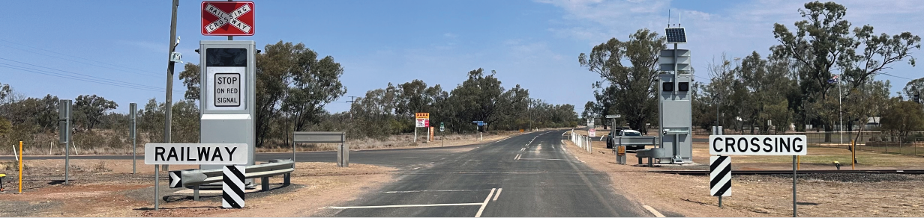

## Integrated engineering solution implemented in Central Queensland

The Ardurad Road level crossing in regional Central Queensland is a busy crossing located near the Capricorn Highway in the town of Blackwater. Over 3000 vehicles per day use the crossing, with over-dimensional and long vehicles frequently traversing the crossing.

There were repeated cases of short stacking, queuing, and near-hits at this level crossing. In addition, there were incidents of overhead electrical equipment failure caused by over-dimensional/over-height vehicles.

Queensland Level Crossing Safety Group members Aurizon and the Department of Transport and Main Roads worked together to implement an integrated solution to address this issue.

The Department of Transport and Main Roads upgraded the intersection and installed road traffic lights to address both the short stacking and queuing and to reduce delays for level crossing users due to train operations. Aurizon integrated the signalling, enabling the road traffic signals to align with the level crossing flashing lights and boom gates. Aurizon also upgraded the multiple corridor access points in the vicinity to restrict Aurizon’s road vehicles from accessing the rail corridor at the intersection to prevent any near-hits and incidents.

The level crossing improvement, commissioned on 21 February 2022, was funded jointly by the Department of Transport and Main Roads and Aurizon. In the two years post implementation of this level crossing solution, there has been no record of level crossing safety incidents at the Ardurad Road level crossing.

## Working together to improve level crossing safety

In 2022-23, there was an alarming uplift in near hits and boom arm strikes at level crossings across Queensland Rail’s network. Queensland Rail recorded 36 near hits with road vehicles and pedestrians across Far North Queensland in 2023, up from 20 the previous year. In South East Queensland, where all level crossings are active, there were 85 boom arm strikes in 2022, up from 72 the previous year.

To address these concerning trends, Queensland Rail partnered with the Queensland Police Service to educate drivers regarding safety in and around level crossings to avoid near hits, boom arm strikes and serious incidents.

In March 2023, Queensland Rail undertook a joint operation with Queensland Police Service at various South East Queensland level crossings with police officers conducting educational and enforcement activities where level crossing offences were detected. In December 2023, Queensland Rail and the Queensland Police Service conducted similar activities at the Collins Avenue in Cairns following a spike in level crossing near hits in the area.

Common themes identified through the patrol and operation were driver distraction and people rushing to save time. Similar to road traffic lights and signage, it is imperative motorists remain alert, drive to the conditions, and obey the road rules at level crossings, which are in place for everyone’s safety. The outcome of the patrols indicate that road users respond to enforcement and are encouraged to drive with caution around rail infrastructure.

While the Queensland Police Service patrols assist in keeping road users safe, the reality is near hits and collisions are avoidable if road users follow the signs and signals in place at level crossings.

# Current challenges

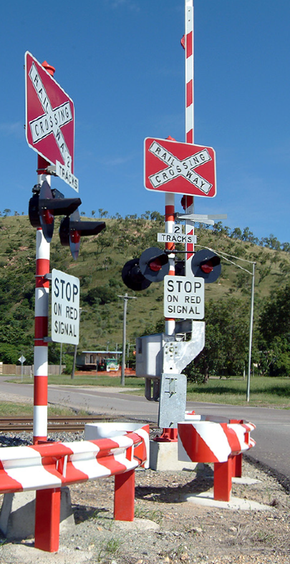Any level crossing collision can result in serious injuries, property damage, service disruptions and in most tragic cases, fatalities. This can lead to substantial social and economic impacts on individuals, businesses, and the community, as well as a loss of confidence in the transport system. The combination of passenger and freight trains, different vehicle types, active transport users all using the rail and road system raises significant concerns about the potential for high impact or catastrophic incidents and fatalities.

In addition, all level crossing incidents that occur are potentially dangerous, although they may not result in an actual collision. Often there are ‘near hits’ between a train and a road user. Sometimes this causes damage to level crossing infrastructure, or equipment failure.

There continues to be no single reason for level crossing collisions and near hits occurring. Contributing factors can include:

* people (both pedestrians and other road users) and the extent to which they obey the law and respond appropriately to the current level crossing environment (including how they deal with distraction issues).
* vehicles and infrastructure, including speed limits, the design of road and rail vehicles, and the design and condition of level crossings and level crossing environments.
* the overall management of rail-road interfaces, including coordination between transport service providers, the allocation of resources, and the ways in which knowledge is applied to enhance safety.

Between 1 January 2018 to 31 December 2023[4] across Queensland level crossings, (involving either pedestrians or road vehicles), there were:

* 1507 near hits
* 64 collisions
* 12 fatalities[5]
* 6 serious injuries[6].

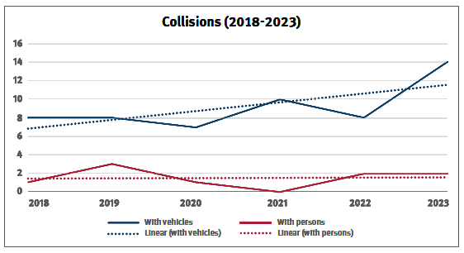

Between 2018-2023, there has been a total of 55 collisions with vehicles and 9 collisions with persons.

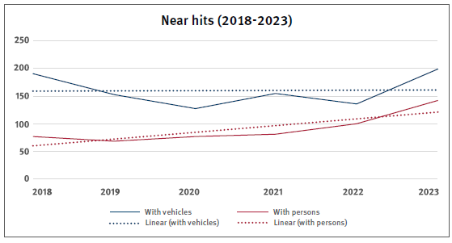

Between 2018-2023, there has been a total of 960 near hits with vehicles and 547 near hits with persons.

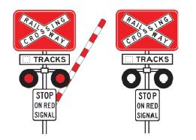

**Active** level crossings are controlled by boom gates and/or red flashing lights.

Collisions by vehicle type at active level crossings:

* 79% light vehicle
* 18% heavy vehicle
* 3% other[7]

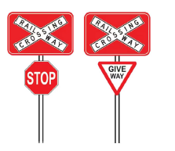**Passive** level crossings are protected by a stop or give-way sign.

Collisions by vehicle type at passive level crossings:

* 58% light vehicle
* 37% heavy vehicle
* 5% other.

Yearly average figures in Queensland (2018-2023):

* **2** fatalities and **1** serious injury occurring at level crossings.
* **9** collisions and **160** near hits between a train and a vehicle.
* **1-2** collisions and **91** near hits with persons which mainly occur at level crossings with active protection.

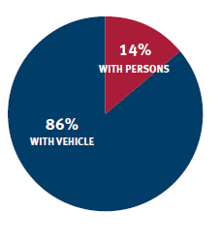

**Collisions (2018-2023)**

Between 2018-2023, **86%** of collisions occurred with vehicles and **14%** with persons.

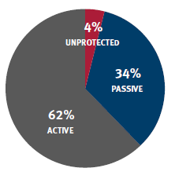

**Collisions with vehicle by level crossing type (2018-2023)**

* **62%** occurred at active level crossings.
* **34%** occurred at passive level crossings.
* **4%** at unprotected level crossings.

# Future challenges

Within the next ten years, Queensland will face significant changes that will impact level crossing safety including:

* Technology advancements with the continuing development of automated vehicles and rail system enhancements on the rail network. This may lead to a new safety risk profile in the level crossing environment that needs to be managed.
* The increased capacity on the passenger rail network and freight rail and road network[8] in both metropolitan and regional areas that will result in increased stoppage times at level crossings. This is likely to increase traffic congestion and may lead to a negative impact on driving behaviours around level crossings.
* The continuing growth of Queensland’s population, including through interstate and international migration[9] will add to the pressure on the rail and road networks.
* The growth in the use of personal mobility devices and motorised mobility devices[10] creates additional risk at level crossings.
* Competing fiscal priorities that may limit available resources for level crossing safety initiatives.

These challenges highlight the necessity to continue to focus on improving level crossing safety in both regional and South East Queensland.

# Appendix A: Strategic Initiatives 2024-2033

## Education and Enforcement

|  |  |  |  |
| --- | --- | --- | --- |
|  | **Strategic initiatives** | **Measures** | **Key Stakeholders** |
| 1 | Support promotion of risk awareness and safe user behaviour around both South East Queensland and regional level crossings across Queensland, through initiatives such as the nationwide Rail Safety Week and other relevant safety awareness campaigns | * Number of level crossing safety awareness campaigns implemented across South East Queensland and regional Queensland * Increase in the level of safety awareness for all level crossing users | Queensland Level Crossing Safety Group  National Level Crossing Safety Committee  Government transport agency  Safety regulators  Enforcement agencies  Rail and road managers  Road users  Industry and community |
| 2 | Promote initiatives to improve safety for heavy vehicles at level crossings including raising awareness within the heavy vehicle industry about heavy-vehicle risks at level crossings, particularly in regional areas | * National heavy vehicle industry awareness and education program implemented in Queensland * Reduced representation of heavy vehicles in incident statistics | Queensland Level Crossing Safety Group  National Level Crossing Safety Committee  Government transport agency  Safety regulators  Enforcement agencies  Rail and road managers  Road users  Industry and community |
| 3 | Encourage compliance and enforcement initiatives to promote a safety culture around both South East Queensland and regional level crossings across Queensland | * Increase in the number of level crossing safety enforcement activities | Queensland Level Crossing Safety Group  Government transport agency  Safety regulators  Enforcement agencies  Rail and road managers  Road users  Industry and community |
| 4 | Encourage rail and road infrastructure managers to implement and comply with interface agreements | * Interface agreements in place for all eligible level crossings * Increase in the number of signed interface agreements and a high level of compliance is reported. | Queensland Level Crossing Safety Group  Rail and road managers  Safety regulators |
| 5 | Support compliance with existing national safety standards and provide input where appropriate to the review and development of nationally recognised standards that impact level crossing safety | * As appropriate, participate in the development of national level crossing safety standards. * Increased adoption of national standards impacting level crossing safety by Queensland rail transport operators | Queensland Level Crossing Safety Group  National Level Crossing Safety Committee  Rail transport operators  National standards organisation/s |

## Assets, technology and innovation

|  |  |  |  |
| --- | --- | --- | --- |
|  | **Strategic initiatives** | **Measures** | **Key Stakeholders** |
| 6 | Support, where appropriate, the promotion of level crossing safety in both the development of the Cooperative Intelligent Transport Systems for autonomous/automated vehicles and the corresponding regulatory frameworks | * As appropriate, participate in the development of regulatory frameworks for autonomous/ automated rail and road vehicles. * Level crossing safety outcomes considered in the regulatory frameworks affecting Queensland. | Queensland Level Crossing Safety Group  Government transport agency  Rail transport operators  Rail and road managers |
| 7 | Support the exploration and adoption of lower-cost, high-impact and emerging technologies to improve level crossing safety | * Investigations of relevant technological opportunities undertaken. * Evidence of low-cost, high-impact interventions and new technologies adopted. * Evaluation of the Queensland Level Crossing Safety Cameras Proof of Concept. | Queensland Level Crossing Safety Group  National Level Crossing Safety Committee  Rail and road managers  Industry  Research institutions |
| 8 | Support and collaborate on initiatives to review the design and condition of level crossing environments and infrastructure to address issues such as short stacking at level crossings | * As appropriate, participate and support any initiatives undertaken to review level crossing environments. | Queensland Level Crossing Safety Group  Rail and road managers |
| 9 | Encourage new major resource and infrastructure projects to find alternative solutions to building new level crossings and minimising any impact on existing level crossings | * Report on ‘No new level crossings where appropriate’ policy. | Queensland Level Crossing Safety Group  Government transport agency  Rail and road managers  Industry and community |

## Data improvement and knowledge management

|  |  |  |  |
| --- | --- | --- | --- |
|  | **Strategic initiatives** | **Measures** | **Key Stakeholders** |
| 10 | Contribute to national initiatives for better data quality and coordination | * As appropriate, participate in the next stage of development of the National Level Crossing Portal database * Increased availability/quality of level crossing data | Queensland Level Crossing Safety Group  National Level Crossing Safety Committee |
| 11 | Support the continuous improvement and use of the Australian Level Crossing Assessment Model to identify current risks and solutions | * Evidence of improvement of the Australian Level Crossing Assessment Model tool, including associated training, provided to Queensland Level Crossing Safety Group * Increase in the number of Queensland level crossings surveyed using the Australian Level Crossing Assessment Model tool | Queensland Level Crossing Safety Group  National Level Crossing Safety Committee  Rail transport operators  National Australian Level Crossing Assessment Model Committee |
| 12 | Review annually Queensland level crossing data and level crossing investigation findings of the Australian Transport Safety Bureau and any safety information released by the Office of the National Rail Safety Regulator to identify trends/lessons learned | * Annual review report for internal use prepared * Trends/lesson learned in level crossing safety incidents identified and disseminated | Queensland Level Crossing Safety Group |
| 13 | Undertake an annual review of the number and types of level crossings in Queensland | * Annual review of the changes in number and types of level crossings in Queensland | Queensland Level Crossing Safety Group  Rail managers |
| 14 | Participate in, and provide direction to, research activities of the National Transport Research Organisation | * Queensland interests addressed in level crossing research * Number of level crossing safety research activities participated in by Queensland Level Crossing Safety Group members | Queensland Level Crossing Safety Group |

## Coordination

|  |  |  |  |
| --- | --- | --- | --- |
|  | **Strategic initiatives** | **Measures** | **Key Stakeholders** |
| 15 | Provide support to the National Level Crossing Safety Committee, including in the implementation of the National Level Crossing Safety Work Plan | * Close coordination with the National Level Crossing Safety Committee achieved. * Work Plan initiatives participated in/progressed by Queensland Level Crossing Safety Group members. | Queensland Level Crossing Safety Group  National Level Crossing Safety Committee |
| 16 | Engage relevant safety regulators in applicable Queensland Level Crossing Safety Group activities | * Relevant safety regulators invited to attend Queensland Level Crossing Safety Group meetings as appropriate. | Queensland Level Crossing Safety Group  Safety regulators |
| 17 | Queensland Level Crossing Safety Group members and stakeholders to collaborate on level crossing safety improvement projects | * Number of projects Queensland Level Crossing Safety Group members have worked on collaboratively. | Queensland Level Crossing Safety Group |
| 18 | Share knowledge and learnings among Queensland Level Crossing Safety Group members | * Key learnings and implications for initiatives of the Queensland Strategy identified and disseminated. * Number of Queensland Level Crossing Safety Group meetings held per year. | Queensland Level Crossing Safety Group |

1. Office of the National Rail Safety Regulator, Rail Safety Report 2022-2023
2. There are approximately 1,400 private level crossings in Queensland. Private level crossings are subject to the RSNL. Responsibilities under the RSNL are the primary means by which to manage safety at these locations (for example, s108 Interface Coordination).
3. This is also consistent with the Office of the National Rail Safety Regulator’s Level Crossing Policy and with the National Strategy’s Level crossing hierarchy of controls.
4. Raw data has been provided by the Office of the National Rail Safety Regulator (ONRSR) for level crossing collision and near hit occurrences and casualties (involving vehicles or persons) in Queensland from 1 January 2018 to 31 December 2023. It is based on notifiable occurrences in accordance with the Rail Safety National Law. For data up to and including 30 June 2022, occurrence definitions are based on those in the Reporting Requirements for Notifiable Occurrences. For data since 1 July 2022, definitions are based on those in the ONRSR Business Glossary. It is noted that given the small number of reported notifiable occurrences, caution needs to be taken when identifying any trends. Trend data has been based on linear trends over the whole period.
5. Fatalities include those caused by trespass.
6. Serious injuries include those caused by trespass.
7. Other include (but not limited to): bicycle, motorcycle, bus, tractor.
8. The Queensland Freight Strategy (2019) indicated that the state’s freight task and volumes will grow more than 20 percent over the next decade; where road transport will carry around 65 percent of all freight tonnages, followed by rail (32.5 percent), and the rest from coastal shipping and air freight tasks.
9. State and territory projections | Centre for Population projections estimate that within the next ten years, the total Queensland population will grow by 1.2 percent annually to over 6 million.
10. Personal mobility devices can include e-scooters, e-skateboards and self-balancing single wheeled devices (like e-unicycles and e-boards). A motorised mobility device is a motorised wheelchair or a mobility scooter.