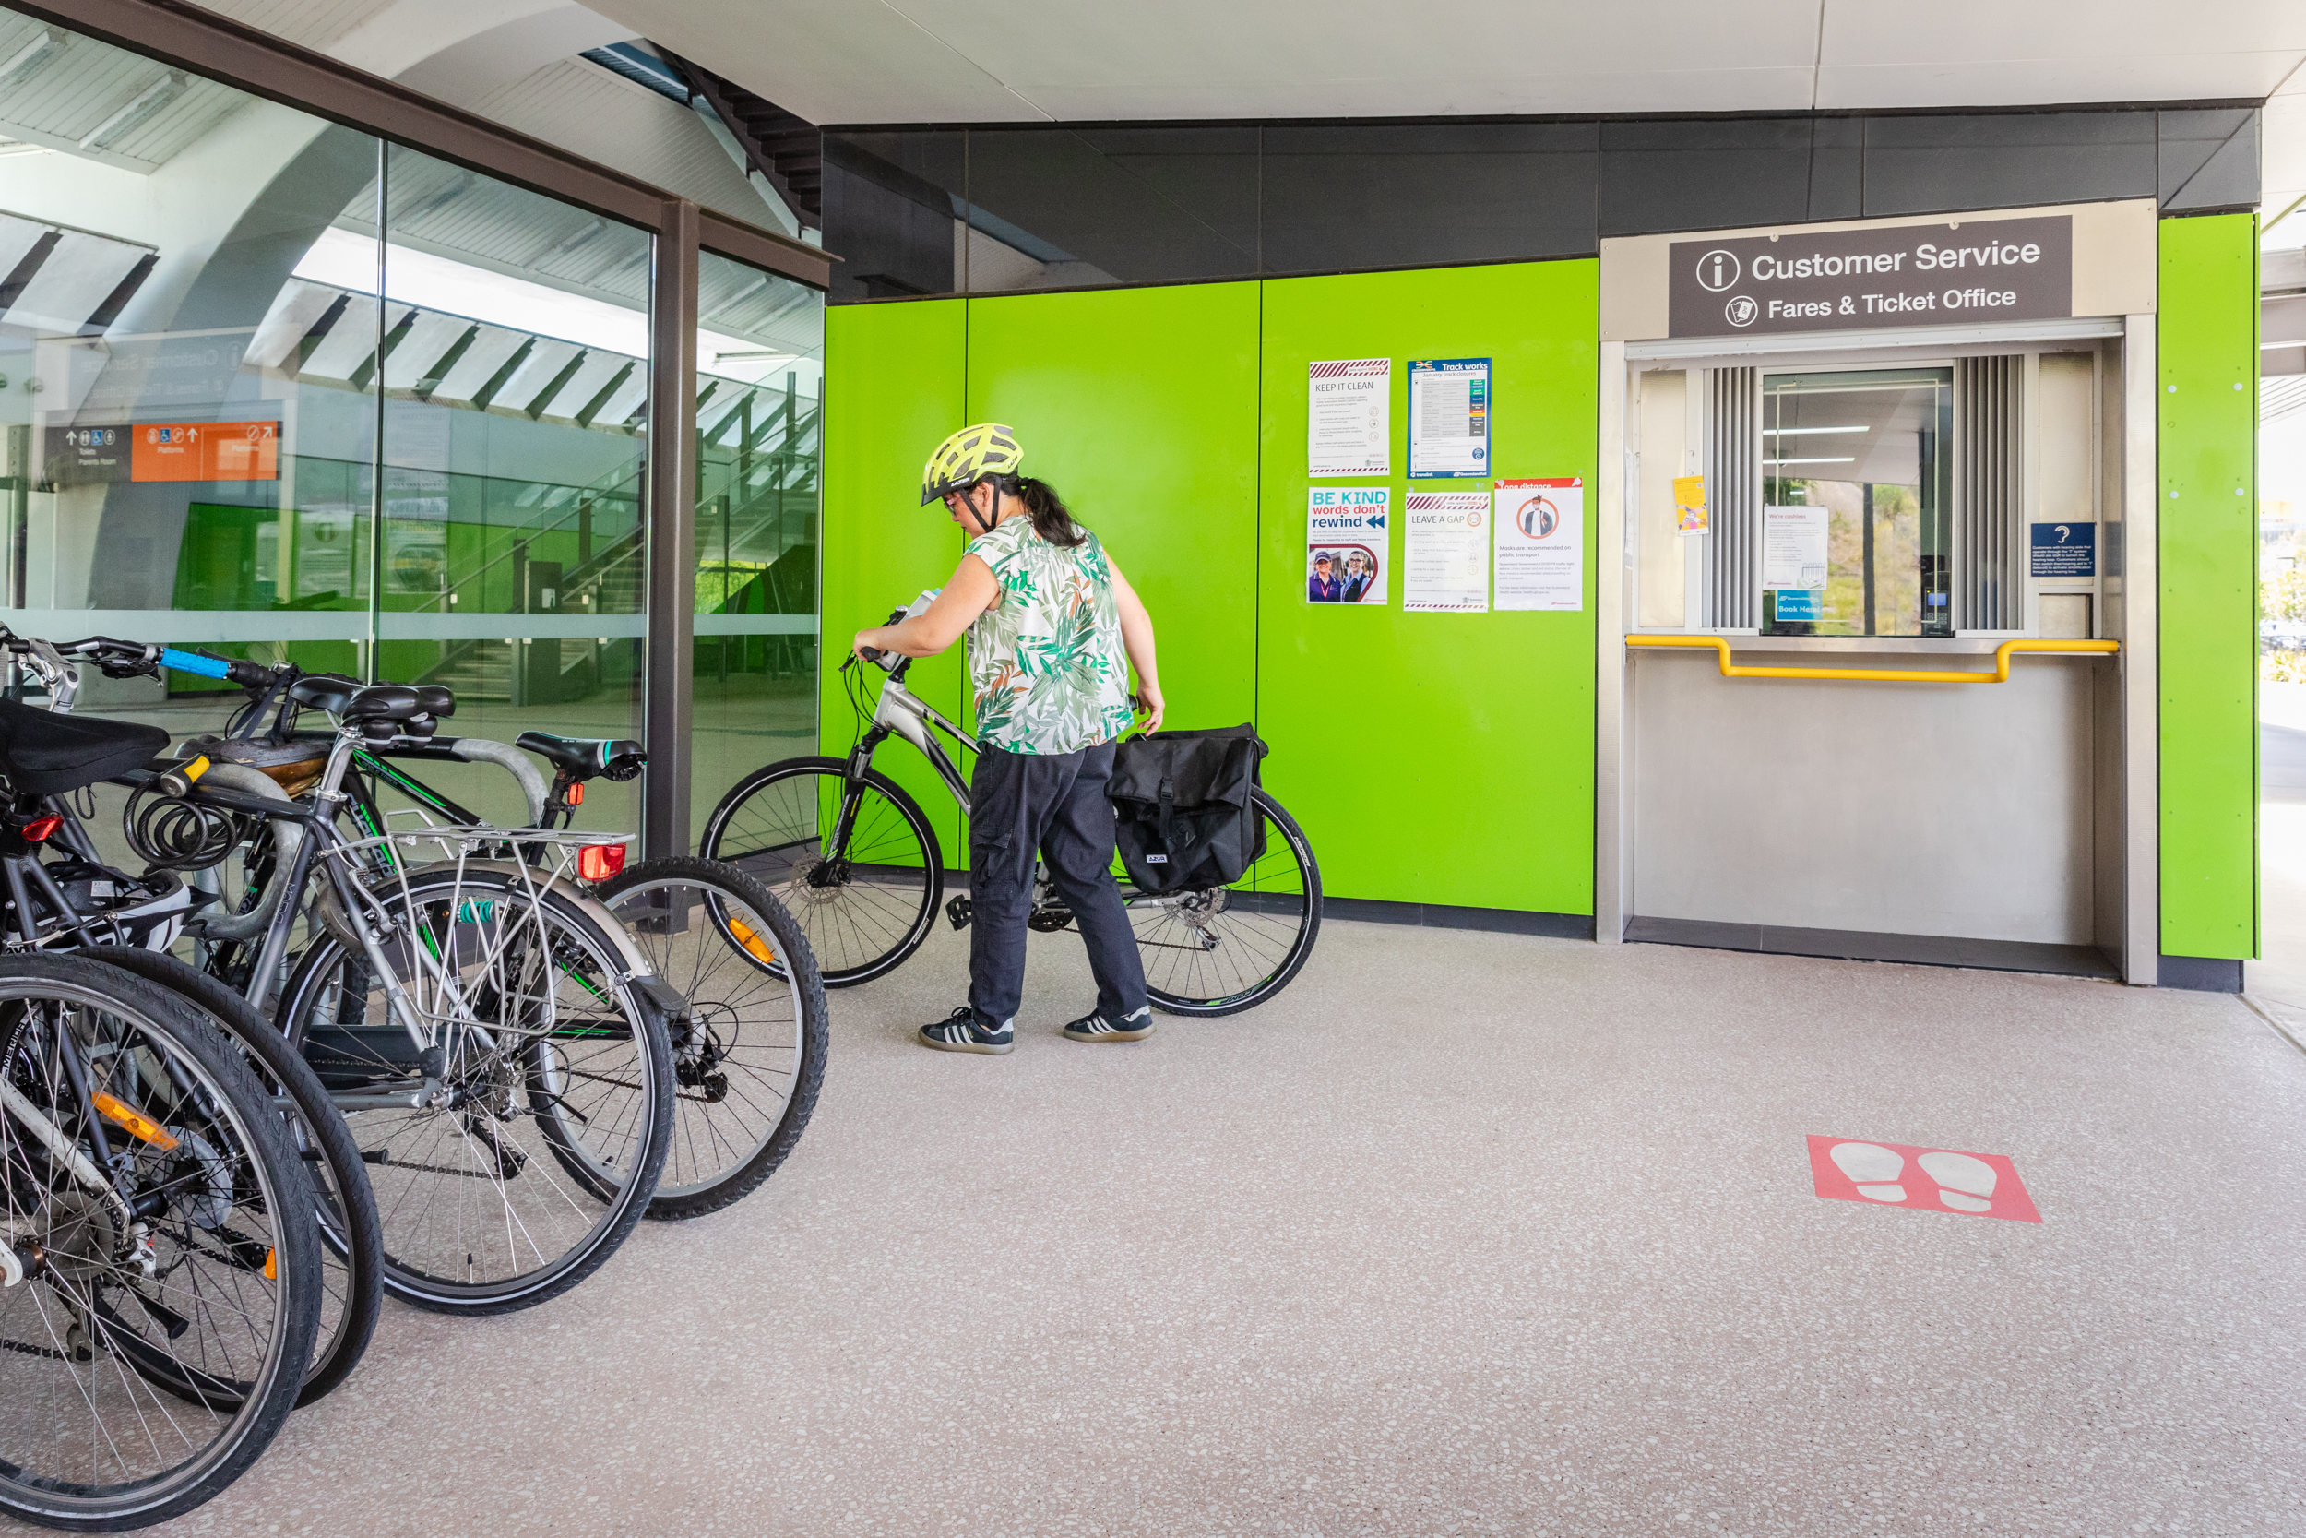

**Bicycle parking at public transport**

**A strategy for South East Queensland**

The Department of Transport and Main Roads (TMR) respectfully acknowledges the Traditional Owners and Custodians of the land and waterways.

We pay respect to their Elders past, present and emerging. TMR recognises those whose ongoing effort to protect and promote Aboriginal and Torres Strait Islander cultures will leave a lasting legacy for future First Nations people.

Copyright: This publication is protected by the Copyright Act 1968. © State of Queensland (Department of Transport and Main Roads), 2024. Enquiries about the use of any material in this publication can be sent to the department at: copyright@tmr.qld.gov.au

Disclaimer: While every care has been taken in preparing this publication, the State of Queensland accepts no responsibility for decisions or actions taken as a result of any data, information, statement or advice, expressed or implied, contained within. To the best of our knowledge, the content was correct at the time of publishing.

Translating and interpreting assistance: If you need an interpreter call the Translating and Interpreting Service (TIS National) on 131 450. If you are deaf or have a hearing or speech impairment, contact us through the National Relay Service: [www.relayservice.gov.au](http://www.relayservice.gov.au).

**Contents**

Introduction 3

Our vision 5

Benefits of bicycle parking at public transport: 7

Our priorities 8

Planning for consistent delivery of bicycle parking at public transport 9

Understanding demand for bicycle parking at public transport 9

Using data to understand and measure what people are doing 9

Trends in micro-mobility 10

Building secure and convenient bicycle parking at public transport 11

Flexible and customer-led bicycle parking design 11

Improving our technical guidance 11

Encouraging more people to use bicycle parking at public transport 13

Making bicycle parking easy to access 13

Improving information on bicycle parking at public transport 13

Promoting bicycle parking at public transport 14

Making it happen 15

Working together 15

Investing in bicycle parking at public transport 15

References 17

# Introduction

Riding to and from public transport is a healthy travel choice and can influence Queensland’s shift towards a sustainable future. More people riding bikes to public transport will increase the vitality of our cities and towns and help encourage a sense of community. This has benefits for all Queenslanders.

When we talk about bikes, we also include e-bikes and personal mobility devices (such as e-scooters).

The Queensland Government is committed to growing the public transport network to create vital connections to jobs, health and other essential services. Our investment in evolving our public transport network to ensure quality and high frequency services and accessible infrastructure will serve the growing Queensland population and support travel in the lead up to and during the Brisbane 2032 Olympic and Paralympic Games.

*Bicycle parking for public transport: A strategy for South East Queensland* is part of a holistic approach to encourage more Queenslanders to ride their bike to access public transport.

It complements our *Creating Better Connections for Queenslanders Plan and our Accessibility and Inclusion Strategy 2023–2024*, and supports the *Queensland Government’s Queensland Cycling Strategy 2017–2027* and *Queensland Walking Strategy 2019–2029*.

This strategy sets the direction for a consistent approach to bicycle parking at public transport in South East Queensland, where most of Queensland’s public transport network is located.

We already have 6500 bicycle parking spaces at public transport stations. This strategy outlines how we will work across government to improve this parking to ensure it is safe, secure and easy to access.

Better bicycle parking will encourage more people of all ages and abilities to ride and park their bikes and use public transport for work, shopping, education and recreation.

Encouraging more people onto public transport is vital to connecting Queenslanders to jobs, education, tourism, health and other essential services. With continued population growth across the region, it is increasingly important to shift towards sustainable and healthy travel choices to help provide a resilient and integrated transport network.

While this strategy identifies what is needed to improve bicycle parking at public transport in South East Queensland, the ideas set out may be used to improve bicycle parking at public transport in other Queensland locations.

This strategy contributes to the Queensland Government’s objectives for the community: Good jobs; Better services; Great lifestyle.

* Supporting jobs
* Making it for Queensland
* Keeping Queenslanders safe
* Connecting Queensland
* Growing our regions
* Building Queensland

# Our vision

### What changes do we want to see in 10 years in South East Queensland?

* Bicycle parking at public transport that is safe, convenient and comfortable for all ages and abilities.
* Riding to public transport is an easy choice particularly for short transport trips.
* Bicycle parking makes the whole public transport journey more accessible.
* Bicycle parking at public transport is provided for in a consistent way in the planning and delivery of public transport infrastructure.

**More people riding to public transport across the network, more often.**

Riding a bike is perfect for short trips and should be a natural choice to access public transport. Bike riders can get their daily exercise and contribute to reducing pollution, traffic and car parking congestion around public transport stations.

More than 460,000 trips are taken on public transport each day.[1] Fifteen per cent of trips from home to public transport are currently made by car[2] and only a very small percentage are made by bike, despite the typically short distances.

We want riding bikes to public transport to be an obvious choice and replace some car trips.

South East Queenslanders have told us that concerns relating to the security of bicycle parking are often the main reason they choose not to park their bike at a station.[3] Addressing the convenience and safety of bicycle parking is also important.

We want to provide safe and accessible bicycle parking infrastructure for people to ride to their local public transport station instead of using a car. Safe and convenient bicycle parking at public transport stations has been proven to increase the number of people riding to public transport.

We will achieve our vision by working with our planning and delivery partners including Queensland Rail. We will also work with the community and local governments to target investment where it will make a difference. We will integrate outcomes with other projects, and coordinate planning for cost-effective delivery.

Embedding riding a bike to public transport, and making it safe and convenient to park there, is one of many ways we will achieve a single integrated transport network accessible to everyone.

Distances up to three kilometres are ideal for riding a bike to public transport[4] but in South East Queensland, 52% of car trips from home to bus stops and stations are under three kilometres and 44% of car trips from home to train are under three kilometres[5].

## Benefits of bicycle parking at public transport:

* Well-planned bike riding infrastructure pays itself off in health benefits and reduced congestion.
* Having the choice to ride a bike to public transport enables more people to access employment, education and services.
* Healthier Queenslanders as they are exercising as part of their travel.
* Safe and secure bicycle parking at stations for all.
* Riding a bike is an equitable travel choice providing independence and freedom for many people.
* Investment in bicycle parking is cheaper and more space efficient when compared to providing car parking.
* More people riding reduces our transport emissions and improves noise and air pollution.

# Our priorities

We listened to residents of South East Queensland and key stakeholders, and looked to successful experiences for delivering bicycle parking at public transport in other communities across Australia and the world, to identify three priorities for South East Queensland:

* Planning for consistent delivery of bicycle parking at public transport.
* Building secure and convenient bicycle parking at public transport.
* Encouraging more people to use bicycle parking at public transport.

# Planning for consistent delivery of bicycle parking at public transport

Consistently providing for bicycle parking in the planning and delivery of public transport infrastructure is a cost-effective way to deliver this type of infrastructure.

Stakeholder and customer feedback has identified an opportunity to deliver bicycle parking at public transport more consistently across the South East Queensland network.

The consistent delivery of bicycle parking at public transport makes riding a more convenient and attractive transport option which is important to getting more people to ride to public transport.

## Understanding demand for bicycle parking at public transport

We want to target our investment in bicycle parking to locations that are supportive to people riding bikes to public transport.

We will create a methodology to understand the demand for bicycle parking at public transport and to estimate the number of spaces we need to provide based on the circumstances at each location. The approach will be drawn from best practice and will consider emerging trends in micro-mobility.

We will use this methodology as input to planning for bicycle parking when we upgrade or build public transport infrastructure at key locations, such as stations and park ‘n’ rides to help identify any bicycle parking improvements.

## Using data to understand and measure what people are doing

We will continue to gather data to understand where and how bicycle parking is being provided and used in South East Queensland. This will ensure our investments are supporting the community where it is most needed and value for money outcomes are achieved.

## Trends in micro-mobility

Queensland is seeing significant growth in personal mobility devices (such as

e-scooters) and different types of bikes across the network. Embracing new technologies and mobility options such as mobility as a service, e-bikes, personal mobility devices and both private and shared micro-mobility parking hubs, can support access to public transport.

These micro-mobility devices enable longer journeys to access public transport, expanding its reach.

The provision of bicycle and micro-mobility device parking at public transport requires a coordinated approach and is important to users more broadly.

We will investigate new parking solutions and will coordinate to deliver the right outcomes to encourage easy first mile/ last mile access to public transport infrastructure by multiple modes including new technologies. These actions will form part of our *E-mobility Parking Plan*.

### Case study: E-mobility parking trial

Brisbane City Council has established ‘e-mobility parking hubs’ which provide a designated place to park shared e-scooters and e-bikes across the inner city of Brisbane.

These consist of both marked and virtual parking locations. The designation of the hubs addresses issues associated with footpath clutter, safety and accessibility concerns in busy areas.

A similar concept could be extended to public transport stations in South East Queensland to manage shared micro- mobility parking hubs.

## Building secure and convenient bicycle parking at public transport

Bicycle parking that is secure, protected from the weather and easy to get to will encourage more people to ride and park bikes at public transport stations.[6]

Providing bicycle parking at stations that is easy to get to, located close to and visible from the station access helps people easily transition from their bike to public transport.

Bicycle parking needs to be well- designed, easy to use and secure to encourage use and support all riders to feel comfortable using the facilities.

## Flexible and customer-led bicycle parking design

The Department of Transport and Main Roads (TMR) will develop more flexible and cost- effective bicycle parking structure designs that better meet the needs of the people using them.

We will work with customers to review bicycle parking products and identify new and innovative designs that support a wide a range of users and cater for the increasing use of different types of bikes and micro-mobility devices.

## Improving our technical guidance

Our technical guidance details how we should deliver well located, secure and comfortable bicycle parking.

We will update our technical guidance to reflect new product designs and emerging trends and embrace best practice outcomes.

### Case study: Springfield Central Train Station – best practice bicycle parking

At Springfield Central train station in Ipswich, bicycle parking has been integrated into the design of the station, resulting in high levels of security and ease of access.

The station provides three separate locations for bicycle parking. Two indoor bicycle storage rooms are located on either side of the station beneath the station platform and provide capacity for 92 bikes, including personal mobility devices. The storage rooms are clearly visible from the surrounding streets and offer 24-hour access to customers. Facilities include personal lockers, showers and toilets. Other features include secure access, CCTV and lighting.

Free standing bicycle racks are also located near the station entrance and accommodate 12 bikes.

The bicycle parking on the southern side of the station near Springfield town centre can be easily accessed from the surrounding local path network and is well utilised.

#### Top 3 priorities to encourage people to ride and use bicycle parking at public transport stations[7]:

* secure parking
* weather proofing
* easy access.

#### Other priorities:

* provision for range of different bike types (eg. cargo, tricycle, e-scooter)
* visibility/close to the station
* well lit
* signage.

# Encouraging more people to use bicycle parking at public transport

Stakeholder and customer feedback has identified an opportunity to increase awareness of facilities available at public transport in South East Queensland and make it easier to access bicycle parking.[8]

Promoting bicycle parking at stations and showing people the benefits of using the facilities is fundamental to encouraging more people to use bicycle parking at public transport.

We will work across government and within communities to make bicycle parking easy and convenient to access. We will trial and measure the impact of promoting bicycle parking to encourage more people to travel by bike to public transport.

## Making bicycle parking easy to access

There is an opportunity to simplify the process to access bicycle parking at public transport to make the process easier and more straightforward.

We will develop a roadmap for how we can use digital technologies to improve access to bicycle parking, including the potential to integrate with Translink’s Smart Ticketing system once it is implemented. Other opportunities to explore to improve access include providing information on space availability and bookings.

We will develop a roadmap for how we can incorporate access to bicycle parking into the new system once it is implemented.

Providing bicycle parking facilities can triple the catchment area of a public transport station for active transport users.[9] This suggests a larger number of commuters may be prepared to travel to their local station or start using active transport where bicycle parking facilities are available.

## Improving information on bicycle parking at public transport

We will collate information about availability of bicycle parking, and explore the best ways to make this easily available to customers through appropriate Translink information channels.

We will improve information signage at stations to direct users to bicycle parking and promote and make bicycle parking easy to find.

## Promoting bicycle parking at public transport

We will work with our partners to develop strategies to deliver promotional and behaviour change programs to increase awareness of the benefits of using bicycle parking at stations when making travel choices.

# Making it happen

Delivering the Bicycle parking for public transport: A strategy for South East Queensland requires us to work with our planning and delivery partners including Queensland Rail to implement actions. Our communities, Bicycle User Groups and other stakeholders also need to be involved.

We will work with local governments and key stakeholders to implement this strategy through the Queensland Cycling Action Plan, which is a well-established mechanism for implementing the broader *Queensland Cycling Strategy 2017–2027*.

Actions will be included in the plan that focus on what we need to do right now to get more people riding bikes to public transport in South East Queensland.

TMR will lead the implementation of the actions, working with state and local government and other stakeholders. We will review actions relating to bicycle parking as part of regular updates to the plan every two years, in consultation with stakeholders.

## Working together

In Queensland, TMR has statewide responsibility for managing the passenger transport system to contribute to its vision of a single, integrated transport network accessible to everyone.

TMR works closely with delivery partners, including Queensland Rail, to plan, operate and manage services. Working together, and combining our resources, will enable us to deliver the priorities in this strategy.

Collaboration is important to achieve a consistent and integrated outcome.

We have engaged our partners in developing an achievable strategy that we can work together to implement. We will continue to talk to bike riders to make sure we are delivering practical and useable products.

## Investing in bicycle parking at public transport

Money spent on bicycle parking at public transport will encourage more people to use public transport.

The benefits of more people riding and catching public transport include greater accessibility, which puts public transport within reach of more people across our communities.

Bicycle parking is currently delivered in many ways. We will continue to integrate the planning of bicycle parking into new and upgraded stations and refine our investment approach.

We will continue to monitor and measure usage to make sure we are delivering bicycle parking that meets our customers’ needs.

### Case study: Careful investment in bicycle parking increases trips by bikes to public transport stations

The United Kingdom (UK) Department of Transport’s Cycle Rail program has provided 80,000 bicycle parking spaces at stations across England. This has included bicycle hubs at key stations with secure card access, CCTV, bike maintenance and hire and repair services.

This investment has resulted in close to a doubling in the number of trips by bikes to train stations in the UK, showing this cost- effective investment really does work.[10]

# References

1. Department of Transport and Main Roads. 2022. *Creating Better Connections for Queenslanders Plan*.
2. Department of Transport and Main Roads. 2019. *Queensland Household Travel Survey (South-East Queensland 2017-2018)*. Brisbane.
3. Arup-Zwart Transport Planning. 2022*. Bicycle Parking at public transport stations user survey*. Unpublished Report prepared for Department of Transport and Main Roads.
4. Department of Transport and Main Roads. 2022. *Customer Research. Brisbane*. Unpublished Report.
5. Department of Transport and Main Roads. 2022. *Queensland Household Travel Survey 2009-2012*. Brisbane.
6. Department of Transport and Main Roads. 2022. *Customer Research. Brisbane*. Unpublished Report.
7. Department of Transport and Main Roads. 2022. *Customer Research. Brisbane*. Unpublished Report.
8. Arup-Zwart Transport Planning. 2022. *Bicycle parking at public transport stations user survey*. Unpublished Report prepared for Department of Transport and Main Roads.
9. Department of Transport and Main Roads. 2022. *Customer Research. Brisbane*. Unpublished Report
10. United Kingdom Department for Transport. 2019. *News article: £6.8 million boost to help thousands more rail commuters travel by bike*.

1. Department of Transport and Main Roads. 2022. Creating Better Connections for Queenslanders Plan.
2. Department of Transport and Main Roads. 2019. Queensland Household Travel Survey (South-East Queensland 2017-2018). Brisbane.
3. Arup-Zwart Transport Planning. 2022. Bicycle Parking at public transport stations user survey. Unpublished Report prepared for Department of Transport and Main Roads.
4. Department of Transport and Main Roads. 2022. Customer Research. Brisbane. Unpublished Report.
5. Department of Transport and Main Roads. 2022. Queensland Household Travel Survey 2009-2012. Brisbane.
6. Department of Transport and Main Roads. 2022. Customer Research. Brisbane. Unpublished Report.
7. Department of Transport and Main Roads. 2022. Customer Research. Brisbane. Unpublished Report
8. Arup-Zwart Transport Planning. 2022. Bicycle parking at public transport stations user survey. Unpublished Report prepared for Department of Transport and Main Roads.
9. Department of Transport and Main Roads. 2022. Customer Research. Brisbane. Unpublished Report
10. United Kingdom Department for Transport. 2019. News article: £6.8 million boost to help thousands more rail commuters travel by bike.