

### South East Queensland

### Level Crossing Program 2024

**Translating and interpreting assistance:** If you need an interpreter call the Translating and Interpreting Service (TIS National) on 131 450. If you are deaf or have a hearing or speech impairment, contact us through the National Relay Service www.relayservice.gov.au

**Copyright:** This publication is protected by the Copyright Act 1968. © The State of Queensland (Department of Transport and Main Roads) 2024. All rights reserved.

**Disclaimer:** This publication is provided as a source of information only and the State of Queensland makes no statements, representations or warranties about its accuracy or completeness. To the extent permitted by law, the State of Queensland disclaims all responsibility for decisions or actions taken as a result of any data, information, statement or advice, expressed or implied, contained within and excludes all liability (including, without limitation, liability in negligence), for all expenses, losses, damages and costs that may be incurred.

## South East Queensland Level Crossing Program

The South East Queensland (SEQ) transport network is fundamental to the economic and social integrity of the region, facilitating the essential movement of people, goods and services.

Level crossings provide an essential interface to manage conflicts between trains, vehicles and active transport users.

Across SEQ, the Queensland Government is delivering a number of significant projects to upgrade and expand the transport network to address growing traffic congestion, strong population growth and economic development.

Increases in travel demand and rail service frequencies will continue to place pressure on capacity constrained infrastructure such as level crossings.

This level crossing program outlines the Queensland Government’s approach to addressing level crossings throughout SEQ. It outlines key objectives, current priorities and important considerations in establishing a broader prioritisation framework to be delivered through the SEQ City Deal level crossing prioritisation project.

This program sets out to achieve the Department of Transport and Main Roads’ vision of connected communities in a sustainable, thriving and inclusive Queensland through the following key principles:

|  |
| --- |
| Safety  * Safe road environments * Safe and reliable train services * Safe active transport |

|  |
| --- |
| Network efficiency  * Transport network resilience * Improved road network operations * Rail operations capacity |

|  |
| --- |
| Accessibility and amenity  * Sustainable place making * Urban integration * Connectivity / wayfinding * Spaces accessible to everyone |

## Key features

* 14 level crossings are being prioritised for upgrade under the SEQ level crossing program
* Getting ready for Cross River Rail, and Logan and Gold Coast Faster Rail by upgrading critical level crossings
* Delivering upgrades that create great places with good urban amenity and accessibility to improve liveability
* No new level crossings on future passenger rail lines
* Integrating innovative responses and learnings
* Adopting a program approach to upgrades by staging and packaging level crossing upgrades to maximise value for money

The Queensland Government is prioritising upgrades to 14 level crossings under its SEQ level crossing upgrade program. This approach is part of a long-term strategy for upgrading, and where appropriate, removing level crossings to improve the performance, safety and resilience of the transport network for all users.

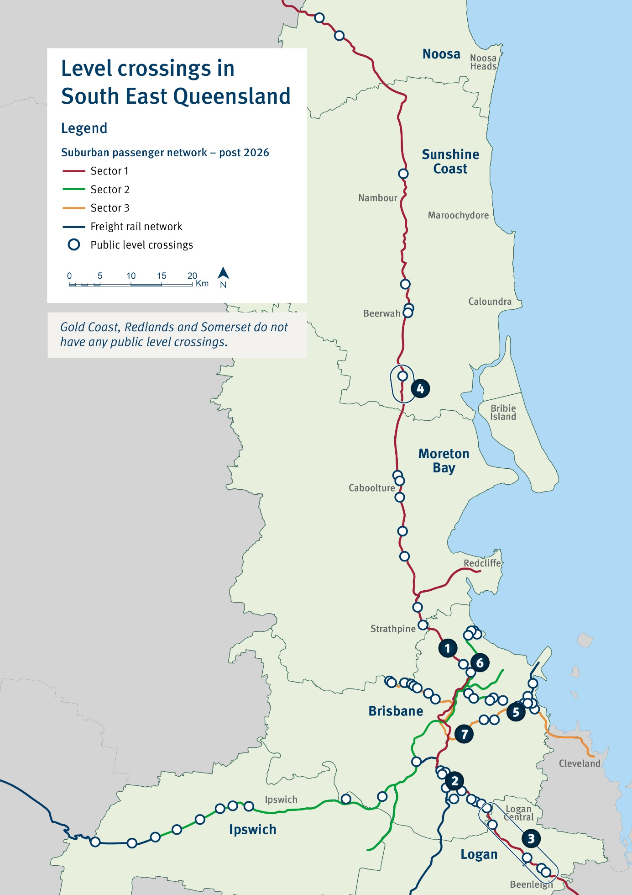

## Current projects

|  |
| --- |
| SEQ City Deal Level Crossing Prioritisation  * Current status: Planning commenced in 2023 * Next phase: Develop prioritisation methodology and assess relative priority of level crossings |

|  |
| --- |
| Beams Road, Carseldine – 1  * Current status: Construction commenced for grade separated (road over rail) overpass * Next phase: Delivery and commissioning |

|  |
| --- |
| Boundary Road, Coopers Plains – 2  * Current status: Detailed design underway for grade separated (road over rail) overpass * Next phase: Finalise detailed design and procure for construction |

|  |
| --- |
| Logan and Gold Coast Faster Rail – 3  * Current status: Construction procurement underway. 5 level crossings being removed at Kuraby, Woodridge, Bethania, Holmview and Beenleigh * Next phase: Commence construction |

|  |
| --- |
| Beerburrum to Nambour Rail Upgrade (Stage 1) – 4  * Current status: Construction procurement and detailed design being finalised. Level crossings being identified for upgrades including 1 at Glass House Mountains and removal of 2 occupational crossings at Beerburrum * Next phase: Commence construction |

|  |
| --- |
| Kianawah Road, Wynnum West (Lindum) – 5  * Current status: Reconfigured level crossing with traffic signals being designed * Next phase: Detailed design and procure for construction* |

|  |
| --- |
| St Vincents Road, Banyo – 6  * Current status: Planning study finalised * Next phase: Subject to future funding commitments |

|  |
| --- |
| Cavendish Road and Stanley Street East, Coorparoo – 7  * Current status: Project investigation* * Next phase: Subject to future funding commitments |

* Project scope, cost and timing subject to further planning and negotiation with the Australian Government and/or relevant local government

|  |
| --- |
| Funding approach The Queensland Government intends to develop an agreed funding approach between the Australian, Stae and local governments. The funding approach may vary depending on road ownership and size and funding capacity of the council. |

## Planning for level crossing precincts

#### Challenges and Opportunities

Trains have priority at level crossings, which can result in traffic congestion and constrained connectivity for communities.

Amenity impacts at level crossings can include noise pollution from trains passing through the crossing (and accompanying horn noise), air pollution from stationary vehicles, as well as visual amenity impacts with crossing interfaces tending to be unsightly.

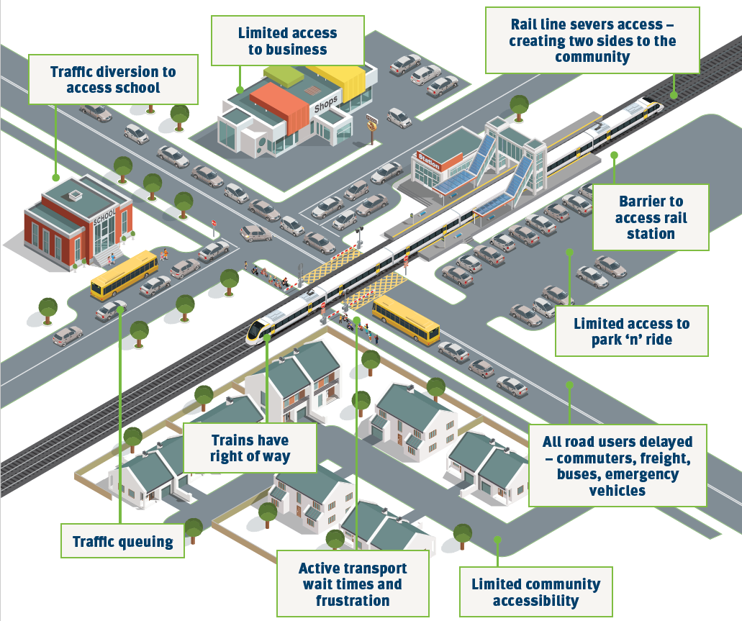

|  |
| --- |
| Upgrade options There are a range of level crossing upgrade options and it is important that upgrades reflect broader precinct surroundings. This includes considering active transport movements, station upgrades, parking, bus interchanges, road network improvements and nearby level crossings.  Upgrading level crossings can present opportunities to deliver better connected communities and improved housing outcomes. Solutions can range from installation of improved safety infrastructure, through to separating road and rail, or closure. It is crucial to design level crossing upgrades to meet the community’s needs as the selected solution will likely remain in place for generations. This is of particular importance for significant and costly upgrades such as road and rail overpasses or underpasses. |

## Program approach

The Queensland Government’s approach to level crossing planning and delivery will deliver safe, efficient and accessible level crossing precincts for SEQ through a prioritised program approach to upgrading level crossings.

A program approach with collaboration and support from all levels of government will ensure value for money investments over time to improve the performance, safety and resilience of the transport network.

Benefits of a coordinated level crossing program include:

* Better solutions and value for money upgrades
* Integration and coordination with related programs and initiatives
* Capturing learnings and continual improvement
* Consistent measurement of benefits realised.

|  |
| --- |
| Lessons learnt from Victoria The Department of Transport and Main Roads is applying insights from the Victorian Government's Level Crossing Removal Project, in particular its program approach, accelerated delivery approach and focus on good urban design outcomes.  While there are opportunities to learn from Victoria, there are features of the SEQ suburban passenger network that are different to the Victorian context.  SEQ has a much lower number of public level crossings and these are also more dispersed across the network. By comparison, many level crossings in Melbourne are in very close proximity to each other and higher levels of congestion are experienced on more crossings. The ability to remove a number of level crossings at the same time over short distances is less achievable in SEQ, nor are the congestion pressures as widespread.  While the Victorian context is different, putting relevant principles into practice in SEQ can help to deliver a value for money program while ensuring level crossing upgrades provide the local community with good outcomes for all users including pedestrians and bike riders. |

There can be good interdependencies between upgrading level crossings and delivering major rail upgrades to enable additional rail services to run without exacerbating road congestion. The Department of Transport and Main Roads is

progressing level crossing upgrades as part of major rail corridor investments including the Logan and Gold Coast Faster Rail and Beerburrum to Nambour Rail Upgrade (Stage 1).

All future passenger rail lines, including current planning for the Direct Sunshine Coast Rail Line from Beerwah to Maroochydore, are being designed to ensure no new level crossings are introduced.

|  |
| --- |
| Packaging Projects Coordinating and staging the planning and delivery of level crossings in packages, can allow for more coordinated solutions across the wider network of level crossings and provide a predictable pipeline for industry. Packaging projects can also present capital works cost efficiency savings. |

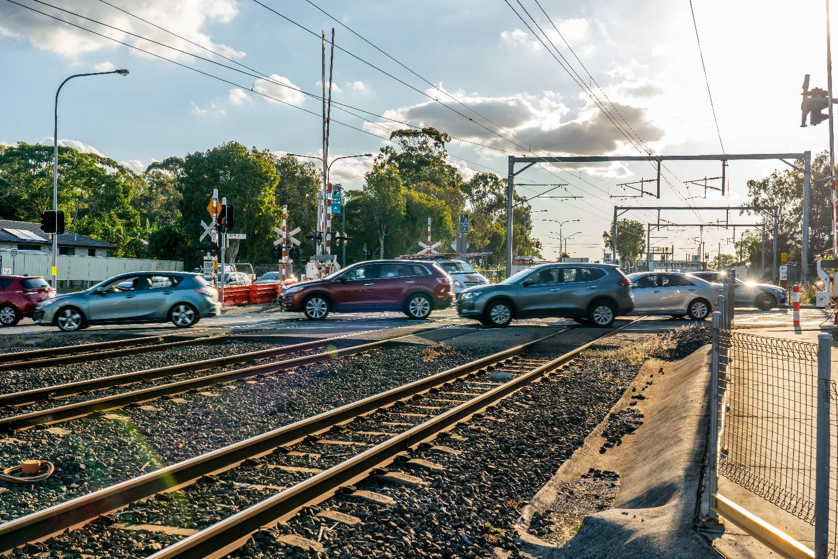

## Level crossing prioritisation

### SEQ City Deal level crossing commitment

As part of the SEQ City Deal, the Department of Transport and Main Roads is working with project partners including Queensland Rail, Council of Mayors (SEQ), and the Australian Government, to deliver a level crossing prioritisation project to identify and agree on high priority level crossings for further detailed investigation and future upgrade.

The project forms part of the *Planning for Future Region-Shaping Infrastructure* commitment led by the Queensland Government in partnership with the Australian Government and Council of Mayors (SEQ). The project will deliver a level crossing prioritisation framework – including prioritisation methodology, priority list of crossings and high level concept solutions for priority crossings for further investigation.

### SEQ level crossing prioritisation

The SEQ City Deal level crossing prioritisation project is the next key step in the Queensland Government's SEQ level crossing upgrade program, and will be informed by this plan.

Initial analysis of SEQ level crossings has identified a range of future investigation priorities. These priority crossings will be confirmed through the SEQ level crossing prioritisation project.

This project will lay the groundwork for identifying opportunities for all three levels of government to collaborate and inform planning and investment priorities in SEQ for the upgrade and removal of level crossings as part of an agreed program of investment.

|  |
| --- |
| Key indicators that may point to a high priority crossing:   * high train volumes (over 200 per day) * high traffic volumes (over 10,000 vehicles a day) * boom gate downtime (over 30% during peak periods) * historical safety incidents * proximity to other level crossings and alternative crossings * consideration of use by buses, trucks, emergency services vehicles, pedestrians and bike riders. |

13QGOV (137468)

[www.tmr.qld.gov.au](http://www.tmr.qld.gov.au) | [www.qld.gov.au](http://www.qld.gov.au)