

**Scarborough Boat Harbour Master Plan**

**Consultation and engagement insights summary**

The Department of Transport and Main Roads (TMR) respectfully acknowledges the Traditional Owners and Custodians of the land and waterways and we pay respect to their Elders past, present and emerging. TMR recognises those whose ongoing effort to protect and promote Aboriginal and Torres Strait Islander cultures will leave a lasting legacy for future First Nations people.

The Queensland Government is committed to providing accessible services to Queenslanders of all cultural and linguistic backgrounds. If you have difficulty understanding this publication and need a translator, please call the Translating and Interpreting Service (TIS National) on 13 14 50 and ask them to telephone the Queensland Department of Transport and Main Roads on 13 74 68.

Contact us for alternative accessible formats.   
Please email: [bhplanning@tmr.qld.gov.au](mailto:bhplanning@tmr.qld.gov.au)   
This information can also be found on our website: <https://www.tmr.qld.gov.au/projects/scarborough-boat-harbour>

Copyright  
This publication is protected by the Copyright Act 1968.   
© The State of Queensland (Department of Transport and Main Roads) 2024.   
All rights reserved.

Disclaimer  
This publication is provided as a source of information only and the State of Queensland makes no statements, representations or warranties about its accuracy or completeness. To the extent permitted by law, the State of Queensland disclaims all responsibility for decisions or actions taken as a result of any data, information, statement or advice, expressed or implied, contained within and excludes all liability (including, without limitation, liability in negligence) for all expenses, losses, damages and costs that may be incurred.

Contents

Introduction 3

About TMR engagement 4

Consultation and engagement overview 5

How we engaged 7

Phase 1 - Early engagement summary 8

Phase 2 - Consultation and engagement summary 14

Phase 3 - Additional feedback on public consultation changes to draft master plan 28

Next steps and future engagement 33

# Introduction

Scarborough Boat Harbour is a strategic state-owned maritime public asset and gateway to the Moreton Bay Marine Park and the broader Queensland coastline. The harbour plays an important role in supporting access to a range of maritime, tourism and recreation functions in a dynamic fast-growing region, and is a key focal point and destination for the region and the Redcliffe Peninsula.

Scarborough Boat Harbour’s limited space is highly valued by a broad range of stakeholders with both complementary and competing needs and objectives around what the future form and function of the harbour could look like. It is therefore important to plan for the harbour’s sustainable long-term future and the Scarborough Boat Harbour Master Plan (master plan) aims to strike a balance between sustaining a working harbour and maritime operations, while enhancing the experience and access for harbour users.

The Scarborough Boat Harbour is one of Queensland’s eight state owned and managed harbours that form a network of important strategic maritime public assets.

The Department of Transport and Main Roads (TMR) manages Queensland’s state boat harbours to protect and enhance their important strategic maritime function, and to protect and provide access to Queensland’s waterways. The state boat harbours also accommodate maritime community groups and clubs, government services and marine rescue. Each harbour plays an important function in its local and regional context, creating a destination that balances sustaining a working harbour and maritime operations, alongside public access and recreation.

The master plan sets out a long-term vision and will serve as a strategic, non-statutory decision-making tool to guide development and implement actions over time. The master plan will be updated, monitored and reviewed, and will be used to inform future detailed planning and investigations, and existing infrastructure planning and prioritisation programs.

The master plan has been informed by supporting technical studies and the consultation and engagement of a broad range of stakeholders and the community.

This document provides a summary of the consultation and engagement process and insights which helped inform the development of the master plan.

# About TMR engagement

TMR has developed the master plan using an evidenced-based approach supported by technical assessments and feedback received from collaborative engagement with Moreton Bay City Council (MBCC), state agencies, tenants, stakeholders and industry, and wider public engagement.

A range of engagement techniques were utilised including digital engagement platforms, interactive maps and surveys, social media, post cards delivered to households, stakeholder workshops, and face-to-face engagement through local pop ups and public forums.

This engagement provided the community and stakeholders the opportunity to find out more and provide feedback on the master plan.

Three phases of consultation were undertaken over the life of the project to inform the master plan which included:

* Early community and stakeholder engagement between 9 September 2021 and 24 October 2021
* Public consultation between 13 November 2023 and 11 March 2024
* Community and stakeholder feedback between 10 June 2024 and 24 June 2024

# Consultation and engagement overview

#### What we did

#### Phase 1 – Early community and stakeholder engagement

* 6.5 week engagement
* Radio and newspaper advertising
* 30,000 fact sheets delivered to local residents and businesses
* 6 pop-up information sessions
* 403 short survey and interactive map responses, 17 emails
* Street ‘boat ramp’ chats
* 64,735 social media impressions
* 3,002 visits to the website
* Stakeholder briefings and emails

#### Phase 2 – Public notification

* 17 week engagement
* 7 pop-up sessions
* 19,750 post cards delivered
* 302 submissions
* 94 emails
* 16 written
* 119 survey responses
* 72 online map responses
* 1426 draft master plan downloads
* 5,582 visits to the website
* 200,300 social media impressions
* Stakeholder briefings and notification emails
* Dedicated project page and hotline

#### Phase 3 – Community and stakeholder feedback

* 2 week engagement
* Over 130 attendees to a community forum held before the commencement of the two week period
* 71 short survey responses
* 10 email responses
* 464 visits to the project webpage

# How we engaged

* Media statement and announcements across various platforms
* A total of 19,750 post cards delivered
* A dedicated project hotline
* 7 community pop-ups and information sessions
* Stakeholder and community workshop
* Online survey and pin drop map
* Handwritten and email submissions
* A dedicated project webpage

#### Who we heard from

Throughout the community engagement stages, we have heard valuable feedback and ideas from a wide range of community members and stakeholders.

* Resident
* Visitor
* Club or marina member
* Harbour worker
* Recreational harbour user
* Community group
* Commercial owner / operator
* Industry organisation.

# Phase 1 - Early engagement summary

TMR undertook a program of early community and stakeholder engagement from 9 September to 24 October 2021 to understand community and stakeholder values about the harbour, as well as ideas about current and future use. An awareness and positioning campaign supported a variety of in-person and online activities during the engagement period.

The findings from this engagement were used to inform the master planning program, including developing background technical studies, draft master plan outcomes and content, and planned engagement activities.

#### Engagement insights

Feedback identified what would encourage more frequent use of Scarborough Boat Harbour and enhance experiences:

* Protection of the natural environment
* Continued support and enhancement of the harbour’s maritime purpose
* Well-planned and improve utilization of public spaces
* Improved public amenities and infrastructure
* More events, activities and activations
* Improved access and connectivity.

Respondents also shared what is special about Scarborough Boat Harbour, including:

* Views, visual amenity and the natural environment
* Location access to water and proximity to Moreton Bay
* Existing facilities, access to the harbour and activities
* A sense of community ownership.

The broad range of feedback received provided valuable insights into what the community values about the harbour and what would enhance user and visitor experience. A number of common themes were identified which are outlined below.

* Enhance the user experience while preserving what makes the harbour special
  + The majority of respondents visited SBH frequently (weekly or fortnightly) or routinely (daily). It was noted that while they enjoyed the harbour and did not want to see it change, opportunities were identified that would enhance usage.
* Protection of natural environment, supported by education and awareness
  + The importance of the natural environment, and its protection, emerged as a strong theme in the stakeholder feedback. There was a notable focus on migratory birds as well as marine life. Maintaining the current natural environment while identifying opportunities to protect and enhance it were identified as ways to encourage more frequent harbour usage, as well as an enhanced visitor experience.
* Support and enhance the harbour’s maritime purpose
  + Feedback identified that the provision of cost-effective and improved marina facilities would increase opportunities for access and use of the harbour. Examples included the provision of additional boat ramps, fuel facilities, maintenance services, wash down facilities, storage and rubbish management.
  + Feedback also identified the need to address harbour capacity and noted improved facilities and infrastructure delivery were needed to accommodate growing demand.
* Planned open spaces and built form
  + There was a consistent theme in the feedback received regarding the need to retain the harbour’s strategic maritime purpose and character, while also providing open space, opportunities for dining, cafés, and land and water-based amenities.
* Improvements to public amenities and infrastructure
  + Feedback identified a need to improve public amenities and infrastructure at the harbour to enhance the user experience, with examples including toilet facilities, lighting, and increased shade.
* Use of public spaces
  + Feedback identified that there is an opportunity to provide new nature reserves, café event spaces and recreational areas at the existing dredge spoil rehandling facility.
* Events, activities and activations
  + New events and activities were identified in the feedback as a way to enhance harbour use and attract new visitors. Suggestions included the provision of water-based and marine activities such as paddle and boat hire and learn-to-sail services, and convention and maritime educational facilities.
* Improved access and connectivity
  + Feedback noted the importance of providing access and accessibility within the harbour and to the surrounding community through pathways, cycleway and water connections. Feedback also identified the need for improved public transport connections to the harbour and enhanced water connections to Moreton Bay.

#### Feedback profile

#### Age

* 14% of respondents were aged 70 years of age or older
* 58% of respondents were aged 50 to 69 years of age
* 25.7% of respondents were aged 30 to 40 years of age
* 2.3% of respondents were aged 18 to 29 years of age.

#### Postcode

* 65% of respondents were from the post-code 4020 – Scarborough, Newport and Redcliffe.

#### How often do you visit?

* 39% visit the Scarborough Boat Harbour routeinely, either daily for work, leisure or recreation
* 37% visit the Scarborough Boat Harbour frequently, either weekly or fortnightly
* 18% visit the Scarborough Boat Harbour sometimes, either monthly or quarterly.

#### Relationship with the harbour

* 61% of respondents identified I live on the Redcliffe Peninsula
* 20% of respondents identified I am a recreational harbour user (motorised)
* 6% of respondents identified I am a recreational harbour user (non-motorised)
* 6% of respondents identified I am a visitor to Scarborough Boat Harbour and the surrounds
* 4% of respondents identified I am part of a community group, club or association
* 2% of responds identified I work in Scarborough Boat Harbour
* 1% of respondents identified I am a Scarborough Boat Harbour commercial owner or operator
* 0% of respondents identified none of the above.

Draft master plan released for public consultation - November 2023

The findings from early engagement, additional stakeholder feedback, and the supporting background technical studies were used to prepare the following draft master plan for public consultation.

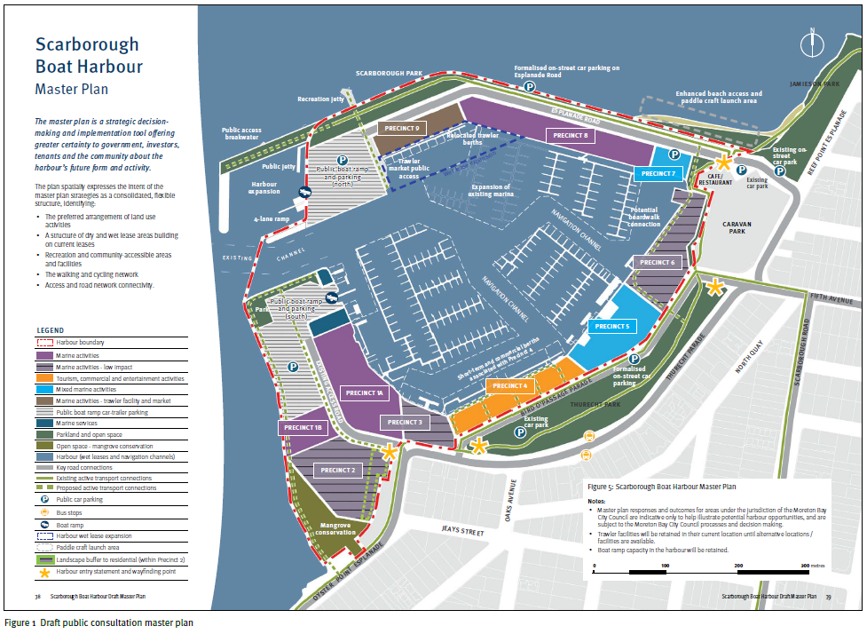

Plan description:

Scarborough Boat Harbour Master Plan

The master plan is a strategic decision-making and implementation tool offering greater certainty to government, investors, tenants and the community about the harbour’s future form and activity.

The plan spatially expresses the intent of the master plan strategies as a consolidated, flexible structure, identifying:

* The preferred arrangement of land use activities
* A structure of dry and wet lease areas building on current leases
* Recreation and community-accessible areas and facilities
* The walking and cycling network
* Access and road network connectivity

Legend

* Harbour boundary
* Marine activities
* Marine activities – low impact
* Tourism, commercial and entertainment activities
* Mixed marine activities
* Marine activities – trawler facility and market
* Public boat ramp car-trailer parking
* Marine services
* Parkland and open space
* Open space – mangrove conservation
* Harbour (wet leases and navigation channels)
* Key road connections
* Existing active transport connections
* Proposed active transport connections
* Public car parking
* Bus stops
* Boat ramp
* Harbour wet lease expansion
* Paddle craft launch area
* Landscape buffer to residential (within Precinct 2)
* Harbour entry statement and wayfinding point.

Notes:

* Master plan responses and outcomes for areas under the jurisdiction of the Moreton Bay City Council are indicative only to help illustrate potential harbour opportunities, and are subject to the Moreton Bay City Council processes and decision making.
* Trawler facilities will be retained in their current location until alternative locations / facilities are available.
* Boat ramp capacity in the harbour will be retained.

# Phase 2 - Consultation and engagement summary

TMR commenced the second round of consultation on 13 November 2023. It was initially planned to close on 11 December, however in response to community and stakeholder feedback the public consultation process was extended until 11 March 2024. The feedback received had varying views across a wide range of topics which are summarised in the following sections.

#### Engagement snapshot

Feedback focused on:

* opportunity to achieve more balanced land-use outcomes including:
  + reconsidering the proposed relocation of the state-managed trawler facility and public boat ramps to the harbours northern arm due to safety, traffic and amenity impacts
  + lower intensity activities along the harbours northern arm such as tourism, hospitality and marina related activities
  + greater provision of open space for public recreation and improved public facilities, particularly on the harbours northern arm
  + retaining maritime industry uses within existing locations in the southern arm of the harbour
* providing additional boat launching capacity, supporting parking facilities and ancillary support services to meet current and future demand
* minimising impacts to terrestrial and marine environments including mangroves, birdlife and marine life
* further information was requested on traffic impacts, future building heights and tidal inundation.

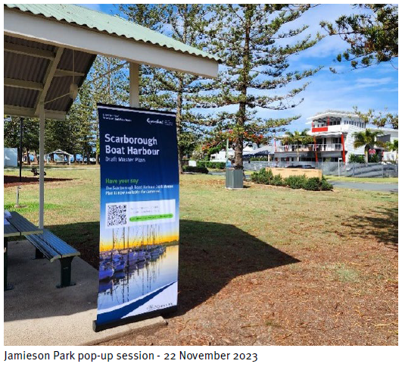

Feedback from some stakeholders outlined that the consultation undertaken in Phase 2 was inadequate and that further engagement was required.

A number of common themes were identified across the feedback received. This feedback is summarised in more detail in the following sections.

#### Uses and activities

#### Key feedback themes:

* Hospitality and tourism
* Trawler facilities and access
* Land use balance
* Commercial activity demand.

#### Key insights from the theme of ‘use and activities’ include the following:

* potential for the harbour to become a hub for community, tourism, hospitality and maritime education uses, in addition to the focus on maritime industry and service sectors – especially in precincts 8 and 9
* mixed views on the location of the trawler facility and open seafood market
* the need for the harbour to provide a balance between maritime activities and other land uses to provide a more balanced mix of uses
* ideas were proposed such as the introduction of a dedicated maritime education facility
* proposed land uses should take into consideration the character of adjoining residential areas.

#### Quotes from the feedback that represent this theme:

* “This area has so much potential for tourism, hospitality and public reaction.”
* “Modernise the existing facilities to attract tourism.”
* “A few more cafes or restaurants in the area would be nice and dedicated births for tourism boats is good.”
* “District 8 and 9 ought to prioristise tourism, commercial ventures, entertainment, education and environmentally susintable activities. This strategy enhances convenience for visitors and tour operators while minimizing congestion within the harbour.”
* “We have on opportunity to get the correct balance for the harbour. The current plan needs to be revised to ensure that the harbour becomes a viable tourism and hospitality destination and valuable community asset rather than overly focused on boat repairs and maintenance.”
* “Maintain the fishing trawlers.”

#### Built form and amenity

#### Key feedback themes:

* Height limits
* Harbour character
* Increase noise
* Increased emissions

#### Key insights from the theme of ‘built form and amenity’ include the following:

* the need to preserve the visual amenity and views across the northern arm by managing overall height limits and built form
* potential increases in noise and air emissions may impact adjoining residential areas.

#### Quotes from the feedback that represent this theme:

* “I have concerns with Precinct 8 and 6. I understand the commercial aspects of these areas and helping to make the area financially viable, my concerns centre around the impact they have to the area.”
* “Height limitations for the proposed buildings. It would be unsightly to see high rise on the spit.”
* “As a former resident of Thurecht Parade, due consideration needs to be given to the lifestyle of local residents during any construction.”
* “The area could do with a tidy up for sure. The intent is what we like but the execution is way off what the peninsula stands for. There is not a lot to like about this plan as its all about bitumen and buildings.”
* “The beautiful northern arm is ideally suited to tourism and hospitality opportunities, not industrial activities which will have a negative environmental and visual impact.”

#### Traffic and car parking

#### Key feedback themes:

* Congestion
* Navigation
* Safety and amenity
* Car and boat trailer parking

#### Key insights from the theme of 'traffic and car parking' include the following:

* concern about the risks and amenity impacts associated with potential increases in traffic volumes at the harbour, in particular to the northern arm
* identification of vehicular access improvements to the northern arm to reduce conflicts between parked vehicles, trailers, boats and commercial vehicles
* opportunity to improve carparking and car-trailer unit parking to meet future demand
* concern master planning process has not sufficiently considered traffic and carparking implications, and additional consideration is required.

#### Quotes from feedback that represent this theme:

* “The local streets will not cope with the additional traffic, boat trailers and industry that is included in the master plan. A single road in and out of Reef Point Esplanade, Jamieson Park and the Scarborough Caravan Park.”
* “More trailer parking.”
* “Parking could be improved, with jetskis put in a dedicated parking space away from usual spots.”
* “I would change the access road from Reef Point Road to the other side of the café accessed from where the current car park is adjacent to the current boat ramp.”
* “My main concern is the increase in traffic both private and commercial.”
* “The area is undergoing massive growth meaning an increase in recreational boating. Parking areas need to be increased.”

#### Additional traffic study findings

In response to concerns raised by stakeholders regarding traffic and parking, TMR undertook an additional assessment of the existing traffic and parking situation at the harbour to identify current and potential future issues.

Based on industry standards for other similar harbours, the harbour traffic generation at Scarborough has been observed to be higher than other harbours, with Sunday being the busiest day. Importantly, more detailed assessment will be required as the preliminary results support the need for a mix of low scale land uses and associated onsite parking, along with the consideration of alternative vehicle access.

#### Environment

#### Key feedback themes:

* Mangrove conservation
* Migratory shorebirds
* Flood and tidal indundation
* Flora and fauna protection.

#### Key insights from the theme of 'environment' include the following:

* feedback that the community values local fauna such as migratory and local birds, frogs, lizards, turtles and dugong
* potential impacts to flora and fauna, including the mangrove conservation areas and area used by migratory birds, along with the suggested relocation of the bike path
* dredging and infrastructure development may impact marine ecosystems and the local wildlife, and needs to be considered.

#### Quotes from feedback that represent this theme:

* “It makes use of the space and improves things greatly and I can’t see why any flora and fauna concerns can’t be addressed as part of the plan.”
* "The Mangrove Conservation area on the southern boundary of the Marina area is a great area, protect and promote the remnant of natural shoreline.”
* “The plan does not address the water inundation issues during king tides and storm surges along Reef Point Esplanade and the entry road to Sea Salt and Vine.”
* “There are a tonne of frogs, birds and reptiles along with the marine life that call this area home.”
* “There are a variety of migratory birds that spend their summer in the section of the bay and the foreshore on the western edge.”

#### Public amenity

#### Key feedback themes:

* Public amenity
* Green space
* Recreational use
* Northern arm loop
* Connection and access improvement

#### Key insights from the theme of ‘public amenity’ include the following:

* the need to increase and protect the extent of available open space
* concerns regarding the conversion of the northern arm into non-green space
* improve public amenities for harbour users, enhancing access for all and creating a destination
* improve footpaths and movement networks to accommodate foot, bicycle and scooter users, including retention of the ‘walking loop’.

#### Quotes from feedback that represent this theme:

* “I like the elements of the plan that enhance pedestrian walkways close to waterfront areas.”
* “Walking and cycling path upgrades would be welcome.”
* “Losing part of the walking loop around the marina that is used by many visitors.”
* “Please make all the parks really cool! Everyone loves going for a walk around here.”
* “Keeping green area is very important to our future generations.”

#### Infrastructure

#### Key feedback themes:

* Boat ramps
* Fuel facilities
* Dredge spoil
* Enhanced beach access
* All tide access

#### Key insights from the theme of 'infrastructure' include the following:

* there is a need to manage on-water traffic and vessels within the internal channels to avoid safety concerns for boats and maritime vessels
* desire for additional boat ramp capacity within their current locations
* introduce an improved beach access and paddle craft launch area to support aquatic and marine activities
* additional and upgraded fuel facilities are required
* dredging and all tide access is essential, along with increasing pontoons at new ramp locations.

#### Quotes from feedback that represent this theme:

* “Has consideration been given to future maintenance dredging requirements and disposal of the spoil or is it assumed that spoil can always be taken to the dredge spoil area near Mud Island? What happens when this facility is no longer available?”
* “Increase the boat ramp offering to accommodate the increase in boat and jetskis ownership.”
* “The concept of additional berthing in precinct 9 is good – but should be for casual visitor/tour berthing – not trawlers.”
* “With the growing trend of people buying boats, I think the new boat ramp needs to be increased to include another double ramp / pontoon offering.”
* “All tide access is essential.”

#### Feedback profile

#### Age

* 25% of respondents were aged 65 years of age or older
* 28% of respondents were aged 55 to 64 years of age
* 21% of respondents were aged 45 to 54 years of age
* 19% of respondents were aged 35 to 44 years of age
* 5% of respondents were aged 24 to 35 years of age
* 2% of respondents were aged 18 to 24 years of age.

#### Post code

* 74% of respondents were from the post code 4020 – Scarborough, Newport and Redcliffe.

#### How often do you visit?

* 59% visit the Scarborough Boat Harbour routeinely, either daily for work, leisure or recreation
* 25% visit the Scarborough Boat Harbour frequently, either weekly or fortnightly
* 9% visit the Scarborough Boat Harbour sometimes, either monthly or quarterly.

#### Relationship with the harbour

* 32% of respondents identified I live on the Redcliffe Peninsula
* 17% of respondents identified I am a recreational harbour user (non-motorised)
* 14% of respondents identified I am a recreational harbour user (motorised)
* 13% of respondents identified I am a visitor to Scarborough Boat Harbour and surrounds
* 13% of respondents identified I am part of a club or marina
* 8% of respondents identified I am part of a community group
* 2% of respondents identified I work in Scarborough Boat Harbour
* 1% of respondents identified I am a Scarborough Harbour commercial owner or operator.

#### Draft master plan changes in response to public consultation feedback

Following public consultation, TMR undertook an extensive review and analysis of all the feedback received, and developed a revised draft master plan. The following points summarise these key changes made to the draft master plan:

* providing shared single vehicle and car-trailer unit overflow parking, landscaping and landscape buffer areas in revised Precinct 1B
* retention of trawler facility in existing location in revised Precinct 5 and investigate enhanced access and function
* maintaining and enhancing existing waterfront marina hospitality in revised Precinct 4
* reconfiguring and enhancing existing public boat ramp in revised Precinct 7 and investigate new direct access road to the northern arm of the harbour
* maintaining and enhancing existing marina in revised Precincts 9A and 9B including low-scale supporting marina-related services, hospitality venues, and overflow carparking
* low scale marine-related tourism and commercial vessel berthing activities, and related hospitality uses in revised Precincts 10A and 10B
* additional open space and improved pedestrian connectivity along the northern arm of the harbour in revised Precinct 11C
* proposed harbour breakwater extension retained for future access and infrastructure purposes at the end of the northern arm of the harbour
* removal of boardwalk in the Mangrove Conversation area in revised Precinct 11A, with improved pedestrian connectivity along existing access roads to the southern arm of the harbour
* relocation of the trawler facility and boat ramps to the northern arm of the harbour was no longer proposed, with the northern arm proposed for low scale tourism activities, hospitality, enhancement of the existing marina and open space for public access
* approximately 26% of the land-side harbour dedicated to open space for public access with a 35% increase in pathway connections improving pedestrian connectivity.

These changes informed the revised draft master plan and aimed to respond to feedback and strike a balance between sustaining a working harbour and maritime operations, while enhancing the experience and access for all harbour users.

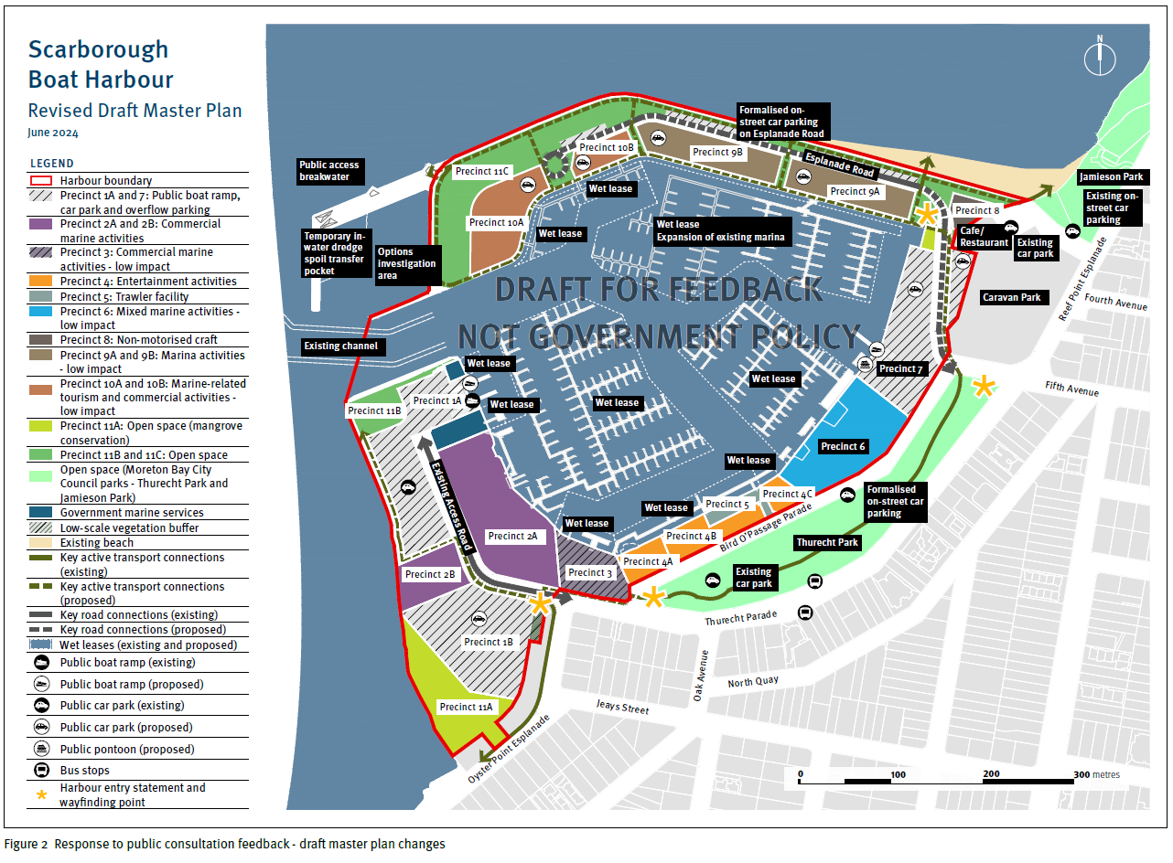

Plan description:

Scarborough Boat Harbour Revised Draft Master Plan June 2024

Legend:

* Harbour boundary
* Precinct 1A and 7: Public boat ramp, car park and overflow parking
* Precinct 2A and 2B: Commercial marine activities
* Precinct 3: Commercial marine activities – low impact
* Precinct 4: Entertainment activities
* Precinct 5: Trawler facility
* Precinct 6: Mixed marine activities – low impact
* Precinct 8: Non-motorised craft
* Precinct 9A and 9B: Marina activities – low impact
* Precinct 10A and 10B: Marine-related tourism and commercial activities – low impact
* Precinct 11A: Open space (mangrove conservation)
* Precinct 11B and 11C: Open space
* Open spaces (Moreton Bay City Council parks – Thurecht Park and Jamieson Park)
* Government marine services
* Low-scale vegetation buffer
* Existing beach
* Key active transport connections (existing)
* Key active transport connections (proposed)
* Wet leases (existing and proposed)
* Public boat ramp (existing)
* Public boat ramp (proposed)
* Public car park (existing)
* Public car park (proposed)
* Public pontoon (proposed)
* Bus stops
* Harbour entry statement and wayfinding point

# Phase 3 - Additional feedback on public consultation changes to draft master plan

TMR published a revised version of the draft master plan on 7 June 2024 on the project webpage and invited the community and stakeholders to share their feedback from 10 June to 24 June 2024.

TMR also presented the revised draft master plan at a community forum held at the Redcliffe Leagues Club on 8 June 2024, with over 130 attendees including representatives from MBCC, industry and local groups.

The survey content focused on 8 key questions:

1. What do you think of the overflow carparking and landscape buffers in the revised Precinct 1B?
2. What do you think about the retention of the trawler facilities and entertainment uses at their current locations?
3. What do you think about retaining and reconfiguring the boat ramp in the revised Precinct 7?
4. What do you think about the potential road access to the northern arm of the harbour through the revised Precinct 7?
5. What do you think about the focus towards marina uses in the revised Precincts 9A and 9B?
6. What do you think about the improvements on the northern spit area with a shift towards low scale marina?
7. What do you think of the improvements to open space within the harbour?
8. Do you have any other comments about the potential draft changes?

#### Engagement insights

A total of 71 survey responses and 13 email responses were received across the feedback period.

#### Key responses are summarised as follows:

* positive response acknowledging TMR had listened to feedback and tried to find a balance between stakeholders
* support for the revised changes on the northern arm, however many responses still indicated a preference for no development on the northern arm
* concern about the visual amenity and views across the northern arm by managing overall height limits and built form
* localised drainage and flood mitigation remained a concern, and further consideration is required
* management of traffic and parking remain a concern, and further consideration is required
* requests for more collaboration and engagement on the draft master plan, alongside many responses that requested the master plan move into implementation to drive improvements and outcomes.

#### Quotes from feedback that represent this theme:

* “A very good outcome for local residents as it addresses significant traffic and safety concerns held by the community.”
* “Road access is always going to be an issue along with parking as the more people you attract the harder it will be to park and the congestion will get worse.”
* “I'm concerned about potential multi level buildings in the area. A height level of no more than a ground and first level building. I'm dead against any form of high rise.”
* “I do not like this. This area is unspoilt and enjoyable as it is. We have berthing, tourism and hospitality available across the harbour.”
* “It's a necessary and adequate compromise. Everyone gets roughly what they want for what is and should remain a working boat harbour. I get the strong impression that the department really did listen and amended the master plan accordingly.”
* “Supported and that this Precinct should be focused on marine tourism, hospitality, commercial and entertainment activities.”

#### Master plan content and structure changes

Following community and stakeholder feedback, TMR made the following changes to the master plan content and structure, as outlined in Figure 3:

* outlining a commitment to no short-term accommodation or residential uses on TMR-controlled land within the Scarborough Boat Harbour
* a commitment to seek a reduction in heights on the northern arm as part of any future amendments to the MBCC planning scheme
* additional clarification that the northern rock wall and temporary spoil transfer pocket will be subject to further detailed investigation and environmental approvals
* ongoing commitment to stakeholder and community engagement on the implementation of the master plan
* commitment to work with MBCC on the management of localised traffic, carparking, drainage and inundation issues as part of any future development and across implementation of the master plan.

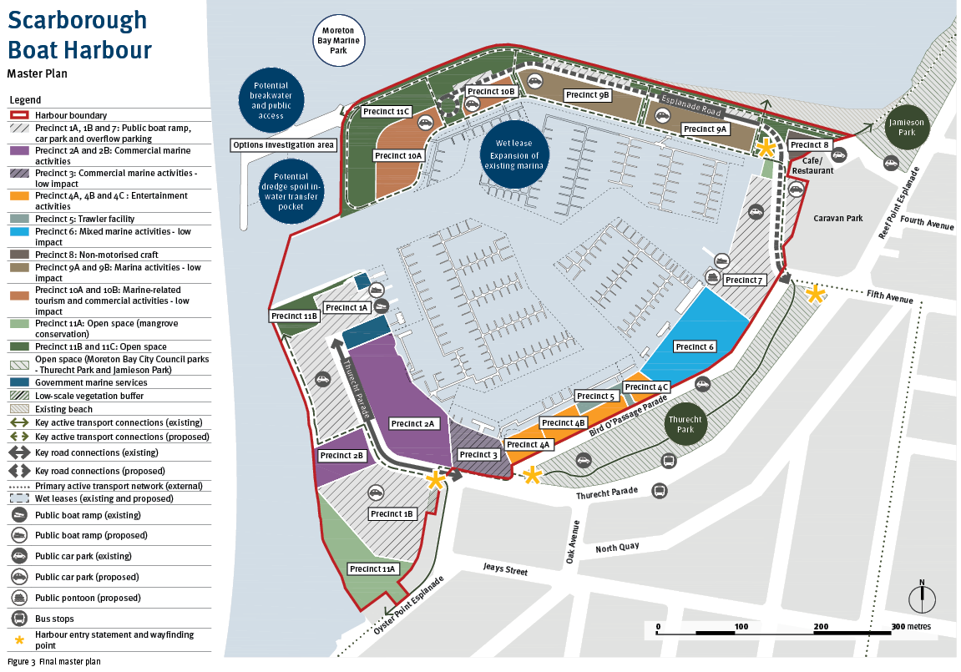

Plan description:

Scarborough Boat Harbour Master plan

Legend:

* Harbour boundary
* Precinct 1A, 1B and 7: Public boat ramp,
* car park and overflow parking
* Precinct 2A and 2B: Commercial marine activities
* Precinct 3: Commercial marine activities - low impact
* Precinct 4A, 4B and 4C : Entertainment activities
* Precinct 5: Trawler facility
* Precinct 6: Mixed marine activities - low impact
* Precinct 8: Non-motorised craft
* Precinct 9A and 9B: Marina activities - low impact
* Precinct 10A and 10B: Marine-related tourism and commercial activities - low impact
* Precinct 11A: Open space (mangrove conservation)
* Precinct 11B and 11C: Open space
* Open space (Moreton Bay City Council parks - Thurecht Park and Jamieson Park)
* Government marine services
* Low-scale vegetation buffer
* Existing beach
* Key active transport connections (existing)
* Key active transport connections (proposed)
* Key road connections (existing)
* Key road connections (proposed)
* Primary active transport network (external)
* Wet leases (existing and proposed)
* Public boat ramp (existing)
* Public boat ramp (proposed)
* Public car park (existing)
* Public car park (proposed)
* Public pontoon (proposed)
* Bus stops
* Harbour entry statement and wayfinding point

# Next steps and future engagement

The master plan sets out a long-term vision and will serve as a strategic, non-statutory decision-making tool to guide development and implementation actions over time, including informing infrastructure planning and prioritisation programs. The transition of Scarborough Boat Harbour towards the vision outlined in the master plan will be achieved through a combination of staged improvements and changes to existing infrastructure and new development and leasing opportunities.

Implementation of the master plan will require ongoing engagement and collaboration with MBCC, harbour and industry stakeholders, leaseholders, Traditional Owners and the community.

A stakeholder and community engagement strategy will be prepared to support implementation of the master plan.

For more information, refer to the master plan.