Transport and Main Roads
  - Accessibility and Inclusion Strategy - Summary
July 2020
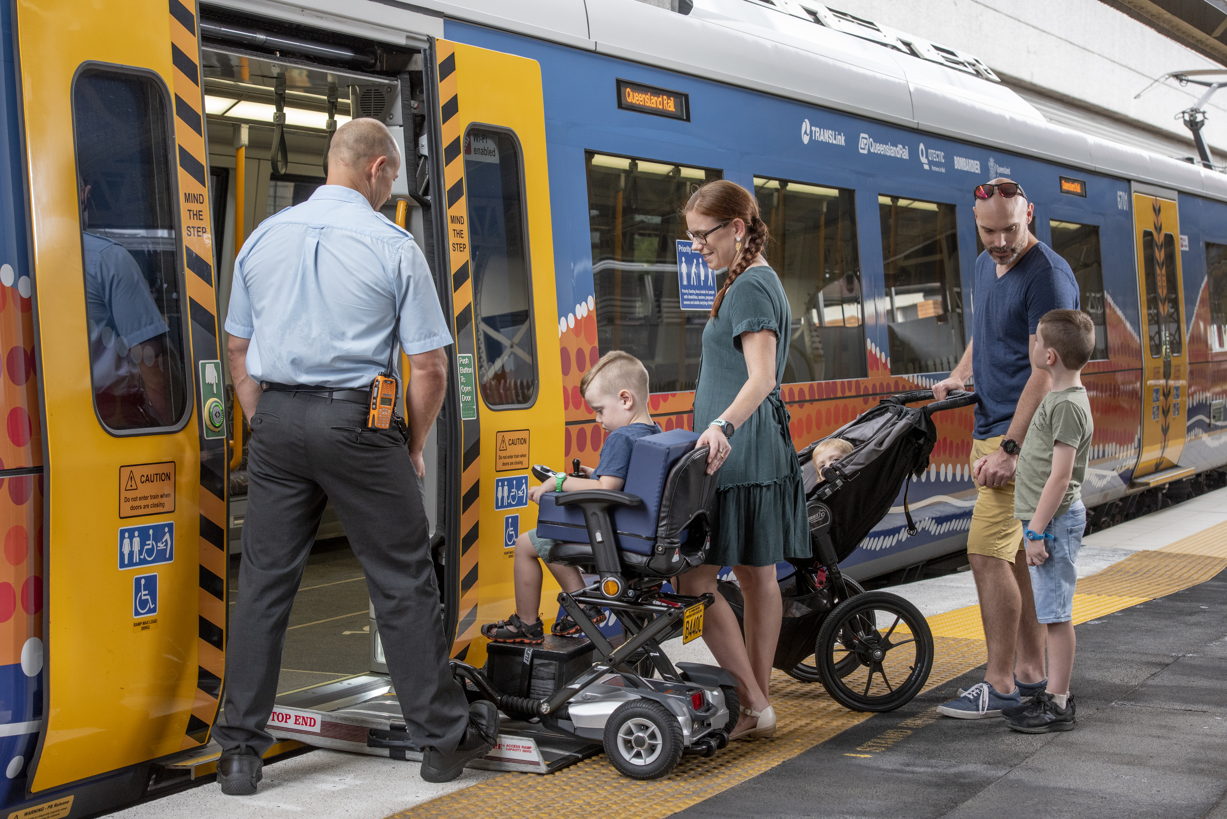


Acknowledgment of Country
The Department of Transport and Main Roads acknowledges the Traditional Owners and Custodians of this land and waterways. We also acknowledge their ancestors and Elders both past and present. The Department of Transport and Main Roads is committed to reconciliation amongst all Australians.

Creative Commons information
© State of Queensland (Department of Transport and Main Roads) 2020
http://creativecommons.org.licences/by/4.0/
This work is licensed under a Creative Commons Attribution 4.0 Licence. You are free to copy, communicate and adapt the work, as long as you attribute the authors.
The Queensland Government supports and encourages the dissemination and exchange of information. However, copyright protects this publication. The State of Queensland has no objection to this material being reproduced, made available online or electronically but only if its recognised as the owner of the copyright and this material remains unaltered.
The Queensland Government is committed to providing accessible services to Queenslanders of all cultural and linguistic backgrounds. If you have difficulty understanding this publication and need a translator, please call the Translating and Interpreting Service (TIS National) on 13 14 50 and ask them to telephone the Queensland Department of Transport and Main Roads on 13 74 68.
Disclaimer: While every care has been taken in preparing this publication, the State of Queensland accepts no responsibility for decisions or actions taken as a result of any data, information, statement or advice, expressed or implied, contained within. To the best of our knowledge, the content was correct at the time of publishing.
The Department of Transport and Main Roads wishes to acknowledge the valuable input and contribution from our local government partners to develop this plan.

TMR commits to lead the delivery of accessible and inclusive transport products, services, information and infrastructure, and TMR workplaces and work practices.

What are TMR aspirations and goals for the accessibility and inclusion strategy?
TMR will lead Queensland’s effort for dignified, accessible and inclusive transport products, services, information and infrastructure, in line with federal, state and local government objectives and broader human rights obligations.
Accessible and inclusive transport is critical to allow everyone to move easily and provide the opportunity to participate in our community and access employment, health, education, recreation and culture.
This strategy will guide us in building accessible and inclusive transport services, products, infrastructure, and workplaces.

Where will TMR focus our effort in accessibility and inclusion?
TMR will focus on both accessibility and inclusion by removing barriers and meeting the needs of:
- All customers of our transport products, services, information and infrastructure across Queensland
- TMR employees and
- delivery partners
We commit to lead in accessibility and inclusion by prioritising:
- Transport services , information , infrastructure and products in Queensland
- Accessible and inclusive TMR workplaces
- Co-design and collaboration with partners

How will TMR succeed in delivering our vision for accessibility and inclusion?
TMR will commit to co-designing and engaging with our customers, our people and partners by:
- Co-designing with our customers, our people and partners
- Making our customers and our people feel welcome and independent
- Listen responsively and continuously improve
- Making inclusion our culture

What capabilities are critical for success?
TMR will develop the capabilities required to become an accessibility and inclusion leader within the transport sector, setting the example for others through:
- Design (applying Universal Design principles)
- Business practices
- Customer information and tools
- Reporting and data on our progress on accessibility and inclusion
- Organisational culture of accessibility and inclusion
- Inclusive leadership

What is the roadmap to fulfil TMR’s vision?
- Initiate change
Prioritise the areas of greatest customer and employee need, and establish the foundation for change Identify opportunities to engage partners in co-design of our products and services
- Embed our guiding principles
Develop the cultural attitudes and capabilities needed to make TMR an inclusive workplace, and begin transformation of our products and services
- Grow our reach throughout Queensland
Establish TMR as an accessibility and inclusion leader within the transport sector, and continue transformation of our products and services

