Appendix B

Infrastructure Sustainability Management Plan (ISMP) – (Planning / Design / Construction)

Project Name @ Type here
[Additional info e.g. Date, Author etc]

June 2024

Document Guidance
- Sections of this document written in italic text and green font are examples of required information. These can be used as they are written and/or amended to suit your project. Once you have reviewed the text to be kept remove italics and replace green font colour with automatic black colour.
  - Note: Titles of documents in italics are to remain untouched.
- Other sections highlighted with form field boxes (Example) are to be reviewed and replaced.
This template can be used as a basis to develop an Infrastructure Sustainability Management Plan (ISMP) for an infrastructure project Planning, Design or Construction project phases.
The purpose of an ISMP is to:
- Be built incrementally and implemented over the project phases and integrated with other significant project development activities / contracts.
- Provide context and direction for sustainability assessments to achieve a certified rating under the Infrastructure Sustainability Council (ISC) Rating Tool IS v2.1.
- Inform the Department of Transport and Main Roads of specific sustainability initiatives to be embedded into a project.
- Become a resource for tenders.
Transport and Main Roads encourages ‘best efforts’ and recognises various achievements and outcomes that have the intent to meet an IS credit. Projects are incentivised to achieve optimum project outcomes through use of the IS rating tool.
Noting the existence of various IS rating requirements for senior management endorsement and approval of content in the ISMP, the project team may wish to add the below provision for the Transport and Main Roads Project Manager’s signature to their ISMP cover page, or within their Document Control / Quality Information pages. It is strongly recommended that additional dedicated / separate evidence is sought for each item requiring endorsement; however, this field may become useful as supporting evidence in the final submission.

Endorsed by the client:
Name: | @ Type here
Role: | Project Manager, Project Name, Transport and Main Roads
Date: | DD/MM/YYY

Contents
Document Guidance i
Endorsed by the client: i
1 Introduction 1
1.1 Purpose of the Infrastructure Sustainability Management Plan 1
1.2 Definitions of terms 1
1.3 Project description 2
1.4 Timeframes and key milestones 2
1.5 Document and data control 3
2 Infrastructure sustainability context 3
2.1 Infrastructure sustainability assessment 3
2.2 IS Rating Scheme 4
2.3 IS Rating process 5
3 Project IS rating strategy 5
3.1 Roles and responsibilities 5
3.2 Materiality assessment 7
3.3 IS Scorecard 8
3.4 Sustainability objectives and targets 9
3.5 Base Case Proposal 10
4 Sustainability implementation 10
4.1 Program 10
4.2 Monitoring and reporting 11
4.3 Risks and opportunities 13
4.4 Knowledge sharing 13
4.5 Decision-making processes 13
5 Interfaces with other documents 14
5.1 Energy use and efficiency 14
Appendix A – ISAP Certificates 15
Appendix B – Materiality Assessment 16
Appendix C – IS Scorecard 17
Appendix D – Workshop Minutes 18
Appendix E – Compliance Register Monitoring Spreadsheet 19
Appendix F – Sustainability Meetings Minutes 22
Appendix G – Risks and Opportunities Registers 23
Appendix H – Decision Making Records 24

Tables
Table 1.4 – Project Name Project Timing 2
Table 2.2(a) – IS v2.1 Themes and Categories 4
Table 2.2(b) – IS Rating Levels 5
Table 3.1 – Project Team Sustainability Responsibilities 6
Table 3.4 – Project sustainability objectives and targets (to be updated / completed) 10
Table 4.1 – Progress Milestones 11
Table E1: IS rating credit compliance progress and evidence 19
Table E2: Functional Specification Requirements 21

Figures
Figure 1.1 – ISMP (X) project application 1
Figure 1.3 – Project Name Location / Alignment 2
Figure 2.2 – Project Stages and IS Rating Types (source: ISC IS Technical Manual v2.1, 2021) 4
Figure 2.3 – Key stage in the IS Rating Process (source: ISC IS Technical Manual v2.1, 2021) 5
Figure 3.1 – Organisational Chart 6
Figure 3.2(a) – Assigned points against the default 8
Figure 3.2(b) – Credit points mapping against the UN SDGs 8
Figure 3.3 – Scorecard summary chart 9

Introduction

Purpose of the Infrastructure Sustainability Management Plan
Describe the purpose of the ISMP and what project it applies to.
Outline which stage the ISMP applies to in the project lifecycle, such as the Business Case phase, as per Figure 1.1.
The purpose of this Infrastructure Sustainability Management Plan (ISMP) is to facilitate the integration, management and implementation of sustainability measures during … The ISMP is an internal Transport and Main Roads tool to guide the project team to identify and apply sustainability deliverables, timeframes, roles and responsibilities.
Figure 1.1 – ISMP (X) project application
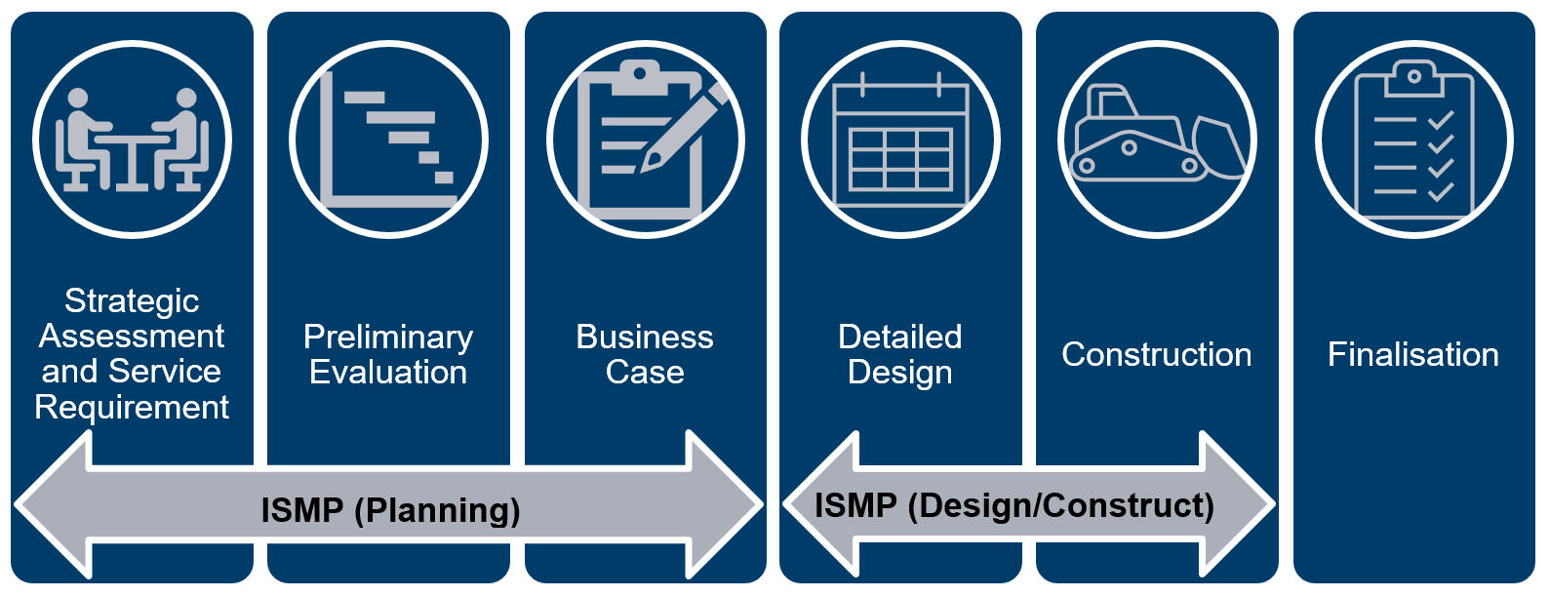

Definitions of terms
Term | Definition
The Client or the Principal | Transport and Main Roads
Project or XXXXX | XXXXX
BAU | Business as usual
BC | Business Case
BCDF | Business Case Development Framework
DD | Detailed Design
EPD | Environmental Product Disclosure
Functional Specification | C75XXS Functional Specification CN-XXXXX
ISAP | Infrastructure Sustainability Accredited Professional
ISMP(X) | Infrastructure Sustainability Management Plan (Planning / Design / Construction)
ITS | Intelligent Traffic Systems
ISC | Infrastructure Sustainability Council
IS v2.1 | Infrastructure Sustainability (IS) Rating Scheme Version 2.1 (v2.1) – requirements defined in the IS Technical Manual, v2.1
MCA | Multi-Criteria Analysis
NLTN | National Land Transport Network
PD | Preliminary Design
PE | Preliminary Evaluation
SASR | Strategic Assessment of Service Requirements
SMART Targets | Specific, Measurable, Achievable, Relevant, and Time-bound Targets
State | State of Queensland
SQP | Suitably Qualified Professional
SWTC | Scope of Works and Technical Criteria
UN SDGs | United Nations Sustainable Development Goals
WSUD | Water Sensitive Urban Design

Project description
Describe the project for which the ISMP applies. Describe aspects such as location(s),chainages, reasoning for undertaking works, benefits from completion and so on. Include a plan / map of the project.
Figure 1.3 – Project Name Location / Alignment
Insert figure

Timeframes and key milestones
Describe the various stages of the project. Outline previous, current and forthcoming project stages and/or milestones in the table below, accompanied by description and status. Note this is a high-level timeline covering the entire project lifecycle; a detailed program for the current phase with IS rating milestones is to be included in Section 4.1.
Table 1.4 – Project Name Project Timing
Project stage | Timing | Description | Status
Strategic Assessment of Service Requirement | 2018-2019 | Key issues and options to meet the service requirement have been analysed | Complete
Preliminary evaluation | 2020 | Preliminary evaluation completed and submitted | Complete
Detailed business case | 2021 | Commencement of the detailed business case | Underway
[...] | [...] | [...] | [...]
[...] | [...] | [...] | [...]

Document and data control
The ISMP is a live document that is amended and updated throughout the duration of the project to capture the status of the sustainability assessment at each phase. The document history and status of this ISMP is provided on page XXXX. XXXX is the primary system used for document management, sharing, storing and transmitting documents for the XXXX phase. Describe who is responsible for reviews and updates.

Infrastructure sustainability context

Infrastructure sustainability assessment
Describe the context to which infrastructure sustainability applies to the project.
The Queensland Government has directed that infrastructure projects over $100 million value (project total cost in P90 estimate) are required to undertake a Sustainability Assessment. The Department of Transport and Main Roads have elected to utilise the Infrastructure Sustainability Council's (ISC) Infrastructure Sustainability (IS) Rating Scheme.
Define sustainability and outline how sustainability (broadly speaking) may be implemented in the context of infrastructure projects in general, or this specific project.
Outline how the project will integrate with the Transport and Main Roads Environmental Sustainability Policy. Example below.
Transport and Main Roads adopted an Environmental Sustainability Policy which sets the direction and focus for the department in protecting and enhancing our environment. The core policy statement is:
Transport and Main Roads aims to be an industry leader and is committed to:
- managing our environmental interactions and incorporating sustainable and innovative solutions to minimise our environmental footprint, as an integral part of our business activities
- continuous improvement in environmentally sustainable practices and partnering with our stakeholders to ensure a resilient and adaptable transport system
- meeting the needs of the current generation while minimising environmental impacts on future generations, and
- contributing to the sustainability of the natural environment, while delivering a single integrated transport network accessible to everyone.

IS Rating Scheme
The IS Rating Scheme administered by ISC is a national, third party assurance framework that evaluates sustainability performance across the planning, design, construction and operation phases of infrastructure development.
Describe the phase the project is at (Preliminary Evaluation / Business Case / Detailed Design / Construction) with regard to Figure 2.2 and whether a rating is being pursued for that phase.
Figure 2.2 – Project Stages and IS Rating Types (source: ISC IS Technical Manual v2.1, 2021)
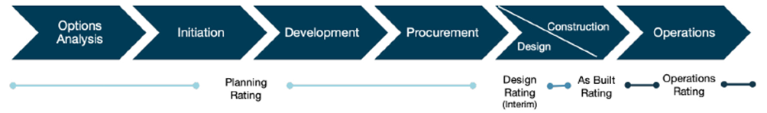
Using the IS v2.1 Rating Scheme, sustainability performance is evaluated against 16 categories that are grouped into four themes covering governance, economic, environmental, and social aspects of sustainability. The IS v2.1 themes and categories are listed in Table 2.2(a).
Table 2.2(a) – IS v2.1 Themes and Categories
Themes | Categories | Abbreviation
Governance | Place | Pla
 | Leadership and Management | Lea
 | Sustainable Procurement | Spr
 | Resilience | Res
 | Innovation | Inn
Economic | Options Assessment | Ecn
 | Benefits
Environment | Energy and Carbon | Ene
 | Environmental Impacts | Env
 | Resource Efficiency and Management | Rso
 | Water | Wat
 | Ecology | Eco
Social | Stakeholder Engagement | Sta
 | Legacy | Leg
 | Heritage | Her
 | Workforce Sustainability | Wfs
When undertaking the IS assessment, points are allocated according to the performance of the project against credits in each category. An overall score is awarded based on the sum of the ‘points achieved’ for each credit on a 110-point scale, with award levels shown in Table 2.2(b).
Table 2.2(b) – IS Rating Levels
Score | Rating level
< 20 | Not eligible for a certified rating
20-34.9 | Bronze
35-59.9 | Silver
60-79.9 | Gold
≥ 80 | Platinum

IS Rating process
The IS Rating Scheme facilitates the implementation of sustainability on the project through a structured process comprising the following four stages, summarised in Figure 2.3.
Figure 2.3 – Key stage in the IS Rating Process (source: ISC IS Technical Manual v2.1, 2021)
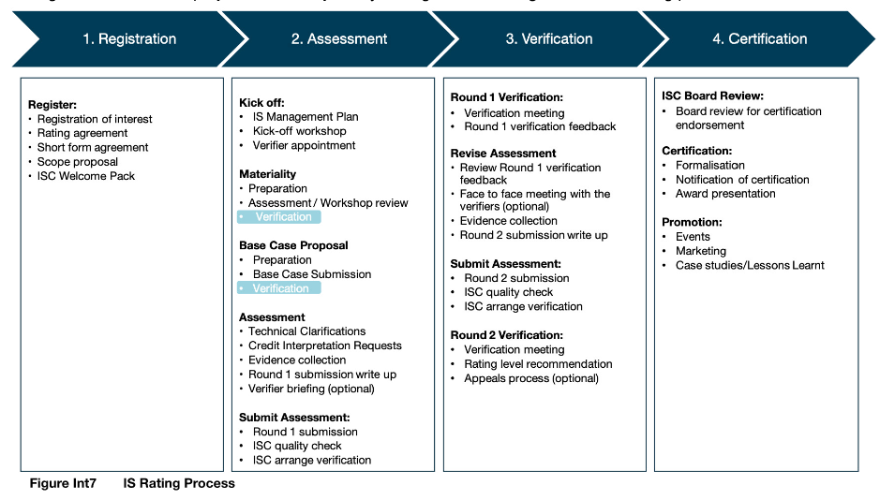

Project IS rating strategy

Roles and responsibilities
This section supports the credit Lea-1 Integrating Sustainability.
Provide an org chart in Figure 3.1 and outline the roles and responsibilities of project team members when it comes to how sustainability aspects are decided, designed, implemented, monitored, managed etc. in Table 3.1. Identify which personnel are working on the project and the organisation they belong to (e.g., Transport and Main Roads, Consultant organisation, Contractor organisation, JV/Alliance, etc.).
Include any ISAP certificates in Appendix A.
The project sustainability organisational chart is provided in Figure 3.1.
Figure 3.1 – Organisational Chart
Insert org chart
Table 3.1 – Project Team Sustainability Responsibilities
Role | Name | Responsibilities
Project Manager | [...] Note: generally this is the TMR Project Manager | The Project Manager is responsible for the overall commercial management of the project, and that monthly claims are managed in accordance with the General Conditions of Contract.  Sustainability specific responsibilities:  - Endorse and promote the project’s ISMP and sustainability objectives and targets.  - Ensure project teams are implementing sustainable design and construction practices in line with the ISMP.  - Ensure all managers and discipline leads understand and are responsible for ensuring their scope of works meet the projects sustainability obligations.  - Maintain governance structures, processes and systems, ensuring integration of all sustainability considerations, initiatives, monitoring and reporting.  - Ensure sufficient resources are made available to implement the ISMP and its obligations.
Sustainability Lead | [...] Note: generally this is a Consultant / Contractor representative | - Hold an Infrastructure Sustainability Accredited Professional (ISAP) accreditation for the duration of the project.  - Liaison with the Project Manager, Design Manager, Design Leads and Transport and Main Roads representatives.  - Oversight of the development/ implementation of the ISMP and achievement of an IS v2.1 Design and As Built Rating.  - Review and approval of sustainability deliverables.  - Attendance at sustainability meetings.
Environmental Lead | [...] Note: generally this is a Consultant / Contractor representative | Provide guidance and as required, review / input for the environmental aspects of sustainability to ensure the best for project environmental outcomes.
Design Manager | [...] Note: generally this is a Consultant / Contractor representative | - Endorse and promote the project’s ISMP and sustainability objectives and targets and their inclusion within the design.  - Ensure project teams are implementing sustainable design requirements in line with the ISMP.  - Ensure all discipline leads understand and are responsible for ensuring their scope of works meet the project’s sustainability obligations.  - Maintain governance structures, processes and systems, ensuring integration of all sustainability considerations, initiatives, monitoring and reporting.
Communications Lead | [...] Note: generally this is a TMR representative | Provide guidance and as required, review / input for the social and stakeholder engagement aspects of sustainability to ensure the best for project social outcomes.
Cultural Heritage Lead | [...] Note: generally this is a TMR representative | Provide guidance and as required, review / input for the cultural heritage aspects of sustainability to ensure the best for project cultural heritage outcomes.
Landscape Architect | [...] Note: generally this is a Consultant / Contractor representative | Provide guidance and as required, review / input for the urban and landscape design aspects of sustainability to ensure the best for project urban and landscape design outcomes.
Climate Change and Natural Hazards / Resilience Advisor(s) | [...] Note: generally this is a Consultant / Contractor representative | - Preparation of risk and impact assessments for climate change and natural hazards, and resilience.  - Development of treatment options in conjunction with design and construction teams.
ISC Project Manager | [...] Note: This is a representative from ISC and is generally identified by ISC during registration. | Facilitate the implementation of the IS Rating through the project development phases.
[...] | [...] | [...]

Materiality assessment
A Materiality Assessment was conducted for the XXXX project using the IS scorecard questionnaire, with multi-disciplinary input from project design leads and senior management at the Sustainability Workshop (DDMMYYY). Each category in the IS Rating Scheme was assigned a materiality based on its importance and potential impact to the overall sustainability performance of the project. Credits with materiality that fell to zero were ‘scoped out’.
The full Materiality Assessment is provided in Appendix B and summarised in two charts as follows:
- The Materiality Chart (Figure 3.2(a)) is a graphical summation of the assigned and default points across the IS rating categories.
- The results are also mapped against the United Nations Sustainable Development Goals (UN SDGs) (Figure 3.2(b)).
These were used to inform the development of sustainability objectives and SMART targets for the credit Lea-1 Integrating Sustainability (refer Section 3.4)
Replace the example Materiality and UN SDG charts below with the charts from the project’s ISC IS v2.1 Scorecard spreadsheet (a copy can be requested from sustainability@tmr.qld.gov.au if required).
Figure 3.2(a) – Assigned points against the default
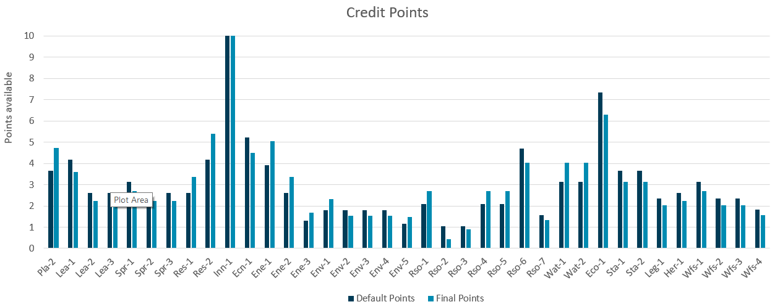
Figure 3.2(b) – Credit points mapping against the UN SDGs
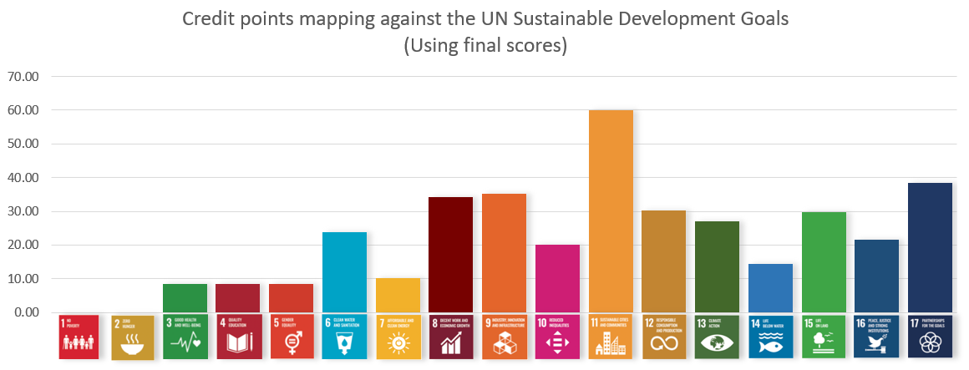
Summarise the Materiality Assessment and resulting charts. Discuss any categories scoped out, where and why did materiality change against defaults, what are the key areas for having high or very high materiality?
Confirm if the Materiality Assessment is still a draft to be formalised following verification (and when that is expected to occur) or if it has been verified (and when that occurred). For projects in Design or Construction phases (i.e., pursuing formal Design or As Built ratings), verification timelines should be discussed with respect to the timing requirements outlined in the IS Technical Manual v2.1 and associated IS Rulings.

IS Scorecard
The project’s IS Scorecard is presented in Appendix C and indicates the project’s targeted levels and associated risk for each credit in the IS Rating. Stretch targets have been identified where there are opportunities for increased sustainability performance. A graphical summary is provided in Figure 3.3.
Figure 3.3 – Scorecard summary chart
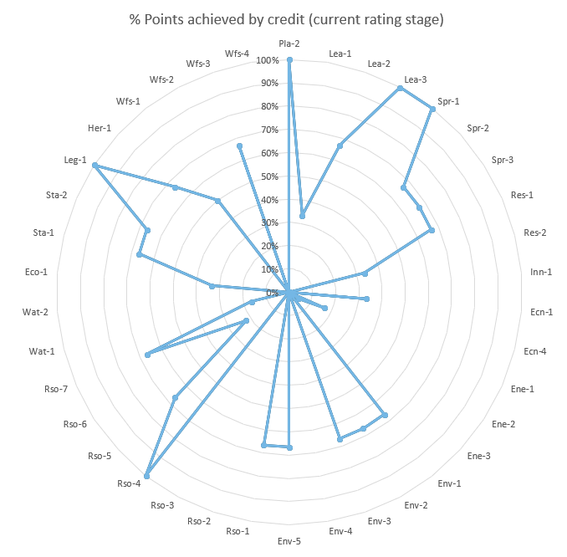
Provide a discussion on the scorecard. What overall score is being targeted? What rating award level does this correspond to? What are the main themes and categories being targeted or not targeted, and what was the process of determining these (e.g., workshops, meetings)? What are the categories and credits associated with greater risk of achievement, and why?
Replace example in Figure 3.3 with the spider chart from the project’s ISC IS v2.1 scorecard, or other appropriate graphical summary.

Sustainability objectives and targets
This section supports the credit Lea-1 Integrating Sustainability.
Complete Table 3.4 with the project’s sustainability objectives and targets. Refer to Transport and Main Roads Guidance Note: Project sustainability objectives and targets (available on the Consultants for Engineering Projects webpage) for guidance. As per the IS Technical Manual v2.1, each target must have a person or position listed as responsible for target performance.
Describe the process used to develop the objectives and targets, e.g., workshop (date, attendees, intent), reference to the Materiality Assessment and alignment with UN SDGs (as per Section 3.2). Columns may be added to Table 3.4 as needed to demonstrate alignment of each objective and target with the Materiality Assessment results and UN SDGs.
Confirm whether these have been formally endorsed by senior management, and the process / date this was completed. Include any relevant meeting minutes from the process in Appendix D.
Table 3.4 – Project sustainability objectives and targets (to be updated / completed)
Sustainability Objective | SMART Sustainability Target (with relevant metric) | UN SDG Alignment | Person / Role Responsible
[...] | [...] | [...] | [...]
[...] | [...] | [...] | [...]

Base Case Proposal
The IS Base Case approach refers to the development of business-as-usual footprints for energy and carbon (Ene-1), materials lifecycle impacts (Rso-6), and water use (Wat-1) over the lifecycle of the asset. These are compared to the Actual Case footprints defined in Design and Construction (As Built) project documentation.
Provide a brief overview of current status and approach for the Base Case Proposal:
Confirm if the Base Case Proposal is still a draft to be formalised following verification (and when that is expected to occur) or if it has been verified (and when that occurred). For projects in Design or Construction phases (i.e., pursuing formal Design or As Built ratings), verification timelines should be discussed with respect to the timing requirements outlined in the IS Technical Manual v2.1 and associated IS Rulings.
Confirm whether the project is applying the Traditional Calculated Base Case methodology, or the Reverse-Calculated Base Case methodology (Transport and Main Roads prefers/promotes the use of the Reverse-Calculated Base Case, also known as the “back-casting” method).
Refer to Transport and Main Roads Guidance Note: Infrastructure sustainability base case framework (available on the Consultants for Engineering Projects webpage) for guidance on the development of the Base Case and BAU assumptions for Transport and Main Roads projects.

Sustainability implementation

Program
Describe what progress milestones will be used to monitor, document and manage sustainability under the ISMP. Outline these in Table 4 or provide a Gantt chart.
For projects in Design or Construction phases (i.e., pursuing formal Design or As Built ratings), ensure that this program includes the start and end dates for the Establishment Period, and all activities required to be undertaken within that period.
Table 4.1 – Progress Milestones
Milestones | Indicative timing / frequency
Establishment Period Start | [...]
Establishment Period End | [...]
Sustainability kick off meeting | [...]
Preparation of initial ISMP | [...]
Weightings assessment | [...]
Verification of Base Case | [...]
Attend planning and sustainability meetings | Weekly
Attend risk and opportunities workshop | @ Type here
Climate change risk assessment workshop | [...]
[...] | [...]
[...] | [...]
[...] | [...]
Completion of credit summary forms | [...]

Monitoring and reporting
This section supports the credit Lea-1 Integrating Sustainability.
Monitoring and reporting of sustainability implementation will be governed through the following activities:
- Quarterly reporting to senior management on performance against the sustainability objectives and targets listed in Section 3.4, in accordance with Lea-1 Level 1.
- Independent sustainability performance reviews/audits in accordance with Lea-1 Level 3 [if targeted by the project].
Include a description of how the project is using the Compliance Register Monitoring Spreadsheet, as relevant to the project and phase. Note the minimum requirements vary slightly depending on project phase and should be defined in the project’s Functional Specification or SWTC (refer Functional Specification templates for each phase on the Consultants for Engineering Projects webpage). A template and additional guidance is provided in Appendix E.
- The Compliance Register Monitoring Spreadsheet (Appendix E) XXXX.
List relevant workshops and meetings below. Where meetings / workshops are recurring, the frequency should be defined. Where activities are used to directly support a credit, the credit should be listed. Examples are provided in italics.
- Monthly sustainability progress meetings (refer minutes in Appendix F).
- Project workshops and meetings, including:
  - Risk and Value Engineering Workshops (Lea-2, Ecn-1).
  - Climate Change and Natural Hazards Risk and Resilience Workshop(s) (Res-1 and Res-2).
  - Liaison with team leads (including attendance at project coordination meetings) and review of reports and plans to ensure that sustainability outcomes are incorporated, and reports can be used to support ISC evidence.
The integration of resulting workshop documentation and decisions relevant to sustainability has been captured in the relevant reports, assessment, management plans and other documents.
- Reviews and updates to this ISMP at key milestones (refer to Section 1.4) as the project progresses. The final update of the ISMP at completion of this phase ensures that sustainability initiatives, requirements and commitments are communicated to future project phases [and included in contract documents if applicable to the project phase].
- Add additional monitoring and reporting mechanisms as relevant.
In this section, projects may also discuss any IS-related details published on the project webpage to meet certain criteria under v2.1 (for example, objectives and targets, or information on the heritage assessment). The process for adding these details to the project webpage is outlined below:
Ensure a project webpage has been created
Confirm recommended sustainability objectives are appropriate for project
Develop a track changes Word Document mock-up of project sustainability commitments
Yes
Update sustainability objectives for the project
No
Proceed through project page update web management procedures
Include reference to IMD exemptions

Risks and opportunities
This section supports the credit Lea-2 Risks and Opportunities.
Describe how risks and opportunities are identified and assessed (including consequence and likelihood criteria), such as via project workshops and registers. Outline frequencies and dates of project workshops if applicable (refer example text below). Include minutes from the initial opportunities/initiatives workshop in Appendix D.
Include a reference to the project’s risks and opportunities register(s) in Appendix G, and/or include a cross-reference to an existing project Transport and Main Roads Risk Register document if this has already been developed to incorporate Lea-2 credit requirements. For a copy of the Transport and Main Roads Risk Register please email sustainability@tmr.qld.gov.au. Projects may use this register to capture both risks and opportunities or use it only for risks while capturing opportunities in a separate register.
A Sustainability Workshop was held on DDMMYYY with project design leads and project senior management to extend infrastructure sustainability to the team and initiate incorporation of sustainability measures in this phase.

Knowledge sharing
This section supports the credit Lea-3 Knowledge Sharing.
Describe knowledge sharing processes for the project, including frequency, forums, topics, attendees as relevant. An example is provided below.
Sustainability knowledge sharing will be a key agenda item at project weekly and monthly meetings or as otherwise agreed during the respective project phase. Discipline Leads and project staff will participate in these meetings as required.
The Sustainability Lead will participate in Transport and Main Roads knowledge sharing sessions that are undertaken with the wider industry and key Transport and Main Roads project stakeholders. A knowledge sharing workshop, alternating with a Major Projects Infrastructure Sustainability Working Group meeting, is held by Transport and Main Roads every six months.
Sustainability knowledge will be shared beyond project boundaries to key stakeholders during all project phases.

Decision-making processes
This section supports the credit Ecn-1 Options Assessment and Significant Decisions.
Transport and Main Roads has developed a Guide to incorporating sustainability into project decision making and a Sustainability Decision-Making Tool (available on the Consultants for Engineering Projects webpage) to assist decision-making for significant issues on the project. The tool can be utilised when considering significant decisions to achieve sustainability outcomes.
Projects are also required to hold a decision-making governance workshop at the start of each phase to establish procedures for decision-making.
Describe the timing, attendees and outcomes of the decision-making governance workshop. Describe the methodologies for identifying and assessing significant decisions, such as holding Options Shortlisting or MCA workshops and using the Sustainability Decision-Making Tool. Be clear if the process is risk driven, and where authority sits for approvals. Include the significant decisions register, and minutes from the decision-making governance workshop, in Appendix H.

Interfaces with other documents
This section should list the reports and sub-plans relevant to the project in its current phase. Some examples that may be developed at different project phases are listed below. For each document, discuss the purpose of the document, how it is relevant to the ISMP / sustainability assessment, and any recommendations for future phases.
Note this list is not exhaustive and may vary depending on factors such as project phase, delivery model, IS rating pathway etc:
- Risk Management Plan
- Decision making records
- Plans / modelling reports for separate resource impacts (e.g., energy, water, materials, waste)
- Climate and natural hazards assessment
- Resilience assessment
- Deconstruction plan
- Miscellaneous construction sub-plans
- Procurement plan
- Urban and landscape design plan
- Ecological impact assessment
Refer example in italics below.

Energy use and efficiency
Opportunities to increase energy efficiency and mitigate GHG emissions during construction and operation are identified as part of the IS initiatives identification process. An Energy Use and Efficiency Plan has been developed to capture outcomes and recommendations relating to energy modelling and initiatives (refer document number / reference).

Appendix A – ISAP Certificates

Appendix B – Materiality Assessment

Appendix C – IS Scorecard

Appendix D – Workshop Minutes
Minutes from sustainability initiatives / objectives and targets workshop(s) as applicable

Appendix E – Compliance Register Monitoring Spreadsheet
Tables E1 and E2 below are templates to capture minimum requirements for the Compliance Register Monitoring Spreadsheet as outlined in the project Functional Specification / SWTC (refer Functional Specification templates for each phase on the Consultants for Engineering Projects webpage). Example rows are completed in italics. Note these are not required to be prepared or presented in Microsoft Word, and columns can be added as needed to assist with other preferred tracking and reporting functions. The emphasis is on enabling the project the flexibility to use this sheet to suit their needs, while fulfilling minimum reporting requirements.
Table E1: IS rating credit compliance progress and evidence
For Preliminary Evaluation and Business Case phases, this table serves as an index to the sustainability assessment package of deliverables, facilitating handover to future phases by enabling information relevant to certain credits to be easily located for review and update. Only information documented to date should be recorded for these phases – i.e., there is no need to identify future evidence.
For Design and Construction phases, this table serves as a milestone progress reporting mechanism, and should be used to record both confirmed and potential evidence for the IS rating submission that is identified as the project progresses. This can then be used to support the development of Credit Summary Forms in the IS rating submission once compilation of the rating commences.
Note: as each DL/ABX.X criterion includes multiple “must” statements as sub-criteria, the project may wish to record these as separate detailed rows or track them at a high level only under the overarching DL/AB X.X criterion statement. This is at the discretion of the project and the appropriateness of such level of detail will vary depending on the current project phase. However, it is strongly recommended that “must” statements are tracked individually if the project is within a formal rating phase (i.e., Design or Construction) to ensure they are not overlooked when preparing the IS rating submission.
To assist with developing Table E1, projects may use the DL/ABX.X and “must” statement (labelled “MSX.X”) criteria available in Word format from the ISC template v2.1 Credit Summary Forms (copies can be requested from sustainability@tmr.qld.gov.au if required).

Credit | Level | Criterion | Requirement / “must” statement | Target  [Achievability level as per scorecard] | Evidence  [Detail in this column may vary depending on project phase] | Comments  [Use as required – e.g., actions, outstanding items, recommendations for next phase]
Lea-1 | Level 1 | DL1.1 | Sustainability objectives, targets, responsibilities and a reporting framework have been developed (or reviewed and updated) | High | ISMP Sections X and Y
Lea-1 | Level 1 | MS1.1a | The following must be finalised within the Establishment Period, and their implementation underway during the phase of the project being rated: ISMP, reporting frameworks, and reviews / audits / monitoring | High | IS Rating Agreement  Contract Award letter  Project program  ISMP Rev 1  DD/MM/YY endorsement email from TMR PM  Quarterly report – QX 20XX  Sustainability progress meeting minutes #1 | Pending email from PM
Lea-2 | Level 2 | DL2.1 | Treatment options for extreme, very high or high indirect risks have been identified and implemented | Medium | TMR Risk Register  Risk Management Plan | Economic risk to be added
Env-1 | Level 2 | DL2.2 | Modelling of water discharges and receiving water has demonstrated no adverse impact in receiving water environmental values | Low | Drainage report – Sections X, Y | Achievement TBC pending modelling for confirmed project footprint
Env-4 | Level 2 | DL2.2 | Modelling demonstrates no recurring or major exceedances of the air quality goals | Not targeted |  | Removed from pathway – recurring exceedances identified
Leg-1 | Level 1 | DL1.1 | Initiatives have been implemented to contribute positively to society or the environment for one priority issue or opportunity | Medium |  | Priority issue not yet identified
Table E2: Functional Specification Requirements
This table is not required past Business Case phase. It serves as an index to the sustainability assessment package of deliverables, facilitating handover to future phases by enabling relevant information to be easily located for review and consideration in subsequent phases.

Clause # | Clause heading | Evidence of compliance | Comments
3.1 | Infrastructure Sustainability Management Plan (Planning) | ISMP(P) revisions issued DD/MM/YYY, DD/MM/YYYY
3.1.2.2.2 | Sustainability objectives and targets | Endorsement obtained DD/MM/YYYY, objectives and targets as per ISMP Section X
3.1.2.2.11 | Environmental considerations from stakeholder engagement | N/A for this project. No engagement on environmental issues was undertaken during Business Case | Potential engagement topics in relation to environmental issues are included in the CEP for next phase
3.1.5 | Monthly progress meetings | Meeting records attached to ISMP(P) Appendix F | Key outstanding actions for next phase include X, refer meeting minutes from DDMMYYYY
3.2 | Inputs to project cost estimate | Refer Business Case cost estimate under headings / items XXXXX | Key costs for review in Design phase include $X for additional land resumptions to provide sufficient water quality design treatments at location X
3.3 | Business Case Sustainability Assessment Chapter | Refer reports XX and YY | Undertaken in accordance with Infrastructure Australia Assessment Framework

Appendix F – Sustainability Meetings Minutes

Appendix G – Risks and Opportunities Registers
Include as applicable to the project, refer guidance in Section 4.3.

Appendix H – Decision Making Records

