Appendix C

Guidance note – Project sustainability objectives and targets

June 2024

Contents
1 Purpose 1
2 Background 1
3 Strategic context 1
4 Sustainability targets 1
5 Guidance for publishing objectives and targets on the project webpage 2
6 Contact team 3

Purpose
This ‘Guidance note’ provides direction and consistency for setting sustainability objectives or targets to meet requirements of the Infrastructure Sustainability Council (ISC) Rating Tool, v2.1 Lea-1 credit. It is also designed to inform project managers and support decision makers in establishing and publishing sustainability objectives or targets.

Background
The Department of Transport and Main Roads is committed to providing environmental, economic, social and cultural benefits to Queensland communities, as part of planning, designing, constructing and operating transport infrastructure. The department places great importance on the sustainability assessment process for all projects that trigger the threshold, ensuring this is part of any major transport project delivered in Queensland. For projects below the threshold sustainability practices are also applied, although not formally certified.
Embedding sustainability dimensions into the planning, design, construction and operation of projects will bring Transport and Main Roads closer to delivering on key government commitments, such as achieving zero net emissions by 2050.

Strategic context
The incorporation of sustainability objectives into project objectives is aligned with state and departmental imperatives, as represented in Figure 3 below.
Figure 3 – Relationship of sustainability projects to whole-of-government strategies and plans
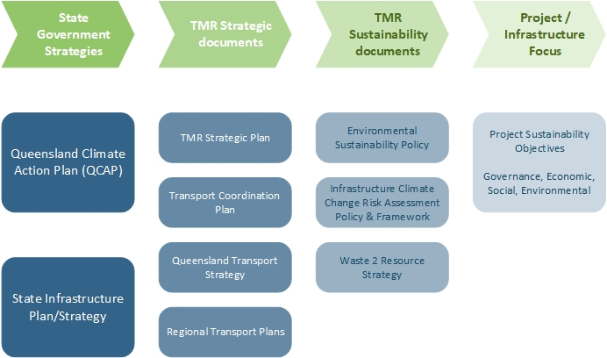

Sustainability targets
The establishment of sustainability objectives, supported by targets, can optimise decision-making by setting a clear focus and direction. Measurable targets also enable consistent reporting on achievements.
To support the implementation of Specific, Measurable, Achievable, Relevant, and Time-bound (SMART) sustainability objectives, preliminary targets and metrics, examples have been captured in Table 4. If the project is seeking an IS rating, the targets must be informed by the project’s Materiality Assessment and relevant United Nations Sustainable Development Goals (UN SDGs) as per the charts in the ISC IS v2.1 Scorecard and in accordance with requirements of Lea-1 DL1.1. This includes ensuring targets cover all IS credit categories identified as very high or high (materiality of 3-4) in the Materiality Assessment. Alignment of objectives and targets with the Materiality Assessment and/or UN SDGs can be demonstrated with additional columns as needed, as indicated by the Table 4 example.
The below are examples only and should only be directly adopted by projects where they are aligned with the project’s Materiality Assessment, UN SDGs, and project-specific priorities / scope of work.
Table 4 – Sustainability objectives and targets
Sustainability Objective | SMART Sustainability Target(s) | UN SDG Alignment
Embed sustainability into the planning, design, construction and operation of the project | Achieve a certified IS rating and demonstrate sustainability leadership through Level 1 under Lea-1, Lea-2 and Lea-3. | 12, 13, 14, 15, 16, 17
Reduce material lifecycle impacts of infrastructure | 15% minimum reduction in material lifecycle impacts as measured by Rso-6 | 11, 12
Reduce whole of life greenhouse gas emissions | 5% minimum reduction in whole of life greenhouse gas emissions as measured by Ene-1 | 7, 11
Develop active transport and accessibility improvements for the community | Community influence active transport and accessibility outcomes as priority stakeholder issues, demonstrated via Sta-2 | 11, 16, 17
Protect and enhance the environment | Achieve Level 2 benchmark for Env-1  Achieve Level 1 benchmark for Eco-1 | 6, 11  14, 15
Implement circular economy principles | Develop and implement a Resource Efficiency Strategy and Action Plan in accordance with Rso-1  Achieve Level 1 benchmark for Rso-4 | 11, 12
Building in resilience and adaptation to potential climate change | Achieve Level 2 benchmark for Res-1 | 9, 11, 13

Guidance for publishing objectives and targets on the project webpage
Projects may wish to publish their project objectives and/or targets on the Transport and Main Roads project webpage. This can be used to support achievement of Lea-1 DL2.2 (noting that Transport and Main Roads are not asking projects to target above Level 1, and there are additional requirements that must be fulfilled to achieve Level 2).
The process for adding IS related details to the project webpage is outlined in below and in Figure 5.
- Ensure a project webpage has been established.
- Confirm or update the recommended sustainability objectives and/or targets.
- Develop an IS related statement of the sustainability objectives and/or targets (as per format in Table 4) under the Project News heading on the webpage.
Figure 5 – Process for adding IS-related details to project webpage
Ensure a project webpage has been created
Confirm recommended sustainability objectives are appropriate for project
Develop a track changes Word Document mock-up of project sustainability commitments
Yes
Update sustainability objectives for the project
No
Proceed through project page update web management procedures
Include reference to IMD exemptions

Contact team
If you need any further assistance in relation to this material, please contact the Program Management and Delivery Unit, Sustainability Team by email: sustainability@tmr.qld.gov.au.

