Appendix E

Guidance Note – Incorporating Sustainability into Project Decision-Making

June 2024

Contents
1 Purpose of this document 1
2 Defining significant initiatives, decisions and issues 1
2.1 Establishing significance parameters and thresholds 1
2.2 Guidance for Planning phase projects 1
2.3 Decision Making Tool application 2
3 Defining and applying MCA criteria for significant initiatives, decisions and issues 2
3.1 MCA criteria requirements 2
3.2 Decision Making Tool application 3

Purpose of this document
The purpose of this document is to facilitate the implementation of sustainability in decision making, specifically in relation to issues or decisions identified as significant for the Project. The process comprises of identifying significant initiatives / issues / decisions and undertaking a scored multi-criteria analysis (MCA) in alignment with the Infrastructure Sustainability (IS) v2.1 credit Ecn-1 Decision Making. An associated spreadsheet / sustainable Decision-Making Tool has been developed comprising of a Decisions Flow Chart and an MCA tool. This guidance should be read in conjunction with utilisation of the tool.
Projects are required to hold a multidisciplinary decision-making governance workshop at the beginning of each phase to establish a decision-making framework that complies with the requirements of the IS v2.1 Ecn-1 credit. Details for the decision-making governance workshop will be outlined in the project’s Functional Specification or SWTC (standard templates are available at the Consultants for Engineering Projects webpage). Further information on the development and application of a decision-making framework is provided in this document.

Defining significant initiatives, decisions and issues

Establishing significance parameters and thresholds
The project must define what constitutes a “significant” initiative, decision or issue in accordance with the requirements under Ecn-1 DL/AB1.1, including establishing parameters and thresholds for at least the following:
- Capital or whole of life value (minimum dollar value).
Note all project initiatives with a capital value greater than $2 million must be identified as significant. Projects may choose to set a significance threshold lower than $2 million.
- Environmental and societal impacts (defined risk or impact level).
- Importance to affected stakeholders (defined risk or impact level).
Example significance parameters and thresholds are included in the IS Technical Manual, v2.1.
All decisions defined as “significant” in accordance with the project’s significance parameters are to be assessed using MCA (refer to Section 3).
Project Managers need to be aware of the potential for overlap or double counting if other MCAs are being completed to determine the preferred option.

Guidance for Planning phase projects
Noting that the IS Technical Manual v2.1requires a maximum cost threshold of $2 million, which may trigger a large number of “significant” decisions for projects going Planning phase (i.e., when major value engineering / optioneering exercises on large-scale design decisions may be undertaken), projects that are in a Planning phase may establish an alternative cost threshold at an order of magnitude more appropriate for the project. For example, this may be 5% of the total project contract value. The threshold shall be determined and agreed with relevant project stakeholders as part of the decision-making governance workshop.
It is emphasised that this guidance only applies to Planning phase projects. Projects in a formal rating phase (i.e., in Transport and Main Roads Design or Construction phase, and pursuing an IS Design and/or As Built rating) must use the $2 million threshold requirement set by the IS Technical Manual v2.1.

Decision Making Tool application
Once significance parameters and thresholds have been determined, update these in the Decision Making Flow Chart in the Decision Making Tool (refer to Figure 2.3 for an example). Ensure all initiatives to be assessed for significance are recorded in the project's Decision Register and identify whether an MCA is to be undertaken.
Figure 2.3 – Sustainable Decision-Making Flow Chart
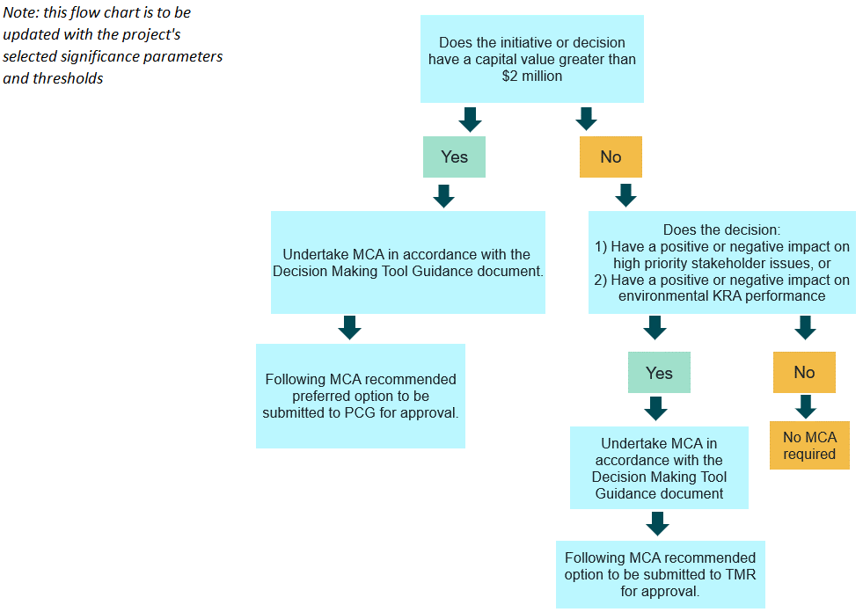

Defining and applying MCA criteria for significant initiatives, decisions and issues

MCA criteria requirements
In order to comply with Ecn-1, the MCA criteria must include at least one criterion for each of the following:
- outward impacts from the project to the environment
- outward impacts from the project to society (i.e., local community stakeholders)
- outward impacts from the project to the economy (i.e., local businesses and supply chain – not to be confused with project/asset financial impacts), and
- monetised whole-of-life cost impact (i.e., project / asset financial impacts).

Decision Making Tool application
Where an initiative, decision or issue has been defined as “significant” and thus requires an MCA, define the options to be assessed using the Decision Making Tool (example provided in Figure 2.3).
The MCA tool includes six aspects including customisable sub criteria and the relevant weightings have been determined as outlined in the following Table 3.2(a).
Table 3.2(a) – MCA tool aspects and weightings
Aspect | Weighting
Environmental | 15%
Social | 15%
Economic | 15%
Financial | 20%
Constructability | 20%
Functionality | 15%
The intention is that the aspect weightings remain the same, however project teams may customise the sub criteria and adjust the criteria weightings as required (ensuring the total weighting for each aspect totals 100%). Should the project team require the aspect weightings to change due to inapplicability or other factors, the revised weightings are to be agreed by the Project Senior Management team, ensuring that the weightings of environmental, social and economic criteria total at least 20%.
Project teams rate the decisions based on a score from 1 to 5 based on the criteria in Table 3.2(b) below.
Table 3.2(b) – Decision criteria ratings
Rating | Decision criteria
1 | Unacceptable, requires mitigation activity
2 | Below average benefits
3 | Average benefits
4 | Above average benefits
5 | Significant benefits
Project teams review the results and determine the preferred option. It is important that the MCA process is undertaken in alignment with the steps described, and that the process and outcomes are recorded for review and approval by Transport and Main Roads. Outcomes and documentation must be provided to the Sustainability Representative.

