Job Number @ Type here

Functional Specification Template

C7523 / C7524 – Design – Public Utility Plant (PUP) Addendum

Replaces Section 2.10 Public Utility Plant (PUP) (Item No. PD 11)' of the 'C7523 – Preliminary Design Functional Specification Template.' and Section '2.6 Public Utility Plant (PUP) (Item No. DD 07)' of 'C7524 – Detailed Design Functional Specification Template'

October 2023
- To be used as a guide when compiling project-specific specifications.
- @ = project-specific detail required.
- For clauses / items not required – insert text “Not Required” in clause heading, do not delete clause.
- Delete this table when document finalised.

Contents
1 Public Utility Plant – Detailed Design 1
1.1 Definition of terms 1
1.2 Referenced documents 1
1.3 Quality system requirements 2
1.3.1 Hold Points, Witness Points and Milestones 2
1.4 Existing documentation 5
1.5 Design deliverables 5
1.6 General requirements for Public Utility Plant (PUP) 5
1.7 Process and tasks 6
1.7.1 Transport and Main Roads workflow and checklist 6
1.7.2 Decision-making 9
1.7.3 Existing assets 9
1.7.4 Local requirements 9
1.7.5 Site validation plan 10
1.7.6 Permits and approvals 10
2 Early Design 10
2.1 Existing PUP 10
2.1.1 PUP Authority contacts list 11
2.1.2 Design standards and specifications 11
2.1.3 PUP Vibration Assessment and exclusion zones 11
2.1.4 PUP Authority communications 12
2.1.5 PUP Drawings and Conflict Matrix 12
2.1.6 Land Requirements outside of project boundary 13
2.2 Future Public Utility Plant / Betterment 13
2.3 Plans and estimate non-contestable works 13
2.4 Negotiations with authorities- contestable works 14
2.4.1 The Consultant must be clear when communicating with asset owners that the department is progressing the Detailed Design stage. After review of the proposed treatments and negotiations finalised, an 'in principle' agreement from the utility confirming the relocation design is required in order to progress the design. Please note, this is not required if the project doesn't affect the utility's assets, or even if the proposed design requires some protection works to protect the utility's assets from vibration as long as the assets are not otherwise disturbed. Check with the Transport and Main Roads Project Manager if uncertain. Letter to authorities 15
2.5 Project specific requirements 16
2.6 PUP report – Preliminary design 16
2.6.1 PUP Design models – BIM 16
3 Detailed design 16
3.1 Design considerations 16
3.2 Negotiations with authorities 17
3.2.1 Letter to authorities 17
3.3 Plans 17
3.3.1 Roadworks contract documents 17
3.3.2 Specifications 18
3.4 Estimate 18
3.5 Report for Contract Administration 18
3.6 Payment 18
Attachment 1 – Design Checklist 20
Attachment 2 – Suitability of Early Works for PUP Checklist 25
Attachment 3 – Design Workflow 27
Attachment 4 – Notification of Initial Design and Commitment to Betterment Approach 31
Attachment 5 – PUP Notification of Roadworks / Network Conflicts Letter Templates 34

Public Utility Plant – Detailed Design
[Delete this text - This document has been drafted to provide as much detail as possible. The requirements and checklists should be customised to fit the scope and type of project work that is required.]

Definition of terms
The terms used in this Functional Specification shall be as defined in Clause 1.1 of C523 Preliminary Design.
The Consultant / Contractor is advised that while there are a number of definitions used in the department, for the purposes of this Functional Specification, Public Utility Plant (PUP) is deemed to cover only non-transport public utility infrastructure, specifically municipal water and sewerage, fixed and radio telecommunications (but not mobile towers), distribution and transmission gas and electricity (including third party owned streetlighting) under State and Federal legislation.
All other third party networks / utilities, commercial or otherwise, and irrespective of their similarities to PUP, that are located in the project Works area including; railways, tramways, aqueduct, conduit, water channel, pipeline (water, bulk water, stormwater pipelines owned by local government, etc.), fixed mechanical conveyor, tower pole, cable (electrical, fibre optic, copper or otherwise), electrical installations or any other utility plant that may be affected by the project is not included in this Functional Specification. Refer to C7523 Preliminary Design / C7524 Detailed Design for guidance on management of these third party assets.

Referenced documents
Referenced documents in this Functional Specification are listed in Table 1.2.
Table 1.2 – Referenced documents
Reference | Title
BS 5228-2:2009 | Code of Practice for Noise and Vibration Control on Construction and Open Sites, Part 2: Vibration
DIN 4150-3:1999 | Vibration in Buildings – Part 3: Effects on Structures
IPWEA Queensland RS-100 | Public Utilities Typical Service Corridors and Alignments Standard Drawing
IPWEA Queensland RS-101 | Public Utilities Typical Service Conduit Sections Standard Drawing
IPWEA Queensland RS-102 | Service Conduit Crossing Standard Drawing
IPWEA Queensland RS-103 | Public Utilities Optic Fibre Pit Standard Drawing
MRTS56 | Construction Surveying
MRTS140 | Horizontal Directional Drilling
MRTS141 | Microtunneling and Pipe Jacking
MRTS142 | Thrust Boring and Auger Boring
MRTS170 | Public Utilities in Road Projects Site Works
MRTS171 | Public Utilities in Road Projects Principal Contractor Responsibilities
TMR Safe Systems Approach | Transport and Main Roads Road Safety Policy
TN163 | TN163 Third Party Utility Infrastructure Installation in State Controlled Roads Technical Guidelines
- | Design Criteria for Bridges and Other Structures: Volume 1
- | Drafting and Design Presentation Standards Manual
- | Road Drainage Manual
- | Road Planning and Design Manual
- | TMR Surveying Standards, Part 1 and Part 2
Where standards differ, the Transport and Main Roads' standards and other technical publications take precedence.

Quality system requirements

Hold Points, Witness Points and Milestones
General requirements for Hold Points, Witness Points and Milestones are detailed in Clause 8.3 of MRTS50 Specific Quality System Requirements. They are defined in the following ways:
- Hold Point means an identified point in a process beyond which the Contractor shall not proceed without written authorisation from the Administrator authorising release of the Hold Point.
- Witness Point means an identified point in a process where the Contractor is required to give the Administrator prior notice with the option to observe an activity.
- Milestone means a point in time within a project which marks the start or completion of an activity.
The Hold Points, Witness Points and Milestones applicable to this Functional Specification are summarised in Table 1.3.1.
Hold Points, Witness Points and Milestones are to be customised to suit the size and scope of the project and in line with the Workflow and Checklist.
Table 1.3.1 – Hold Points, Witness Points and Milestones
Project Manager: delete / add relevant Hold Points, Witness Points and Milestones as applicable.

Clause | Hold Point | Witness Point | Milestone
1.7.1.4 | @ Type here  Confirm and/or obtain agreement from the utilities and Project Manager on any design review process, for assets where the department or its Contractor will undertake relocation / protection designs
1.7.1.5 & 1.7.5 | @ Type here  Reviewed Site validation / pothole plans and engaged subcontractors to undertake survey and potholing Works in accordance with AS 5488 (if it was not already undertaken in the Business Case as Early Works)
1.7.1.9 |  |  | @ Type here  Developed preliminary alignments of proposed PUP relocations and confirmed if standard alignments are achievable
1.7.1.10 & 2.1(b) | @ Type here  Assessed and confirmed the line and level of existing PUP to the extent necessary to enable potential conflicts (including any height clearances to wires) to be identified and discussed in detail with the responsible authorities
1.7.1.11 & 2.1.3 | Submit Design Predicted Construction Vibration Assessment Report to TMR for review prior to submission to the relevant service authority for discussion |  | @ Type here  Provided updated PUP drawings with concept alignments to PUP authorities for review and agreement
1.7.1.13 |  |  | @ Type here  Confirmed and obtained formal engagement offers and any initial upfront payments
1.7.1.14 | @ Type here  Reviewed the terms of engagement, timeframe, costs, deliverables and so on and signed off by Transport and Main Roads
1.7.1.17 |  |  | @ Type here  Met with PUP authorities and agreed on all protection and relocation Works
1.7.1.18 |  |  | @ Type here  Assessed and confirmed any impacts to the environments, cultural heritage, future maintenance and access for utilities etc
1.7.1.19 |  |  | @ Type here  Developed the PUP BIM model for existing and proposed PUP for applicable projects
1.7.1.20 |  |  | @ Type here  Assessed and confirmed all new PUP for constructability and risk
1.7.1.21 |  |  | @ Type here  Assessed and confirmed PUP construction staging safety in design and temporary Works, if applicable
1.7.1.23 |  |  | @ Type here  Requested and received updated PUP estimates and bill of quantities
1.7.1.24 |  |  | @ Type here  Assessed PUP for Early Works, where practical
1.7.1.25 & 1.5.1(a)(i) | @ Type here  Drafted a PUP report documenting all the decisions, agreements and findings on PUP. (Preliminary Design Package)
1.7.1.28  2.1(c) | @ Type here  Assessed and confirmed if any additional survey and potholing Works are required, especially at tie-in locations to existing PUP assets
1.7.1.39 | @ Type here  Finalised the certified (RPEQ) and endorsed PUP relocation design drawings and obtained confirmation through the Project Manager or that all alignments are accepted by the utilities and department
1.7.1.46 | @ Type here  Finalised contractual arrangements with PUP authorities including utilities' payment of PUP upgrades / betterment and identification of the essential service management strategy
1.7.1.48 |  |  | @ Type here  Finalised Early Works package and early procurement, if applicable
1.7.1.49 & 1.5(a)ii |  |  | @ Type here  Finalised the Detailed Design PUP Report. (Detailed Design Package)
3.2.1 | Received letter of endorsement for the IFC drawings for contestable works

Existing documentation
Project Manager: insert details about existing information available to the Consultant if / where applicable.

Design deliverables
- The Consultant shall complete the Detailed Design deliverables in two stages being the:
  - Initial (Preliminary) Design Hold Point, and
  - the final Detailed Design package.
The requirements and deliverables for each phase is included within the relevant section of this Functional Specification below. Deliverables for Design and Construct projects shall be in accordance with the contract for the project.

General requirements for Public Utility Plant (PUP)
There are multiple types of projects that require different approaches to PUP. Customising the PUP Functional Specifications to suit the style of project is critical to ensure that all legislative, technical and project requirements are met. For instance, where the Options Analysis and Business Case are rolled together, all Hold Points, Witness Points, Milestones and Checklist items should be reviewed and new lists relevant to the combined stage should be drafted.
Alterations to existing PUP must comply (where possible) to department document TN163 Third Party Utility Infrastructure Installation in State Controlled Roads Technical Guidelines. Any deviation from these requirements must be documented.
The Consultant shall ensure that administrative data and Site investigations of existing utility assets conform to specified quality level documented in TMR Surveying Standards.

Process and tasks

Transport and Main Roads workflow and checklist
The Consultant is required to utilise the Transport and Main Roads checklist and workflow as the framework to assist with considering PUP in the Detailed Design stage. The Consultant is required to adapt these documents to fit the circumstances of the individual project and provide a short rationale to justify any adaptation. Changes to the checklist must be approved by the Transport and Main Roads Project Manager or delegate. A copy of the workflow and checklist templates are included as Attachments 1, 2 and 3 of this Functional Specification. A list of the minimum outputs and required tasks is provided below:

Consulted with the Department's ITS&E and Corridor Management teams for their input to the Preliminary Design stage

Coordinated meetings with PUP authorities to share Early Design information, scope, requirements, timeframe, standards (particularly in relation to vibration exposure), review previous upgrade and/or betterment agreements (see Clause 2.2 for definition)

Requested PUP condition survey or asset validation, if this was not completed in the Business Case stage (or is more than 12 months old). [Note, it is the obligation of the designer to validate and ensure that data on asset condition and location is accurate.]

Confirm and obtain agreement from the utilities and Project Manager on any design review process, for assets where the department or its Contractor will undertake relocation designs Hold Point

Reviewed Site validation / pothole plans and engaged subcontractors to undertake survey and potholing Works in accordance with TMR Surveying Standards (if it was not already undertaken in the Business Case as Early Works) Hold Point

Undertook survey validation reviews of the data provided

Cross-referenced the survey data into the PUP model and updated the utility services to reflect the change in quality level and the indicative information (QL-D) is removed / trimmed.

Confirmed all PUP features / layers in the model have been turned on

Developed preliminary alignments of proposed PUP relocations and confirmed if standard alignments (see IPWEA Queensland RS-100, RS-101, RS-102, RS-103 for general arrangements) to TMR satisfaction are achievable Milestone

Assessed and confirmed the line and level of existing PUP to the extent necessary to enable potential conflicts (including any height clearances to wires) to be identified and discussed in detail with the responsible authorities Hold Point

Provided updated PUP drawings with alignments to PUP authorities for review and agreement Milestone

Engaged PUP authorities or design consultants (where the PUP authorities do not want to undertake the design) to undertake preliminary and Detailed Design of PUP relocations

Confirmed and obtained formal engagement offers and any initial upfront payments. Ensure these have sufficient detail about the scope of Works, payment and variation so that there is confidence in what is being delivered by the PUP authorities. If there are not agreed contract templates, the contracts should have legal review Milestone

Reviewed the terms of engagement, timeframe, costs, deliverables etc. and signed off by Transport and Main Roads Hold Point

Once the preliminary PUP relocation designs are developed, they must be cross referenced with all the designs into the PUP model and a 'space proofing' review (to ensure the design fits in all networks) undertaken.

Checked all new PUP designs were not in conflict with existing or new structures

Met with PUP authorities and agreed on all protection and relocation Works (this can be in person or via video conference) Milestone

Assessed and confirmed any impacts to the environments, cultural heritage, future maintenance and access for utilities and so on Milestone

Developed the PUP BIM model for existing and proposed PUP, inclusive of mains, conduits, pits, manholes and so on Milestone

Assessed and confirmed all new and existing PUP for constructability and risk Milestone

Assess and confirmed PUP construction staging and temporary Works, if applicable Milestone

Discussed and agreed with PUP authorities if Transport and Main Roads can undertake any civil Works on behalf of the PUP authority

Requested and received updated PUP estimates and bill of quantities Milestone

Assessed PUP for Early Works and planned for Early Works where practical Milestone

Drafted a PUP report documenting all the draft design plans, decisions, agreements and findings on PUP Hold Point

Consulted with the Department's ITS&E and Corridor Management teams for their input to the Detailed Design stage

Coordinated meetings with PUP authorities to share Detailed Design information, scope, requirements, timeframe etc

Assessed and confirmed if any additional survey and potholing Works are required, especially at tie-in locations to existing PUP assets Hold Point

Assessed and confirmed proposed PUP designs complies with the TN163 Third Party Utility Infrastructure Installation in State Controlled Roads Technical Guidelines

Assessed and confirmed proposed PUP HDD designs complies with the following Transport and Main Roads technical specifications:
- MRTS140 Horizontal Directional Drilling
- MRTS141 Microtunneling and Pipe Jacking
- MRTS142 Thrust Boring and Auger Boring.

Cross referenced all final PUP designs into the PUP model and undertook a final ‘space proofing’ review

Assessed and confirmed proposed PUP designs meets future maintenance and safe access to utilities

Assessed and confirmed minimum clearance to aboveground powerlines / cables are achieved with the new finished surface levels including exclusion zones for maintenance staff

Assessed and confirmed if any power pole relocations can be relocated outside of the area of interest, subject to Site specific risk assessment (e.g. clear zone). If not, are safety barriers warranted?

Assessed and confirmed clearances to cut batter slopes, subgrade excavation level, invert of table drains etc

Assessed and confirmed clearances to existing and new structures, as well as new guardrail, fence line etc

Assessed and confirmed if any property connections are impacted and if so, specified the mitigation measures

Assessed and confirmed which existing PUP assets are required to be grout filled and capped and/or removed

Finalised the certified (RPEQ) and endorsed PUP relocation design drawings and obtained confirmation through the Project Manager or that all alignments are accepted by the utilities and department Hold Point

Finalised the PUP BIM model, if applicable

Finalised constructability and risk reviews for electrical PUP assets

Finalised constructability and risk reviews for water / sewer PUP assets

Finalised constructability and risk reviews for telecommunication PUP assets

Finalised constructability and risk reviews for gas PUP assets

Finalised PUP estimate in 3PCM and bill of quantities

Finalised contractual arrangements with PUP authorities including utilities' payment of PUP upgrades / betterment, and identification of their management strategy regarding disruption of essential services (such as medical, emergency services, police, defence forces) Hold Point

Finalised PUP Supplementary Specifications

Finalised Early Works package and early procurement, if applicable Milestone

Finalised the Detailed Design PUP Report Milestone

Decision-making
When considering the action to take to manage network conflicts, technical, cost, constructability, efficiency, safety, land availability and a range of other factors will impact on the decision to design out conflicts, protect in place or relocate utility assets. The rationale for the approach must be documented for each utility network to demonstrate sufficient research, information gathering and evidence has informed the approach. Some of this work may have already been undertaken in the Business Case stage.
The Consultant is required to utilise the Transport and Main Roads Road Safety Policy and Safe Systems Approach in conjunction with Transport and Main Roads technical documentation (Transport and Main Roads standards, guidelines and specifications and Australian Standards when there is not a Transport and Main Roads document) to form the foundation of decision-making. Where practicable and economical, relocation or alterations to PUP shall be avoided. However, where the design increases the risks associated with aboveground utility assets, relocation will be required to maintain or increase road safety.

Existing assets
Information to identify existing utility assets may need to be sourced from various agencies including DBYD, local government and water authorities, previous designs, As Constructed data, the department’s GIS and District / Region Corridor Management team. The Consultant shall be responsible for liaising with all relevant agencies.
The Consultant shall liaise with the responsible public utility authorities with regard to any alterations to their existing plant, programmed Works and any provisions for future plant that are required as a result of the proposed roadworks.

Local requirements
Project Manager: include reference to local requirements including the planning section of the district that has a GIS database of written undertakings from service providers. This includes offers to relocate services at no expense to the department. The Consultant shall contact relevant district officers and determine if any written undertakings have been made that may affect the project.
The Consultant shall ensure that all Authorities that control the following services will be consulted:
- @ Type here Electricity
- @ Type here Sewage
- @ Type here Gas
- @ Type here Water
- @ Type here Telecommunications carriers
- @ Type here Local Government
- @ Type here Streetlighting, and
- @ Type here Department’s ITS&E

Site validation plan
If a Site Validation Plan was undertaken in the Business Case stage and is less than twelve months old, a review and validation that the data is still current should be undertaken by the Consultant with the utilities and DBYD.
Otherwise, the Consultant shall prepare a Site Validation Plan with matrix identifying where potholing and/or cable location Works should be undertaken. The Site Validation Plan shall be submitted to the Project Manager for approval. Hold Point
Upon the release of the Site Validation Plan Hold Point, the Consultant shall engage a service locator to undertake the Site validation Works. Unless otherwise agreed the consultant shall be responsible for the Principal Contractor duties when engaging the services of a subcontractor.
The Consultant shall liaise with the Project Manager to arrange for surveyors to record the survey data of validation Works. Survey data shall be recorded as per the MRTS56 Construction Surveying requirements so that the Project Manager can upload it into the relevant Transport and Main Roads project, GIS and Building Information Management (BIM) systems.

Permits and approvals
The Consultant is responsible for obtaining all relevant permits and approvals from nearby service authorities, the department (Transport and Main Roads), and other government departments when undertaking Site validation Works, i.e. gas spotter requirement when potholing gas main.
Confirm all relocations are contained within the identified project boundary of the Approved Recommended Option, unless otherwise agreed with third party.

Early Design

Existing PUP
- The Consultant is required to ensure that the Transport and Main Roads Project Manager is kept informed of any conflict that may be critical to the future design or is a major relocation cost. Where practicable and cost effective, conflicts with PUP should be avoided.
- The Consultant shall ensure that the line and level of existing PUP shall be established to the extent necessary to enable potential conflicts (including any height clearances to wires) to be identified and discussed in detail with the responsible authorities. Hold Point
- If requested, the Consultant shall prepare a potholing schedule for approval of the Project Manager before relocation design work commences. Hold Point
- The Consultant shall ensure that traffic control operations shall comply with any local requirements.
Project Manager: include local requirements.
- The Consultant shall also meet the requirements of related local requirements set out in @ Type here:
Project Manager: include reference to local documents for example Environmental Management Preconstruction Strategy.

PUP Authority contacts list
The Consultant shall create review and update the list of PUP authority contacts developed during the Business Case.

Design standards and specifications
The Consultant is required to:
- Confirm and obtain agreement on design standard requirements, protection treatments relocation extents and design review costs identified in the Business Case pertaining to PUP relocation and protection Works.
- Confirm and obtain agreement from the utility and Project Manager on any design review process, for assets where the department or its Contractor will undertake relocation designs Hold Point
- Confirm and obtain resourcing capabilities of PUP authorities to undertake Works and identify indicative timeframes for PUP Works.
- Establish agreement on any cost sharing arrangement or future provision requirements as further detailed in Clause 2.2, and
- Detail PUP authority involvement including how input has been taken into account.

PUP Vibration Assessment and exclusion zones
The Consultant shall undertake a Design Predicted Construction Vibration Assessment specific to the type of utility asset. The Consultant shall meet the requirements specified in applicable industry standards, asset owner's requirements, British Standard BS 5228-2:2009 and or German Standard DIN 4150-3:1999 as nominated by the Consultants' vibration specialist. The design predicted construction vibration assessment from preliminary design shall be updated as required during the detailed design.
The assessment shall be conducted and/or supervised by a Registered Professional Engineer of Queensland (RPEQ) with relevant experience in vibration assessment for infrastructure projects. The report shall be submitted to the Department by the signing RPEQ and not the report author unless they are the signing RPEQ, prior to submission to the relevant service authority for discussion. Hold Point
The Consultant's RPEQ (conducting the vibration assessment) shall consult with the design team to obtain expected details of construction. The Consultant will assess a range of different equipment sizes and methods (e.g. different piling methods, multiple roller sizes, multiple hammer sizes, milling / profiling machinery, combined plant for insitu subgrade treatments etc.) to determine if there are any restrictions/limitations to equipment selection in order to maintain safe working distances and /or allowable vibration limits. Whilst vibration issues should be resolved in Preliminary Design, where a vibration issue arises, it is expected that the Consultant's RPEQ (conducting the vibration assessment) shall develop a solution to vibration issues in consultation with the PUP design team and revise the vibration assessment to resolve any issues (e.g. plant for triple blend mix of the subgrade cannot be reduced in size therefore adjustment to the PUP treatment strategy (protect/relocate and so on) is required.
It is the responsibility of the Consultant to provide the assessing RPEQ (conducting the vibration assessment) with contact details and relevant information of the asset owner's vibration criteria and other requirements. Where further information is required, where the asset owner may not have a criterion, the asset owners preferred process (if utilising BS 5228-2:2009 or GIN 4150-3:1999 is not accepted without conditions) shall be requested by the Consultant's RPEQ (conducting the vibration assessment) in writing and all correspondence to and from the asset owner shall be appended to the PUP and Design Predicted Construction Vibration Assessment report.
The Consultant shall provide the assessing RPEQ (conducting the vibration assessment) information on the type, location, condition, etc. of assets. Where this information is not provided, the Consultant's RPEQ (conducting the vibration assessment) is to source this information from the asset owners. The information obtained by the Consultant's RPEQ (conducting the vibration assessment) shall be clearly documented in the assessment report.
The Consultant's RPEQ (conducting the vibration assessment) in the preparation of the Design Predicted Construction Vibration Assessment Report, shall summarise vibration issues, equipment restrictions, etc and provide project specific vibration mitigation. Vibration mitigation shall be provided to ensure that safe working distances and/or vibration limits are maintained.

PUP Authority communications
The Consultant shall liaise with the various authorities to establish, to the extent necessary, the potential conflicts with the proposed roadworks of any existing plant.
The Consultant shall liaise with the various authorities to develop the most appropriate and cost-effective avoidance, relocation or protection treatment acceptable to the authority and the Principal, including proposed alignments for relocated services, exclusion zones and vibration limits.
The Consultant shall produce drawings and a conflict register identifying all PUP conflicts and proposed treatment options as further detailed in Clause 2.1.6.

PUP Drawings and Conflict Matrix
The Consultant shall:
- Review the PUP drawings and all in principle agreements established during Business Case.
- Review potholing information obtained in Business Case.
- Review conflict matrix, and drawings created in the Business Case, and
- Update PUP drawings and conflict matrix identifying assets to a Quality Level B standard as specified in TMR Surveying Standards and Attachment 3 – Design Workflow.

Land Requirements outside of project boundary
Where relocation Works involve construction on private property, the Consultant shall advise the responsible authorities that it is their responsibility to obtain any necessary permits from the property owner (for example, clearing work, excavation, and so on).
Notwithstanding the above, PUP relocation shall:
- conform with the following local requirements
- @ Type here
Project Manager: include reference to local documents for example Underground Services

Future Public Utility Plant / Betterment
Betterment is when the utility wants to upgrade or better their network while Transport and Main Road's project is affecting the PUP. This can include larger assets, an increased number of assets, more complex assets and so on to be installed. The Consultant shall arrange a betterment agreement to be reviewed by legal services and signed / executed by the appropriate utility delegate so that it is legally binding. Provision for future PUP will be at the responsible authorities' cost. Any betterment must be paid by the utility in full, and include materials, labour, and provision for potential delay costs due to the utility betterment if the Works cause issues. A letter template to use with utilities to document expectations is available in Attachment 4.
The Consultant shall inform the authorities that the department will not allow trenching across the new road after construction as per the TN163 Third Party Utility Infrastructure Installation in State Controlled Roads Technical Guidelines.
Further, the agreement must make the utility responsible for costs associated with withdrawal from betterment Works after the project has allowed for it in schedule and design.

Plans and estimate non-contestable works
The Consultant shall prepare drawings showing the proposed relocation and or protection Works required. In liaison with the various authorities a preliminary estimate of cost shall also be prepared for both the civil and specialist Works of each of the services.
The Consultant is required to be clear when communicating with asset owners that the department is in the initial / draft (preliminary) or Detailed Design stage – depending on the project timeline. The accuracy of estimates will need to increase for planning purposes and the detail required should be specified to the utility and detailed quotations will be required for detailed designs. In some circumstances, utilities may be entitled to charge for the time taken to form a detailed quote. The Consultant shall note that until a final design has been completed, utilities may be unable to provide an accurate detailed quote. If detailed quotes are required, the Consultant shall ensure clear advice regarding the level of detail needed and for which design is provided to the asset owner.
When requesting costs for relocation or protection of existing PUP, the Consultant shall provide the utility provider all the required data necessary to make an informed decision and shall include relevant specifications to meet the road construction requirements. These may include but is not limited to:
- Relevant Design documentation and electronic files
- Space proofed service corridor for the utility provider's designer
- Conflicts with or positions of other services the utility provider's designer may need to design out
- Australian, state and local government forms and specifications (underground services)
- lateral clearance (for poles)
- environmental requirements
- clearing requirements
- traffic control requirements, and
- backfill requirements.
The Consultant shall establish a potential timeline for the treatment required to manage conflicts with utility assets, including contingency for likely, high impact risks. The Consultant is required to enquire of any scheduling or procurement constraints on the proposed solution for each asset owner (for example, lead time for procuring a designer, sourcing materials, service moratoriums over holiday periods).
The Consultant shall ensure that:
- The relocation and protection Works shall be scheduled as Principal’s Materials in the estimate for the road construction contract.
- Separate itemised estimates shall be provided for the PUP relocation Works Contracts, and
- Provision for future PUP shall be at the cost of the responsible authority.
The utility may want to bring forward network upgrades of assets to minimise costs (see Clause 2.2).

Negotiations with authorities- contestable works
To finalise and specify PUP relocation / protection Works, the Consultant shall liaise closely with the various responsible authorities to determine a cost-effective treatment acceptable to both the authority and the Principal, on such issues as:
- allowance for possible future PUP
- relocation / protection Works to be carried out by the authorities including specialised Works and any civil Works that the authority may wish to carry out
- relocation / protection Works to be included in the relevant construction Contract (for example, TIC-CO) and confirmation of the standard that any such relocations / protection must adhere to
- easement / alignment requirements
- management of the environment, and
- timing of both the specialised and civil Works, with regard to the overall construction Contract, including necessary lead time for the purchase and supply of equipment.
The Consultant should note that while the majority of this work may close to completion, confirming timelines, constraints and hold points for the utility Works, including contingency for likely, high impact risks, is important to avoid considerable time and delay costs during construction.
The Consultant shall check all scheduling or procurement constraints on the proposed Works for each asset owner (for example, lead time for procuring a designer, sourcing materials, service moratoriums over holiday periods).
The Consultant shall prepare all necessary plans and so on, for discussion with the relevant authorities.

The Consultant must be clear when communicating with asset owners that the department is progressing the Detailed Design stage. After review of the proposed treatments and negotiations finalised, an 'in principle' agreement from the utility confirming the relocation design is required in order to progress the design. Please note, this is not required if the project doesn't affect the utility's assets, or even if the proposed design requires some protection works to protect the utility's assets from vibration as long as the assets are not otherwise disturbed. Check with the Transport and Main Roads Project Manager if uncertain. Letter to authorities
If not already completed, the consultant shall send a letter formally informing each PUP owner that the project may have a conflict with their assets. Letter Templates have been made available in Appendix 5 for use in these circumstances.
After completion of the preliminary design, the Consultant shall prepare a formal draft letter from the Principal to the authority which shall be accompanied by:
- plans detailing all relocation / protection work to be carried out by the authority, and
- specifications for civil Works to be carried out by the authority where such civil Works need to meet a standard to allow for the construction of the road (for example: backfill requirements, enveloping pipe structural requirements, environmental requirements including weed control).
The letter shall fully detail the department’s timing and co-ordination requirements and request the authority to prepare and submit suitable plans, specifications, and so on for their specialist and all other agreed civil Works.
The letter shall request an itemised formal offer for the proposed Works. Where the authority does not wish to carry out the relocation / protection work itself, the consultant shall call quotes from approved suppliers and recommended industry specialists for the work. Quotes must show the Queensland Department of Transport and Main Roads as the client (not the Consultant) and shall be forwarded to the relevant departmental district office. It should be noted that for most non-contestable relocations/protections have at least some of the work carried out by the utility.
There may be agreed standard contracts, letters of offer, recoverable Works agreements and processes between Transport and Main Roads and the specific utility. Check with Transport and Main Roads so they can be used when undertaking the formal offer.

Project specific requirements
The Consultant is advised of the following project specific requirements which must be considered:
- Electricity and Streetlight relocations
@ Type here Project Manager to add any project specific requirements – undergrounding of overhead cables, clearances, agreements to relocate facilities, and so on.
- Water and Sewerage main relocations
@ Type here Project Manager to add any project specific requirements - clearances to maintenance / control equipment, and so on.
- Low-impact and non-low impact (e.g. mobile towers) Telecommunications
@ Type here Project Manager to add any project specific requirements – clearances to new pits, agreements to relocate facilities, and so on.
- Distribution and Transmission Gas pipelines, and
@ Type here Project Manager to add any project specific requirements – clearances to maintenance / control equipment, and so on.

PUP report – Preliminary design
The Consultant is required to include a report on PUP within the Project Planning Report (PUP Preliminary Design Package).

PUP Design models – BIM
Where the main contract does not require a BIM model, the Consultant shall prepare a 3D model (12D or IFC) of all utilities and underground services for the purpose of clash detection and coordination. The model shall include all existing and proposed utilities and underground services including electrical and ITS, power poles, light poles and traffic poles (as applicable), SW drainage network, culverts, surface levels and subgrade levels. All other items specified in the parent Function Specification C7523 and C7524 shall apply.
Spaced proofed service corridors with vertical / horizontal asset alignments are to be delivered to the utility provider as part of non-contestable works. Due to long lead times in design and procurement of communications, electrical and gas utilities, this information will allow utility providers to begin preliminary assessments to develop a cost estimate / quotes for the subsequent design phases.

Detailed design

Design considerations
It is expected that the Consultant will have scoped and accommodated the majority of design considerations for PUP in the PUP Preliminary Design Package Hold Point. Refinement of design should attempt to minimise changes unless absolutely necessary to minimise re-work of the total project design.

Negotiations with authorities
To finalise and specify PUP relocation / protection Works, the Consultant shall liaise closely with the various responsible authorities to determine any final amendments or additions to the design and documentation. Note, this may require several submissions and revisions to achieve a mutually beneficial outcome for approval.
By this stage the Utility providers should have been engaged to conduct, and be near completion of, the non-contestable works design in order to incorporate the utility design into the overall Project designs for space proofing and service conflict checks.
Upon review and no further amendments, detailed quote for construction works should be received from the utility providers.
The Consultant shall check all scheduling or procurement constraints on the proposed Works for each asset owner (for example, lead time for procuring a designer, sourcing materials, service moratoriums over holiday periods).

Letter to authorities
After agreement on the above issues has been reached, the Consultant shall prepare a formal draft letter from the Principal to the authority which shall be accompanied by:
- plans detailing all relocation / protection work to be carried out by the contractor, specialist contractor and/or the authority, and
- specifications for civil Works to be carried out by the authority where such civil Works need to meet a standard to allow for the construction of the road (for example: backfill requirements, enveloping pipe structural requirements, environmental requirements including weed control).
The letter shall fully detail the department’s timing and co-ordination requirements and request the authority to prepare and submit suitable plans, specifications, and so on for their specialist and all other agreed civil Works.
The letter shall request an itemised formal offer for the proposed Works. Where the authority does not carry out the relocation / protection work itself, the consultant shall call quotes from approved suppliers and recommended industry specialists for the work. Quotes must show the Queensland Department of Transport and Main Roads as the client (not the Consultant) and shall be forwarded to the relevant departmental district office.
There may be agreed standard contracts, letters of offer, recoverable Works agreements and processes between Transport and Main Roads and the specific utility. Check with Transport and Main Roads so they can be used when undertaking the formal offer.
After design drawings and documentation is finalised, a IFC design endorsement or no objection letter / correspondence is required from the utility providers in order to progress to construction. Hold Point

Plans

Roadworks contract documents
The Consultant shall prepare separate plans for the Construction Contract documents that clearly identifies:
- all existing PUP to remain including grout filling and/or protection treatment
- all existing PUP to be decommissioned and/or removed
- all proposed relocated PUP (use large pen size), and
- the constructability report and Safety in Design (SiD) report.
These plans can be a composite of the various Authority Plans but shall include complete details of civil Works to be carried out by the Contractor including; potholing; clearing, trenching, backfilling, protection Works, installation of conduits, manholes, pits and so on in accordance with the Transport and Main Roads Drafting and Design Presentation Standards Manual.
These plans shall clearly identify the Works to be carried out by others (under the control of the relevant service authorities).

Specifications
The Consultant shall compile specifications for all civil works included in the construction Contract.
This may include annexure of supplementary specifications detailing the service authorities permit and approval processes during construction, point of contact during construction, preferred sub-contractors list to conduct asset relocation works and any policy or process required by the construction principal contractor to facilitate approval of relocation works, and contracts for works that utilities request are used between the utility and Transport and Main Roads during relocation / protection works.
The Consultant shall compile specifications for civil Works to be carried out by the authority where such civil Works need to be of a particular standard to allow for the construction of the road infrastructure (including backfill requirements, manhole requirements, enveloping pipe structural requirements and so on.).

Estimate
The Consultant shall include the cost of Works to be carried out by the relevant authorities as Principal's Materials and Work.

Report for Contract Administration
The Consultant shall prepare a report on the status of PUP treatment or relocation Works to assist the Contract Administrator. This report shall include indicative timeframes provided from the service authority for the proposed relocation / protection Works, confirmation of alignment acceptance from the service authority and road authority, details of an easement requirements and timeframes for easement approval, a copy of the relevant service authority plans, a copy of the relevant service authority specifications (if any), an estimate for the proposed Works plus the Principal's letter(s) to the relevant authority(s).

Payment
All costs associated with the preparation of the preliminary plans, documents and reports shall be provided for under Fixed Fee Item PD 11.
All costs associated with the preparation of detailed design plans, specifications, contract documentation and reports shall be provided for under Fixed Fee Item DD 07. This includes all work necessary to arrange for the relevant Utility Authority to prepare non-contestable works quotes for the protection or relocation of services.
The Consultant shall not be required to pay for the cost of the preparation of the plans and specifications by the relevant authority. The Consultant shall arrange for these costs to be invoiced directly to the Principal.
All costs associated with the preparation of the Public Utility Plan (PUP) clash detection and coordination model shall be allowed for in Item No. PD25 / DD27 Building Information Modelling (BIM). Where main contract does not require a project wide BIM model, then this item shall be itemised specifically as PD25 / DD27 Building Information Modelling (BIM)-PUP only.

Attachment 1 – Design Checklist
Program Delivery and Operations | Issued Date: xx/xx/20
Design Stage Checklist  Completed by:  Project Name:  Project / Contract No: | Version: 1.0  Date: xx/xx/20

Note: This checklist has been developed to provide general guidance for PUP management on Road Infrastructure Projects. It can be used by departmental staff and Consultants to check that key aspects of utility management are covered in this stage. For any proposed changes or amendments to the checklist, please send all correspondence to tmr.techdocs@tmr.qld.gov.au.

Item | Tasks / Description | Date Completed | Comments
1.0
1.7.1.1 | Consulted with the Department's ITS&E and Corridor Management teams for their input to the Preliminary Design stage.
1.7.1.2 | Coordinated meetings with PUP authorities to share Early Design information, scope, requirements, timeframe, standards (particularly in relation to vibration exposure), review previous upgrade and/or betterment agreements.  If there is no agreement in place stipulate a cut-off date to finalise an agreement for any upgrades. This date must be before item 3.3. in the checklist.
1.7.1.3 | Requested PUP condition survey or asset validation, if this was not completed in the Business Case stage (or is more than 12 months old).
1.7.1.4 | Confirm and obtain agreement from the utilities and Project Administrator on any design review process, for assets where the department or its Contractor will undertake relocation designs. Hold Point
1.7.1.5 | Reviewed Site validation / pothole plans and engaged subcontractors to undertake survey and potholing Works in accordance with TMR Surveying Standards (if it was not already undertaken in the Business Case as Early Works).  Data from any potholing must be carefully checked and validated and additional potholing may be required to fill any information gaps.
1.7.1.6 | Undertook survey validation reviews of the data provided.
1.7.1.7 | Cross-referenced the survey data into the PUP model and updated the utility services to reflect the change in quality level and the indicative information  (QL-D) is removed / trimmed.
1.7.1.8 | 1.7.1.8 Confirmed all PUP features / layers in the model have been turned on.  E.g. Stay wire, pits, valves, hydrants, manholes etc.
1.7.1.9 | Developed concept ‘fat pen’ alignments of proposed PUP relocations and confirmed if standard alignments are achievable.
1.7.1.10 | Assessed and confirmed the line and level of existing PUP to the extent necessary to enable potential conflicts (including any height clearances to wires) to be identified and discussed in detail with the responsible authorities. Hold Point
1.7.1.11 | Provided updated PUP drawings with concept alignments to PUP authorities for review and agreement.  The updated drawings should include the conflicts register at the back, stating which PUP assets are not impacted, for protection and for relocation.
1.7.1.12 | Engaged PUP authorities or design consultants to undertake preliminary and detailed design of PUP relocations.
1.7.1.13 | Confirmed and obtained formal engagement offers and any initial upfront payments.
1.7.1.14 | Reviewed the terms of engagement, timeframe, costs, deliverables etc and signed off by Transport and Main Roads. Hold Point
1.7.1.15 | Once the preliminary PUP relocation designs are developed, they must be cross referenced with all the designs into the PUP model and undertook a 'space proofing' review (to ensure the design fits in all networks) undertaken.
1.7.1.16 | Checked all new PUP designs were not in conflict with existing or new structures.
1.7.1.17 | 1.7.1.17 Met with PUP authorities and agreed on all protection and relocation Works.
1.7.1.18 | Assessed and confirmed any impacts to the environments, cultural heritage, future maintenance and access for utilities etc.
1.7.1.19 | Developed the PUP BIM model for existing and proposed PUP, inclusive of mains, conduits, pits, manholes etc.  Only applicable to certain projects. Will be specified as a deliverable.
1.7.1.20 | Assessed and confirmed all new PUP for constructability and risk.
1.7.1.21 | Assessed and confirmed PUP construction staging and temporary Works, if applicable.
1.7.1.22 | Discussed and agreed with PUP authorities if Transport and Main Roads can undertake any civil Works on behalf of the PUP authority.  E.g. Excavation, laying conduits and backfill.
1.7.1.23 | Requested and received updated PUP estimates and bill of quantities.
1.7.1.24 | Assessed PUP for Early Works and planned for Early works where practical.  Refer to the Early Works Suitability Checklist for details.
1.7.1.25 | Drafted a PUP report documenting all the draft design plans, decisions, agreements and findings on PUP Hold Point.
1.7.1.26 | Consulted with the Department's ITS&E and Corridor Management teams for their input to the Detailed Design stage.
1.7.1.27 | Coordinated meetings with PUP authorities to share Detailed Design information, scope, requirements, timeframe etc.
1.7.1.28 | Assessed and confirmed if any additional survey and potholing Works are required, especially at tie-in locations to existing PUP assets. Hold Point
1.7.1.28 | 1.7.1.29 Assessed and confirmed proposed PUP designs complies with the TN163 where it crosses state-controlled road.
1.7.1.30 | Assessed and confirmed proposed PUP HDD designs complies with the following Transport and Main Road's technical specifications.  - MRTS140 Horizontal Directional Drilling  - MRTS141 Microtunneling and Pipe Jacking  - MRTS142 Thrust Boring and Auger Boring
1.7.1.31 | Cross referenced all final PUP designs into the PUP model and undertook a final ‘space proofing’ review.  This is normally assessed in 12d or similar software packages.
1.7.1.32 | Assessed and confirmed proposed PUP designs meets future maintenance and safe access to utilities.  E.g. Manhole covers, valve covers, pit lids are raised or lowered to suit finished surface levels. Driveway / easement access to utilities are not blocked or adversely impacted.
1.7.1.33 | Assessed and confirmed minimum clearance to aboveground powerlines / cables are achieved with the new finished surface levels.
1.7.1.34 | Assessed and confirmed if any power pole relocations can be relocated outside of the area of interest, subject to Site specific risk assessment (e.g. clear zone). If not, are safety barriers warranted?
1.7.1.35 | Assessed and confirmed clearances to cut batter slopes, subgrade excavation level, invert of table drains etc.
1.7.1.36 | Assessed and confirmed clearances to existing and new structures, as well as new guardrail, fence line etc.  E.g. Bridge piers, gantry footings, traffic light/CCTV footings.
1.7.1.37 | Assessed and confirmed if any property connections are impacted and if so, specified the mitigation measures.
1.7.1.38 | Assessed and confirmed which existing PUP assets are required to be grout filled and capped and/or removed.
1.7.1.39 | Finalised the certified (RPEQ) and endorsed PUP relocation design drawings and obtained confirmation through the Project Administrator that all alignments are accepted by the utilities and department. Hold Point.
1.7.1.40 | Finalised the PUP BIM model, if applicable.  The Level of Development LOD required is 300.
1.7.1.41 | Finalised constructability and risk reviews for electrical PUP assets.
1.7.1.42 | Finalised constructability and risk reviews for water / sewer PUP assets.
1.7.1.43 | Finalised constructability and risk reviews for telecommunication PUP assets.
1.7.1.44 | Finalised constructability and risk reviews for gas PUP assets.
1.7.1.45 | Finalised PUP estimate in 3PCM and bill of quantities.
1.7.1.46 | Finalised contractual arrangements with PUP authorities including utilities' payment of PUP upgrades / betterment, and identification of their management strategy regarding disruption of essential services (such as medical, emergency services, police, defence forces) Hold Point
1.7.1.47 | Finalised PUP Supplementary Specifications.  Ensure PUP authority contact details, construction specifications, timeframe and any other information the Contractor needs to know are included.
1.7.1.48 | Finalised Early Works package and early procurement, if applicable.
1.7.1.49 | Finalised the Detailed Design PUP Report.

Attachment 2 – Suitability of Early Works for PUP Checklist
Suitability of Early Works for PUP Checklist | Issued Date: xx/xx/xx
To be used in planning, design and construction stages.  Completed by:  Project Name:  Project / Contract No: | Version: 1.0  Date: xx/xx/xx

The purpose of Early Works is to reduce risk in the delivery / time constraint in the main construction contract and avoid project delays and latent conditions, which ultimately results in variation claims to Transport and Main Roads. However, Early Works should be assessed on a case-by-case scenario and do not work for all situations.

Suitable for Early Works | Tick if applicable to your project | Not Suitable for Early Works | Tick if applicable to your project
PUP which require a long lead time to procure and install (e.g. 33 kV< electrical cables, transmission gas mains, mobile towers, large diameter, water / sewer mains), Large Optical and copper cables |  | PUP relocations into an embankment area which currently does not exist (e.g. the road finished surface level is getting raised considerably)
Relocation of overhead PUP infrastructure below ground or like-for-like into a new area |  | When extensive bulk earthworks are required to be completed first
PUP relocations near railways, airfields or ports, where any delays will be detriment to the project budget |  | Highly trafficked urban areas where multiple open road excavation will negatively impact traffic conditions and/or pedestrian movements
Multiple unknown PUP which were not identified in DBYD / GIS and only found during potholing investigations and none of the PUP authorities are aware of the asset |  | Minor Works Contract (e.g. new acceleration lane, minor road safety upgrade projects etc) where the construction value is less than $5M and risk is low
PUP relocations that can be installed in shared trenches or trenchless excavation (e.g. HDD or pipe jacking) |  | PUP relocations onto a new bridge or onto an existing bridge where it will impact any upgrade Works to the bridge
PUP relocations which can only occur in certain periods or non-peak periods of the year
PUP relocations into an easement which requires land resumption
PUP relocations out of the existing roadway or road widening areas and into the new verge area
High risk or complex PUP relocations which may cause delays to the main construction program (e.g. multiple connections / shutdowns)
PUP relocations which are high risk to safety and may cause delays (e.g. relocation Works on bridges)

Attachment 3 – Design Workflow
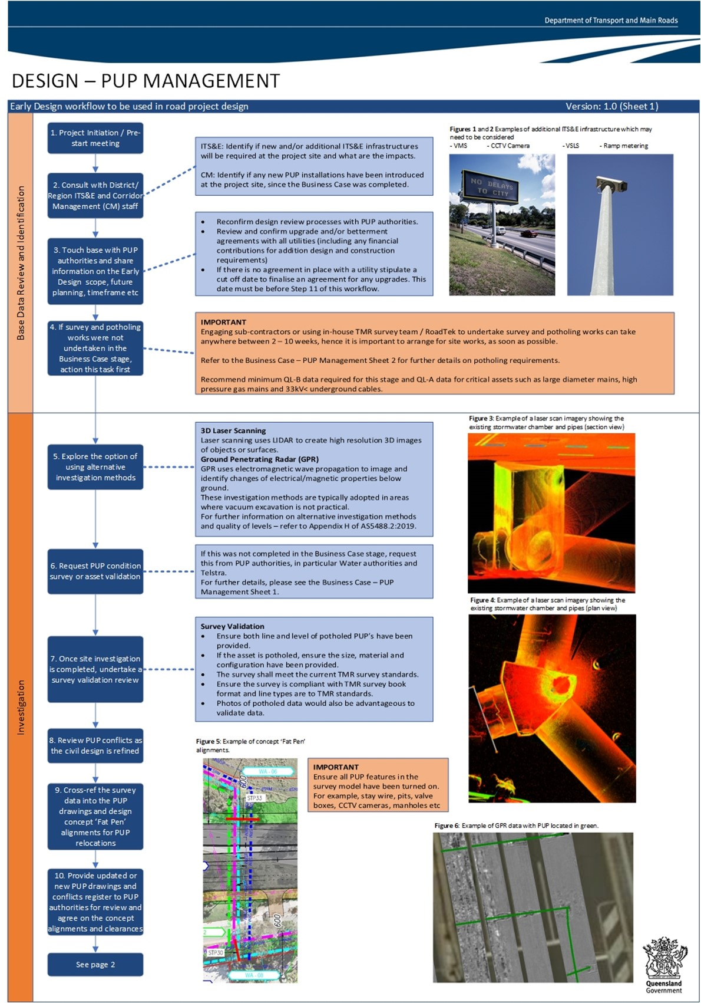
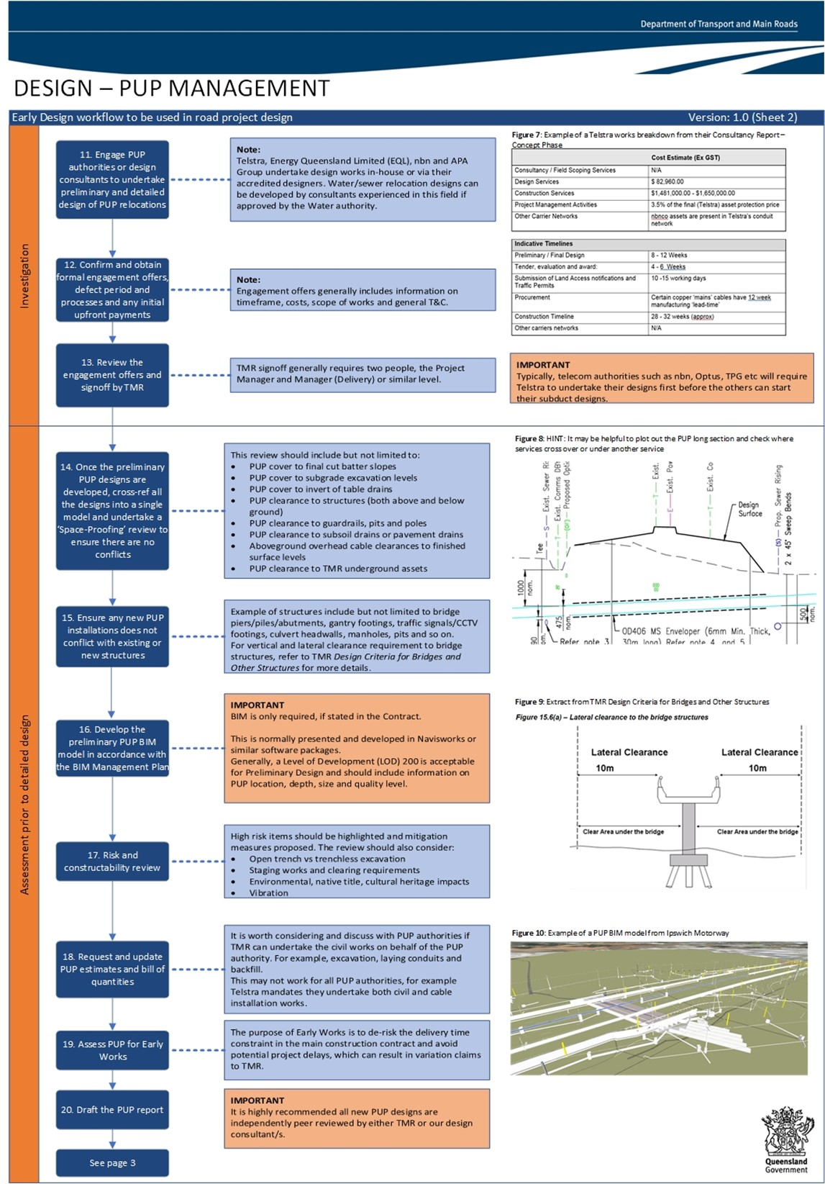

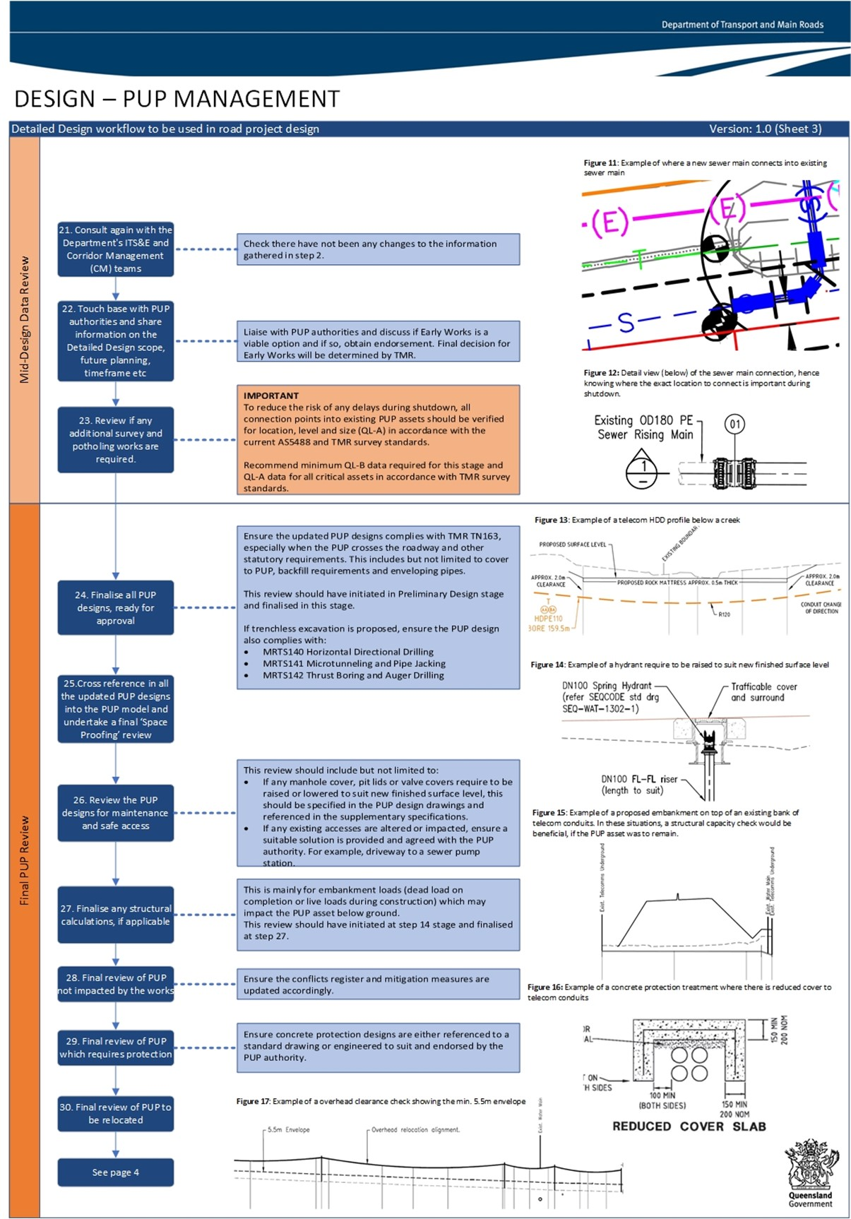
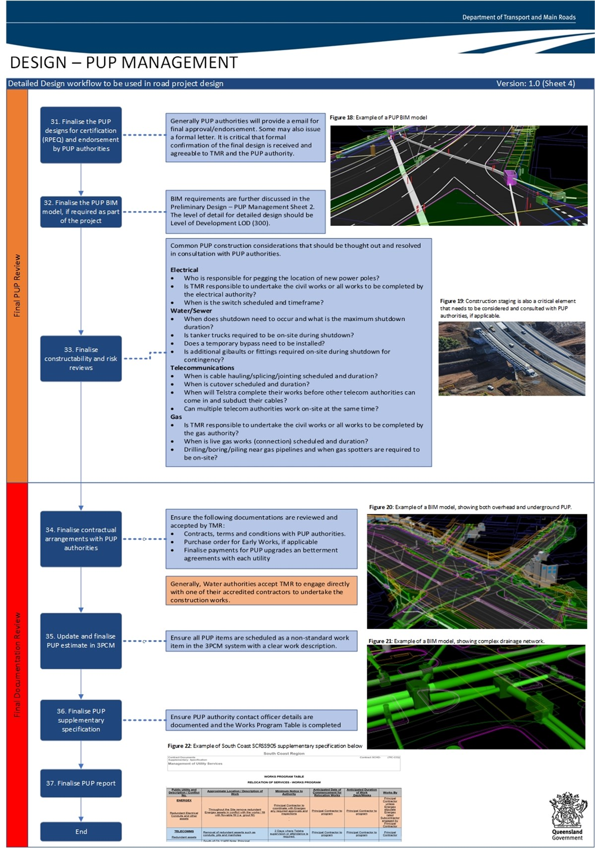

Attachment 4 – Notification of Initial Design and Commitment to Betterment Approach
Date:
TMR Project No: |  | TMR Project Name:
Description of TMR Project (high level):
PUP Authority Contact: | Phone: |  | Email:
TMR Project Manager: | Phone: |  | Email:

Checklist of utilities types and the parts of the Acts that empower Transport and Main Roads to require utilities undertake protection and/or relocation Works on their network assets.
Public Utility Type | Legislative Act to undertake protection / relocation Works by public utilities made under | Check the appropriate box
Electricity | s.106 Electricity Act 1994 | ☐
Distribution Gas | s.94 Gas Supply Act 2003 | ☐
Transmission Gas | s.428 Petroleum and Gas (Production and Safety) Act 2004 | ☐
Water Distribution (QUU / Unitywater) | s.53BX South East Queensland Water (Distribution and Retail Restructuring) Act 2009 Part 3 - Public Entity Work | ☐
Local Government Water | Transport Infrastructure Act 1994, Clause 82 | ☐
Telecommunications | Transport Infrastructure Act 1994, Clause 82 | ☐
 | Please note that some utilities have bespoke agency specific notification forms which must be used. Consultant should ask the Project Administrator for copies so that the agency specific form is used for these Utility Providers.

[Letter template for Initial design and betterment approach commitment with Utility assets. This cannot be used instead of other notification]
[Insert Date]
Our ref
Your ref
Enquiries

[Utility entity]
[Insert Address]

Dear [Add Name of Addressee]
Notice of commencement of initial design which may affect [Insert Utility Name]'s network
In accordance with section [[Delete those that do not apply] s.106 Electricity Act 1994, s.94 Gas Supply Act 2003, s.428 Petroleum and Gas (Production and Safety) 2004, s.53BX South East Queensland Water (Distribution and Retail Restructuring) Act 2009, s.82 Transport Infrastructure Act 1994] I hereby give you notice of the following proposed roadwork preliminary design:
Department of Transport and Main Roads  Project No: | Project Name:
Description of TMR Project (high level):
PUP Authority Contact: | Phone: | Email:
TMR Project Manager: | Phone: | Email:

To be carried out at the following location:
[Insert the location of the proposed roadworks, including the name of the state-controlled road and sufficient details to enable the utility Provider to identify all of its infrastructure that may be impacted by the proposed roadworks]
The Transport and Main Roads project identified above is currently in the initial Design stage. While Transport and Main Roads intention is to avoid conflicts with existing Utility assets as part of this design development, some conflicts may be unavoidable. This letter is advising you of our intentions in accordance with the appropriate legislative Act identified above.
Attached to this letter is an initial design outlining the section of the State Controlled Road we are planning to upgrade for your information and records.
In addition to the proposed roadworks Transport and Main Roads would like to extend an offer [Insert Utility Name] to discuss opportunities for you save money and upgrade your network within the limits of this project if you are prepared to fund the upgrades and they do not delay our project. If you would like to take up this offer please contact Transport and Main Roads by [Insert Date]. Opportunities to upgrade your network during this project will be difficult to accommodate once we have progressed to 30% preliminary design so we encourage you to respond in writing to this offer after careful consideration confirming your intention.
Alternatively, [Insert Utility Name] may, within [Insert Days] Business Days of the date of receipt of this notice, make written submissions to Transport and Main Roads detailing your proposed upgrades and funding commitments. This timeframe may be extended upon consultation with Transport and Main Roads.
If you do not respond or contact us within the stated period from the date of receipt of this notice this offer will be retracted and we will continue to liaise with you to resolve those conflicts which are unavoidable.
Should you have any queries in relation to this notice, please do not hesitate to contact [Insert Details of Contact Officer].
Yours sincerely

[Insert Name of Officer]
[Insert Title of Officer]
Xxxxxxxx
xxxxxxx
address
address Queensland 4000
Telephone +61 7
Website www.tmr.qld.gov.au
Email xxxx@tmr.qld.gov.au
ABN 39 407 690 291

Attachment 5 – PUP Notification of Roadworks / Network Conflicts Letter Templates
For Consultant to complete:
Date:
TMR Project No: |  | TMR Project Name:
Description of TMR Project (high level):
PUP Authority Contact: | Phone: |  | Email:
TMR Project Manager: | Phone: |  | Email:

Checklist of utilities and the parts of the acts that require you to notify them of w that may affect their assets:
Public Utility Type | Legislative Act to undertake protection and/or relocation Works by Public Utilities made under | Check the appropriate box
Electricity | Electricity Act 1994, Clause 99 | ☐
Distribution Gas | Gas Supply Act 2003, Clause 91 | ☐
Transmission Gas | Petroleum and Gas (Production and Safety) Act 2004, Clause 427 | ☐
Water Distribution (QUU / Unitywater) | South East Queensland Water (Distribution and Retail Restructuring) Act 2009 Part 3 - Public Entity Work, Clause 53BU | ☐
Local Government Water | Transport Infrastructure Act 1994, Clause 80 | ☐
Telecommunications | Transport Infrastructure Act 1994, Clause 80 | ☐
 | Please note that some utilities have bespoke agency specific notification forms which must be used. Consultant should ask the Project Administrator or Departmental Delegate for copies so that the agency specific form is used for these Utility Providers.

[Letter template for Notice of Conflict with Utility assets - Electricity]
[Insert Date]
Our ref
Your ref
Enquiries

[insert Entity]
[Insert Address]

Dear [Add Name of Addressee]
Notice of work affecting electricity entity’s Works under section 99 of the Electricity Act 1994
In accordance with section 99 of the Electricity Act 1994, I hereby give you notice of the following proposed roadworks:
Department of Transport and Main Roads  Project No: | Project Name:
Description of TMR Project (high level):
PUP Authority Contact: | Phone: | Email:
TMR Project Manager: | Phone: | Email:

to be carried out at the following location:
[Insert the location of the proposed roadworks, including the name of the state-controlled road and sufficient details to enable the electricity entity to identify all of its electricity infrastructure that may be impacted by the proposed roadworks]
The Transport and Main Roads project identified above is currently in the Detailed Design stage. While Transport and Main Roads have attempted to avoid conflicts with existing PUP assets as part of this design development, some conflicts may be unavoidable. This letter is advising you of the identified conflicts in accordance with the appropriate legislative Act identified above.
Attached to this letter are the documents identified in the below table. These documents provide details of the Transport and Main Roads project, PUP conflicts identified, and the interim treatment being proposed to address the identified PUP conflicts.
It is requested that you review the attached documents and advise on your, and other relevant representatives from your organisation, availability for a follow up meeting with Transport and Main Roads representatives on [Enter Date and Time] at [Enter Location for Meeting] to discuss the identified conflicts, confirm if any assets have been overlooked and the suitability of the proposed treatment options.
A copy of the following documents regarding the proposed roadworks is attached to this notice. [Remove any that do not apply and this instruction]
Attachment Number | Description | Date / Version of document
1 | Road corridor drawings (identifying existing PUP location)
2 | Type Crossing Sections
3 | Resumption drawings, showing new property boundaries
4 | Longitudinal sections adjacent to new property boundaries
5 | Longitudinal sections along new / existing pavement alignment
6 | PUP Conflict identification table (Conflict Matrix)
7 | Quality Level A and/or B Subsurface Utility Information
8 | Proposed treatments (high level protection / relocation)
9 | Summary of relevant Geotechnical Investigation Reports
10 | Summary of relevant Environmental, Cultural Heritage and Native Title reports
11 | Proposed milestone program for Transport and Main Roads Works (include details of resumption process, fencing relocations, PUP relocations / protection commencement, PUP relocations / protection completion (if PUP relocation/protection delivered as Early Works), road construction commencement, road construction completion)
12 | Details of design consultant engaged for Transport and Main Roads project
13 | Additional information: [Enter Description]

Alternatively, [Insert Utility Name] may, within 14 calendar days of the date of receipt of this notice, make written submissions to Transport and Main Roads about the proposed roadworks. This timeframe may be extended upon consultation with Transport and Main Roads.
Information about the vibration exposure standards for your assets, and any other technical relevant standards or guidelines that may apply to working near your assets would be appreciated.
Before finalising the proposed roadworks, Transport and Main Roads will consider any written submissions made by you within the stated period.
If you do not respond within the stated period from the date of receipt of this notice, Transport and Main Roads may proceed to finalise the proposed roadworks.
Should you have any queries in relation to this notice, please do not hesitate to contact [Insert Details of Contact Officer].
Yours sincerely

[Insert Name of Officer]
[Insert Title of Officer]
Xxxxxxxx
xxxxxxx
address
address Queensland 4000
Telephone +61 7
Website www.tmr.qld.gov.au
Email xxxx@tmr.qld.gov.au
ABN 39 407 690 291

[Letter template for Notice of Conflict with Utility assets – Distribution Gas]
[Insert Date]
Our ref
Your ref
Enquiries

[insert Distribution Gas Organisation's name]
[Insert Address]

Dear [Add Name of Addressee]
Notice of road works on a State-controlled road under section 91 of the Gas Supply Act 2003
In accordance with sections 90 – 91 of the Gas Supply Act 2003, I hereby give you notice of the following proposed roadworks:
Department of Transport and Main Roads  Project No: | Project Name:
Description of TMR Project (high level):
PUP Authority Contact: | Phone: | Email:
TMR Project Manager: | Phone: | Email:

to be carried out at the following location:
[Insert a description of the location of the proposed roadworks, including the name of the state-controlled road and sufficient details to enable the gas distributor to identify all of its gas infrastructure that may be impacted by the proposed roadworks]
The Transport and Main Roads project identified above is currently in the Detailed Design stage. While Transport and Main Roads have attempted to avoid conflicts with existing PUP assets as part of this design development, some conflicts may be unavoidable. This letter is advising you of the identified conflicts in accordance with the appropriate legislative Act identified above.
Attached to this letter are the documents identified in the below table. These documents provide details of the Transport and Main Roads project, PUP conflicts identified, and the interim treatment being proposed to address the identified PUP conflicts.
It is requested that you review the attached documents and advise on your, and other relevant representatives from your organisation, availability for a follow up meeting with Transport and Main Roads representatives on [Enter Date and Time] at [Enter Location for Meeting] to discuss the identified conflicts, confirm if any assets have been overlooked and the suitability of the proposed treatment options.
A copy of the following documents regarding the proposed roadworks is attached to this notice. [Remove any that do not apply and this instruction]
Attachment Number | Description | Date / Version of document
1 | Road corridor drawings (identifying existing PUP location)
2 | Type Crossing Sections
3 | Resumption drawings, showing new property boundaries
4 | Longitudinal sections adjacent to new property boundaries
5 | Longitudinal sections along new / existing pavement alignment
6 | PUP Conflict identification table (Conflict Matrix)
7 | Quality Level A and/or B Subsurface Utility Information
8 | Proposed treatments (high level protection/ relocation)
9 | Summary of relevant Geotechnical Investigation Reports
10 | Summary of relevant Environmental, Cultural Heritage and Native Title reports
11 | Proposed milestone program for Transport and Main Roads Works (include details of resumption process, fencing relocations, PUP relocations / protection commencement, PUP relocations / protection completion (if PUP relocation/protection delivered as Early Works), road construction commencement, road construction completion)
12 | Details of design consultant engaged for Transport and Main Roads project
13 | Additional information: [Enter Description]

Alternatively, [Insert Utility Name] may, within 30 business days of the date of receipt of this notice, make written submissions to Transport and Main Roads about the proposed roadworks. This timeframe can be extended upon consultation with Transport and Main Roads.
Information about the vibration exposure standards for your assets, and any other technical relevant standards or guidelines that may apply to working near your assets would be appreciated.
Before finalising the proposed roadworks, Transport and Main Roads will consider any written submissions made by you within the stated period.
If you do not respond within 30 business days from the date of receipt of this notice, Transport and Main Roads may proceed to finalise the proposed roadworks.
Should you have any queries in relation to this notice, please do not hesitate to contact [Insert Details of Contact Officer].
Yours sincerely

[Insert Name of Officer]
[Insert Title of Officer]
Xxxxxxxx
xxxxxxx
address
address Queensland 4000
Telephone +61 7
Website www.tmr.qld.gov.au
Email xxxx@tmr.qld.gov.au
ABN 39 407 690 291

[Letter template for Notice of Conflict with Utility assets – Transmission Gas]
NOTE! There may be a contract regulating this crossing, check with Commercial Property before sending this letter]
[Insert Date]
Our ref
Your ref
Enquiries

[insert Transmission Gas Organisation's name]
[Insert Address]

Dear [Add Name of Addressee]
Notice of road works on a State-controlled road under section 427 of the Petroleum and Gas (Production and Safety) Act (2004)
In accordance with section 427 of the Petroleum and Gas (Production and Safety) Act 2004, I hereby give you notice of the following proposed roadworks:
Department of Transport and Main Roads  Project No: | Project Name:
Description of TMR Project (high level):
PUP Authority Contact: | Phone: | Email:
TMR Project Manager: | Phone: | Email:

to be carried out at the following location:
[Insert a description of the location of the proposed roadworks, including the name of the state-controlled road and sufficient details to enable the gas distributor to identify all of its gas infrastructure that may be impacted by the proposed roadworks]
The Transport and Main Roads project identified above is currently in the Detailed Design stage. While Transport and Main Roads have attempted to avoid conflicts with existing PUP assets as part of this design development, some conflicts may be unavoidable. This letter is advising you of the identified conflicts in accordance with the appropriate legislative Act identified above.
Attached to this letter are the documents identified in the below table. These documents provide details of the Transport and Main Roads project, PUP conflicts identified, and the interim treatment being proposed to address the identified PUP conflicts.
It is requested that you review the attached documents and advise on your, and other relevant representatives from your organisation, availability for a follow up meeting with Transport and Main Roads representatives on [Enter Date and Time] at [Enter Location for Meeting] to discuss the identified conflicts, confirm if any assets have been overlooked and the suitability of the proposed treatment options.
A copy of the following documents regarding the proposed roadworks is attached to this notice. [Remove any that do not apply and this instruction]
Attachment Number | Description | Date / Version of document
1 | Road corridor drawings (identifying existing PUP location)
2 | Type Crossing Sections
3 | Resumption drawings, showing new property boundaries
4 | Longitudinal sections adjacent to new property boundaries
5 | Longitudinal sections along new / existing pavement alignment
6 | PUP Conflict identification table (Conflict Matrix)
7 | Quality Level A and/or B Subsurface Utility Information
8 | Proposed treatments (high level protection / relocation)
9 | Summary of relevant Geotechnical Investigation Reports
10 | Summary of relevant Environmental, Cultural Heritage and Native Title reports
11 | Proposed milestone program for Transport and Main Roads Works (include details of resumption process, fencing relocations, PUP relocations / protection commencement, PUP relocations / protection completion (if PUP relocation/protection delivered as Early Works), road construction commencement, road construction completion)
12 | Details of design consultant engaged for Transport and Main Roads project
13 | Additional information: [Enter Description]

Alternatively, [Insert Utility Name] may, within 30 business days of the date of receipt of this notice, make written submissions to Transport and Main Roads about the proposed roadworks. This timeframe can be extended upon consultation with Transport and Main Roads.
Information about the vibration exposure standards for your assets, and any other technical relevant standards or guidelines that may apply to working near your assets would be appreciated.
Before finalising the proposed roadworks, Transport and Main Roads will consider any written submissions made by you within the stated period.
If you do not respond within 30 business days from the date of receipt of this notice, Transport and Main Roads may proceed to finalise the proposed roadworks.
Should you have any queries in relation to this notice, please do not hesitate to contact [Insert Details of Contact Officer].
Yours sincerely

[Insert Name of Officer]
[Insert Title of Officer]
Telephone +61 7
Website www.tmr.qld.gov.au
Email xxxx@tmr.qld.gov.au
ABN 39 407 690 291
Xxxxxxxx
xxxxxxx
address
address Queensland 4000

[Letter template for Notice of Conflict with Utility assets – Local Government Water]

[Insert Date]
Our ref
Your ref
Enquiries

[insert LG Water Utility name]
[Insert Address]

Dear [Add Name of Addressee]
Notice of road works on a State-controlled road under section 80(2) of the Transport Infrastructure Act 1994
In accordance with section 80 of the Transport Infrastructure Act 1994 ("the TIA"), I hereby give you notice of the following proposed roadworks:
Department of Transport and Main Roads  Project No: | Project Name:
Description of TMR Project (high level):
PUP Authority Contact: | Phone: | Email:
TMR Project Manager: | Phone: | Email:

to be carried out at the following location:
[Insert the location of the proposed roadworks, including the name of the state-controlled road and sufficient details to enable the water authority to identify all of its water infrastructure that may be impacted by the proposed roadworks]
The Transport and Main Roads project identified above is currently in the Detailed Design stage. While Transport and Main Roads have attempted to avoid conflicts with existing PUP assets as part of this design development, some conflicts may be unavoidable. This letter is advising you of the identified conflicts in accordance with the appropriate legislative Act identified above.
Attached to this letter are the documents identified in the below table. These documents provide details of the Transport and Main Roads project, PUP conflicts identified, and the interim treatment being proposed to address the identified PUP conflicts.
It is requested that you review the attached documents and advise on your, and other relevant representatives from your organisation, availability for a follow up meeting with Transport and Main Roads representatives on [Enter Date and Time] at [Enter Location for Meeting] to discuss the identified conflicts, confirm if any assets have been overlooked and the suitability of the proposed treatment options.
A copy of the following documents regarding the proposed roadworks is attached to this notice. [Remove any that do not apply and this instruction]
Attachment Number | Description | Date / Version of document
1 | Road corridor drawings (identifying existing PUP location)
2 | Type Crossing Sections
3 | Resumption drawings, showing new property boundaries
4 | Longitudinal sections adjacent to new property boundaries
5 | Longitudinal sections along new / existing pavement alignment
6 | PUP Conflict identification table (Conflict Matrix)
7 | Quality level A and/or B Subsurface Utility Information
8 | Proposed treatments (high level protection / relocation)
9 | Summary of relevant Geotechnical Investigation Reports
10 | Summary of relevant environmental, cultural heritage and native title reports
11 | Proposed milestone program for Transport and Main Roads Works (include details of resumption process, fencing relocations, PUP relocations / protection commencement, PUP relocations / protection completion (if PUP relocation/protection delivered as Early Works), road construction commencement, road construction completion)
12 | Details of design consultant engaged for Transport and Main Roads project
13 | Additional information: [Enter Description]

Alternatively, [Insert Utility Name] may, within 20 business days of the date of receipt of this notice, make written submissions to Transport and Main Roads about the proposed roadworks. Before finalising the proposed roadworks, Transport and Main Roads will, consider any written submissions made by you within the stated period.
Information about the vibration exposure standards for your assets, and any other technical relevant standards or guidelines that may apply to working near your assets would be appreciated.
Transport and Main Roads notes you [are/are not] part of the October 2017 'TMR/Local Government Cost Sharing Arrangement' and all processes in the arrangement regarding your water/sewerage assets [apply/do not apply].
If you do not respond within 30 business days from the date of receipt of this notice, Transport and Main Roads may proceed to finalise the proposed roadworks.
Should you have any queries in relation to this notice, please do not hesitate to contact [Insert Details of Contact Officer].
Yours sincerely

[Insert Name of Officer]
[Insert Title of Officer]
Xxxxxxxx
xxxxxxx
address
address Queensland 4000
Telephone +61 7
Website www.tmr.qld.gov.au
Email xxxx@tmr.qld.gov.au
ABN 39 407 690 291

[Letter template for Notice of Conflict with Utility assets – QUU/Unitywater]

[Insert Date]
Our ref
Your ref
Enquiries

[insert QUU/Unitywater]
[Insert Address]

Dear [Add Name of Addressee]
Notice of Public Entity Work under section 53BU of the South-East Queensland Water (Distribution and Retail Restructuring) Act 2009
In accordance with section 53BU of the South-East Queensland Water (Distribution and Retail Restructuring) Act 2009 ("the SEQ Water Act"), I hereby give you notice of the following proposed roadworks:
Department of Transport and Main Roads  Project No: | Project Name:
Description of TMR Project (high level):
PUP Authority Contact: | Phone: | Email:
TMR Project Manager: | Phone: | Email:

to be carried out at the following location:
[Insert the location of the proposed roadworks, including the name of the state-controlled road and sufficient details to enable the distributor-retailer to identify all of its water infrastructure that may be impacted by the proposed roadworks]
The Transport and Main Roads project identified above is currently in Detailed Design stage. While Transport and Main Roads have attempted to avoid conflicts with existing PUP assets as part of this design development, some conflicts may be unavoidable. This letter is advising you of the identified conflicts in accordance with the appropriate legislative Act identified above.
Attached to this letter are the documents identified in the below table. These documents provide details of the Transport and Main Roads project, PUP conflicts identified, and the interim treatment being proposed to address the identified PUP conflicts.
It is requested that you review the attached documents and advise on your, and other relevant representatives from your organisation, availability for a follow up meeting with Transport and Main Roads representatives on [Enter Date and Time] at [Enter Location for Meeting] to discuss the identified conflicts, confirm if any assets have been overlooked and the suitability of the proposed treatment options.
A copy of the following documents regarding the proposed roadworks is attached to this notice. [Remove any that do not apply and this instruction]
Attachment Number | Description | Date / Version of document
1 | Road corridor drawings (identifying existing PUP location)
2 | Type Crossing Sections
3 | Resumption drawings, showing new property boundaries
4 | Longitudinal sections adjacent to new property boundaries
5 | Longitudinal sections along new / existing pavement alignment
6 | PUP Conflict identification table (Conflict Matrix)
7 | Quality Level A and/or B Subsurface Utility Information
8 | Proposed treatments (high level protection / relocation)
9 | Summary of relevant Geotechnical Investigation Reports
10 | Summary of relevant Environmental, Cultural Heritage and Native Title reports
11 | Proposed milestone program for Transport and Main Roads Works (include details of resumption process, fencing relocations, PUP relocations / protection commencement, PUP relocations / protection completion (if PUP relocation/protection delivered as Early Works), road construction commencement, road construction completion)
12 | Details of design consultant engaged for Transport and Main Roads project
13 | Additional information: [Enter Description]

Alternatively, [Insert Utility Name] may, within 30 business days of the date of receipt of this notice, make written submissions to Transport and Main Roads about the proposed roadworks.
Information about the vibration exposure standards for your assets, and any other technical relevant standards or guidelines that may apply to working near your assets would be appreciated.
Before finalising the proposed roadworks, Transport and Main Roads will, within the terms of section 53BU(3) of the SEQ Water Act, consider any written submissions made by you within the stated period.
If you do not respond within 30 business days from the date of receipt of this notice, Transport and Main Roads will proceed to finalise the proposed roadworks.
Should you have any queries in relation to this notice, please do not hesitate to contact [Insert Details of Contact Officer].
Yours sincerely

[Insert Name of Officer]
[Insert Title of Officer]
Xxxxxxxx
xxxxxxx
address
address Queensland 4000
Telephone +61 7
Website www.tmr.qld.gov.au
Email xxxx@tmr.qld.gov.au
ABN 39 407 690 291

[Letter template for Notice of Conflict with Utility assets – Telecommunications]

[Insert Date]
Our ref
Your ref
Enquiries

[insert Telco name]
[Insert Address]

Dear [Add Name of Addressee]
Notice of road works on a State-controlled road under section 80(2) of the Transport Infrastructure Act 1994
In accordance with section 80 of the Transport Infrastructure Act 1994 ("the TIA"), I hereby give you notice of the following proposed roadworks:
Department of Transport and Main Roads  Project No: | Project Name:
Description of TMR Project (high level):
PUP Authority Contact: | Phone: | Email:
TMR Project Manager: | Phone: | Email:

to be carried out at the following location:
[Insert the location of the proposed roadworks, including the name of the state-controlled road and sufficient details to enable the Telco to identify all of its telecommunications infrastructure that may be impacted by the proposed roadworks]
The Transport and Main Roads project identified above is currently in the Detailed Design stage. While Transport and Main Roads have attempted to avoid conflicts with existing PUP assets as part of this design development, some conflicts may be unavoidable. This letter is advising you of the identified conflicts in accordance with the appropriate legislative Act identified above.
Attached to this letter are the documents identified in the below table. These documents provide details of the Transport and Main Roads project, PUP conflicts identified, and the interim treatment being proposed to address the identified PUP conflicts.
It is requested that you review the attached documents and advise on your, and other relevant representatives from your organisation, availability for a follow up meeting with Transport and Main Roads representatives on [Enter Date and Time] at [Enter Location for Meeting] to discuss the identified conflicts, confirm if any assets have been overlooked and the suitability of the proposed treatment options.
A copy of the following documents regarding the proposed roadworks is attached to this notice. [Remove any that do not apply and this instruction]
Attachment Number | Description | Date / Version of document
1 | Road corridor drawings (identifying existing PUP location)
2 | Type Crossing Sections
3 | Resumption drawings, showing new property boundaries
4 | Longitudinal sections adjacent to new property boundaries
5 | Longitudinal sections along new / existing pavement alignment
6 | PUP Conflict identification table (Conflict Matrix)
7 | Quality Level A and/or B Subsurface Utility Information
8 | Proposed treatments (high level protection / relocation)
9 | Summary of relevant Geotechnical Investigation Reports
10 | Summary of relevant Environmental, Cultural Heritage and Native Title reports
11 | Proposed milestone program for Transport and Main Roads Works (include details of resumption process, fencing relocations, PUP relocations / protection commencement, PUP relocations / protection completion (if PUP relocation/protection delivered as Early Works), road construction commencement, road construction completion)
12 | Details of design consultant engaged for Transport and Main Roads project
13 | Additional information: [Enter Description]

Alternatively, [Insert Utility Name] may, within 20 business days of the date of receipt of this notice, make written submissions to Transport and Main Roads about the proposed roadworks. This period may be extended upon TMR's discretion.
Information about the vibration exposure standards for your assets, and any other technical relevant standards or guidelines that may apply to working near your assets would be appreciated.
Before finalising the proposed roadworks, Transport and Main Roads will, consider any written submissions made by you within the stated period.
If you do not respond within 30 business days from the date of receipt of this notice, Transport and Main Roads will proceed to finalise the proposed roadworks.
An extract of sections 80-82 of the TIA is attached to this notice for your convenience.
Should you have any queries in relation to this notice, please do not hesitate to contact [Insert Details of Contact Officer].
Yours sincerely

[Insert Name of Officer]
[Insert Title of Officer]
Xxxxxxxx
xxxxxxx
address
address Queensland 4000
Telephone +61 7
Website www.tmr.qld.gov.au
Email xxxx@tmr.qld.gov.au
ABN 39 407 690 291

Extracts of sections 80 - 82 of the Transport Infrastructure Act 1994
80 Specification of chief executive’s requirements about public utility plant
(1) The construction, augmentation, alteration or maintenance of public utility plant on a State-controlled road must be undertaken in accordance with the chief executive’s requirements and at the expense of the owner of the plant.
(2) Road works on a State-controlled road made necessary by the construction, augmentation, alteration or maintenance of public utility plant on a State-controlled road must be undertaken in accordance with the chief executive’s requirements and at the expense of the owner of the plant.
(3) Requirements mentioned in subsection (1) or (2) are to be notified in writing to the owner of the plant within a reasonable period.
81 Information by owner of public utility plant to chief executive
(1) A person who wants to take action mentioned in section 80 must give a written notice to the chief executive of the person’s intention to carry out work on a State-controlled road within a reasonable time before taking the action.
(2) If public utility plant is constructed, augmented, altered or maintained on a State-controlled road, the owner of the plant must prepare records that adequately define the location of the plant on the road at the time of the construction, augmentation, alteration or maintenance of the plant.
(3) The owner of public utility plant on a State-controlled road must, if asked by the chief executive, supply information to the chief executive to define adequately the location of the plant in a specified area.
82 Liability for damage or expenses
(1) Unless the chief executive otherwise agrees, the chief executive is not liable for damage caused by the chief executive to public utility plant on a State-controlled road if—
(a) the chief executive had, before the damage was caused, asked for information under section 81(3) from the owner of the plant and—
(i) the owner had not, within a reasonable time, complied with the request; and
(ii) the damage was caused because of the failure to comply with the request; or
(b) information supplied to the chief executive under section 81(3) does not define in adequate detail the location of the plant and the damage was caused because of the failure to define in adequate detail the location of the plant; or
(c) the damage was caused because of the plant having been constructed, augmented, altered or maintained other than under the chief executive’s requirements under this division.
(2) If the chief executive incurs additional expense in carrying out road works on a State-controlled road because—
(a) the owner of public utility plant had not supplied within a reasonable time information asked for by the chief executive under section 81(3); or
(b) information supplied to the chief executive did not define in adequate detail the location of public utility plant; or
(c) public utility plant had not been constructed, augmented, altered or maintained under the chief executive’s requirements; the owner of the plant is liable to pay to the chief executive the additional expense.

