Walking Network Planning Project

ESRI ArcPro guide
This guidance is reproduced with permission from the Principal Pedestrian Networks: Guidelines for state and local government (State of Victoria).
It has been amended from its original format by Queensland Government Department of Transport and Main Roads.

Use this guidance on how to create a walking network map in ESRI ArcGIS Pro. This analysis will require the use of ArcGIS Pro Network Analyst extension.

You can use this instructional GIS document for the relevant stages of the Walking Network Planning project:
- Build- up your map to determine the data-led walking network plan.
- Edit your walking network plan after engagement consultation.
- Mark your walking network plan for actions that are location specific.
- Package GIS files at the project finalisation.

Build the Walking Network Plan

Step 1: Collate background data
The layers required to complete the analysis are listed under Walking Network Planning guidance map data resources.

ABS Meshblock data

Link to digital boundary page:
https://www.abs.gov.au/statistics/standards/australian-statistical-geography-standard-asgs-edition-3/jul2021-jun2026/access-and-downloads/digital-boundary-files

Link to Meshblock population counts page:
https://www.abs.gov.au/census/guide-census-data/mesh-block-counts/latest-release

To prep the ABS data for use in WNP

The data is available by default for the whole of Australia. Create an ABS account to use 'Table Builder' to make a Queensland Dataset download.

- Extract full Australia MB shapefile, query by attribute -> "STE_NAME21" = ’Queensland’
- Save the results of this query to a new table "MB_2021_QLD", "QLD_MB_2021".
- Open the downloaded excel spreadsheet for population counts and delete all sheets apart from the Queensland ones (Sheets 3 and 3.1).
- Delete any rows that are not related to the table attributes: Delete top rows down to field row. Delete rows below attribute layers (footer information) for example. "Cells in this table have been randomly adjusted to avoid the release of confidential data." to be deleted ensure the column headers are kept.
- Copy the sheet 3.1 rows (excluding headers) into sheet 3 and then delete sheet 3.1
- Add an attribute index to the QLD meshblock file for the MB_CODE21 attribute. You may need to close this in Arc first.
- Open the QLD MB file and population count spreadsheet in ArcGIS Pro.
- You can remove fields from the QLD MB table if you like or want to reduce the file size. Ensure MB_CODE21 and MB_CAT21 are kept.
- Add a population field to QLD_MB, ensure it is either float or double attribute type
- Add a join to the QLD MB file using MB_CODE21 field
- QLD_MB is input table, population spreadsheet is the join table
- MB_CODE21 is the join field
- Use field calculator to fill the added population attribute using the joined 'Person' field
- Remove the join
- This should be done before creating the Meshblock centroids.

Step 2: Determine the primary destination
Map the selected location(s) for the primary destination.

Destinations
- Primary destinations are places people regularly visit and can be public transport hubs, town centres, schools, hospitals and community service facilities.
- Apply a 2 kilometre buffer around the primary destination point.
- Include points for other locations (Secondary Destinations) that people may walk to within the 2 kilometre buffer.

Note: It is well understood that some destinations that are visited more frequently by many people such as a shopping centre when compared to other destinations such as a single ‘clubhouse’ or small playground. To address this, we encourage considering your overall approach to the WNP (Radial, Precinct or Corridor) to be important as well as evaluating walking routes priority when output. The route review and manual editing is completed in Step 8 Review WNP.

Step 3: Creating the road network
Enable the Network Analyst Extension on your current ArcGIS Pro session.
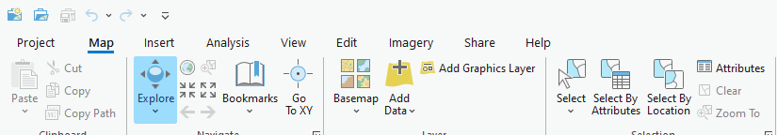
Figure 1: Arc ribbon. Source: TMR, 2023
- Select Project>Licensing>Configure your licensing options. A window with extensions will show.
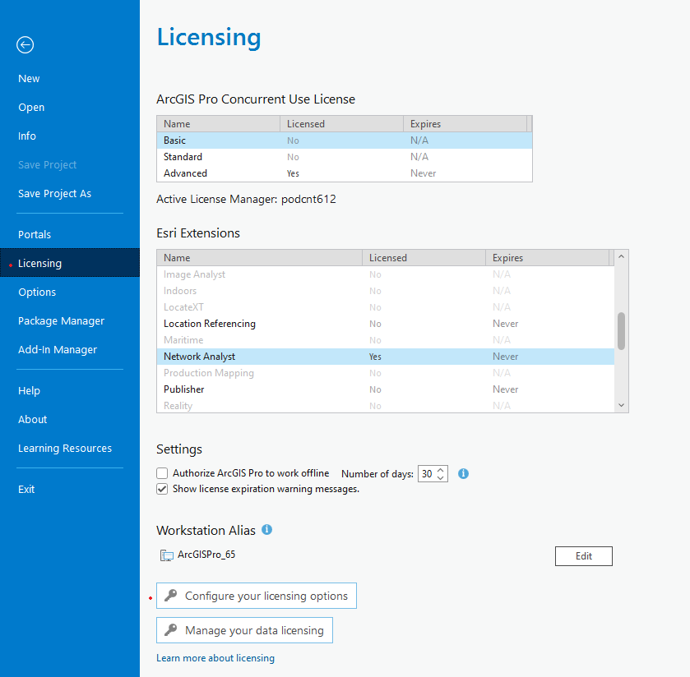 | 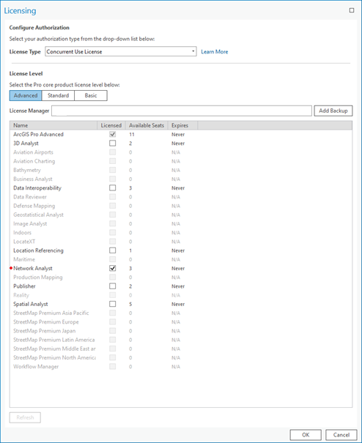
Figure 2: ArcGIS Pro Licensing, Source: TMR, 2023 | Figure 3: ArcGIS Pro Configure Licensing, Source: TMR, 2023

- Download the road network layer as a shapefile (the Queensland Roads and Track layer on QSpatial)
- Create a geodatabase in the project folder, open the catalog window and navigate to the project folder. Right click on the project folder and select New>File Geodatabase.
- Right click on the new geodatabase and select New>Feature Dataset
- Enter a name and coordinate system for the feature dataset, GDA2020 is preferred but not mandatory.
- In the catalog window navigate to the downloaded roads and tracks shapefile, right click, and select Export>Feature Class to Feature Class. Select the created feature dataset as the output feature class location. Ensure the output is open in the map frame. Ensure that Coordinate system matches the coordinate system selected in the feature dataset.
- Run the Create Network Dataset tool, Geoprocessing>Network Analyst>Network Dataset>Create Network Dataset
- Select the created feature dataset as the Target Feature Dataset
- Enter a name for the output network dataset
- Select Queensland roads and tracks as the Source Feature Classes
- Select 'None' for model elevation
- Run the Build Network tool, Geoprocessing>Network Analyst>Network Dataset>Build Network, and select the created network dataset as the Input Network Dataset.
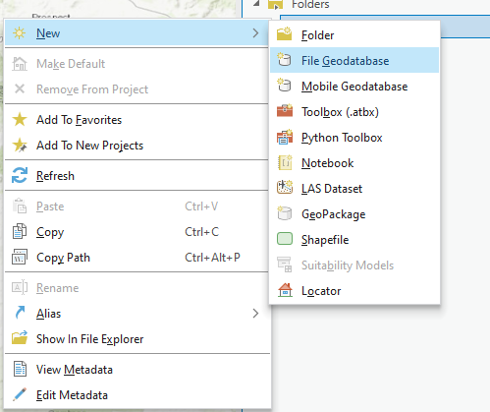  Figure 4: File Geodatabase, Source: TMR, 2023 | 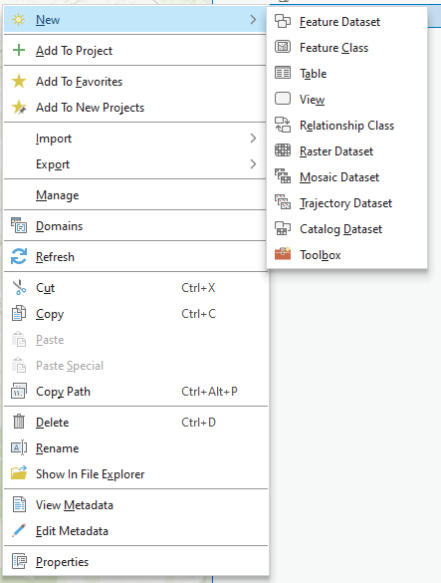  Figure 5: Dataset Options, Source: TMR, 2023
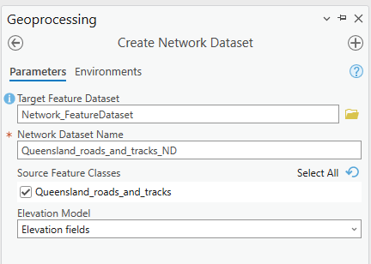 | 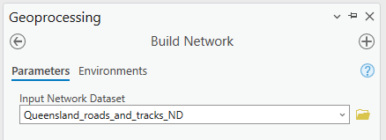
Figure 6: ArcGIS Pro create Feature Dataset, Source: TMR, 2023 | Figure 7: ArcGIS Pro Build network, Source: TMR, 2023
- This can also be repeated if local government has shapefile information on footpaths/ recreational paths.
Note: If you need in-depth instructions and information on all the settings; ESRI provides detailed instructions https://pro.arcgis.com/en/pro-app/latest/help/analysis/networks/how-to-create-a-usable-network-dataset.html

Walking Network Plan Schema
Name | Alias | Definition | Type
ROUTE_ID | Route ID | Unique identifier | Integer
NAME | Name | Name of route | Text
ALIAS | Alias | Alternate name of route composed of street or park name | Text
TYPE | Type | Primary, Future Primary, Secondary or Future Secondary defining the hierarchy of the route. Legend field. | Text
WNP_NAME | Walking Network Plan Name | Name of the Walking Network Plan this route is within | Text
REGION | TMR Region | Transport and Main Roads Region containing the route | Text
DISTRICT | TMR District | Transport and Main Roads District containing the route | Text
LGA | Local Government Area | Local Government Area containing the route | Text

Step 4: Map the walkable catchment

- Create both a 1km and 2km walking catchment when developing a WNP.Walkable catchment (isochrones)
- The walkable catchment that can extend beyond 2 kilometres can depend on a number of factors such as:
  - Proximity to attractive walking environments such as activity centre
  - Major barriers such as highways, water bodies
  - Alternative transport modes.
- There are a variety of methods to do this, including using googlemaps to understand actual walkable distance and that requires local knowledge of the walking network.
- Add the primary destination(s) layer to the working Project. From the network analyst tool bar drop down list (under the analysis tab ribbon), choose 'Service Area' from the New Network Analysis Type list. Ensure that Primary Destination feature class matches the coordinate system of the Network dataset.

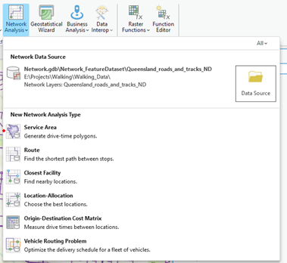
Figure 7: ArcGIS Pro Network Analyst. Source: TMR, 2023
- Open the Service Area Layer ribbon and select Import Facilities.
- Fill the window in as shown and select 'OK'.
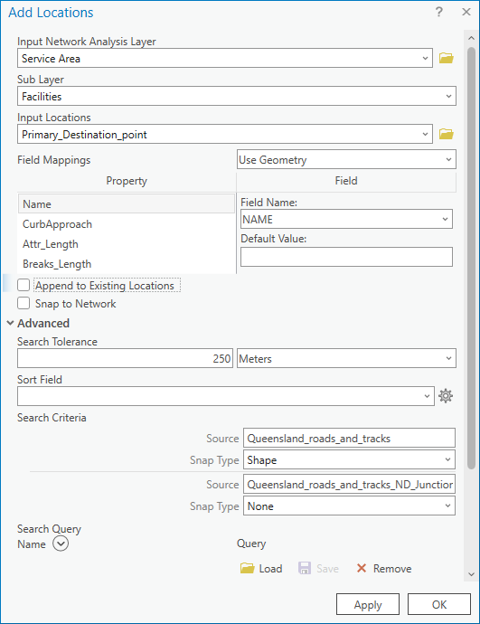
Figure 8: Arc Network Analyst Dialogue Window. Source: TMR, 2023
- In the Service Area Layer ribbon set the Cutoffs to 1000 and 2000 and ensure that Direction is set to Away from Facilities.
- Click “Run” button on the Service Area Layer ribbon.

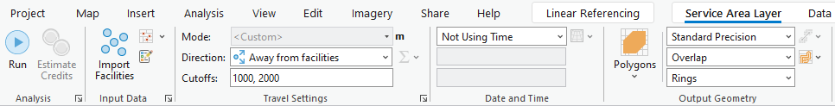
Figure 10: Arc Network Analyst Dialogue Window. Source: TMR, 2023

- Layers will be grouped under 'Service Area' and are temporary. The result of the service area will be sitting in the 'Polygons' layer.
- Right click 'Polygons' layer and export the catchments as a feature class in the working folder.

Step 5: Map existing residential population densities

Residential population
To understand the potential trips that can occur, there are a few methods.
ABS Census meshblock data for residential population within the WNP buffer can be used.
- Add the Meshblock area layer and data table into the Project.
- Join the table to the area.
- Export the layer with the joined data as a feature class.

This next step will create a point at the centre of each meshblock, which are also called centroids. Create centroids out of the Meshblock area layer. If you have an ArcGIS Pro Desktop, you use the 'Feature to Point' tool.

For WNP that contain new developments, centre points with an estimated population can be added. Those with population zero can be removed.

Low population or low densities
In very low density or low population areas, the Mesh Block layer may create a draft WNP that has obvious broken links and missing routes. This is because the location of the centroid in the Mesh Block is weighted based on the location of residential addresses. This application of Mesh Block data works best in locations with higher populations and consequently more centroids from which to draw routes.
- Create manual population meshblocks in GIS based on available ABS information (majority of populated meshblock contain between 30-60 dwellings). Manual route editing can be calculated from trip attractors based on TMR trip generation.

Trip generation
- Use trip generation rates when determining secondary destination population if Meshblock population or employment data is not available.
- Trip generation rates are specifically for that land use. Undertake a manual assessment to determine the appropriate rate and yield to adopt for each secondary destination. Refer to TMR's Guide to Traffic Impact Assessment (Section 8.2.1) for trip generation rate resources.
- For example, let's determine the secondary destination population for a school:
- Confirm student numbers: search for the school on the Department of Education Schools Directory, and click on the 'Enrolment details' tab. For this example, 363 students are enrolled.
- Confirm appropriate trip rate: peak generation rate for a primary school is 0.28 trips per student.
- Calculate estimated population: 0.28 trips per 363 students = 102 secondary destination population for the primary school.

- Use walking access point/s when mapping the primary/secondary destinations. Designate routes to/from actual entry points to create a realistic and accessible walking network. This applies particularly for larger land uses, for example a hospital, because the entry(s) for walking will likely differ from the centre point of the destination (or main vehicle access point).
- For the shortest routes between primary/secondary destinations, ensure that the route to exit and re-enter the catchment to avoid barriers as needed.

Route intensity
- For determining the intensity of routes, combine both Meshblock population data and the secondary destination population data along each route. This will provide a more realistic representation of secondary route designations compared with primary route designations. Where secondary destination populations are not considered in determining route intensity, this may result in a disproportionate number of primary routes and create an adverse influence on ability to program works.
- For more complex urban environments, consider creating a hierarchy/weighting of secondary destinations relative to the type of primary destination, to help define primary or secondary routes on the network.

Step 7: Determine shortest distance routes
- Add the network dataset that was created in Step 3, along with the Meshblock centroids that were created in Step 1 to the working Project. From the Network Analyst toolbar drop down list, choose 'New Closest Facility'.
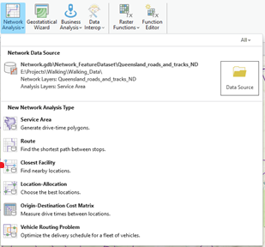
Figure 9: Arc Network Analyst Window. Source: TMR, 2023

- Import the facilities and incidents, match the settings to those shown in Figure 10. You can decide which layer (primary destinations or meshblock centroids) will serve as facilities and which one will serve as incidents. This is optional, but if there are any line barriers that will need to be added, you can add them into this step.
- In the “Closest Facility” ribbon set the properties as shown in the figure below, note the Direction should be away from the Primary Destination whether it is loaded as the facilities or incidents. Click “Run”.
- Layers will be grouped under ‘Closest Facility’ and are temporary. The result of the closest facility will be sitting in the 'Routes' layer.
- Right click 'Routes' layer and export the closest facility routes as a feature class in the working folder.
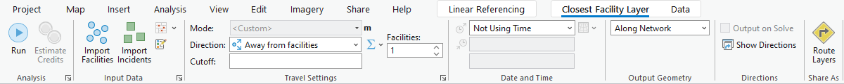
Figure 10: Arc Network Analysis settings, Source: TMR, 2023

Step 8: Review WNP

Review the project purpose, and types of WNP in the Stage 2 Guidance.
Ensure you have Primary, Secondary routes, captured logical destinations.
Manually edit and add routes based on the road network or council footpath data if necessary prior to stakeholder engagement to make a logical connected WNP.
- Undertake a manual review of the existing footpath network, particularly within park/recreation areas and 'shortcuts' within residential areas.
- Utilise the contour layer to identify paths where gradients exceed 5%.
- Highlight these >5% gradient routes for review during stakeholder liaison to confirm whether they should be removed and other routes considered as part of the WNP.

Radial WNP:
  - You have undertaken the process outlined above and generated shortest routes from residential populations (ABS Meshblock location) to the primary destination, and from the primary destination to secondary destinations.

Precinct WNP:
There is an additional method relevant in converting the radial WNP into a precinct WNP:
  - Option A: Repeat the GIS step process with another nearby destination as the primary and overlay the radial maps. You can undertake this process more than twice. Similar to a heatmap this will allow you to generate understanding of 'primary' routes for multiple destinations.
  - Option B: Manually draw walking routes connecting into the radial network during engagement. Connect secondary destinations to other secondary destinations based on clear desire line attractions. Identify ‘logical’ cross-connection gaps in the walking network by connecting secondary destinations to other secondary destinations based on clear desire line attractions and add to feature class.

Corridor WNP:
  - Create multiple WNP for relevant locations (such as public transport stops) along the corridor.
  - Draw a linear route representing transport corridor and connections to existing network.

Engagement Maps
Prepare the WNP maps for review during the stakeholder engagement workshop.

Additional maps may be provided to aid conversations:
- for communicating active transport relationship, create Principal Cycle Network Map
- any existing path infrastructure map (such as existing pedestrian crossings, footpaths, shared paths, boardwalks, parks).
- Contour routes map with >5% gradient routes highlighted.
- Inset maps zoomed in if there is a focus area of project which may include building entrances, crossings (if at a neighbourhood scale), ATSIP/First Nations cultural heritage sites.
- Any photographs, or supporting information such as crash maps from the network pinned at mapped locations.
- Provide and show known future walking networks, local or state master planning, growth areas, school catchment maps or capital works plans.
- Land Use zoning maps.
- Recommend showing future walking network as a dashed line etc. to distinguish future planning from the existing network.
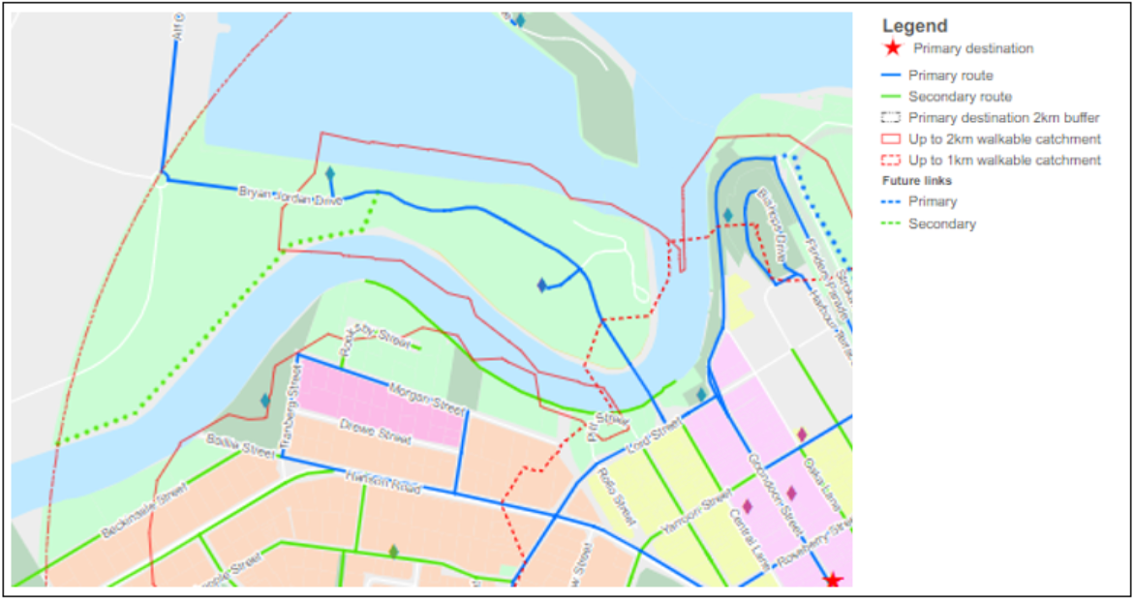
Figure 11: Example future walking network plans. Source TMR, 2020

Engagement edits

Edit your walking network plan after engagement consultation:

- Manual recategorization of secondary or primary routes.
- Future strategic routes.
- Adding or removing destinations.
- Capturing short-cuts and cross-catchment routes.

Capture changes in WNP map and also brief description of the changes in Walking Network Planning project report.

Action Program Supporting Map

For actions that are location specific, mark-up your walking network plan.

- Create a feature class in the working folder with GPS location and categorized works as Essential, Important.
- Capture area-wide interventions in separate icon/annotation.
- Apply an icon or label for locations points/works and include categories in the legend.
- Gaps in the existing network:
  - Showing the Action program on a map of the existing network clearly highlights where works could complete missing links and address any existing gaps.
- Primary and secondary WNP routes:
  - Highlight on a supporting map how the Action Program aligns with the primary and secondary routes of the WNP. This can help to identify the type and scale of walking infrastructure improvements relative to the hierarchy of the network.
- Funding opportunities: by showing PCNP alignment overlaps with PWP works related items highlights PCN grant funding.

Optional: Calculate Route Distance

If you want to be able to calculate total distance of primary walking routes and secondary walking routes, undertake these following steps. You may find this useful for:
- statistics/quantification
- understanding broad project benefits (people with new access)
- relationship to broader government ambition
- calculating proposed walking environment improvements.

- To calculate the length of a route right click on the layer in the layer list and open the attribute table.
- In the attribute table right click on the table headings and open the ‘Fields’ view. Within the Fields view click ‘Click here to add a new field’. Set the field name to length_m or length_km depending on the units you want to use and the field type to ‘Float’.
- Click save in the Fields ribbon and close the Fields table.
- Use calculate geometry on the newly made field. You may need to change the map projection to a Projected Coordinate System.
  - Set the Property to Length
  - Set the units to metres or kilometres depending on which you want.
- To get the total length select the length field and use Statistics, this will open a new pop-up box showing the statistics of the selected field.
- You can also export to CSV file. In the attribute table open the table options and hit export.
  - Set the output table file type to text file and change the name from ‘.txt’ to ‘.csv’. Hit Save and then hit OK.
- Repeat for secondary routes.

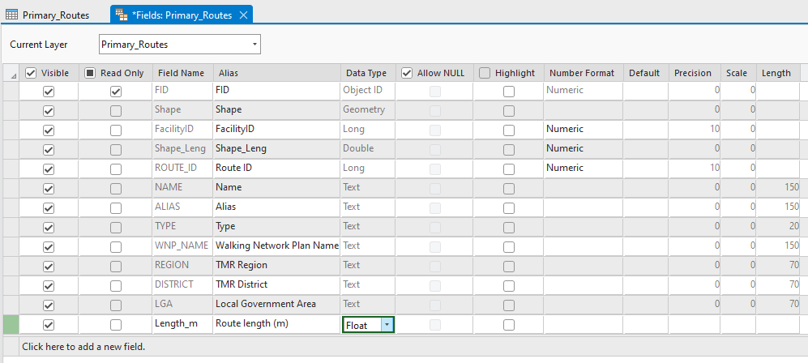
Figure 12: attribute table field view. Source TMR, 2023

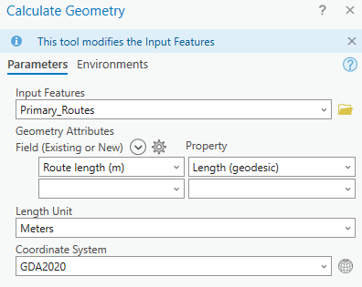 | 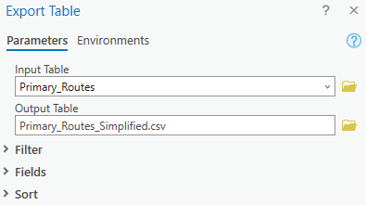
Figure 13: Calculate Geometry. Source TMR, 2023 | Figure 14: Export with File Name. Source TMR, 2023
An amount of overlap between Primary and Secondary is expected as routes within Primary or Secondary networks use the same path/road. As Primary to Secondary destination output all the routes start from the same location, routes overlap until they get further away from that starting point. This section will consolidate the many trips information into singular line representation.

Save it as another shapefile called 'Routes Simplified'.

- Ensure Primary and Secondary routes have a unique identifier, this will be used to aggregate the final output back into routes.
- Use the Split line at vertices tool to disaggregate Primary_Route layer into node-to-node features
  - Geoprocessing Toolbox -> Data Management -> Features -> Split Lines at Vertices
  - Repeat for Secondary_Route
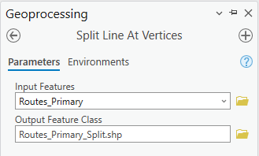 | 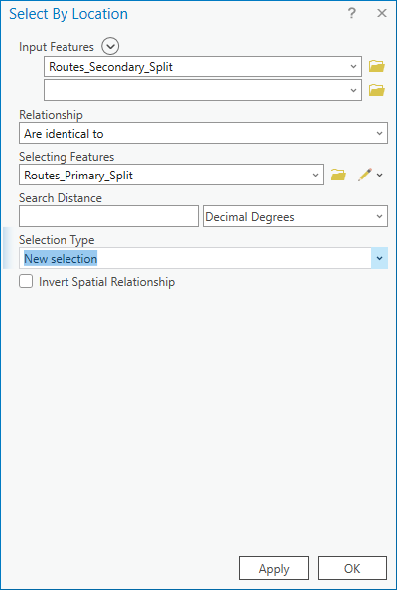
Figure 16: Split Line at Vertices. Source TMR, 2023 | Figure 15: Select By Location. Source TMR, 2023
- Delete any Secondary_Split features that are identical to any object in the ‘Primary_Split’ layer
  - In the map ribbon - Selection - Select by Location
  - Input Features Secondary_Split
  - Relationship Are Identical To
  - Selecting Features Primary_Split
  - Right click ‘Secondary_Split’ in table of contents and open the attribute table
  - Navigate to Show Selected Records view, delete selected
  - In the Edit ribbon use the Save edits button
- Delete features in the Primary_Split layer that have duplicate geometries.
  - GeoprocessingToolbox -> Data Management Tools -> General -> Delete Identical
  - Set Field(s) to Shape
  - Repeat for Secondary_Split
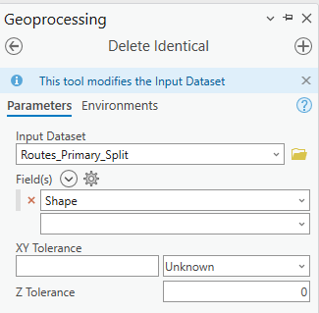

Figure 17: Delete Identical. Source TMR, 2023
- Dissolve the Primary_Split layer to re-aggregate into a single object per route
  - Geoprocessing -> Pairwise Dissolve
  - In the Fields list select all WNP attributes if they have been included, otherwise select the unique identifier.
  - Repeat for Secondary_Split.

Project Finalisation

At the end of the project, package and provide WNP map shapefiles (zipped map package is preferred) to TMR and local government and relevant stakeholders;

Walking Network Plan Shapefiles
- Primary Routes
- Secondary Routes
  - If you have used alternative WNP route hierarchy, ensure "primary routes" and "secondary routes" are captured within attribute table.
- Routes simplified (if developed)
- Primary Destination
- Secondary Destinations
- Up to 1km Walkable Catchment/Isochrone
- Up to 2km Walkable Catchment/Isochrone
- Primary Destination 2km Buffer
- Council footpath data
- Council cycle network - if more extensive than PCN²
- Land Use/Zoning
- Include population datafile if process was not based on ABS meshblock data (i.e needed to be generated).

Action Program excel

Action Program map (if created)

Walking Network Planning project report

More information about ABS data : https://www.abs.gov.au/ausstats/abs@.nsf/Lookup/by%20Subject/1270.0.55.001~July%202016~Main%20Features~Mesh%20Blocks%20(MB)~10012 For more information about specifically about centroids https://www.abs.gov.au/AUSSTATS/abs@.nsf/Lookup/2071.0.55.001Explanatory%20Notes12016?OpenDocument
If generated and available to share with DTMR.

