Walking Network Planning Project

QGIS guide
This guidance is reproduced with permission from the Principal Pedestrian Networks: Guidelines for state and local government (State of Victoria).
It has been amended from its original format by Queensland Government Department of Transport and Main Roads.

Use this guidance on how to create a walking network map in QGIS. QGIS is a free program available for use by practioners and using QGIS doesn't require any additional extensions or plugins. It is also easier to save output into different formats, for example it supports saving as shapefile and MapInfo tab files natively.

You can use this instructional GIS document for the relevant stages of the WNAP project:
- Stage 2: Build- up your map to determine the data-led walking network plan.
- Stage 3.1.4: Edit your walking network plan after engagement consultation.
- Stage 4: Mark your walking network plan for actions that are location specific.
- Stage 5.1.1: Package GIS files at WNAP project finalisation.

Build the Walking Network Plan

Step 1: Collate background data
The layers required to complete the analysis are listed under Walking Network Planning Guidance Map data resources. Store datasets in the same projected coordinate system before starting.

ABS Meshblock data

Link to digital boundary page:
https://www.abs.gov.au/statistics/standards/australian-statistical-geography-standard-asgs-edition-3/jul2021-jun2026/access-and-downloads/digital-boundary-files

Link to Meshblock population counts page:
https://www.abs.gov.au/census/guide-census-data/mesh-block-counts/latest-release

To prep the ABS data for use in WNP

The data is available by default for the whole of Australia. Create an ABS account to use 'Table Builder' to make a Queensland Dataset download.

- Extract full Australia MB shapefile, query by attribute -> “STE_NAME21”= ’Queensland’
- Save the results of this query to a new table "MB_2021_QLD", "QLD_MB_2021".
- Open the downloaded excel spreadsheet for population counts and delete all sheets apart from the Queensland ones (Sheets 3 and 3.1).
- Delete any rows that are not related to the table attributes, ensure the column headers are kept.
- Copy the sheet 3.1 rows (excluding headers) into sheet 3 and then delete sheet 3.1
- Add an attribute index to the QLD meshblock file for the MB_CODE21 attribute.
- Open the QLD MB file and population count spreadsheet in QGIS. If spreadsheet is formatted correctly, you can drag and drop to open in QGIS.
- You can remove fields from the QLD MB table if you like or want to reduce the file size. Ensure MB_CODE21 and MB_CAT21 are kept.
- Add a population field to QLD_MB, ensure it is either float or double attribute type
- Add a join to the QLD MB file using MB_CODE21 field
- QLD_MB is input table, population spreadsheet is the join table
- MB_CODE21 is the join field
- Use field calculator to fill the added population attribute using the joined 'Person' field
- Remove the join
- This should be done before creating the Meshblock centroids.

Step 2: Determine the primary destination
Map the selected location(s) for the primary destination.

Destinations
- Primary destinations are places people regularly visit and can be public transport hubs, town centres, schools, hospitals and community service facilities.
- Apply a 2 kilometre buffer around the primary destination point. Use a projection that supports metres/kilometres (for example. Use a localised zone)
- You can find the buffer in the Vector toolbar. Click ‘Geoprocessing Tools’ and ‘Buffer’. Alternatively, it can be applied through the ‘Processing Toolbox’ window: Click ‘Vector Geometry’ then ‘Buffer’.
- Include points for other locations (Secondary Destinations) that people may walk to within the 2 kilometre buffer.

Note: It is well understood that some destinations that are visited more frequently by many people such as a shopping centre when compared to other destinations such as a single ‘clubhouse’ or small playground. To address this, we encourage considering your overall approach to the WNP (Radial, Precinct or Corridor) to be important as well as evaluating walking routes priority when output. The route review and manual editing is completed in Step 8 Review WNP.

Step 3: Road Network
- QGIS does not require you to create a road network dataset: you just need to download and open.
- Each menu that requires the network will ask for you to select the ‘Road network’ layer.
- Download the Queensland Roads and Track layer layer as a shapefile (the download is from QSpatial) and open in QGIS.

Step 4: Map the walkable catchment
In the Processing Toolbox open the Network analysis dropdown and select 'Service area (from layer)'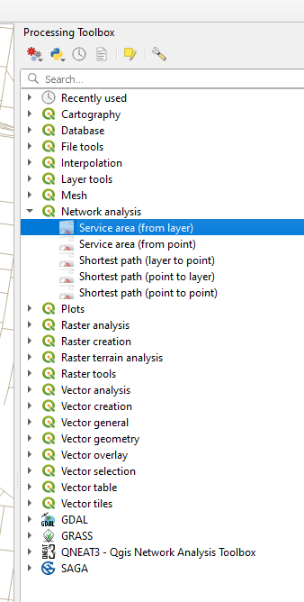
Figure 1: Processing Toolbar, Source: TMR, 2023

- Fill out the Service Area menu like the image below.
- Use the roads and footpaths data as the vector layer representing network and the Primary Destination as the vector layer with start points.

For 2km isochrone
- Set the Path type to calculate to Shortest and the Travel cost to ‘2000’.
- Note that QGIS toolbar will default cost is in metres. If the network layer units are set to kilometres use ‘2’ (to represent 2 kilometres) instead.
- Note: the output files from this tool do not need to be kept so can be output as a temporary file.

- Change the output for 'Service Area (boundary nodes)' to 'create temporary layer'.
- Ensure 'open output file after running algorithm' is checked and click 'Run'.
- For clarity rename the output layers to include '_2km' as the default name will be the same for the 1km output.

For 1km isochrone
Repeat with the Cost changed to 1000 and rename output layers to include '_1km'.

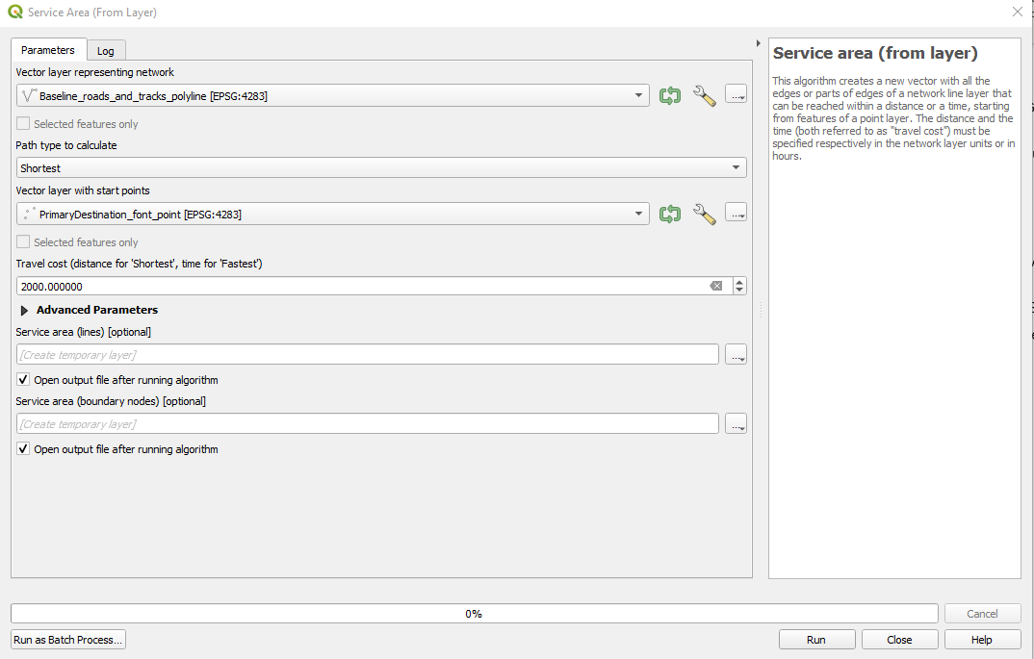
Figure 2: Service Area Parameters, Source: TMR, 2023

Converting data into Polygon
- The Service Area output will be a polyline dataset.
- The polyline data needs to be converted into a polygon. To do this conversion, use the 'Concave hull (Alpha Shapes)' tool.
- Open the 'Vector Geometry' dropdown and select 'Concave hull (Alpha Shapes)'.

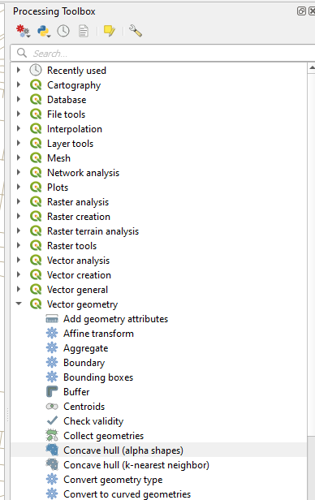
Figure 3: Processing toolbar, Source: TMR, 2023
- Use 'Service area (boundary nodes)_2km' layer as the Input, leave the default Threshold of 0.3 and deselect 'Allow Holes'.
- Save the output to a file named like 'Upto_2km_WalkableArea'.
- Repeat using the 'Service area (boundary nodes)_1km' to output the 'Upto_1km_WalkableArea' layer.
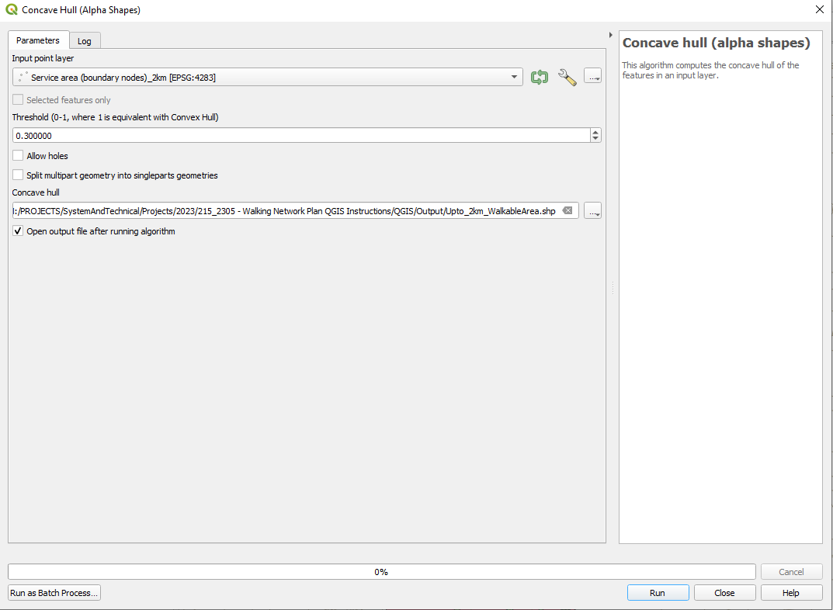
Figure 4: Concave Hull tool with selections, Source: TMR, 2023

Walking Network Plan Schema
Name | Alias | Definition | Type
ROUTE_ID | Route ID | Unique identifier | Integer
NAME | Name | Name of route | Text
ALIAS | Alias | Alternate name of route | Text
TYPE | Type | Primary, Future Primary, Secondary or Future Secondary defining the hierarchy of the route. Legend field. | Text
WNP_NAME | Walking Network Plan Name | Name of the Walking Network Plan this route is within | Text
REGION | TMR Region | Transport and Main Roads Region containing the route | Text
DISTRICT | TMR District | Transport and Main Roads District containing the route | Text
LGA | Local Government Area | Local Government Area containing the route | Text

Step 5: Map existing residential population densities

This is effectively a repeat of steps from Step 1:'To prep the ABS data for use in WNP' but in more detail.

Residential population
To understand the potential trips that can occur, there are a few methods.

ABS Census meshblock data for residential population within the WNP buffer can be used.
- Open the ABS meshblock population csv. QGIS Layer Add Delimited Text layer
- File Format CSV Select the QLD Meshblock Population CSV
- In the 'Geometry Definition' dropdown select 'No geometry'
- Hit 'Add'
- Right click on the Meshblock geometry table and select 'Properties'
- In the 'Joins' menu hit the plus button to add a new join.
- Select the meshblock attribute table as the 'Join layer'.
- Set the 'Join field' to 'Mb_code21'.
- Set the 'Target field' to 'Mb_code21.
- Open the 'Joined fields' drop down and only select the 'PERSONS' field. This attribute name may have changed, if 'PERSONS' is not available identify the field that contains the meshblock population and select that.
- Hit 'OK' in the 'Edit Vector Join' menu and then hit 'Apply' in the 'Joins' menu.

Save your meshblock geometry table with '_Pop' (or similar) added to the file name to indicate it includes population data.

This next step will create a point at the centre of each meshblock, which are also called centroids.
Create centroids out of the Meshblock area layer. Instead of identifying one tool, this guidance offers three that will allow you to do this stage and you can pick whichever produces the output that best fits the local road and footpath network:
- Using the new layer create a centroids layer using the Polygon Centroids tool, ensure 'Centroids for each part' is checked on. You may need to use a different tool as this tool does not care if the centroid is outside of the polygon.
- Using 'Point on surface' will provide a point that is always within the input polygon.
- 'Pole of inaccessibility' can also be used as it is meant to output the most internal point (farthest point from every edge), however it also has limitations.

For WNP that contain new developments, centre points with an estimated population can be added. Those with population zero can be removed.

Low population or low densities
In very low density or low population areas, the Mesh Block layer may create a draft WNP that has obvious broken links and missing routes. This is because the location of the centroid in the Mesh Block is weighted based on the location of residential addresses. This application of Mesh Block data works best in locations with higher populations and consequently more centroids from which to draw routes.
- Create manual population meshblocks in GIS based on available ABS information (majority of populated meshblock contain between 30-60 dwellings). Manual route editing can be calculated from trip attractors based on TMR trip generation.

Trip generation
- Use trip generation rates when determining secondary destination population if Meshblock population or employment data is not available.
- Trip generation rates are specifically for that land use. Undertake a manual assessment to determine the appropriate rate and yield to adopt for each secondary destination. Refer to TMR's Guide to Traffic Impact Assessment (Section 8.2.1) for trip generation rate resources.
- For example, let's determine the secondary destination population for a school:
- Confirm student numbers: search for the school on the Department of Education Schools Directory, and click on the 'Enrolment details' tab. For this example, 363 students are enrolled.
- Confirm appropriate trip rate: peak generation rate for a primary school is 0.28 trips per student.
- Calculate estimated population: 0.28 trips per 363 students = 102 secondary destination population for the primary school.

- Use walking access point/s when mapping the primary/secondary destinations. Designate routes to/from actual entry points to create a realistic and accessible walking network. This applies particularly for larger land uses, for example a hospital, because the entry(s) for walking will likely differ from the centre point of the destination (or main vehicle access point).
- For the shortest routes between primary/secondary destinations, ensure that the route to exit and re-enter the catchment to avoid barriers as needed.

Route intensity
- For determining the intensity of routes, combine both Meshblock population data and the secondary destination population data along each route. This will provide a more realistic representation of secondary route designations compared with primary route designations. Where secondary destination populations are not considered in determining route intensity, this may result in a disproportionate number of primary routes and create an adverse influence on ability to program works.
- For more complex urban environments, consider creating a hierarchy/weighting of secondary destinations relative to the type of primary destination, to help define primary or secondary routes on the network

Step 7: Determine shortest distance routes
From the Network Analysis dropdown select 'Shortest Path (point to layer)'

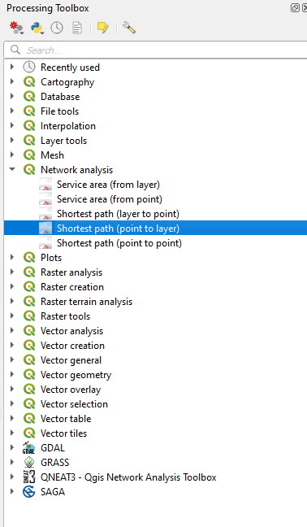 | 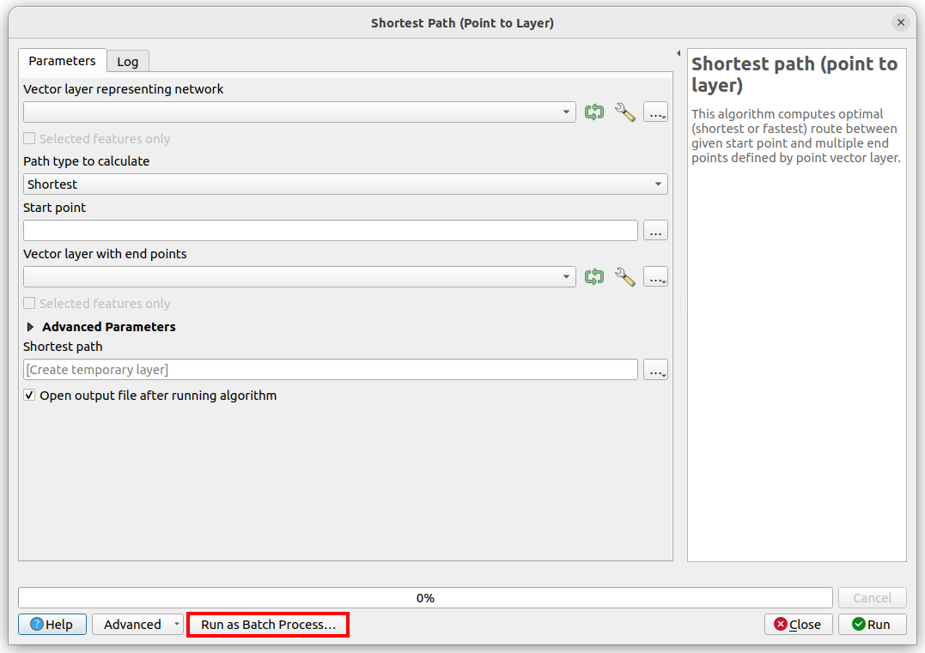
Figure 5: Processing Toolbox, 2023 | Figure 6: Shortest Path (point to Layer), Source: TMR, 2023

- From the Network Analysis dropdown select 'Shortest Path (point to layer)'
- Run the 'Shortest path (point to layer)' tool as batch process.
- Open the tool and click the 'Run as Batch Process' button.

- Then fill the third column '(Start point)' with the 'Add Values by Expression...' option.
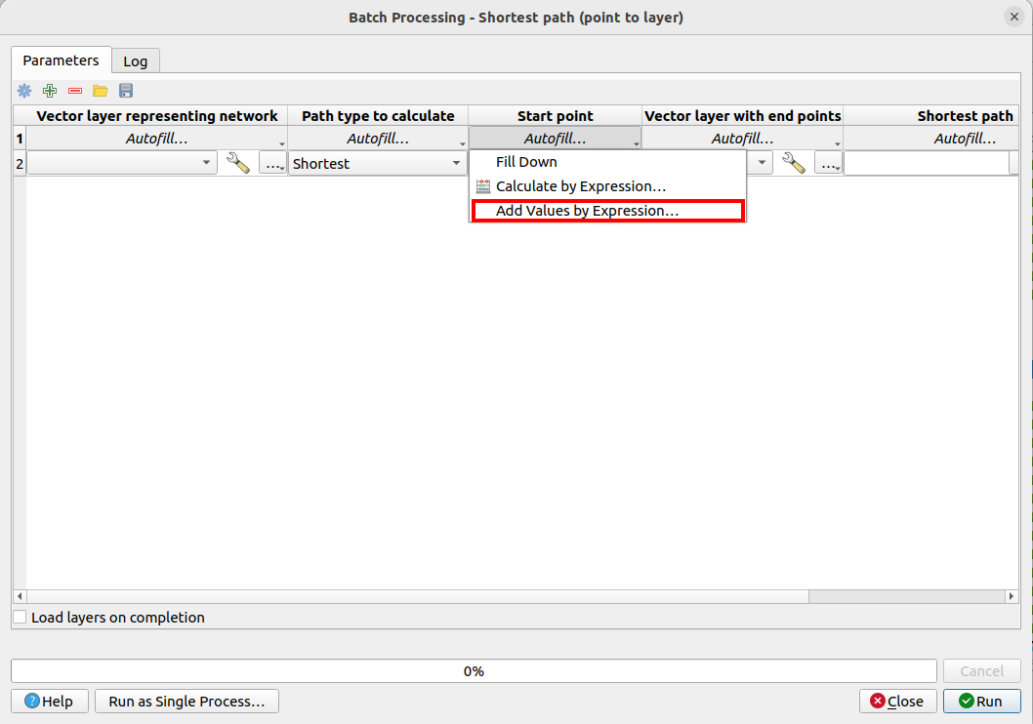
Figure 7: Batch Processing, Source: TMR, 2023
- Use this expression to fill the ‘Start point’ column.
- Aggregate ( '<Primary Destination>','array_agg',$geometry)
- Replace the name of <Primary Destination> with the name of the Primary Destination table
- Note: The preview will be ' No feature was found on this layer to evaluate the expression', this message can be ignored.

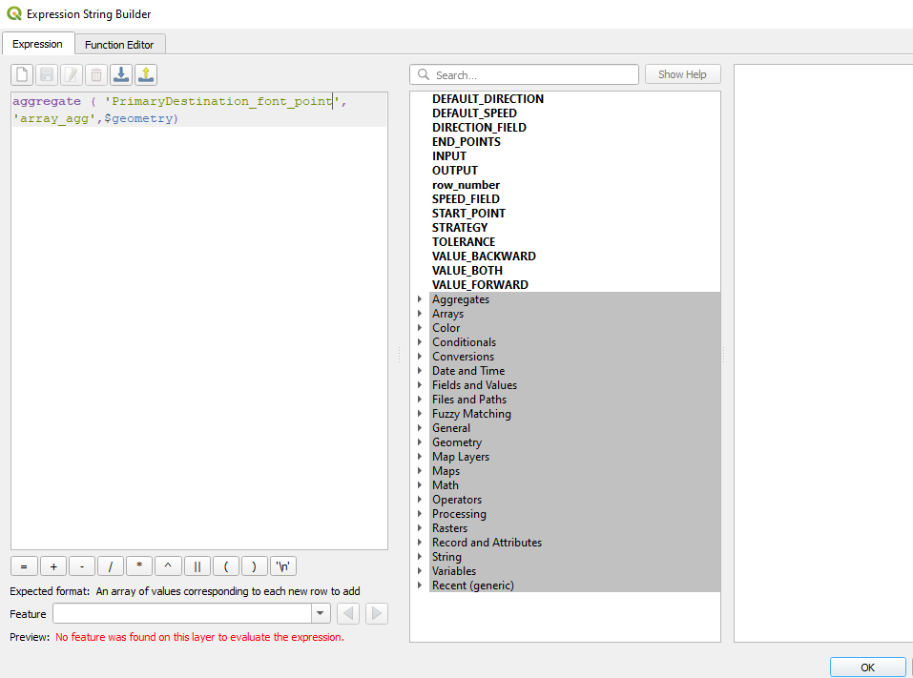 | 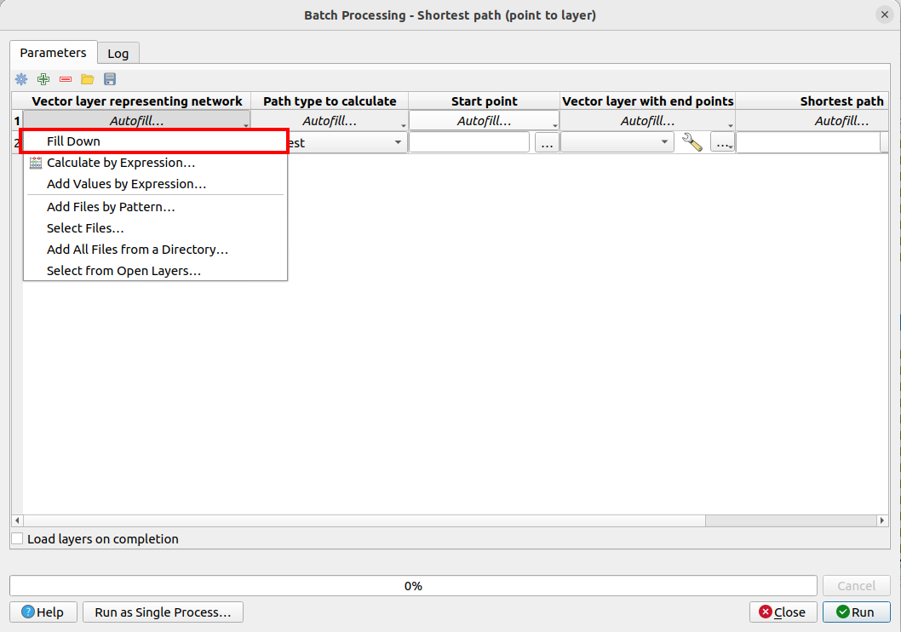
Figure 8: Expression String Builder, Source: TMR, 2023 | Figure 9: Autofill Fill Down function, Source: TMR, 2023
- Set the first column, ‘Network’ to the road/footpath layer.
- Set end points to the ‘Secondary Destination’ table.
- Set Shortest Path, output, to 'TEMPORARY OUTPUT'
- Use Autofill – Fill Down for the network layer, end point and shortest path columns.
- Then scroll down the table and remove the last row.
Note: deleting the last row is because this row is created by default and is not required (the start point field will be empty).
- Ensure that Load layers on completion is selection and hit 'Run'.

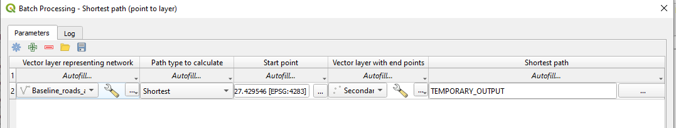
Figure 10: Example of the Batch Process Row completed, Source: TMR, 2023

- As there is only one ‘Start Point’ in the ‘Primary Destination’ table the result can be saved as 'ShortestPath_Primary_to_Secondary', or similar suitable table name.
- After saving this table, remove any temporary layers from the QGIS Layers window.

- Repeat using the same network: ‘start point’ and ‘shortest path fields’ and replacing the end points with the meshblock centroids layer.
- Save the repeated process output file as 'ShortestPath_Primary_to_Meshblock'.

Optional: Shortest routes to secondary destinations.
- Recommended for Precinct Network approach.
- Note: These steps rely on the secondary destinations being spread around the WNP area, so it may not be of benefit to every WNP.
If desired, you can create a ‘Shortest Routes Secondary’ to ‘Meshblock’ file. It can provide additional connections to a location / make a network look more complete or filled in. I have attached an example ‘Secondary_to_Meshblock_Example' from the data created for as an example for Southport. Specifically for Southport, you can see how the secondary to meshblock layer allows for locations to be connected to from both sides / travel directions.
- Before starting this process remove any temporary layers created for the previous shortest path processes.
- For this process, use ‘Secondary Destination’ as the ‘Start Point’ in place of the ‘Primary’ and the ‘end points’ layer will be the Meshblocks. Use the following expression for the start points: aggregate ( '<Secondary Destination>','array_agg',$geometry).

- Replace label of <Secondary Destination> with the name of the ‘Secondary Destination’ table.
- This process can be quite slow depending on the amount of start and end locations used and may need to be run overnight.
- The output will be a temporary layer for each Secondary Destination containing a route to each Meshblock.
- Open the 'Vector general' menu and use the 'Merge Vector Layers' tool to combine the output temporary layers into a single layer.
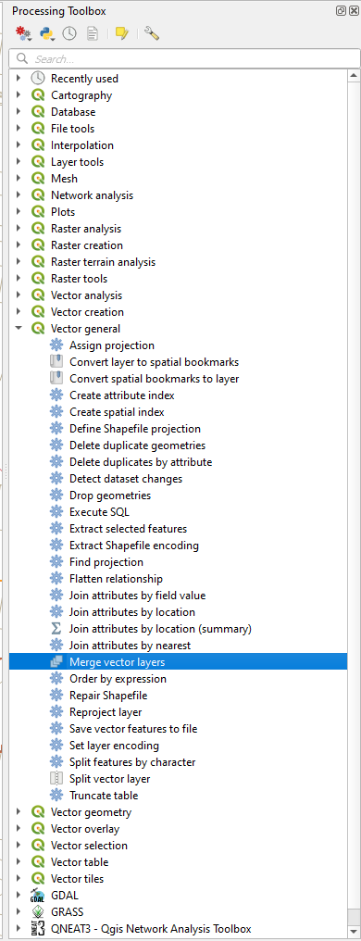 | 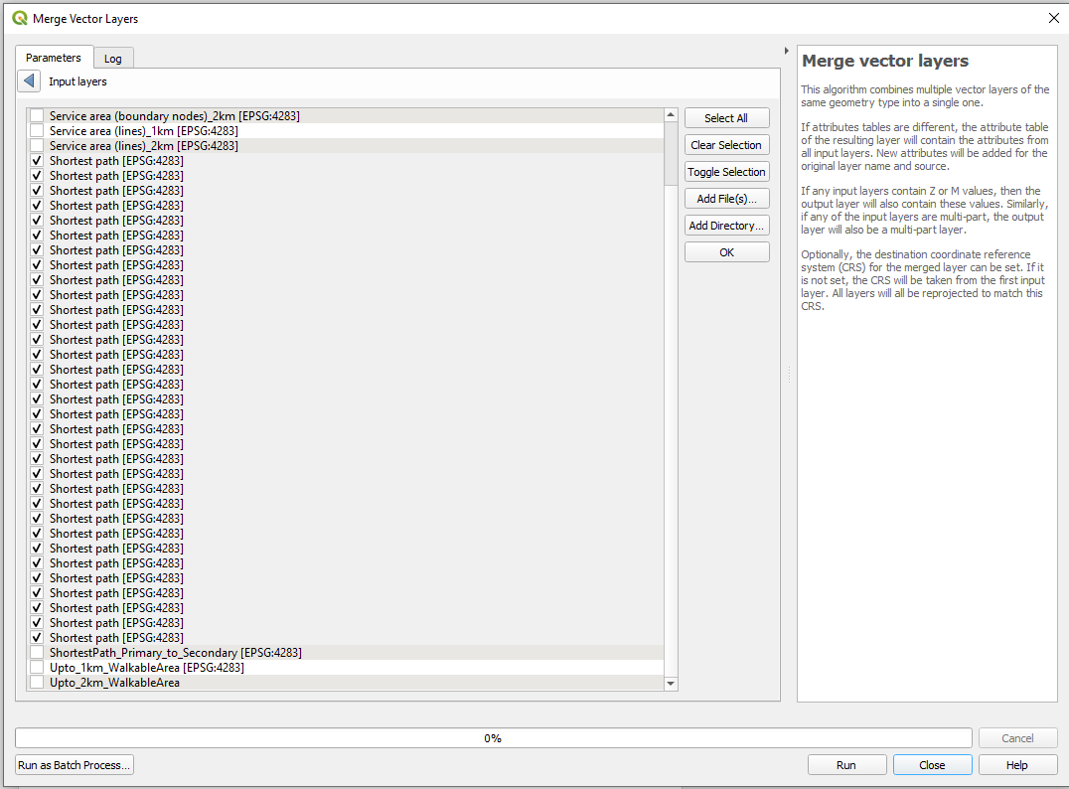
Figure 11: Merge Vector Layers, Source: TMR, 2023 | Figure 12: Merge Vector Layers Parameters, Source: TMR, 2023

- Merge all layers called 'Shortest Path'.
- The output merged layer from this process will be called 'Merged'.
- Save this layer as 'ShortestPath_Secondary_to_Meshblock'.

Step 8: Review WNP

Review the WNAP project purpose, and types of WNP in Guidance Section 2.1.
Ensure you have Primary, Secondary routes, captured logical destinations.
Manually edit and add routes based on the road network or council footpath data if necessary prior to stakeholder engagement to make a logical connected WNP.
- Undertake a manual review of the existing footpath network, particularly within park/recreation areas and 'shortcuts' within residential areas.
- Note: ‘Snapping’ should be turned on. Snapping can be enabled by going through Project, click ‘Snapping Options’ then the ‘magnet’ (enable snapping) icon. You can set your own tolerance so long as the final output network is fully connected. You should also change the snapping type to suit your mapping needs. The Snapping tool is vertex by default but adding segment (essentially allowing for snapping to anywhere on the line) will add a lot more snappable locations.
- Utilise the contour layer to identify paths where gradients exceed 5%.
- Highlight these >5% gradient routes for review during stakeholder liaison to confirm whether they should be removed and other routes considered as part of the WNP.

Radial WNP:
  - You have undertaken the process outlined above and generated shortest routes from residential populations (ABS Meshblock location) to the primary destination, and from the primary destination to secondary destinations.

Precinct WNP:
There is an additional method relevant in converting the radial WNP into a precinct WNP:
  - Option A: Repeat the GIS step process with another nearby destination as the primary and overlay the radial maps. You can undertake this process more than twice. Similar to a heatmap this will allow you to generate understanding of 'primary' routes for multiple destinations.
  - Option B: Manually draw walking routes connecting into the radial network in the WNAP Engagement process. Connect secondary destinations to other secondary destinations based on clear desireline attractions. Identify ‘logical’ cross-connection gaps in the walking network by connecting secondary destinations to other secondary destinations based on clear desireline attractions and add to feature class.

Corridor WNP:
  - Create multiple WNP for relevant locations (such as public transport stops) along the corridor.
  - Draw a linear route representing transport corridor and connections to existing network.

Engagement Maps
Prepare the WNP maps for review during the stakeholder engagement workshop.

Additional maps may be provided to aid stakeholder conversations about the Walking environment:
- for communicating active transport relationship, create Principal Cycle Network Map
- any existing path infrastructure map (such as existing pedestrian crossings, footpaths, shared paths, boardwalks, parks).
- Contour routes map with >5% gradient routes highlighted.
- Inset maps zoomed in if there is a focus area of WNAP project which may include building entrances, crossings (if at a neighbourhood scale), ATSIP/First Nations cultural heritage sites.
- Any photographs, or supporting information such as crash maps from the network pinned at mapped locations.
- Provide and show known future walking networks, local or state master planning, growth areas, school catchment maps or capital works plans.
- Land use zoning maps.
- Recommend showing future walking network as a dashed line etc. to distinguish future planning from the existing network.
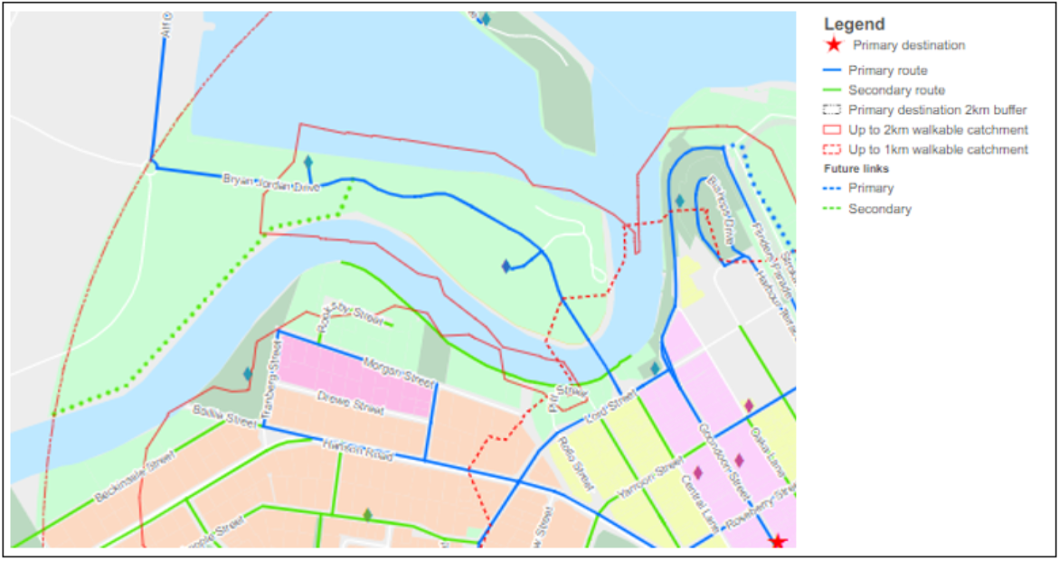
Figure 13: Example walking network plans with Land Use zoning. Source TMR, 2020

Engagement edits

Edit your walking network plan after engagement consultation:
- Manual recategorization of secondary or primary routes.
- Future strategic routes.
- Adding or removing destinations.
- Capturing short-cuts and cross-catchment routes.
Capture changes in WNP map and also brief description of the changes in WNAP report.

Action Program Supporting Map

For actions that are location specific, mark-up your walking network plan.

- Create a feature class in the working folder with GPS location and categorized works as Essential, Important.
- Capture area-wide interventions in separate icon/annotation.
- Apply an icon or label for locations points/works and include categories in the legend.
- Gaps in the existing network:
  - Showing the Action program on a map of the existing network clearly highlights where works could complete missing links and address any existing gaps.
- Primary and secondary WNP routes:
  - Highlight on a supporting map how the Action Program aligns with the primary and secondary routes of the WNP. This can help to identify the type and scale of walking infrastructure improvements relative to the hierarchy of the network.
- Funding opportunities: by showing PCNP alignment overlaps with PWP works related items highlights PCN grant funding.

Optional: Calculate Route Distance

If you want to be able to calculate total distance of primary walking routes and secondary walking routes, undertake these following steps. You may find this useful for:
- statistics/quantification
- understanding broad project benefits (people with new access)
- relationship to broader government ambition
- calculating proposed walking environment improvements.

- To calculate the length of a route right click on the layer in the layer list and open the attribute table.
- Use the field calculator to create a new field, name this new field length_m or length_km depending on the map units.
  - Set the output field type to Decimal number (real)
  - Set the output field length to a high enough value to account for the object length and that the precision is high enough.
  - Use the ‘$length’ expression and hit OK.
- You can use Basic Statistics for fields to calculate the total length of all routes.
- Processing Toolbox -> Vector Analysis -> Basic Statistics for fields
- Select the primary_routes / primary_routes_simplified layer and the length field that was just created and hit OK. This will produce a html link that will open a summary of the selected field, include sum of the route length.
- You can also export the output file to a csv, right click the layer in the layer list and select Export -> Save Feature as and set the format to comma separated values (CSV).
- Repeat for secondary routes.

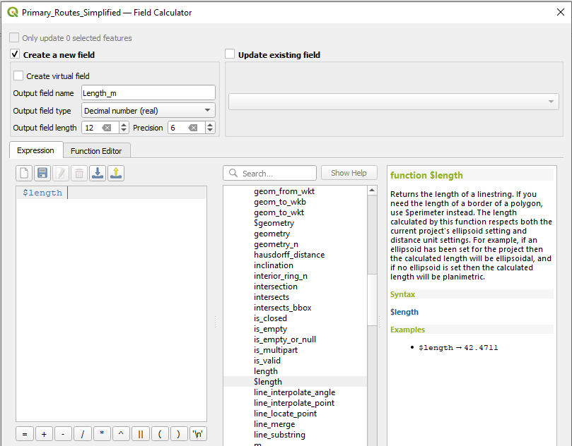 | 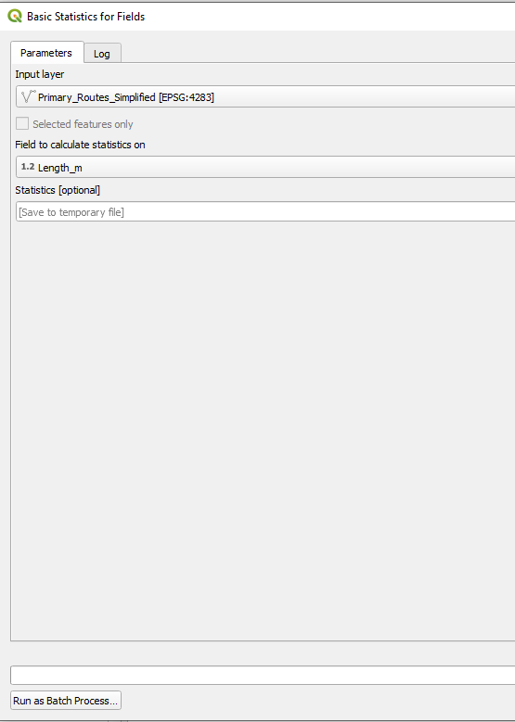
Figure 14: Primary Routes Simplified. Source TMR, 2023 | Figure 15: Statistics for Fields. Source TMR, 2023

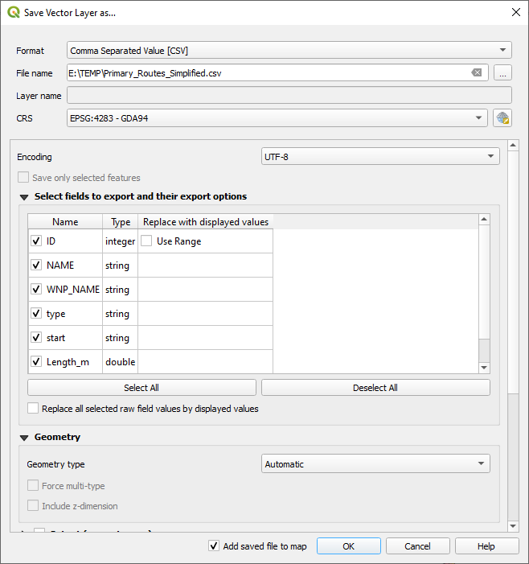
Figure 16: Save Vector Layer. Source TMR, 2023

An amount of overlap between Primary and Secondary is expected as routes within Primary or Secondary networks use the same path/road. As Primary to Secondary destination output all the routes start from the same location, routes overlap until they get further away from that starting point. This section will consolidate the many trips information into singular line representation.

Save it as another shapefile called 'Routes Simplified'.

- Ensure Primary and Secondary routes have a unique identifier, this will be used to aggregate the final output back into routes.
- Use the Explode lines tool to disaggregate Primary_Route layer into node-to-node features
  - Processing ‘Toolbox’ -> ‘Vector Geometry’ -> ‘Explode lines’
  - Repeat for ‘Secondary_Route’
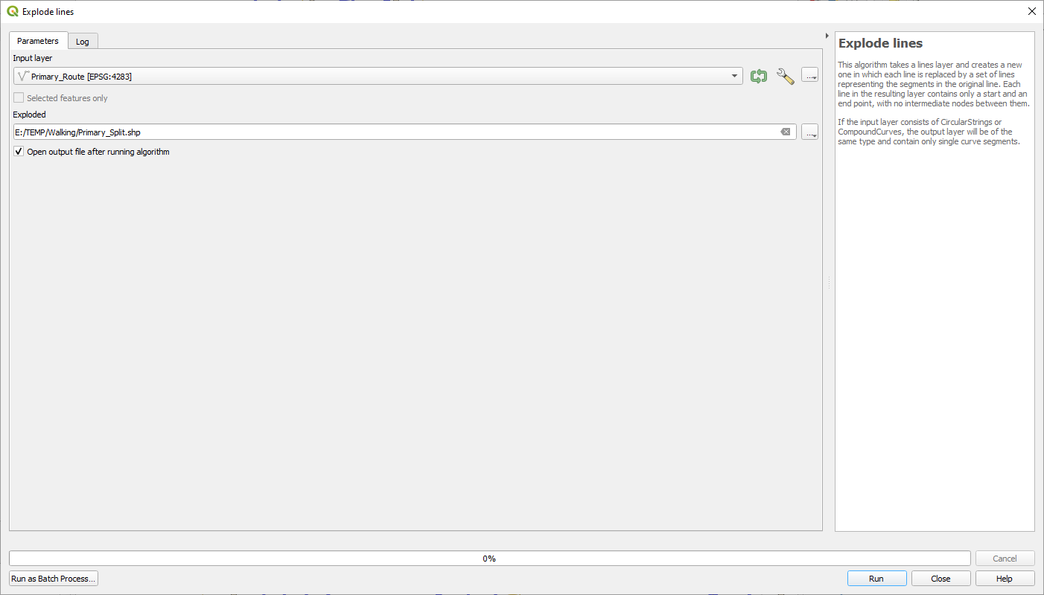
Figure 17: Explode Lines. Source TMR, 2023
- Delete any Secondary_Split features that are identical to any object in the Primary_Split layer
  - From the Processing Toolbox – Vector selection - Select by Location
  - Select features from Secondary_Split
  - Where features - equal
  - By comparing the features from - Primary_Split
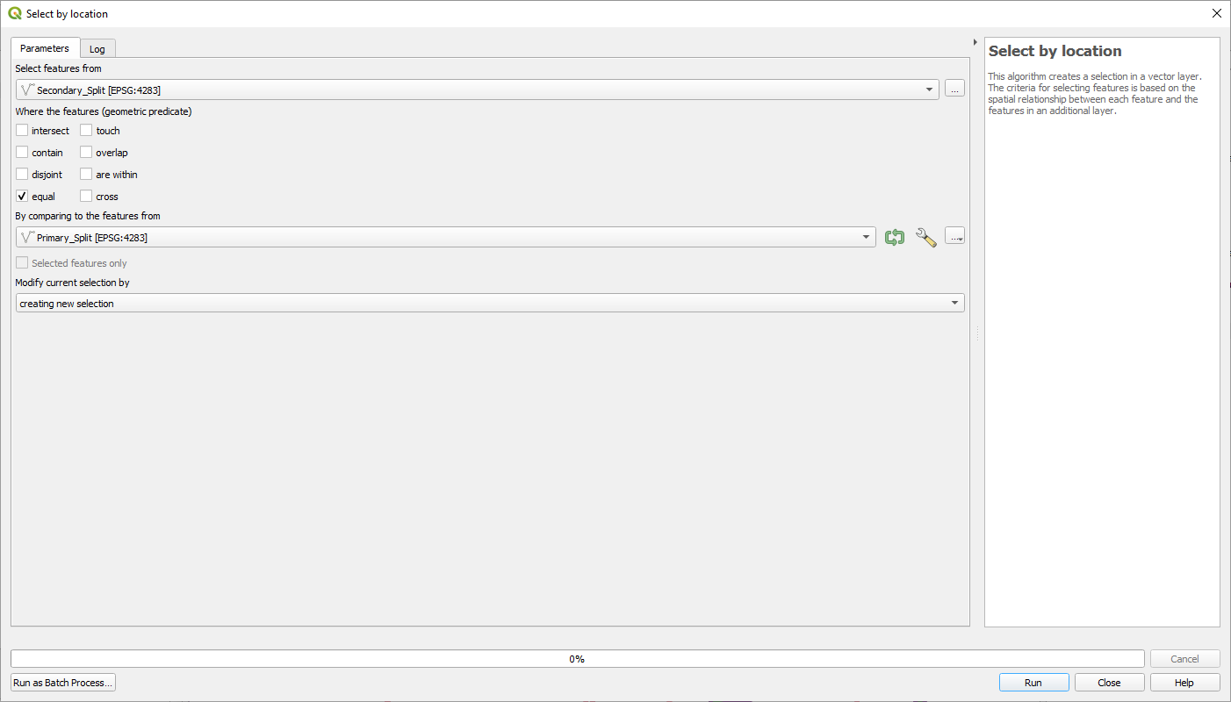
Figure 18: Select by Location Parameters. Source TMR, 2023.

  - Right click Secondary_Split in the layers list, open the attribute table, and select ‘toggle editing mode’
  - Hit the ‘delete selected’ button, save edits and then toggle editing mode off.
  - In the Editor toolbar select the Editor drop down and press Save Edits. Open the drop-down menu again and select Stop Editing.
- Delete features in the Primary_Split layer that have duplicate geometries.
  - Processing Toolbox -> Vector general -> Delete duplicate geometries
  - Repeat for Secondary_Split
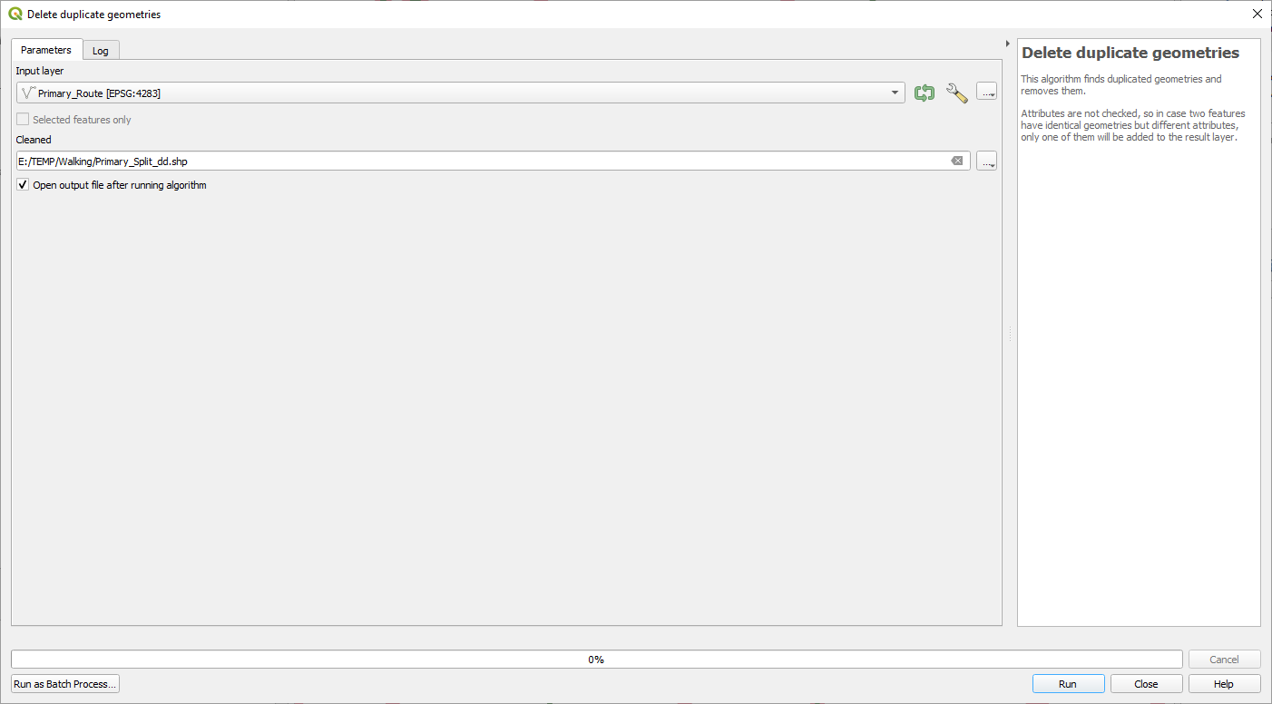
Figure 19: Delete Duplicate. Source TMR, 2023

- Dissolve the Primary_Split_dd layer to re-aggregate into a single object per route
  - Processing Toolbox -> Vector Geometry -> Dissolve
  - In the Dissolve field(s) menu select all WNP attributes if they have been included, otherwise select the unique identifier.
  - Repeat for Secondary_Split
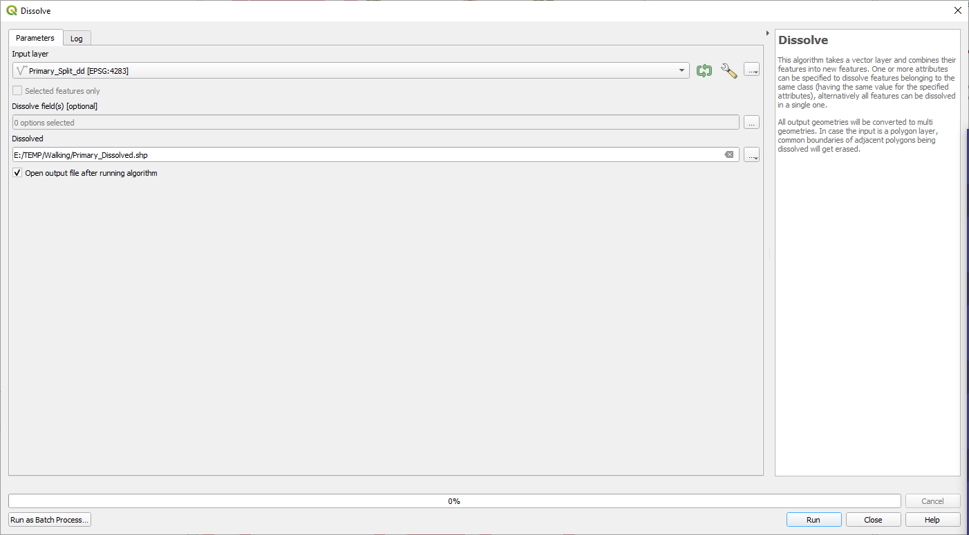
Figure 20: Dissolve. Source TMR, 2023

Project Finalisation

At the end of the project, package and provide WNP map shapefiles (zipped map package is preferred) to TMR and local government and relevant stakeholders;

Walking Network Plan Shapefiles
- Primary Routes
- Secondary Routes
  - If you have used alternative WNP route hierarchy, ensure "primary routes" and "secondary routes" are captured within attribute table.
- Routes simplified (if developed)
- Primary Destination
- Secondary Destinations
- Up to 1km Walkable Catchment/Isochrone
- Up to 2km Walkable Catchment/Isochrone
- Primary Destination 2km Buffer
- Council footpath data
- Council cycle network - if more extensive than PCN²
- Land Use/Zoning
- Include population datafile if process was not based on ABS meshblock data (i.e needed to be generated).

Action Program excel
Action Program map (if created)

WNAP project report

This value is a cap on how convex the output is allowed to be. It roughly means a lower threshold will be more angular and a higher threshold will be more rounded around the edges and fill in more empty space. To understand this in more detail, visit https://gis.stackexchange.com/questions/1200/what-are-definition-algorithms-and-practical-solutions-for-concave-hull This page has an image to understand visually.
Each tool also outputs a different result for all locations but primarily varying centroids locations will only impact larger population areas.
More information about ABS data : https://www.abs.gov.au/ausstats/abs@.nsf/Lookup/by%20Subject/1270.0.55.001~July%202016~Main%20Features~Mesh%20Blocks%20(MB)~10012 For more information about specifically about centroids https://www.abs.gov.au/AUSSTATS/abs@.nsf/Lookup/2071.0.55.001Explanatory%20Notes12016?OpenDocument
As a note, as the ‘explode’ tool disaggregates so there is only a start and end node if two lines occupy the same space (that is, lines are along the same road) but are different lengths they will not be removed through this process as they are not 'identical'.
If generated and available to share with TMR.

