Walking Network Planning Guidance
Superseded by 2024 Guidance Update
Cycling and Walking Team, 17 April 2024

Creative Commons information

© State of Queensland (Department of Transport and Main Roads) 2015
http://creativecommons.org.licences/by/4.0/
This work is licensed under a Creative Commons Attribution 4.0 Licence. You are free to copy, communicate and adapt the work, as long as you attribute the authors.
The Queensland Government supports and encourages the dissemination and exchange of information. However, copyright protects this publication. The State of Queensland has no objection to this material being reproduced, made available online or electronically but only if it's recognised as the owner of the copyright and this material remains unaltered.
The Queensland Government is committed to providing accessible services to Queenslanders of all cultural and linguistic backgrounds. If you have difficulty understanding this publication and need a translator, please call the Translating and Interpreting Service (TIS National) on 13 14 50 and ask them to telephone the Queensland Department of Transport and Main Roads on 13 74 68.
Disclaimer: While every care has been taken in preparing this publication, the State of Queensland accepts no responsibility for decisions or actions taken as a result of any data, information, statement or advice, expressed or implied, contained within. To the best of our knowledge, the content was correct at the time of publishing.

This is a copy of guidance which was originally hosted on the Department of Transport and Main Roads website from 2021 to April 2024. It has been provided for reference only. Anyone preparing a Walking Network Plan should now refer to the updated guidance at https://www.tmr.qld.gov.au/travel-and-transport/pedestrians-and-walking/guidance-and-resources

Document control options

Departmental approvals
Refer to the appropriate Risk Assessment Tool for relevant reviewer and approver
Date | Name | Position | Action required  (Review/endorse/approve) | Due
15/04/2024 | Andrew Ross | Principal Planner | Review | 15/04/2024
16/04/2024 | Robyn Davies | Manager (Cycling and Walking) | Approve | 17/04/2024

Risk level
☐ GACC major ☐ GACC minor ☐ High risk (but not GACC) ☐ Medium risk
Prepared by | Sarah E Schwaner
Title | Planner
District & Region
Branch & Division | Transport Strategy and Planning Branch  Policy, Planning and Investment Division
Project/program | Walking Network Planning Guidance update
Project number
Project location | Online
Status | This is a copy of guidance that was superceded in April 2024. For the current guidance, refer to https://www.tmr.qld.gov.au/travel-and-transport/pedestrians-and-walking/guidance-and-resources
DMS ref. no. | 455/02107

Contents

Walking Network Planning Guidance [As published on TMR website from 2021 to April 2024]

1. How to use this guidance 4
2. Stage 1: Prepare draft walking network plan 6
3. Stage 2: Test the draft walking network plan 7
4. Stage 3: Finalise the walking network plan 8
5. Stage 4: Prepare draft works program 9
6. Stage 5: Finalise and implement the works program 11
7. Stage 6: Evaluate and promote the network plan and works program 12
Appendix 1: Mapping 16
Appendix 2: Stakeholder workshop 24

- How to use this guidance
- What is it?
- Who is it for?
- When should you use it?

What is it?
More people will walk when everyday destinations are connected by comfortable, direct, safe and accessible routes. Walking network plans (WNPs) are a first step to creating better places to walk.
The Queensland Government is committed to achieving the Queensland Walking Strategy 2019–2029 vision of walking becoming 'an easy choice for everyone, every day'. When we talk about walking, we also include running and moving with the help of a mobility device (such as a wheelchair, mobility cane or a walking frame).
The following guidance supports practitioners to prepare WNPs and a prioritised works program to make the plan a reality.
The guidance integrates two existing guidelines to create an approach that works for Queensland circumstances:
- Guidelines for developing Principal Pedestrian Networks (Victorian PPN) (State of Victoria, 2015)
- Walkability Improvement Tool (WIT) (Queensland Treasury, 2020).
The Department of Transport and Main Roads (TMR) would like to acknowledge the Victorian Department of Transport for permission to use the PPN guidelines in this way.
The Victorian guideline refers to development of a Principal Pedestrian Network (PPN). In Queensland this is called a Walking Network Plan (WNP). For PPN in the Victorian guideline, read WNP.
There are six stages:
- Stage 1 – Prepare draft walking network plan
- Stage 2 – Test the draft walking network plan
- Stage 3 – Finalise the walking network plan
- Stage 4 – Prepare draft works program
- Stage 5 – Finalise and implement the works program
- Stage 6 – Evaluate and promote the network plan and works program
This process has been tested and refined in collaboration with three pilot local governments: Logan City Council, Gladstone Regional Council and Mount Isa City Council. You can view case studies from each council.
Each stage of the guidance describes key tasks, identifies links to the source guidelines and explains how to apply these in a Queensland context. There are also links to additional walking guidance and resources on the TMR website, which provide valuable assistance for every stage of the process.
For planning walking infrastructure in greenfield sites refer to the Street Design Manual: Walkable Neighbourhoods (Institute of Public Works Engineering Australasia, Queensland, 2020).

Who is it for?
Guidance has been developed for Queensland local and state authorities, transport practitioners, planners, urban designers, architects, developers and community groups.
You can request a model scope of works for a project/tender to develop a WNP by sending an email to walking@tmr.qld.gov.au.

When should you use it?
Use the guidance to:
- create an overarching walking network plan to achieve a safer, comfortable and more connected walking environment
- undertake precinct planning around walking destinations such as shops, schools and public transport stations
- prioritise and plan works, budgets and funding schedules to implement improvements to walking environments.

- Stage 1: Prepare draft walking network plan

Key tasks:
- understand local walking 'vision'
- identify primary destination(s) that will be the focus of the walking network
- identify other key destinations to be included that communities walk to i.e. secondary destinations
- use GIS to prepare draft WNP (i.e. walkable catchment and shortest distance between destinations)

Source guidance:
Victorian PPN:
- Delineating the PPN, Steps 1-9
- Validating the PPN, Step 5
- Appendix B (MapInfo guidance, 2015 version)
- Appendix B (ArcGIS guidance, 2020 version)

Notes for Queensland users
Prior to preparing a WNP, be clear about why you want the plan and how it will be adopted and used. Prepare a precinct walking vision and objectives.
Take a multidisciplinary approach: identify local land use planning, transport, tourism, health and recreation policies that support the development of a WNP. If local policies are limited, draw on the objectives of the Queensland Government (2019) Queensland Walking Strategy 2019–2029, which puts walking at the top of the sustainable transport hierarchy.
Identify existing information/feedback from stakeholders and the community about current conditions for walking that might help define plan objectives.
The road authority needs to identify how they will manage their implementation and ongoing monitoring and delivery of the WNP and works program. The governance arrangements will define ownership, roles and responsibilities to help deliver the vision for walking in the precinct.
Refer to Appendix 1 for guidance on how to prepare a draft WNP. (Victorian PPN, Delineating the PPN Steps 1-9, pg 26-43).
Pedestrian and Walking Guidance and Resources
Why walking matters
Planning for walking
Urban planning and design

- Stage 2: Test the draft walking network plan

Key tasks:
- organise stakeholder engagement workshop
- conduct local walking audits
- capture stakeholder feedback
- identify possible works and priorities

Source guidance:
WIT:
- Steps 5-7
- Appendix 2
Victorian PPN:
- Validating the PPN, Step 1
- Validating the PPN, Step 4

Notes for Queensland users
Organise a stakeholder workshop, including a walking audit. Access a range of resources and templates to help you do this at Appendix 2.
Identify which stakeholders to invite. Include disability groups and organisations, or representatives with accessible auditing knowledge, and adopt a co-design approach to improve accessibility for all walkers.

Pedestrian and Walking Guidance and Resources
Why walking matters
Pedestrian characteristics
Audits and measuring walkable environments
Planning for walking

- Stage 3: Finalise the walking network plan

Key tasks:
- update and finalise the draft network plan using walking audits and stakeholder feedback
- adopt network plan

Source guidance:
Victorian PPN:
- Validating the PPN, Step 6

Notes for Queensland users
Update the WNP to include changes recommended through the stakeholder engagement workshop. (Victorian PPN, Validating the PPN Step 6, pg 51).
Changes are likely to include:
- amendments to secondary destination locations
- adding cross-precinct primary routes to ensure key network walking paths are captured
- rationalising, realigning and, if necessary, removing secondary routes to better reflect how the community wants to use the walking network.
Liaise closely with key stakeholders when finalising the WNP to encourage a sense of ownership and buy-in ahead of adopting a finalised plan.

Pedestrian and Walking Guidance and Resources
Planning for walking
Urban planning and urban design

- Stage 4: Prepare draft works program

Key tasks:
- identify works needed to implement plan
- undertake preliminary design assessment
- identify costs and timescales

Source guidance:
WIT:
- Step 8

Notes for Queensland users
Use the stakeholder engagement and walking audit outcomes to inform the works and actions.
Confirm that the governance arrangements agreed at Stage 1 are working as plan preparation moves to designing and managing construction of walking infrastructure.
After development of an approved WNP, allow enough time to investigate options and feasibility prior to preparing the works program.
Ensure that you understand relevant desired infrastructure standards for primary and secondary routes. The walking guidance and resources listed on the TMR site are particularly helpful for this stage. Austroads has published an overview of where to find updated walking content in its Guide to Traffic Management and Guide to Road Design. [here]
You can also consider (WIT, Step 8, pg 19):
- non-infrastructure initiatives: for example, walking promotion, marketing, education and behaviour change initiatives
- temporary, quick, and easy to implement measures
- supporting facilities such as wayfinding guidance
- works related to maintenance of existing walking and supporting facilities.
Discussions should also include potential coordination with other scheduled relevant works in the precinct. (WIT, Step 8, pg 19).

Pedestrian and Walking Guidance and Resources
Planning for walking
Supporting facilities
Shade and street trees
Construction and maintenance
Paths for walking
Road crossings
Speed management and integrated treatments
Urban planning and urban design
Universal access
Promotion, encouragement, and behaviour change

- Stage 5: Finalise and implement the works program

Key tasks:
- prioritise works
- adopt works program
- commence identified works

Source guidance
WIT:
- Step 9

Notes for Queensland users
The WIT defines proposed works as Essential, Important or Non-Essential. These categories are subjective and contextual to each road authority. For example, if there have been recent complaints received by local government regarding lack of respite areas (shading, seating and so on) along a corridor, these works may be ranked as Essential with a desire to implement in the short term. (WIT, Step 9, pg 20-21).
Ideally, categorise identified works as Essential or Important to help maximise the likelihood of implementation. (WIT, Step 9, pg 20-21). Broadly, examples of improvements under each of these themes are:
- Essential: safety related (that is, footpath provision on streets classified as greater than Collector, crash, or hazardous location, speed limit reviews, lighting;); accessibility (provides access for people with disability); missing links (including crossings); street trees; removal of trip hazards.
- Important: works that encourage walking (crossings at desire lines, seating/street furniture/decluttering of path area); wayfinding; footpath widening; pavement upgrades for amenity; art installations (although in some locations any of these improvements could be regarded as Essential depending on vision and objectives for the precinct).
In addition to the WIT guidance on prioritising works, identify timing and responsible party for delivering works. Download an example template here.
When determining concept costs for each works item, also consider the costs and resources involved in further engineering analysis, assessment, approvals and ongoing maintenance. (WIT, Step 9, pg 21).
Co-ordinate between local and state road authorities to understand if/when there are other works that are planned or being undertaken in the area that may enable the proposed walking enhancements to be included at the same time for potentially lower cost. For example, planned road maintenance may provide an opportunity to include walking improvements/amenity within the corridor. (WIT, Step 9, pg 20-21).
Funding opportunities for walking infrastructure projects can come from a variety of sources:
- joint council/state/federal/private sector investment
- for projects also on a high priority Principal Cycle Network route, you can apply for a TMR Cycle Network Local Government grant
- developer contributions
- local council budget dedicated to walking (active travel) infrastructure
- related upcoming or ongoing projects
- state or federal government support, including infrastructure grants and funding for road safety improvements.

- Stage 6: Evaluate and promote the network plan and works program

Key tasks:
- evaluate improvements to the walking network
- promote new infrastructure

Source guidance
Victorian PPN:
- Implementing the PPN, Step 3

Pedestrian and Walking Guidance and Resources
Planning for walking
Walking data
Auditing and measuring walkable environments
Promotion, encouragement, and behaviour change

Notes for Queensland users
Identify the following:
- What are your overall objectives and desired outcomes?
- What data is already available?
- What additional data would need to be collected?
- How can this data be collected and what is the budget for evaluation?
Whether you are evaluating a plan or a project will influence your approach, including collection of baseline data and timing of post-implementation data collection. Data collected for a project can supplement data sourced for precinct evaluation.
At the precinct level, collect baseline data prior to starting any works, and undertake follow up measurements a minimum of six months after interventions have been implemented. Evaluate every two years once implementation is complete.
Only collect data that will assist with evaluating the plan or a project. Use measures that are influenced directly by the improvements. For example, speed reduction measures can be assessed using before/after speed surveys.
Before and after photos document the improvements to walking, how they were achieved and the difference they made.
Use the following information to identify the types of data that may be suitable for evaluating your plan or project.
Pedestrian and Walking Guidance and Resources
Planning for walking
Walking data
Auditing and measuring walkable environments
Promotion, encouragement, and behaviour change

Evaluating plans

Change in demand
What to measure:
- Growth in number and types of people walking
- Growth in walking mode share
- Mode shift/diversion rates
Data sources:
- Travel surveys/diaries/hands up surveys (schools)
- Census journey to work
- Mobile phone data
- Origin – destination data
- On street surveys (tracking trip lengths and routes, types of people using facilities, delays experienced etc)
- Walking participation survey
- Intercept surveys

Safety
What to measure:
- Reductions in vehicle traffic volumes and traffic speed
- Reduction in number of fatalities and hospitalisations that are related to pedestrians
Data sources:
- Traffic counts
- Speed surveys
- TMR Road crash database
- Before/after road safety audits

Attitudes/perceptions
What to measure:
- % of residents that feel comfortable walking in their local area
- Perception of safety, including personal security
- % of population who consider they have good accessibility to a range of services (by walking)
Data sources:
- Statistical phone/online surveys or intercept surveys
- Online spatial interactive mapping (e.g. social pinpoint)

Economic change
What to measure:
- Cost benefit analysis of projects in precinct
- Vacancy rates/ land or rent values
- Turnover
Data sources:
- Active transport economic appraisal tool
- Real estate data
- Local business surveys

Evaluating works
Change in demand
What to measure:
- Growth in number of people walking along key corridors
Data sources:
- Manual and/or automatic counts
- Mobile phone/Bluetooth data
- Observational surveys
- Intercept surveys with users
- Traffic signal operational data (pedestrian crossing activation)
- Cordon counts
Delivery outcomes
What to measure:
- Provision of completed works
Data sources:
- Footpaths (length)
- Supporting infrastructure (e.g. shade/street trees, wayfinding signage)
- Crossings/intersection improvements (number improved/added)
- Speed reduction (length)

Promoting plans and new infrastructure

Engage with:
- people who live, work, shop and play in the precinct
- walking-related community groups and programs (for example, Queensland Walks, Heart Foundation, 10,000 steps, Parkrun)
- other relevant tourism and recreation groups and operators (for example, Outdoors Queensland, Bushwalking Queensland). Encourage the creation of themed maps/walking routes that enable visitors/tourists to explore the precinct.
If the project is on a high priority Principal Cycle Network route, you can apply for a TMR Infra+ grant to promote the new infrastructure using behaviour change techniques.

Pedestrian and Walking Guidance and Resources
Planning for walking
Walking data
Auditing and measuring walkable environments
Promotion, encouragement, and behaviour change

Appendix 1: Mapping
For step-by-step guidance when using MapInfo for GIS mapping, refer to Victorian PPN, pg 58-76).
Read on to find step-by-step guidance when using ArcGIS for GIS mapping.
In Queensland, pedestrian networks are called walking networks.
For best results, map both a 1km and 2km walking catchment when developing a WNP. (Victorian PPN, Delineating the PPN Step 2, pg 28-29).
When mapping the pedestrian network, use both the existing footpath/pathway network and road network (Baseline roads and tracks dataset from Open Data Portal – Queensland Government). Undertake a manual review of the existing footpath network, particularly within park/recreation areas and 'shortcuts' within residential areas. (Victorian PPN, Delineating the PPN Step 3, pg 30-31).
When determining secondary destination population, if Meshblock population or employment data is not available specifically for that land use, use trip generation rates. This will require a manual assessment to determine the appropriate rate and yield to adopt for each secondary destination. Refer to TMR's Guide to Traffic Impact Assessment (Section 8.2.1) for trip generation rate resources. (Victorian PPN, Delineating the PPN Step 6, pg 36).
For example, let's determine the secondary destination population for a school:
- Confirm student numbers: search for the school on the Department of Education Schools Directory, and click on the 'Enrolment details' tab. For this example, 363 students are enrolled.
- Confirm appropriate trip rate: peak generation rate for a primary school is 0.28 trips per student.
- Calculate estimated population: 0.28 trips per 363 students = 102 secondary destination population for the primary school.
When mapping the primary/secondary destinations, use walking access point(s). Designating routes to/from actual entry points will create a realistic and accessible walking network. This applies particularly for larger land uses, for example a hospital, because the entry(s) for walking will likely differ from the centre point of the destination (or main vehicle access point). (Victorian PPN, Delineating the PPN Step 7, pg 38-39).
When determining the shortest routes between primary/secondary destinations, ensure that the route to exit and re-enter the catchment to avoid barriers as needed. (Victorian PPN, Delineating the PPN Step 7, pg 38-39).
When determining the intensity of routes, combine both Meshblock population data and the secondary destination population data along each route. This will provide a more realistic representation of secondary route designations compared with primary route designations. Where secondary destination populations are not considered in determining route intensity, this may result in a disproportionate number of primary routes and create an adverse influence on ability to program works. (Victorian PPN, Delineating the PPN Step 8, pg 40-41).
For more complex urban environments, consider creating a hierarchy/weighting of secondary destinations relative to the type of primary destination, to help define primary or secondary routes on the network. (Victorian PPN, Delineating the PPN Step 9, pg 42-43).
Prepare the following maps for review during the stakeholder engagement workshop (Victorian PPN, Validating the PPN Step 1, pg 45):
- Show known future walking networks, local or state master planning or capital works plans. Recommend showing future walking network as a dashed line etc. to distinguish future planning from the existing network, as shown in this example:
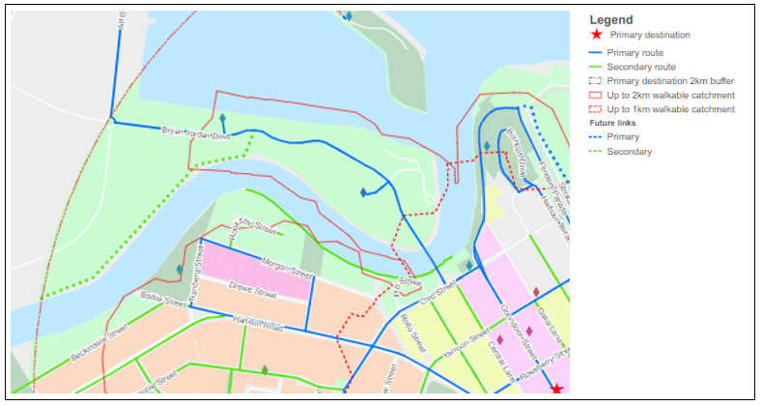
- When mapping the walking network, utilise the contour layer to identify paths where gradients exceed 5%. Highlight these for review during stakeholder liaison to confirm whether they should be removed and other routes considered as part of the WNP.
- Overlay the crash history (pedestrian-related incidents) to help inform path alignment and initial works program.
- Overlay the TMR Principal Cycle Network Plan (PCNP) to identify synergies with existing active travel priorities.

ESRI ArcGIS guide
[This guidance is reproduced with permission from the forthcoming updated version of Principal Pedestrian Networks: Guidelines for state and local government (State of Victoria).]
The following provides a guide to undertaking the analysis mapping in ESRI ArcGIS. This analysis will require the use of ArcGIS’ Network Analyst extension. The step numbers align with those in the current Victorian PPN guidance (Part 2, Section 1: Delineating the PPN).

Step 1: Collate background data
The layers required to complete the analysis are:
- Meshblock area and data table
- Road network – for pedestrian access.
Collate the data required for the analysis. Road network data is available at www.data.qld.gov.au/dataset/baseline-roads-and-tracks-queensland.
ABS Meshblock data is available from the Australian Bureau of Statistics.

Step 2: Determine the primary destination
Map the selected location(s) for the primary destination.

Step 3: Creating the road network
Enable the Network Analyst Extension on your current ArcMap session.
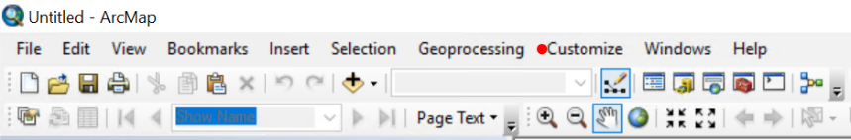
Select Customize>Extensions. A window with extensions will show.
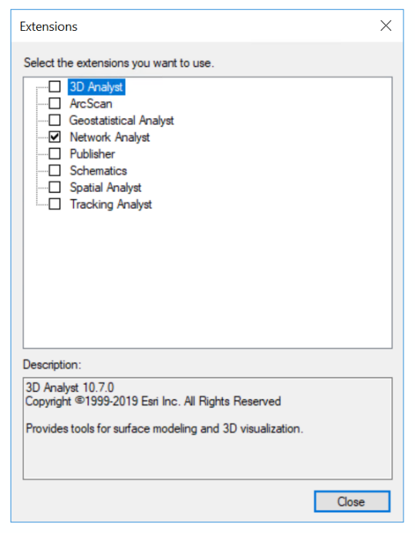
Create a new feature dataset in ArcCatalog for the road network to be stored in. Add the road network layer that will be used for the analysis in the current MXD.
Right click on the newly created feature data set. Navigate to New/Network Dataset.
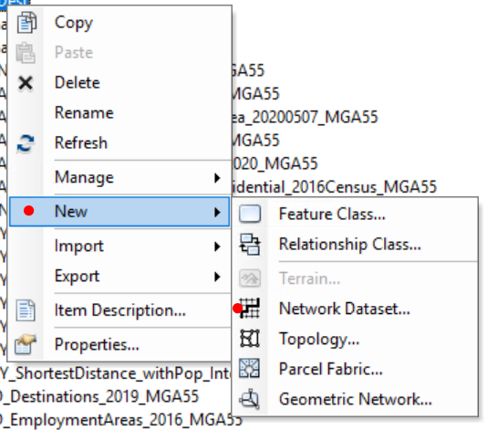
Choose the name for your network dataset, then choose the version of your network dataset. Click 'Next'.
Choose the road network layer to use as source for the network data set, click 'no' to model turns in the network since this is going to be used for pedestrian analysis. You can continue through the process leaving the options with the default choices, you will then get to a point where it will ask if you want to establish driving directions. As this is a pedestrian analysis, this won’t be necessary. Click 'Next'.
A summary of all the settings you have chosen will be displayed. Select 'Finish'.
If you need in-depth instructions and information on all the settings; ESRI provides detailed instructions https://desktop.arcgis.com/en/arcmap/latest/extensions/network-analyst/exercise-1-creating-a-network-dataset.htm

Step 4: Map the walkable catchment
Add the primary destination(s) layer to the working MXD. From the network analyst tool bar drop down list, choose 'New Service Area'.
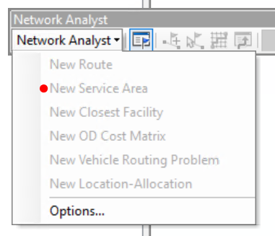
Select to show Network Analyst window.
Right click on Facilities and choose 'Load Locations' to open the dialogue window.
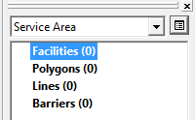
Fill the window in as shown and select 'OK'.
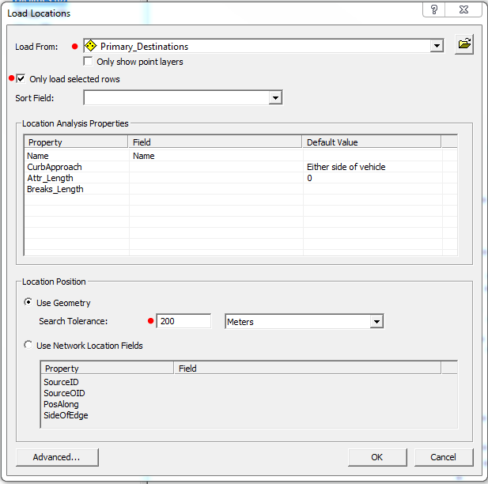
Click on 'Service Area Properties' button to be able to change the default breaks shown on the service area. Change the 'Default Breaks' to 2000 and click 'OK'.
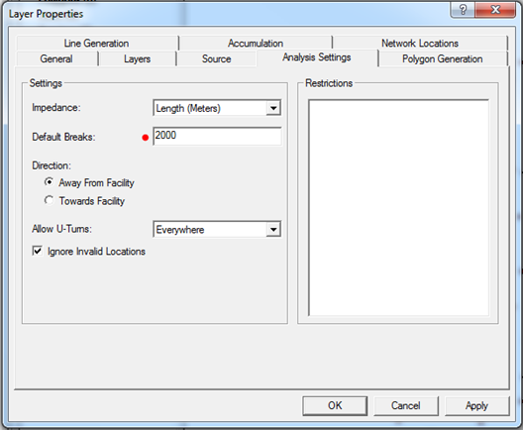
Click “Solve” button on the Network Analyst tool bar to calculate the catchment.
Layers will be grouped under 'Service Area' are temporary. The result of the service area will be sitting in the 'Polygons' layer.
Right click 'Polygons' layer and export the catchment as a feature class in the working geodatabase.

Step 5: Map existing residential population densities
Add the Meshblock area layer and data table into the MXD.
Join the table to the area.
Export the layer with the joined data as a feature class.
Create centroids out of the Meshblock area layer. If you have an ArcGIS Pro Desktop you use the 'Feature to Point' tool. An alternative is use QGIS using the Polygon Centroids tool.

Step 7: Determine shortest distance routes
Add the network dataset that was created in Part 2, along with the Meshblock centroids that were created in Part 4 to the working MXD. From the Network Analyst toolbar drop down list, choose 'New Closest Facility'.
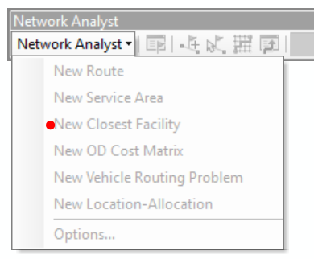
Add the facilities and the incidents to the model. You can decide which layer will serve as facilities and which one will serve as incidents. This is optional, but if there are any line barriers that will need to be added, you can add them into this step.
Go through the “Layer Properties” dialogue and set the properties on the “Analysis Settings “tab. Click “OK”.
Select “Solve” button on the Network Analyst tool bar to calculate the catchment.

Appendix 2: Stakeholder workshop
This section provides supporting information for the validation stage of the Victorian PPN (Step 4, pg 48).
Contact walking@tmr.qld.gov.au for copies of the following resources to help prepare and run the stakeholder workshop:
- Stakeholder workshop suggested invitation list
- Example stakeholder workshop agenda and runsheet to guide facilitators to prepare and run the workshop
- Example of a field log sheet for completion during a walking audit
- Walkable Neighbourhood Design Options powerpoint to present good examples of walking treatments/actions.
These resources will help you to gather a diverse range of stakeholder input and feedback to incorporate into a refined WNP and draft works program.
Prepare maps for review during the stakeholder engagement (refer Appendix 1
Include an opportunity to present the local walking ‘vision’ for the precinct (see 'How to use this guidance') during the workshop. This will help define the purpose of developing the WNP for the precinct and/or objectives of the project and encourage community feedback and support. This will also have an influence on the selection of works/solutions that may be included in your program.
A key element of the stakeholder workshop is to provide participants with an opportunity to undertake a walking audit to help them 'get into the shoes' of someone who walks. This can help shape how the stakeholders perceive the network and inform how the draft WNP is amended. The runsheet describes how to organise an on-site walking audit at the beginning of the workshop. (WIT, Step 5-7, pg 16-19).
If you’re aware accessibility is poor in the precinct, consider developing an accessible map of the area to help focus where improvements are needed most. Access examples previously prepared by TMR of this type of inclusive mapping.
Undertake walking audit close to workshop location (800m to 1km). Where possible, align walking audit route(s) with a primary route of the WNP. Prepare map printouts of the walking audit routes for participants’ reference. Use the example field log sheet.
Encourage feedback from all participants, for example, by breaking into multiple smaller groups:
- For face-to-face stakeholder engagement workshops, use large printouts of the WNP to provide participants the opportunity to provide feedback on the plan directly with markers and so on. These will be a valuable resource when finalising the WNP in the next stage.
- For virtual workshops, use online engagement resources such as Google Jamboard or Microsoft Miro to allow participants to provide direct feedback on the draft WNP.
To help facilitate participant discussion on potential works/actions, workshop with the group to identify priority routes/areas group to focus on before considering whole precinct area.
When discussing potential works/actions along priority routes, use the Walkable Neighbourhood Design Options video to illustrate good examples of walking treatments/actions. The organiser/facilitator can use the text on the slides and talk to the presentation. Ideally, complement this with local examples or scenarios to help ground the ideas in a familiar context. Alternatively, participants can watch the presentation without anyone speaking.

